ABDOMINAL PAIN CLOCK: *From ‘Teaching in the Hospital,’ Jeff Wiese*

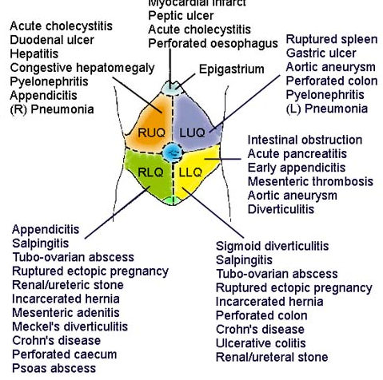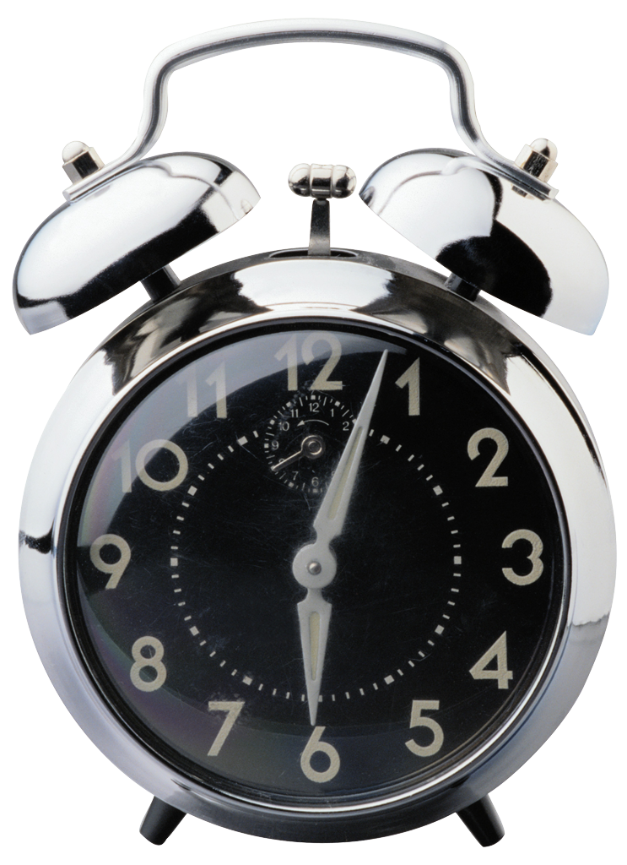

12pm: Esophagus, stomach, duodenum

esophageal rupture, esophagitis, GERD, gastritis, ulcer, gastric cancer, gastroparesis

duodenitis, duodenal perforation

1pm: inferior MI, PNA

referred pain via vagus for inferior MI

2pm: splenomegaly, splenic infarction, splenic abscess

splenomegaly causes: leukemia, lymphoma

3pm: RP organs: aorta, pancreas, kidneys

AAA, pancreatitis, ureteral stone, perinephric abscess

4pm: diverticulitis, colitis, large bowel obstruction, impaction

5pm: non-pregnancy related pelvic disease

endometritis, salpingitis, tubovarian abscess, ovarian cyst/rupture, PID

6pm: urinary tract disease

urethritis, prostatitis, cystitis, orchitis, hernias

7pm: pregnancy-related pelvic disease

ectopic pregnancy

8pm: appendicitis & ileocecal disease

Crohns, UC

9pm: (front of abdomen) small bowel disease

ischemic bowel, Meckel’s diverticulum, SBO, Crohn’s, cancer

10pm: liver & gallbladder

hepatitis, cholecystitis, choledocholithiasis, cholangitis

11pm: PNA or irritation of diaphragm

\*Solid organ pain (pancreas, liver, spleen) = CONSTANT because it’s the stretch of the capsule causing th pain

\*Obstructed hollow tube pain = INTERMITTENT because it’s when the muscular tube squeezes against the obstruction

\*pain starts at the embryologic origin