FII_portfolio_opt_R

Marcus Antonio Cardoso Ramalho

### Context

This work is part of Marcus Ramalho undeargraduation final project in administration on Universidade Federal Fluminense, entitled: Análise de risco e rentabilidade de uma carteira de fundos de investimento imobiliário.

This part of the project is focused on a method of optimization for a portfolio. The code itself, from the data aquisition to the optmization was adapted from various sources and built using the knowledge aquired by the student during the first covid-19 pandemic year when Dr. Ariel Levy offered a remote course on finance with R for administration students.

To better understand this project first we need to present some simple concepts about FII’s and risk in finance. FII’s or Fundos de Investimento Imobiliário are a booming tipe of real state investment in Brazil, there was more than one milion investor in 2020 , in their majority small investor, comparing with 2010 when there was less than fifty thousand investors, the growth of the market is notable. The appeal of this investment is related to the changes in the Brazilian economy after 2016. With the lowest basic interest rate ever, market players saw in FII’s an opportunity to earn more when compared to risk-free investments, with a lower risk compared to other equity assets.

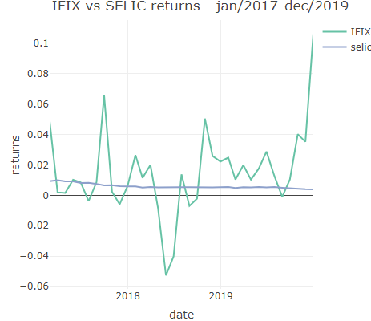

### Risk

### Purpose

This project aimed to select a optmized portfolio considering a scenario of low economy basic interest rate

### Metodology

This work relied on the use of RStudio and various R packages to manipulate and understand the data, including: Tydiverse(Wickham et al. 2019) ,Lubridade (Grolemund and Wickham 2011)for general data manipulation, plotly(Sievert n.d.) and ggplot2(Wickham 2016) for data visualization and quantmode(Ryan et al. 2022), tidyquant(Dancho and Vaughan 2022) and PerformanceAnalitycs(Peterson et al. 2020) for financial data vesting, manipulation and computation.

For the assets selection some assumptions were made. Using a filter tool from the website Clube do FII(ClubeFII, n.d.), all assets with the IPO (Inicial public offering) prior the year of 2017 and mean monthly liquidity greater than R$ 2,000.00 were selected.

The chosen assets price data was downloaded within the time window of 2017 to 2019 with the package quantmod(Ryan et al. 2022) and Yahoo Finance(“Yahoo Finance - Stock Market Live, Quotes, Business & Finance News,” n.d.) as source. After the price data vesting, followed the monthly returns calculation using dplyr(Wickham et al. 2022) and xts(Ryan et al. 2020) to transform the daily returns in monthly returns.

### Results

### Conclusion

ClubeFII. n.d. “Clube FII - O maior site de Fundos Imobiliários do Brasil.” <https://www.clubefii.com.br>.

Dancho, Matt, and Davis Vaughan. 2022. “Tidyquant: Tidy Quantitative Financial Analysis.” <https://CRAN.R-project.org/package=tidyquant>.

Grolemund, Garrett, and Hadley Wickham. 2011. “Dates and Times Made Easy with **Lubridate**.” *Journal of Statistical Software* 40 (3). <https://doi.org/10.18637/jss.v040.i03>.

Peterson, Brian G., Peter Carl, Kris Boudt, Ross Bennett, Joshua Ulrich, Eric Zivot, Dries Cornilly, et al. 2020. “PerformanceAnalytics: Econometric Tools for Performance and Risk Analysis.” <https://CRAN.R-project.org/package=PerformanceAnalytics>.

Ryan, Jeffrey A., Joshua M. Ulrich, Ross Bennett, and Corwin Joy. 2020. *Xts: eXtensible Time Series*. <https://CRAN.R-project.org/package=xts>.

Ryan, Jeffrey A., Joshua M. Ulrich, Ethan B. Smith, Wouter Thielen, Paul Teetor, and Steve Bronder. 2022. “Quantmod: Quantitative Financial Modelling Framework.” <https://CRAN.R-project.org/package=quantmod>.

Sievert, Carson. n.d. *Interactive Web-Based Data Visualization with R, Plotly, and Shiny*. Accessed September 30, 2022. <https://plotly-r.com/>.

Wickham, Hadley. 2016. *Ggplot2: Elegant Graphics for Data Analysis*. New York, NY: Springer Science+Business Media, LLC.

Wickham, Hadley, Mara Averick, Jennifer Bryan, Winston Chang, Lucy McGowan, Romain François, Garrett Grolemund, et al. 2019. “Welcome to the Tidyverse.” *Journal of Open Source Software* 4 (43): 1686. <https://doi.org/10.21105/joss.01686>.

Wickham, Hadley, Romain François, Lionel Henry, Kirill Müller, and RStudio. 2022. *Dplyr: A Grammar of Data Manipulation*. <https://CRAN.R-project.org/package=dplyr>.

“Yahoo Finance - Stock Market Live, Quotes, Business & Finance News.” n.d. <https://finance.yahoo.com/>.