EMULASO:

- Protocolos:

  - Generales:

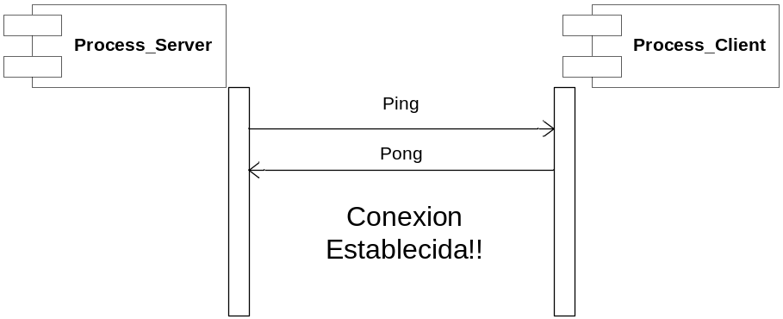

Ping = 0
H | Vacio
16

Pong = 1
H | Vacio
16

  - MShell:

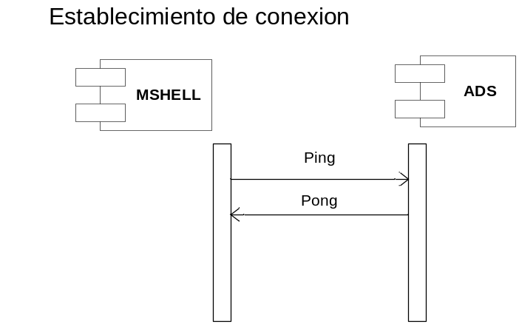

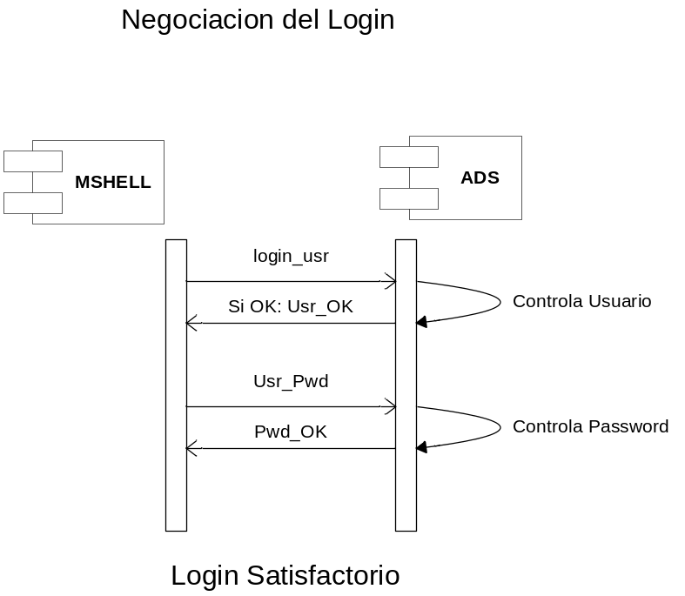

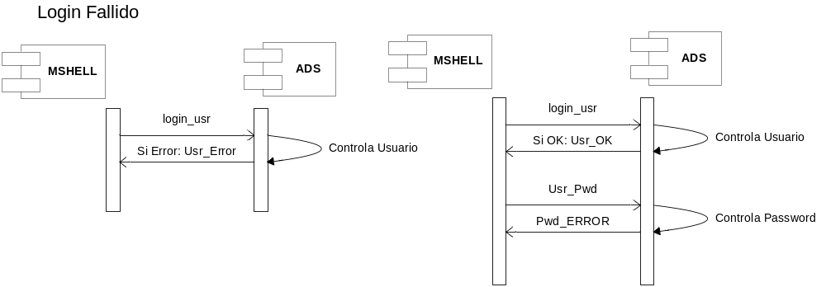
Login_Usr = 2
H | User_name
16 | Char(15)

Login_Usr = 3
H | User_password
16 | Char(15)

Usr_OK = 7
H | Vacio
16

Usr_ERROR = 8
H | Vacio
16

PWD_OK = 9
H | Vacio
16

PWD_ERROR = 10
H | Vacio
16

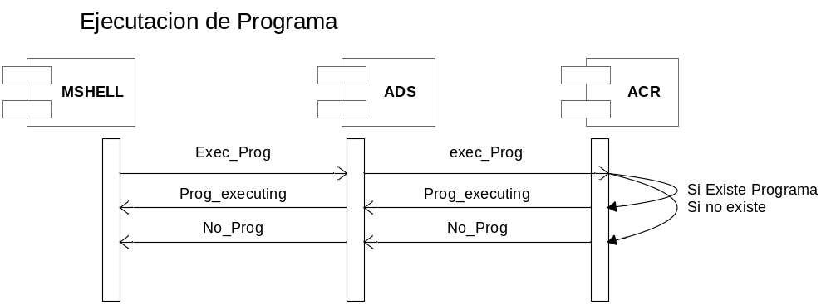
Exec_Prog = 6
H | Program_Name
16 | 30

Prog_Executing = 20
H | Program_name
16 | 30

No_Prog = 21
H | Program_name
16 | 30

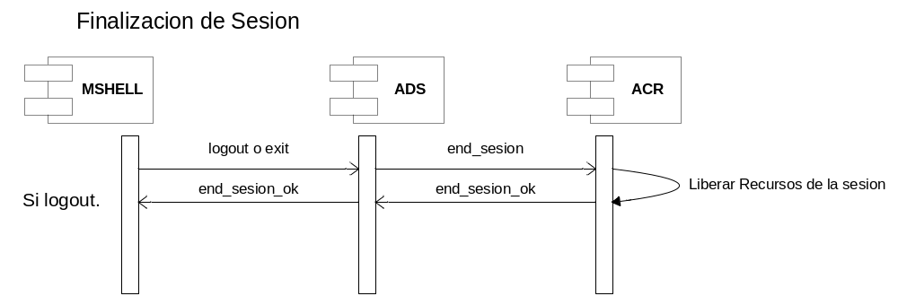
LOGOUT = 4
H | Vacio
16
Exit = 5
H | Vacio
16

End_Sesion = 22
H | User_name
16 | Char(15)

End_Sesion_OK = 23
H | User_name
16 | Char(15)

  - ADS

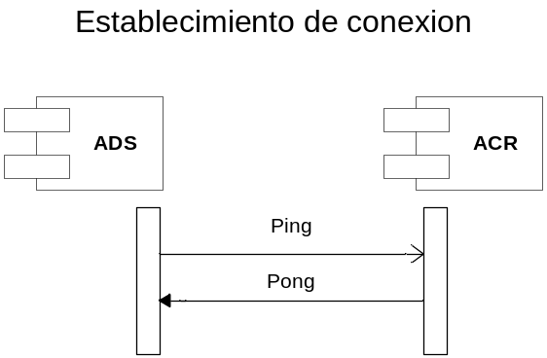

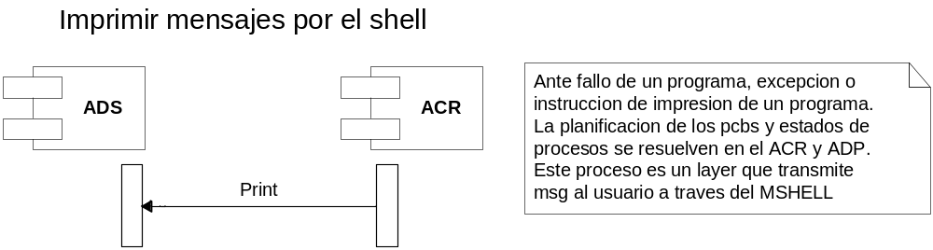

Para las funcionalides restante ver MSHELL

PRINT = 11
H | Msg
16 | Char(30)

  - ACR

Se levanta primero que el ADS y lo crea.

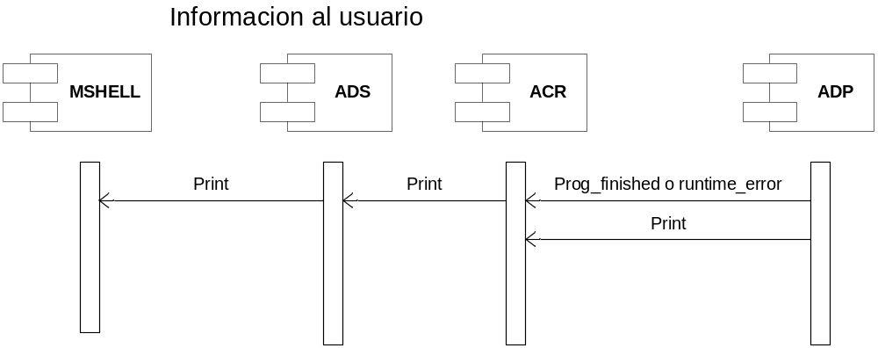

Runtime_Error = 13
H | Error_msg
16 | Char(30)

Prog_Finished = 14
H | Program_name
16 | Char(30)

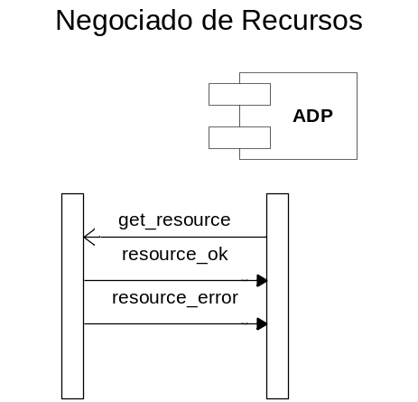
Get_Resource = 23
H | Id_PCB(4) | Id_Resource(1)
16 | Long | char

Resource_OK = 15
H | Id_PCB(4) | Id_Resource(1)
16 | Long | char

Id_Resource = { Disco = 0, Impresora = 1, Cinta = 2 }
Id_PCB = autonumber

Resource_Error = 15
H | Id_PCB(4) | Id_Resource(1)
16 | Long | char

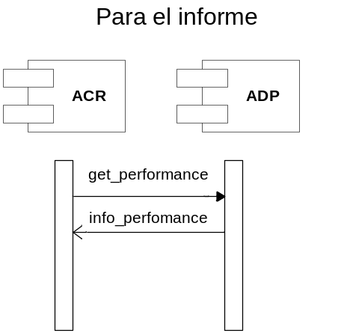

Get_Performance = 16
H | Empty
16

Info_Performance = 27
H | Performance
16 | ??

Con respecto al PCB:

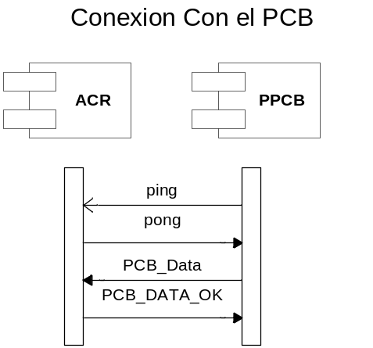

PCB_DATA = 31
H | data
16 | ???

PCB_DATA_OK = 41
H | empty
16

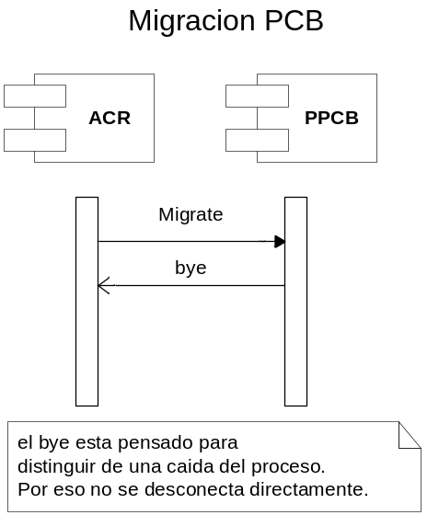

MIGRATE = 18
H | ACR_IP? | ACR_PORT
16

bye = 32
H | empty
16 | ???

  - ADP:

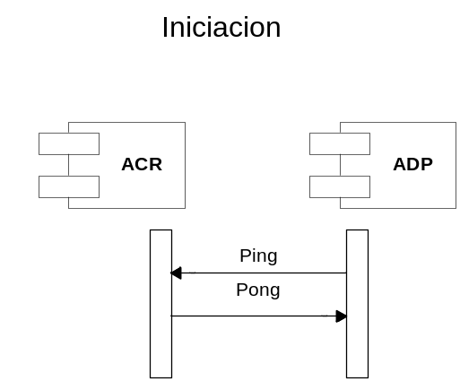

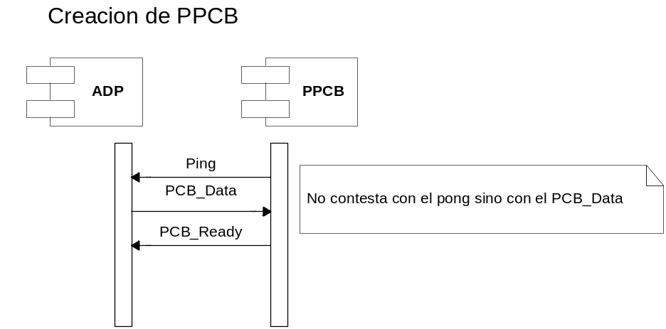

PCB_DATA = 17
H | Data
16 | ???

PCB_Ready = 29
H | Empty
16

Migracion de PCB para equilibrar carga

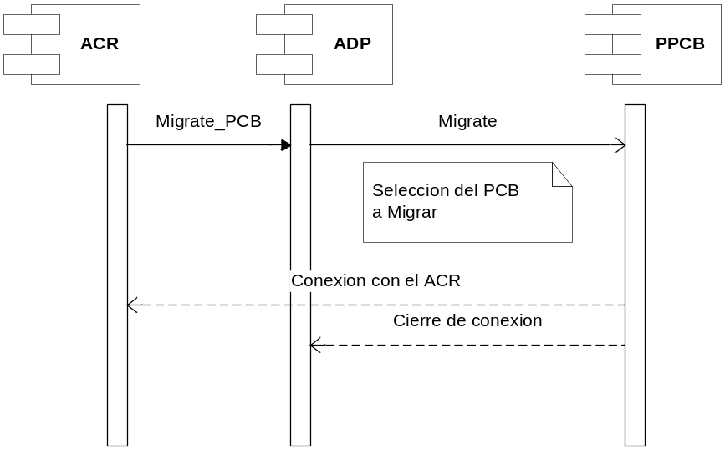
Migrate_PCB = 42
H | Empty
16

MIGRATE = 18
H | ACR_IP? | ACR_PORT
16

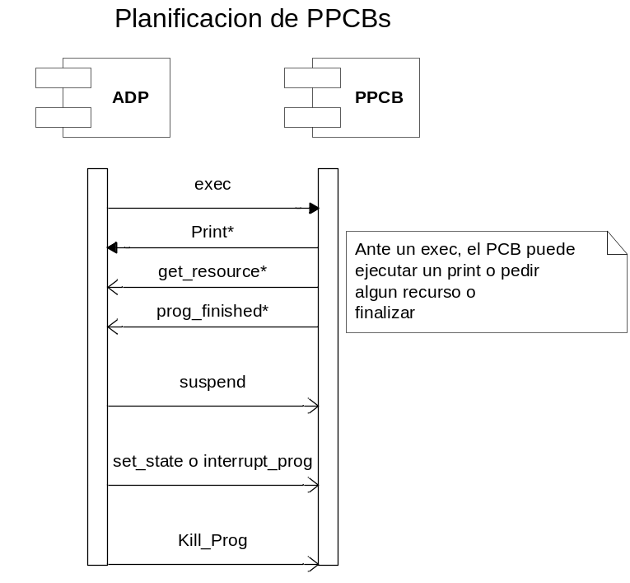

Exec
H | empty
16

Get_Resource = 23
H | Id_PCB(4) | Id_Resource(1)
16 | Long | char

Finish_Prog = 30
H | Id_PCB
16 | Long(4)

Set_State = 20
H | State_pcb
16 | Char

Interrupt_Prog = 25
H | Id_Resource
16 | Char

Kill_Prog = 24
H | Empty
16

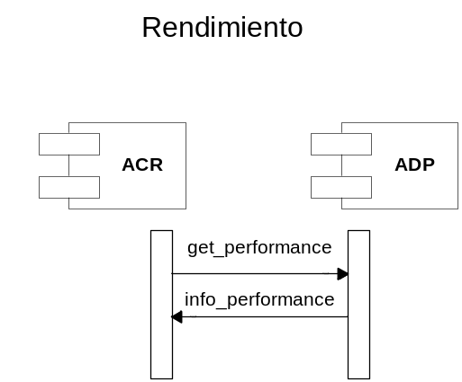

  - PPCB

Las funcionalidades ya fueron descriptas en los procesos ADP y ACR.

