**Exercise :**

The objective of this exercise is to do an analysis of the coffee price, ideally to model it.

So the exercise is to collect the data from the different sources below, structure them, plot them, analysze them (individually, then related to the variable to be explained)

**Data sources:**

* *dxy.txt*: Text file containing information about the DXY index.
* *escp_msf_exercise.sqlite*: Sqlite database containing variables to be studied, created based on the below schema.

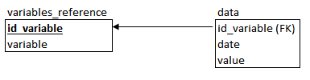

The list of variables is:

'coffee_total_consumption_usda'

'china_gdp_yoy_forecast'

'sugar_nearby'

'crude_nearby'

'coffee_nearby'

'vix_index'

'colombia_coffee_exports'

'non_commercial_net_position'

'coffee_inventory'

* *Quandl*: Extract the data from the following datasets

*USTREASURY/YIELD*: US rates for different maturities

*ODA/CHN_NGDPDPC*: China GDP per capita