Analysis
Background to and identification of problem:
- Identify your client and the organisation they work for
- What is the purpose of the organisation i.e. what services do they provide? What do they sell or what do they manufacturer?
- Explain your connection to the client
Description of the Current System:
- Briefly describe the existing system
- Identify the problem(s) with the old system that need to be solved in the new system
- End with a concise aim for the project (In order to get into band 4 (10 – 12 marks) the examiner must be able to say ¨Yes, I know what the aim of this project is¨.
Identification of the prospective user(s):
- Identify the employee(s) that will be the end-users of the system. This is not necessarily the client.
- Consider that end-users may have different responsibilities and hence will use the system in different ways.
- Describe the competency of each end-user and the implications for system design.

Identification of user needs and acceptable limitations:
You must now use formal methods to identify the user’s needs; your personal view of the problem in the last two sections is not enough.
- Interviews with end-users (It is important that the end-users responses are consistent with your descriptions in previous sections.)
- Surveys + Brief Analysis
- Personal observations of current system
- Analysis of existing documentation (must be consistent with previous sections + with the analysis data dictionary.

Data Source(s) and Destination(s):
- Who or what provides the information that is inputted into the existing system?
- Will this data source change in the new system?
- What happens to the inputted information after it is processed? Is it stored or is it outputted? Who receives the out putted information?

Data Volumes:
The volume of data you system will be required to process will depend on several factors:
- The type of file it deals with (e.g. Images, Sound or Text)
- The number of employee’s that will need to access the system
- The frequency with which the users access the program

Analysis Data Dictionary (from perspective of end user):
Identify the data that is stored about each entity in the current system.
Entity Name
Data | Data Type | Description

DfDs (existing and proposed system):

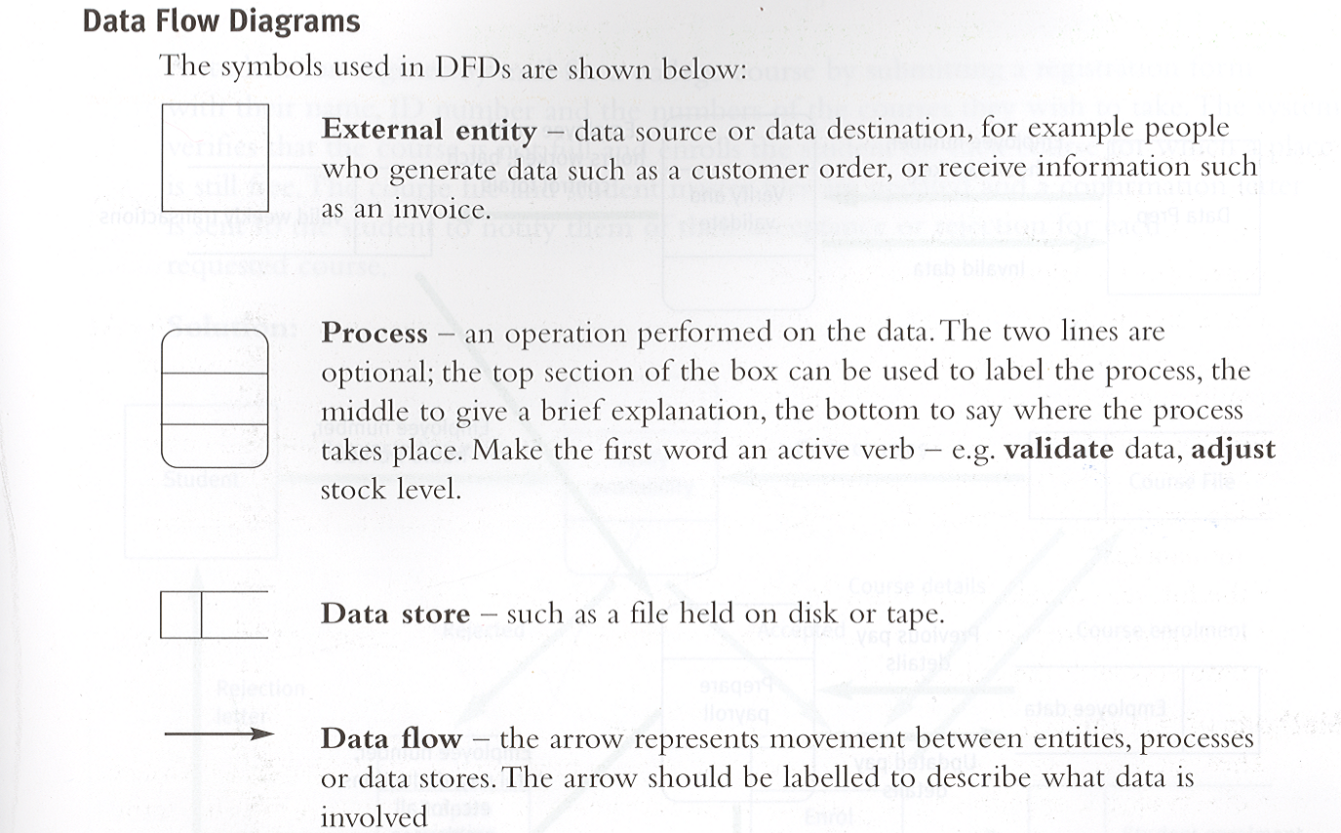

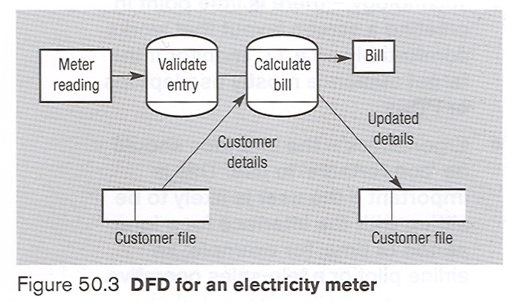

E-R Models for database projects:
Identify the entities in your system – the things for which your project will store data.
Next you need to identify the relationships between the entities: one-to-one, one-to-many, many-many. Finally you need to draw a diagram that shows the entities and the relationships between them, the E-R diagram
E.g. An un-normalised ER-Diagram
Makes a booking with
Pupil
Teacher

Entity description:
Describe each entity by wiring the name followed by its attributes enclosed in brackets. The primary key must be clearly indicated by an underline.
E.g.
Pupil( pupiLNo, Surname, forename, form, teacherNo, bookingTime, bookingDate)
Teacher(teacherNo, Surname, title, subject, pupilNo, bookingTime, bookingDate)
Objectives for the proposed system: (p232 A2 Computing):
- You must produce clear and measurable objectives that are specific to your project. Generalised objectives such as ‘user friendly’ or ‘system must load in n seconds’ are not acceptable.
Specific – State precisely what you will achieve?
Measurable – You are able to measure your success?
Achievable – Are you capable of achieving your objectives?
Realistic – Can you achieve them in time with your available resources?
Time – When do you want to achieve the objectives by?
- Your objectives should concern
- System Inputs
- System Outputs
- System Processing
- System Storage
- Other user requirements, which have been identified above.
- Important: Your objectives must make it clear to the examiner that yours is a complex open ended project.
e.g. The user must be able to:
- Input details of new clubs
- Remove details of clubs when no longer needed
- Edit details of existing clubs
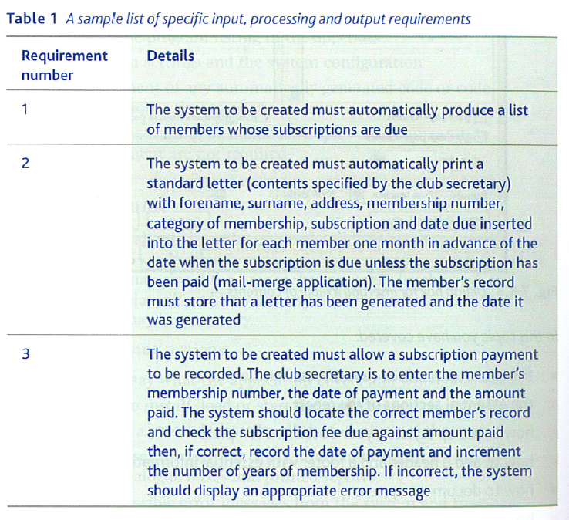
Realistic Appraisal of the feasibility of potential solutions:
This section should be an analysis of alternative computing solutions (a manual paper based system is not an option)
The possible alternatives are;
- A Spreadsheet (Microsoft Excel)
- A Database (Microsoft Access)
- A bespoke programming solution in Language 1
- A bespoke programming solution in Language 2
Identify the strengths and weaknesses of each method with respect to the needs of the problem. In this section you are analysing each individual method separately, you are not comparing alternatives.
Important: Don’t just copy from a textbook the advantages and disadvantages of each alternative, the analysis must be about what benefits the solution would have for your particular project.
Justification of chosen solution:
In this section you are justifying your choice. You must focus on the negatives of alternative solutions (see above) and the positives of the chosen solution for this specific problem.
When you come to compare the two different programming solutions instead of saying ¨I only know one programming language¨ explain ¨ Of the two solutions, I have more experience with X, therefore I will not have to spend valuable time learning Y¨.

