Class definitions (diagrams) and details of objective behaviours and operations

You need to draw class diagrams for each class. You will also have to produce a summary table for each class that gives a written description of each method. Descriptions should include pseudo code for any non-trivial algorithms.

Class Name
Class Diagram:

Attributes:
- Each attribute on a separate line
- Attributes are displayed in the format
name: attribute type

Use Flight
flightNumber: Integer
departureTime: Date
flightDuration: Minutes
delayFlight (numberOfMinutes: Minutes)
getArrivalTime(): Date
Responsibility: To calculate when a flight will arrive at its destination, taking account of any delays.

Operations are displayed in the format:
Operation Name(parameters in):type of value returned

The responsibility is a description of what the class has to do – that is, what its attributes and operations are trying to accomplish.

Operation Name | Description
delayFlight | The number of minutes the plane is to be delayed is passed in and added onto the flightDuration attribute.  Algorithm: flightDuration += delayFlight
getArrivalTime | flightDuration is added to departureTime to return the expected arrival time.  Alogrithm: arrivalTime = departureTime + flightDuration

Association Diagrams and Multiplicity:

When classes are connected together, the connection is called an association. You visualize the association as a line connecting the two classes, with the name of the association just above the line. It is helpful to indicate the direction of the relationship, and you show that with a filled triangle pointing in the appropriate direction.

Plays on
Player
Team

The association drawn so far between Player and Team suggests that the two classes are in a one-to-one relationship. Common sense tells us that this isn’t the case. A football team has eleven players and this must be represented on the association. Multiplicity is the number of objects from one class that relate with a single object in an associated class. To represent this by placing the numbers above the association line near to the appropriate class.

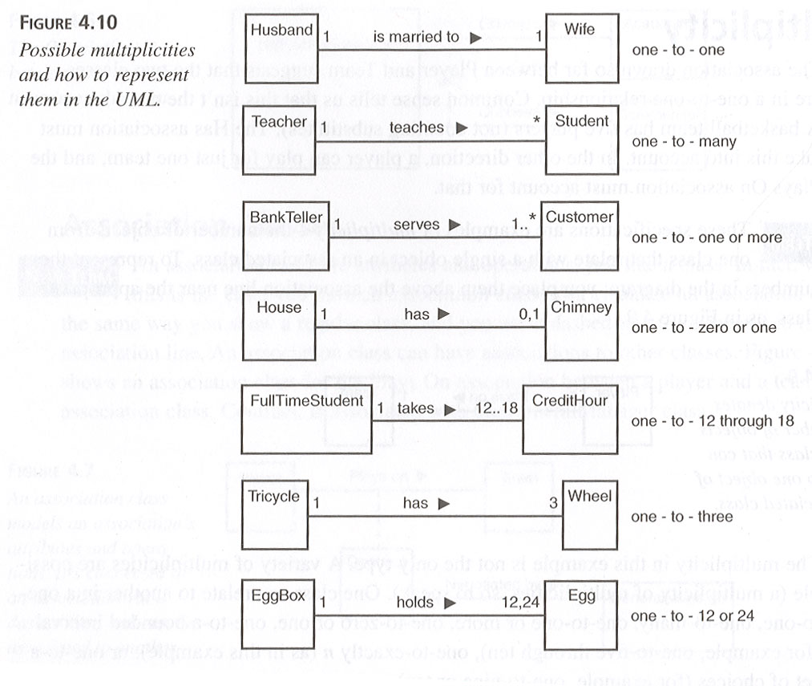
Player
Team
Plays on
11
1

