Design

- Overall system design:

Summary table detailing all:
- Inputs
- Processes
- Storage
- Outputs

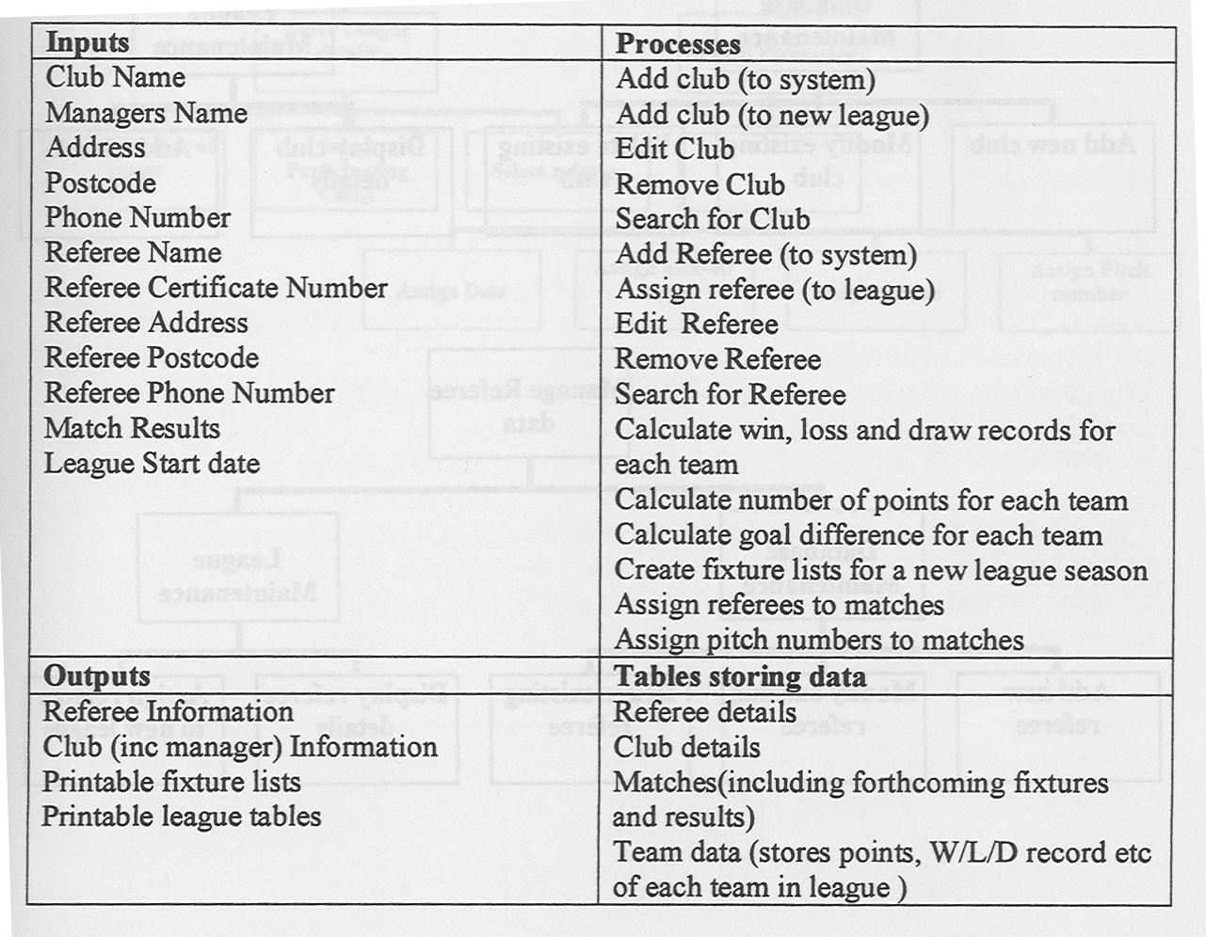

- Description of modular structure of system:

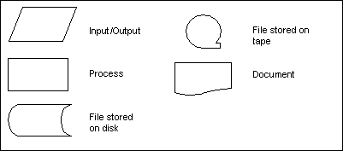
- Create a system flow diagram showing how the processes interconnect and the files they access (p248 A2 Computing)

Username
&
Password
CustomerFile
Validate Password
Access Denied Dialog
Create Invoice
Order Details
Invoice

OrderFile

- Describe each process in more detail using structure diagrams.
- A structure diagram uses a ‘top down approach’ to explain how a program is put together. Starting from the program name, the programmer breaks the problem down into a series of steps.
- Each step is then broken down into finer steps so that each successive layer of steps shows the modules and procedures that make up the program in more detail.
- The text at each level consists of only a few words – if you want more detail about what the process involves you need to move further down the diagram. The component parts from each section are organised from left to right to show how the system will work.

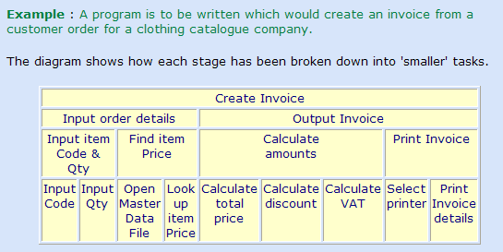

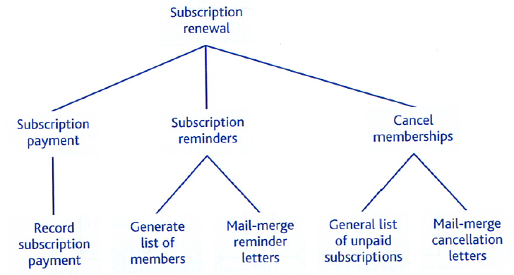
- You can represent a structure diagram as a chart or a table
- Definition of data requirements (Design Data Dictionary)

- You must include a data dictionary for each table in the database and file in the login system.
- The design data dictionary should include data types and validation for all the data that will be stored in the new system.
- Start with the Analysis Data Dictionary and add entries for variables you need for processing.
- You must decide on data types for all data items, including data structures such as arrays.
- Add validation rules with reasons why they are required and what they are testing.
- How are the values to be stored while the program is running and what data needs to stored in database tables or files.

See the ‘Worked Example’ (p254 A2 Computing)

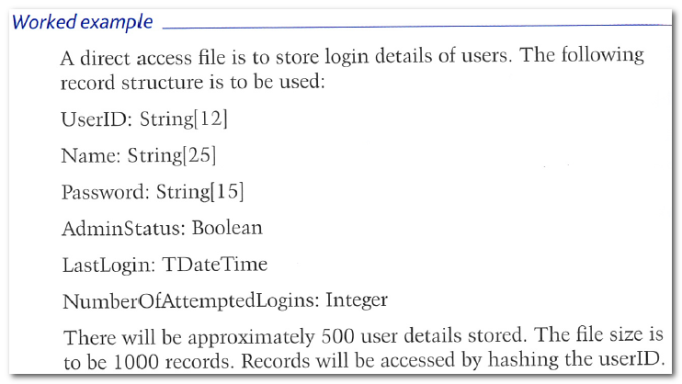

- Database design including description of normalised relations and revised E-R diagram

Example:

Pupil
Teacher
Booking

Pupil( pupiLNo, Surname, forename, form)
Booking(booking No, teacherNo, pupilNo, bookingTime, bookingDate)
Teacher(teacherNo, Surname, title, subject)
- Identification of storage material and format

- Discuss where the program will be stored e.g. on the school network.
- Explain how data will be written from and read into your program.
- Approximate the size of the completed program and its data files (Remember this is an open-ended project)
- Justify a back-up strategy for both the program and the data files.

- Identification of processes and suitable algorithms for data transformation

You must identify the standard algorithms you will use to create system functionality. For example, if a search function is required, which standard algorithm would be appropriate, sequential or binary? The algorithms should be written in pseudocode (see Helpsheet) and references should be used if they are taken from the textbook.

- Hashing Algorithm (p255 A2 Computing)
- Binary Search (p116 A2 Computing)
- Bubble Sort (p92 AS Computing)
- Linear Search (p91) AS Computing
- XOR Encryption Algorithm??

Note: If you intend to use any complex SQL queries in your program you need to write them here (see p256 A2 Computing)

- User interface design (HCI) rationale including:

- In MS Word create mock-ups of your GUI. Annotate using callouts to justify your design choices.

- When designing your GUI bear in mind

  - Who will use the system? What previous experience of computers or other GUI’s to they have. How have you designed your GUI so that it is familiar to them?
  - Does your user require prior knowledge or training to complete a task?
  - Will the system cater for both beginners and experienced users?
  - How have you designed your GUI to ensure that a task is completed effectively i.e. what have you done to ensure that a user does not make a mistake.
  - How have you designed your GUI so that a user can complete their task efficiently i.e. what have you done to ensure that user doesn’t spend five minutes trying to find the correct way to add a new customer.

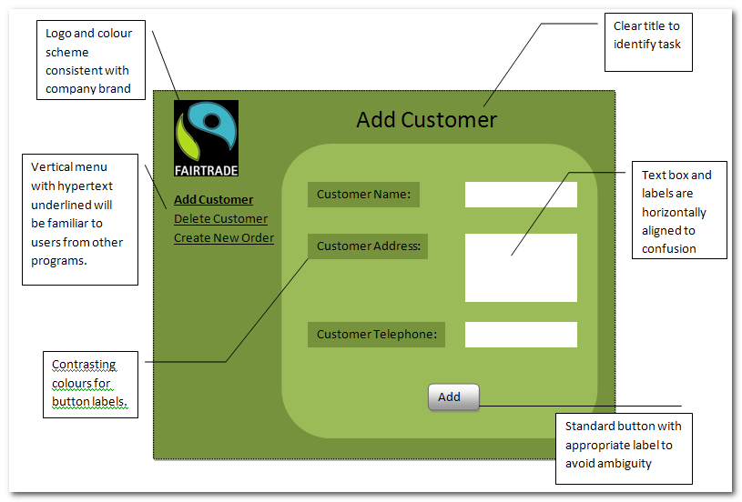

- Look at Fig. 7.2.4 (p251 A2 Computing) to see how you should present your user interface diagram and the flow of contrxample:
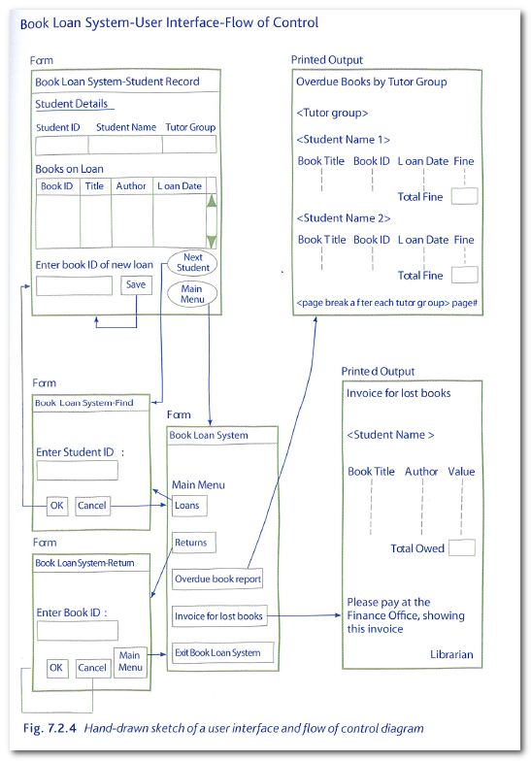
- Sample of planned data capture and entry:

- As part of your GUI you will need to design data input forms to capture data (see above)

- The following points should be noted when designing data input forms.

  - The form should be given a title;
  - The form should not be cluttered – spaces and blanks are important;
  - It should give some indication of how many characters can be entered in each field of data;
  - The user should be given a chance to go back and correct any field before the data is accepted;
  - Items should appear in a logical sequence to assist the user;
  - Default values should wherever possible be prewritten onto the form so that a minimum of data entry is required.
  - Full exit and ‘help’ facilities should be provided;
  - Lower case in a display is neater and easier to read than all upper-case;
  - Colours should be carefully chosen to be legible and easy on the eyes;
  - ‘Attention getting’ devices such as blinking cursors, bold, underlining or italics should not be over-used.

- Sample of planned valid output designs:

- You will also need to produce designs of your output, whether it is a form on the screen or a physical printout.

- Description of measures planned for security and integrity of data:

- Brief discussion of validation techniques used (see data dictionary)
- Sample of error messages (avoid unnecessary repetition)

X
Input Error: You must enter a valid 4 digit customer number.

- Explain how data input errors can be corrected (e.g. program allows customer data to be modified/updated)
- Describe your back-up strategy

- Description of measures planned for system security:

- Read the ‘Computer Security Procedures’ p219 A2 Computing

- It is important that your discussion of system security is in the context of your problem and not simply a re-wording of the text-book

- Overall test strategy:
There are several testing strategies you will need to employ to ensure that your system performs as expected:
- Unit Testing:
  - Black Box Testing: Entering test data into each form and checking the resulting output against the expected outcome.
  - White Box Testing: Testing every aspect of the program e.g. how the program reacts if it fails to find the correct text file; what happens if buttons are pressed in the wrong sequence
- Integration Testing: Once each form has been tested ensure that the work together e.g. once you’re certain you can add a student and a teacher, test that you can make a booking between the two.
- System Testing: involves testing the system as a complete unit rather than as individual classes and making sure that it satisfies the specification agreed with the user.

Using the technical language, above, to explain how you will test your system. Remember, it is important that your testing strategy is in context and not simply a re-wording of the text book.

