Algorithms
- Linear Search (p91 AS Computing) 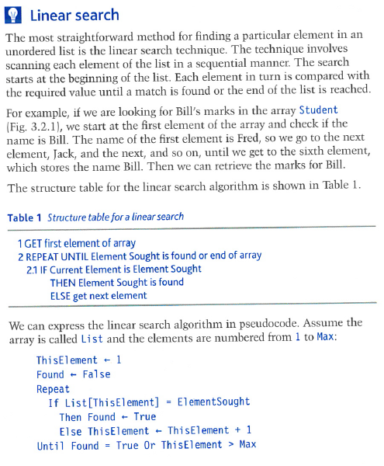

- Hashing Algorithm (p255 A2 Computing) 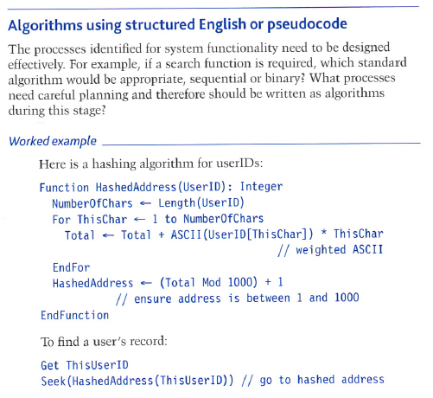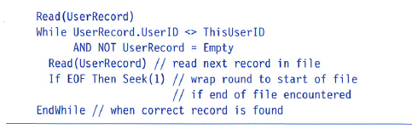

- Complex SQL Queries (P256 A2 Computing)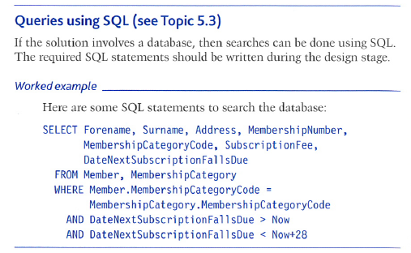

- Binary Search (p116 A2 Computing)
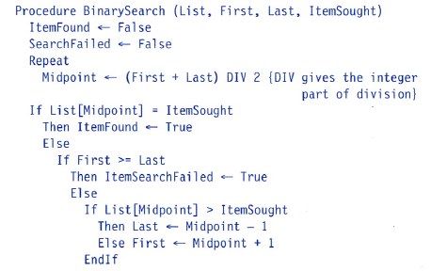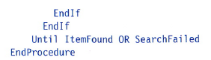
Or
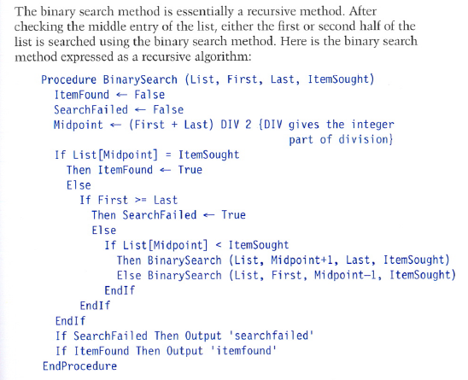

- Bubble Sort (p92 AS Computing)
