

Language Enginering Report

A look into Catamorphisms and their role in parser design



Alex robinson

ar15247@my.bristol.ac.uk

# LANGUAGE ENGINERING REPORT

ALEX ROBINSON

Abstract. TODO

## 1. Introduction

1.1. Introduction. Brief introduction to category theory with the aim to understand vocabulary, move onto F-Algebras and then Catamorphisms with practical examples in Haskell. Then move onto designing a small combinatorial parsing library similar to parsec in Haskell. Implementation of a small BNF showing how BNF translates to parser combinators.

## 2. Category Theory, F-Algebras, and Catamorphisms

2.1. Category Theory. Category Theory (CT) is a generalisation of how various structural concepts are described in mathematics such as groups and rings. A Category is composed of:

* A collection of objects, $A, B, C, …$
* A collection of morphisms, $f, g, h, …$ which relate to a pair of objects, $f: A→B$. $A->B$ is known as the type and f is a morphism from source $A$ to target $B$
* A composition on morphisms denoted $f∘g$

2.1.1. Axioms of categories:

1. Composition of morphisms is associative
$$f∘\left(g∘h\right)=(f∘g)∘h$$

2. Categories are closed under composition
$$let f:B→C, g:A→B. Then their exists h:A→C, such that h=f∘g$$

3. Every object has an identify morphisms such that

$${id}_{A}:A→A, g:A→B, and so g∘{id}_{A}={id}_{B}∘g=g$$

Some objects represent empty in some sense for example $\{\}$ is the empty set, these objects are unique i.e. there exists only one empty set. In CT this unique trait is called *initially*, an object is initial if for any object in a mapping there exists a single mapping from it to the object. There can only be only one initial in a category.

2.2. Functors. A homomorphism is a mapping between categories, a functor is a homomorphism preserving categorical structure. Given categories $C$ and $D$ we define a functor $F:C→D$ which can be applied to any object or morphism in $C$ to map into $D$ for example $A ∈C$ can be mapped to $F(A)∈D$ or $f:A→B$ becomes $F\left(f\right): F\left(A\right)→F(B)$.

2.2.1. Axioms of functors:

1. Given an identify morphism ${id}_{A}$ and object $A$, $F\left({id}_{A}\right)={id}_{F(A)}$
2. Functors distribute over morphism composition $F\left(f∘g\right)=F(f)∘F(g)$

Axiom *2.* is practically useful when you imagine the functors as a list or similar container, the RHS is a two pass algorithm: mapping over structure applying g, and then again applying f. This axiom guarantees this can be transformed this into a single-pass algorithm performing $f∘g$. This is known as fusion.

2.3. F-algebras. Natural numbers can be represented as the recursive structure:

data Nat = Zero | Succ Nat

With this three can be represented as Succ(Succ(Succ Zero)). Nat is a category, and operators on natural numbers such as addition are functors which map Nat into itself, these are known as *endofunctors*. However, in order to transform a Nat into an integer a functor with signature $F(A)→A$, where $A$ is either an integer with addition or Nat.

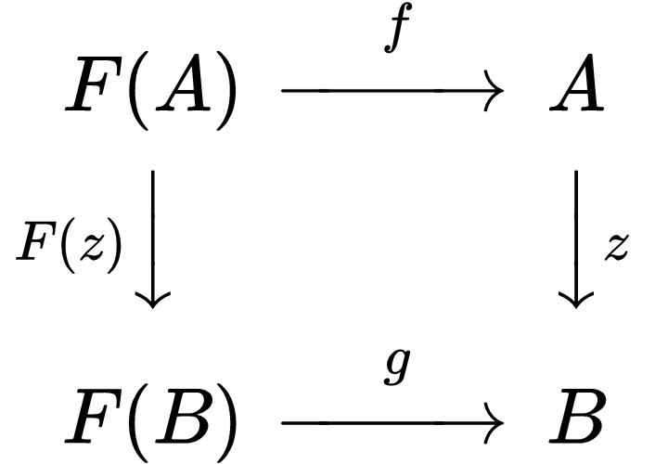This is an F-algebra. Let $C$ be a category with objects $A, B ∈C$ and an endofunctor $F: C→C$. Let $z: A→B$ be a functor mapping $A$ to $B$. There exists two F-algebras $f:F(A)→A$ and $g:F(B)→B$.

Paths from $F(A)$ to $B$ are equal, so $g∘F(z)=z∘f$. As the identity functor is a homomorphism and composing homomorphism produce a homomorphism this means F-algebras form a category of F-algebras. For the general class of functor, this category has an initial object (labelled $z$ above) which is the distinct functor from the initial algebra to any other F-algebra, this is called the *catamorphism*.

2.4. Catamorphisms and Fixed Point Recursion. Catamorphisms act like a generalisation of the fold on lists, it computes a value from a container like structure and a function. The program bellow demonstrates the practical use of catamorphisms in programming.

TODO: Talk about practical applications of catamorphism + fixed point recursion + move program to appendix and only use small example, reference data type created above!

type Algebra f a = f a -> a

-- Fix is FixedPoint

-- Fix also know as Mu

data Fix f = Fix {unFix :: f (Fix f)}

deriving instance (Show (f (Fix f))) => Show (Fix f)

cata :: Functor f => Algebra f a -> Fix f -> a

cata f = f . fmap (cata f) . unFix

data Nat n = Zero | Succ n deriving Show

instance Functor Nat where

fmap _ Zero = Zero

fmap f (Succ n) = Succ (f n)

out :: Fix Nat -> Int

out = cata f where

f :: Nat Int -> Int

f Zero = 0

f (Succ n) = n + 1

in' :: Int -> Fix Nat

in' 0 = Fix Zero

in' n = Fix (Succ (in' (n-1)))

oneMore :: Fix Nat -> Fix Nat

oneMore = cata f where

f :: Nat (Fix Nat) -> Fix Nat

f Zero = Fix (Succ (Fix Zero))

f (Succ n) = Fix (Succ n)

double :: Fix Nat -> Fix Nat

double = cata f where

f :: Nat (Fix Nat) -> Fix Nat

f Zero = Fix Zero

f (Succ n) = Fix (Succ (Fix (Succ n)))

add :: Fix Nat -> Fix Nat -> Fix Nat

add a = cata (f a) where

f :: Fix Nat -> Nat (Fix Nat) -> Fix Nat

f b Zero = s b

f _ (Succ n) = Fix (Succ n)

mul :: Fix Nat -> Fix Nat -> Fix Nat

mul a = cata (f a) where

f :: Fix Nat -> Nat (Fix Nat) -> Fix Nat

f _ Zero = Fix Zero

f _ (Succ n) = add a n

-- Is there a formal name for this?

s :: Fix Nat -> Fix Nat

s = cata f where

f :: Nat (Fix Nat) -> Fix Nat

f Zero = Fix Zero

f (Succ n) = Fix (Succ n)

2.4. Category Theory oriented Programming. Focus on type and operators, extreme generalisation, better modularity, better control through properties of types. TODO

## 3. Building a monadic parser

## 4. Conclusion

## References

## Appendix