Loan Calculator App

Dependencies installed

1. React Router

2. Axios

3. Material UI

Git Hub Repository Link

[<https://github.com/alex-ajith/Loan-Calculator>]

## Live Site Link

## [<https://loan-calculator-assess.netlify.app/>]

Output

Home page/ Loan Calculation page  
  
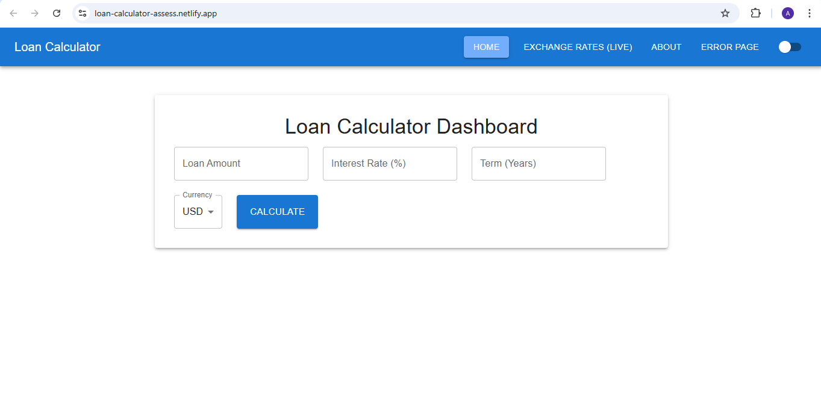

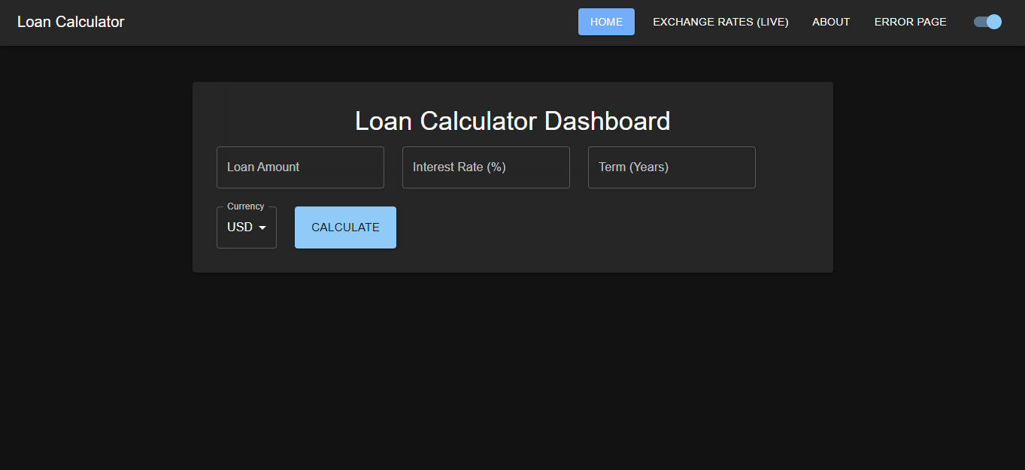

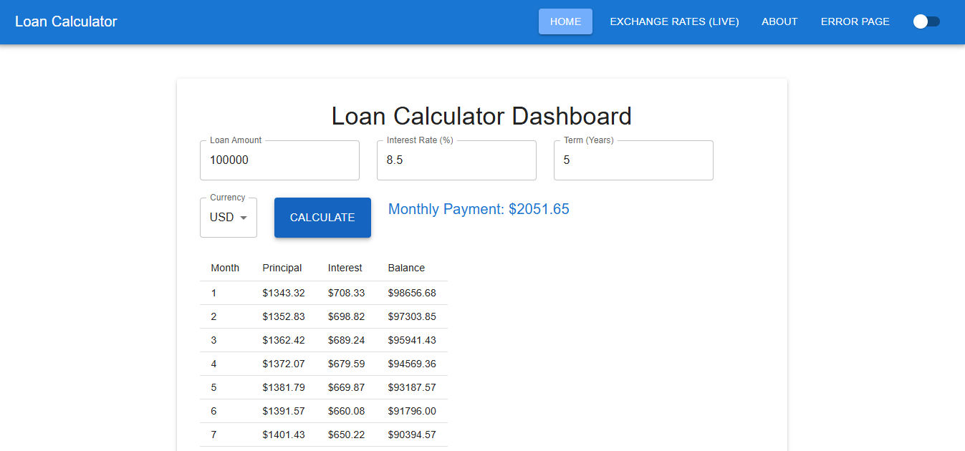

Exchangerates page

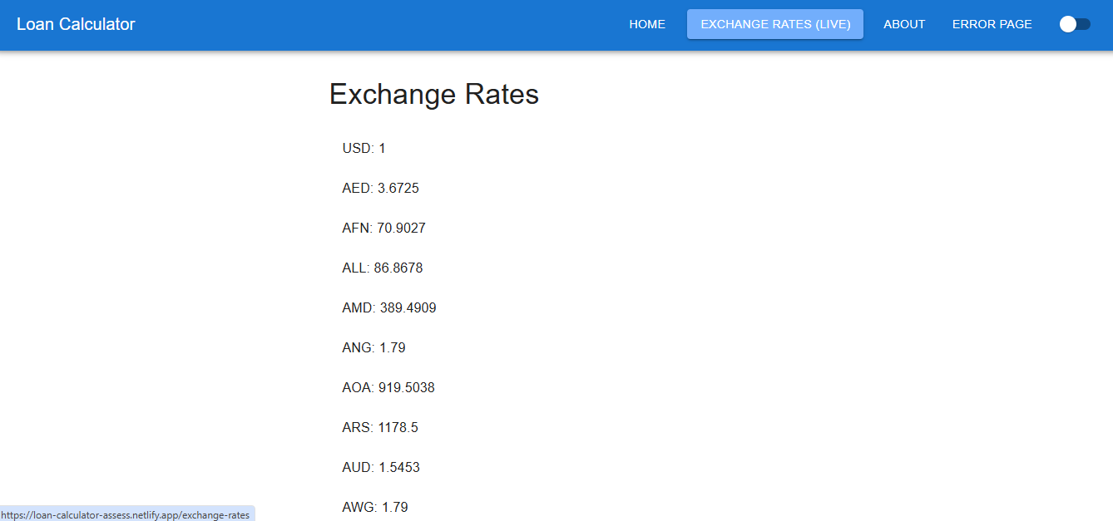

About Page  
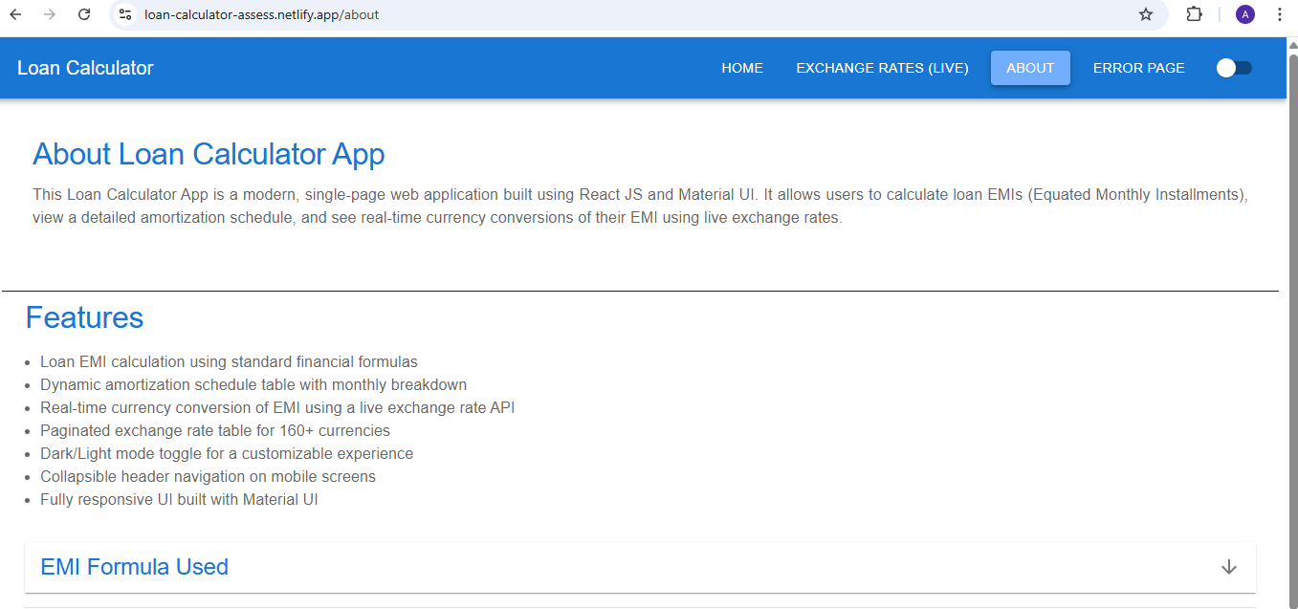

Error page or page not found

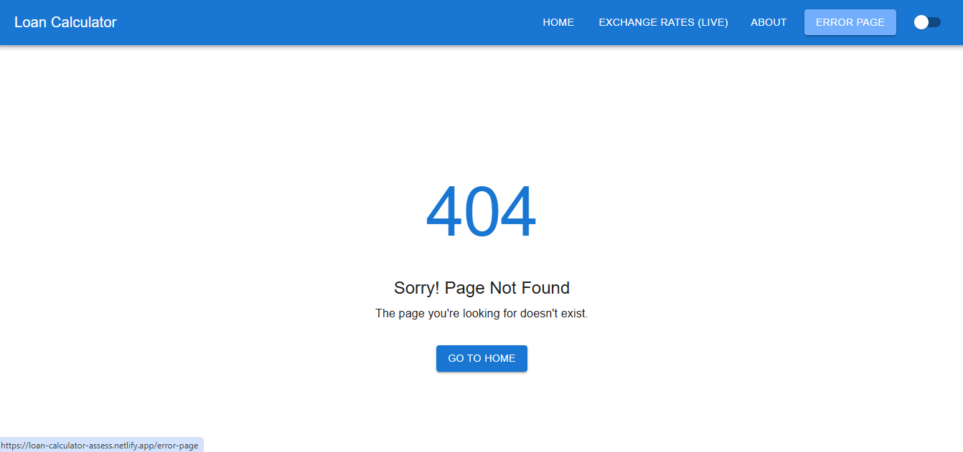

Mobile view  
