1.Main differences in network and transport layers of ISO OSI and TCP/IP

a. Transport Layer: ISO transport layer in connection oriented only while TCP transport layer is both.

b. Network Layer: TCP is connectionless oriented while ISO is both.

c. Congestion Control: ISO congestion control is in network layer while TCP is in transport layer .

2. Name the protocol for the functionality described below  
 a. Network Layer Protocol in the TCP/IP stack that provides routing and packet forwarding service.

IP Protocol.

b. Application protocol that provides the IP Address of a host, given that host’s fully qualified domain name: DNS

c. A protocol that helps a client program to discover the port number of a remote server for a given service: port-mapper protocol (RPC remote procedure protocol).

3.a. What is more suitable for video streaming, movies and TV shows (real time not important)? TCP

3.b. Video-conferencing (live; real time important) among multiple participants: UDP

4 A packet travels from a source host to destination host over the TCP/IP network shown below. Note that the source and destination reside on IPv4 network but the packet must traverse an IPv6 network in the middle.

Suppose the packet sent in an HTTP packe; draw and lavel the complete packet formats including headers and trailer (for each layer) and payload in the zones marked with question marks1 and 2 above.

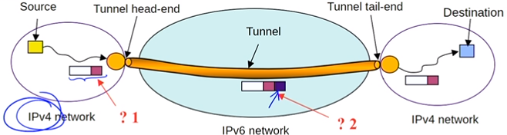

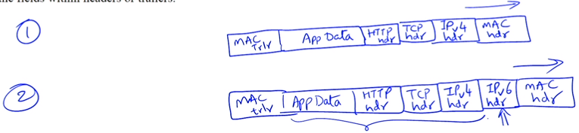

5. In the Indirect TCP protocol suggested by Bakre and Badrinath for wireless networks, in what way are TCP semantics violated? – Once the middle guy ACKs the request to the Txer, if the middle guy fails to forward the ACK to Rxer, it cannot take back the ACK it sent to Txer:  
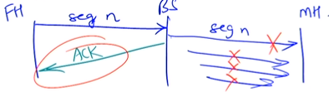

6. Can a single TCP source ever saturate a communication link? No due to congestion control!

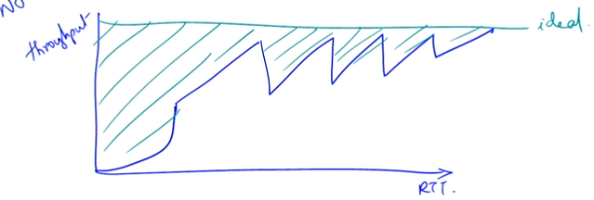

7. When designing a low-power, low-performance embedded network appliance, is the RFC 793 (exponential forgetting) or the Jacobson-Karels algorithm more suitable for adaptive retransmission timer? RFC 793 since RFC 793 uses sample and estimated RTT values. Using Jacobson-Karel would be undesirable due to the computational overhead added by determining mead deviation of the RTTs.

8. Is it possible that both copies of the webpage will be delivered to the same browser when user opens two different browsers in order to fetch the same webpage? No since each browser will differ in destination port number provided by the server once the connection is established. Could happen if port number gets corrupted just right enough that it matches the port number of the other browser and passes crc error check as well.

9. A TCP connection experience packet loses where each segment has 10 bytes of data and segment #15 is lost while remaining segments are delivered correctly and in order. Show message exchange:

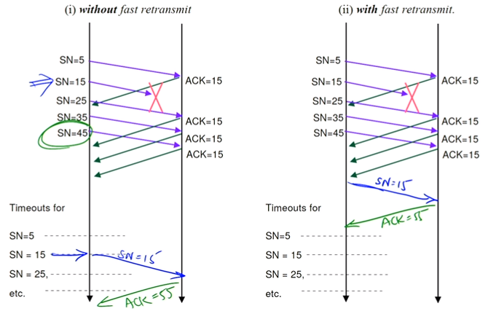

10. Sketch a plot of TCP Reno sender’s congestion windows (cwnd; measures in # of segments) against round trip times (RTT) of TCP segments under following scenario. TCP Reno sender starts in slow start phase until it reaches a slow-start threshold of 6 segments. It then goes into congestion avoidance phase till it notices 3 duplicate ACKs which occur when the cwnd is 12 segments. At this point, the slow-start threshold is adjusted (show new value) and TCP transmission continues. Next, a multip-segment loss is seen when cwnd is 10 causing the threshold to be adjusted again (show new value) and the transmission continues.

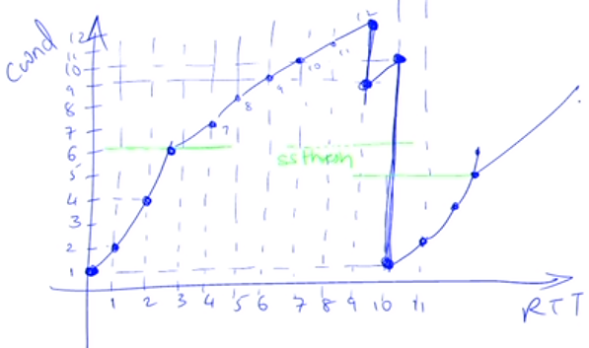

Start at cwnd = 1

Keep doubling the cwnd until slow-start threshold (6 segments) is reached.

Keep increasing the cwnd by 1 from 6 and up until 3 duplicate ACKs a received at cwnd=12

Since its TCP Reno, we don’t drop to slow start; instead TCP Reno goes into congestion avoidance phase and it restarts at 12/2 + 3 = 6

Keep increasing cwnd by 1 until multi segment packet loss is incountered at cwnd=10; Loss of multiple pakets is recognized as a congestion problem by TCP Reno and we go back to slow start.

Go back to slow start at cwnd=1 and the slow-start threshold set at 10/2=5.

11. Client initiates a connection teardown:

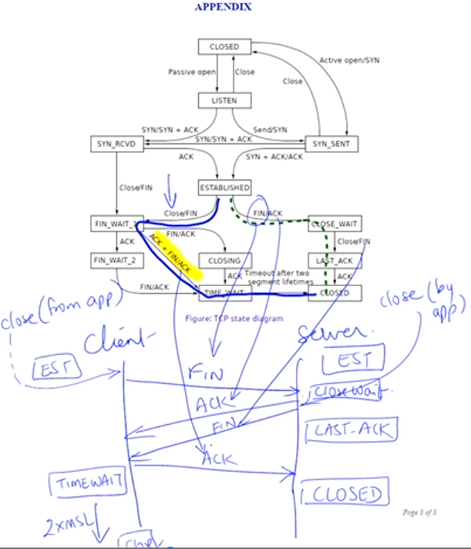

12. On a cross-country link between two TCP entities, the bandwidth is 1 Gbps and RTT is 100 ms. What should the awnd size be to maximize TCP’s link utilization? What the window scaling factor has to be since awnd is 16-bit field?

B=1Gb=10^9, RTT=100ms, awnd >= DBP!

DBP = RTT\*R=10^-1 \* 10^9 = 10^9

Awnd >= 10\*/8 = 100 M /8=12.5 MByte

Awnd>=12.5 MB

Window scaling factor should be

12.5 \* (10^6) / (2^16)=190.735

ceillog(190.735,2) = 8 bits -> 2^8 = 256