# General Info

Application was developed in Visual Studio Code with C# Dev Kit

https://marketplace.visualstudio.com/items?itemName=ms-dotnettools.csdevkit

# Application structure:

→ exercise

→ → ApiGateway: gateway that contain all the rest api for the application

→ → FieldSimulation: WPF application for a field exercise

# Design overview:

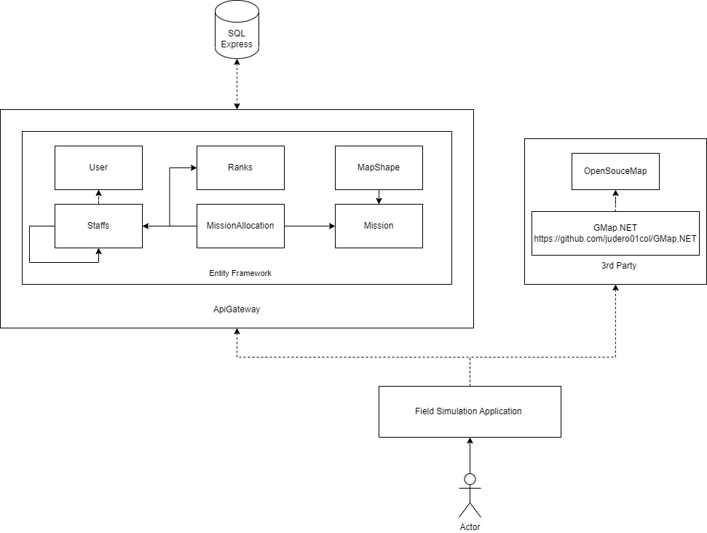

# ApiGateway endpoints:

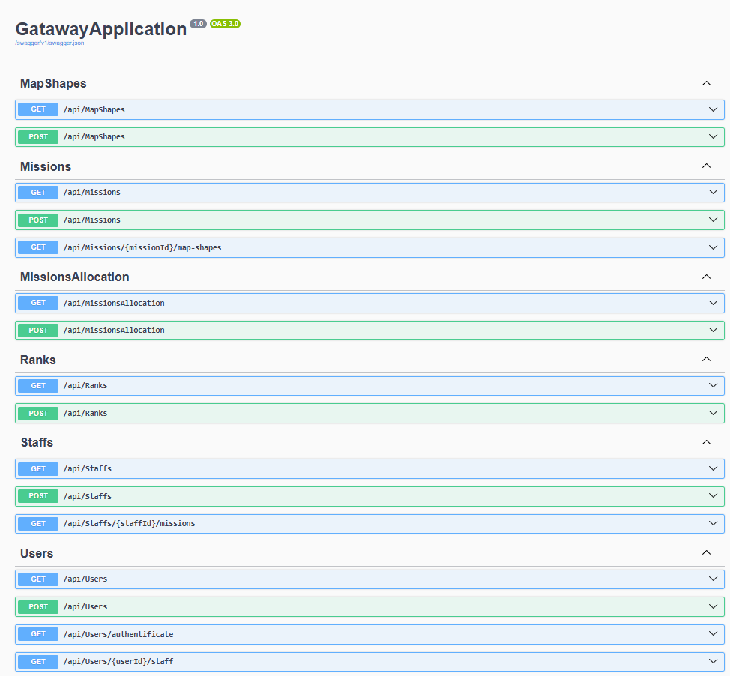

# How to start the application:

## ApiGateway start and setup:

1. Configurate the database connetion:

Change the connection string from *root/ApiGateway* edit *appsettings.json.* Change ConnectionString→ DefaultConnection

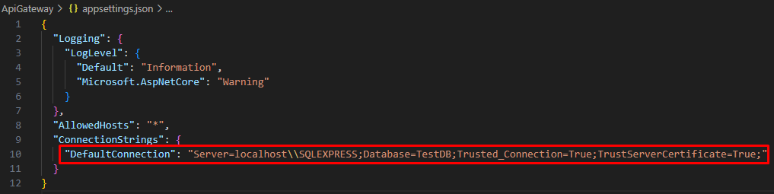

2. Deploy the database:

From *root/ApiGatway* run in terminal: dotnet ef database update



3. Start apiGateway service:

From *root/ApiGatway* run in terminal: dotnet run



4. Open Swagger and add a user, a rank, a staff, a mission and a mission allocation:

Access: http://localhost:5171

- add user: from Swagger expend users → post. Press on Try it out and user and password and press execute.

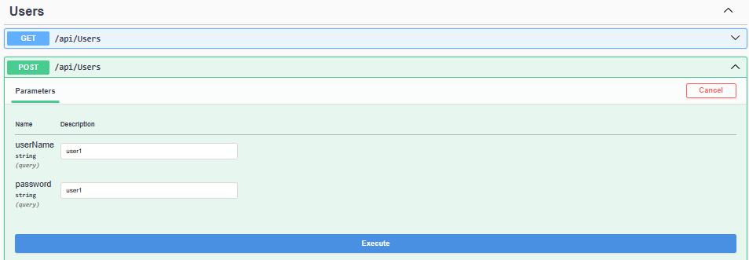

- add a rank: from Swagger expend ranks → post. Press on Try it out and the rank name.

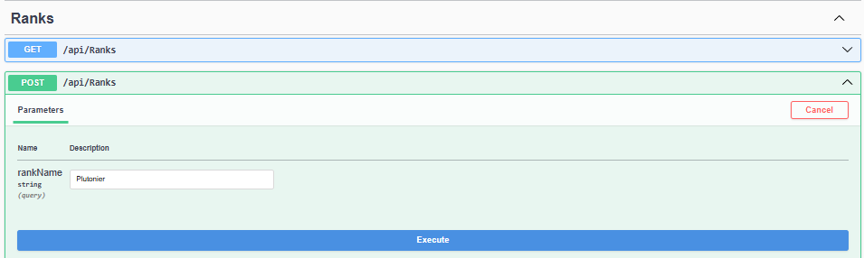

- add a staff: from Swagger expend Staffs → post. Press on Try it out and full name, identification color (it can be any hex color), initials (it can be any 2 letter string), the of the created user, the id of the created rank and press execute.

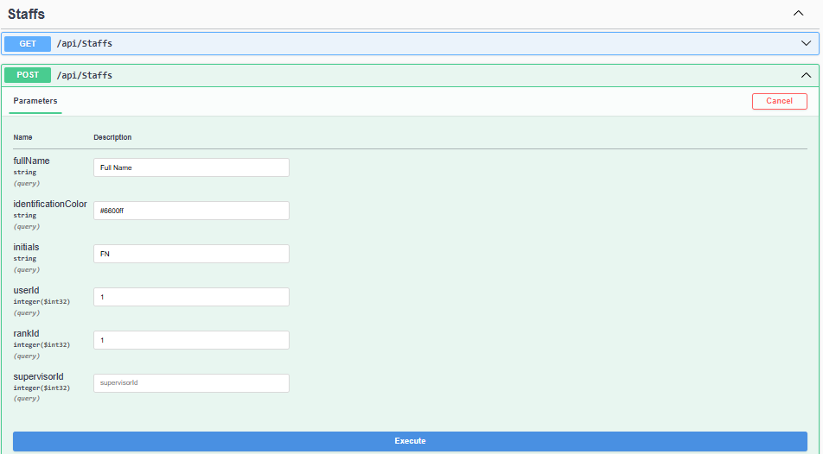- add a mission: from Swagger expend Staffs → post. Press on Try it out and add the full name, the mission start position latitude, the mission start position longitude and press execute.

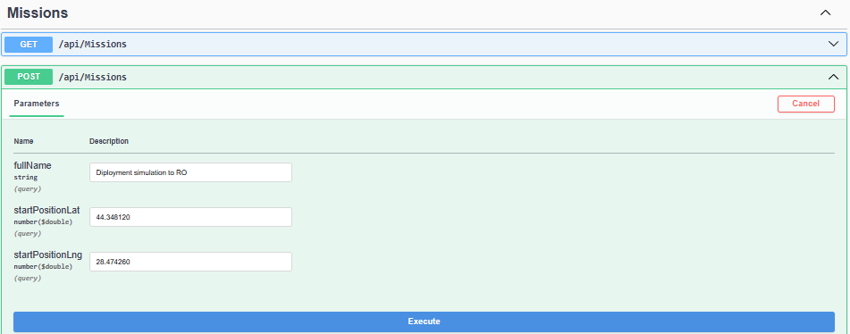- add mission allocation: from Swagger expend Staffs → post. Press on Try it out and add the create staff id, the created mission id and press execute

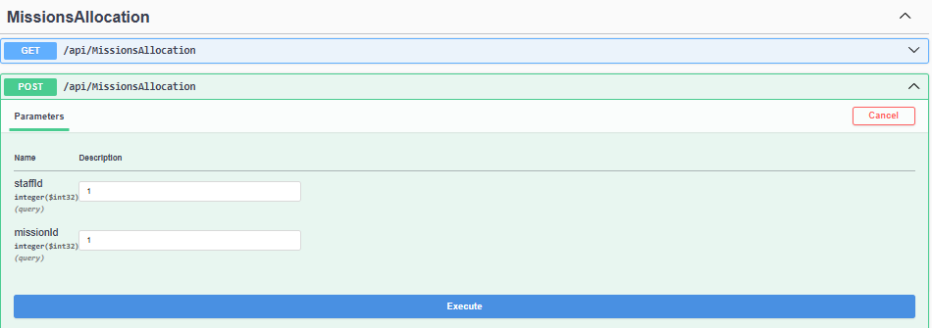

## FieldSimulation start:

1. Start FieldSimulation application:

From *root/FieldSimmulation* run in terminal: dotnet run

