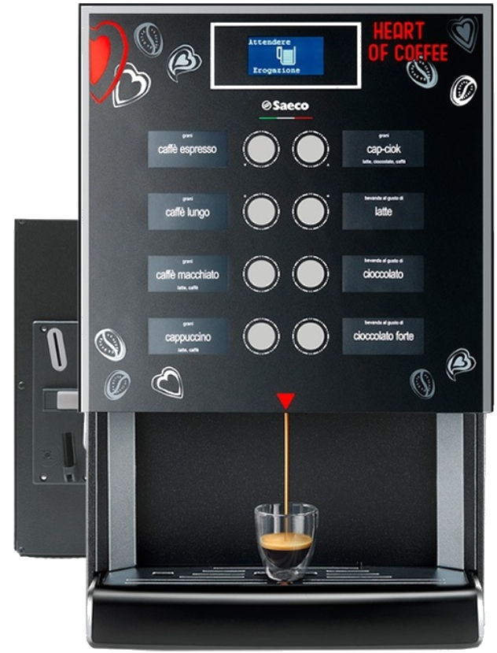

**Latte 1.10**

**Soupe 1.20**

**Chocolat 1.10**

**Chocolat fort 1.40**

**Capuccino 0.60**

**Café Machiatto 0.70**

**Café Longo 0.80**

**Café Expresso 0.80**