Evaluation Warning: The document was created with Spire.Doc for .NET.

- SSO
Executive Summary
  Project Name: | SSO2
  Project Version:
  SCA: | Results Present
  WebInspect: | Results Not Present
  WebInspect Agent: | Results Not Present
  Other: | Results Not Present
   | Issues by Priority
  Impact |  | 0  High | 0  Critical
  Impact |  | 0  Low | 0  Medium
   |  | Likelihood

 | Total | Status
  SANS Top 25 2011 groups
Insecure Interaction | 0
  PASS
Porous Defenses | 0
  PASS
Risky Resource Management | 0
  PASS

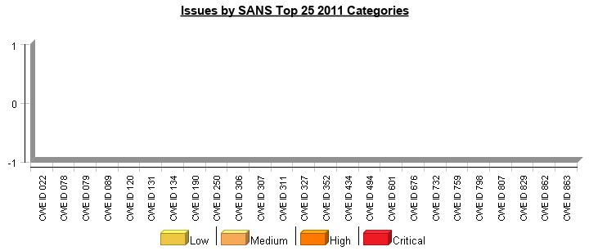

Project Description

This section provides an overview of the Fortify scan engines used for this project, as well as the project meta-information.

SCA

Date of Last Analysis: | Aug 28, 2019, 9:09 AM | Engine Version: | 18.20.1071
Host Name: | WIN-L337070IF4S | Certification: | NOT PRESENT
Number of Files: | 569 | Lines of Code: | 24,022

- DSP

Executive Summary
  Project Name: | DSP2
  Project Version:
  SCA: | Results Present
  WebInspect: | Results Not Present
  WebInspect Agent: | Results Not Present
  Other: | Results Not Present
   | Issues by Priority
  Impact |  | 0  High | 0  Critical
  Impact |  | 0  Low | 0  Medium
   |  | Likelihood

 | Total | Status
  SANS Top 25 2011 groups
Insecure Interaction | 0
  PASS
Porous Defenses | 0
  PASS
Risky Resource Management | 0
  PASS

Project Description

This section provides an overview of the Fortify scan engines used for this project, as well as the project meta-information.

SCA

Date of Last Analysis: | Aug 28, 2019, 2:02 PM | Engine Version: | 18.20.1071
Host Name: | WIN-L337070IF4S | Certification: | VALID
Number of Files: | 345 | Lines of Code: | 19,002

- ODA

Executive Summary
  Project Name: | ODA
  Project Version:
  SCA: | Results Present
  WebInspect: | Results Not Present
  WebInspect Agent: | Results Not Present
  Other: | Results Not Present
   | Issues by Priority
  Impact |  | 0  High | 0  Critical
  Impact |  | 0  Low | 0  Medium
   |  | Likelihood

 | Total | Status
  SANS Top 25 2011 groups
Insecure Interaction | 0
  PASS
Porous Defenses | 0
  PASS
Risky Resource Management | 0
  PASS

* The detailed sections following the Executive Summary contain specifics.

Project Description

This section provides an overview of the Fortify scan engines used for this project, as well as the project meta-information.

SCA

Date of Last Analysis: | Aug 28, 2019, 1:24 PM | Engine Version: | 18.20.1071
Host Name: | WIN-L337070IF4S | Certification: | NOT PRESENT
Number of Files: | 265 | Lines of Code: | 8,944

