Nikolai G. BURMA
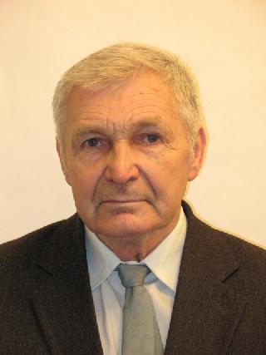
E-mail: burma@ilt.kharkov.ua
Phone: +(380) 57 341 0959
Name: Nikolai Burma
Business Address:
B.I. Verkin Institute for Low Temperature Physics & Engineering,
National Academy of Sciences of Ukraine, 47 Nauky Ave.,
61103 Kharkov, Ukraine

Title: Senior Researcher, Scientific degree: PhD

Date and place of birth: 01.03.1940, Kharkov, Ukraine

Education, academic degrees and titles:

Graduated from Kharkov Polytechnical Institute in 1962

Ph.D. (Solid State Physics), Institute for Low Temperature Physics and Engineering, Kharkov, Ukraine, 1985.

Senior Researcher Diploma (Solid State Physics), B.I. Verkin Institute for Low Temperature Physics & Engineering NASU, Kharkov, Ukraine, 2007

Institutional Affiliations:
Since 1962 has worked at ILTPE as an engineer, junior researcher, (1962-1986),
from 1986 – leading researcher.

Area of Expertise: Piezomagnetic and Piezoelectric effects in solids, Electron properties of metals, Ultrasonic in superconductors;

List of recent relevant publications:

1. Kolodyazhnaya, M.P., Zvyagina, G.A., Bilych, I.V., Zhekov, K.R., Kharchenko, N.F., Fil, V.D.Low Temperature Physics, 2017, 43, N10, pp. 1240-1242
2. Kolodyazhnaya, M.P., Zvyagina, G.A., Gudim, I.A., Burma N.G, Zhekov, K.R., Fil, V.D. Low Temperature Physics , 2017, 43, N8, pp. 924-929
3. Gaydamak, T. N., Gudim, I. A., Zvyagina, G. A., Bilych, I. V., Burma, N. G., Zhekov, K. R., & Fil, V. D. Low Temperature Physics, 2016, 41, N8, pp. 614-618
4. Gaydamak, T.N., Gudim, I.A., Zvyagina, G.A., Bilych, I.V., Burma N.G., Zhekov, K.R., Fil, V.D. Physical Review B" 92 , В. 21-1 P. 214428-1-7,
5. Avramenko, Y.A., Bezuglyi, E.V., Burma, N.G., Fil, V.D. YA Avramenko, EV Bezuglyi, NG Burma, VD Fil, Physical Review B 84 (21), 214504 (2011)
6. VD Fil, TV Ignatova, NG Burma, AI Petrishin, DV Fil, NY Shitsevalova
Low Temperature Physics 33 (12), 1019-1022 (2007)

Number of papers published: about 50, and 14 patents.

