 | CURRICULUM VITAE | 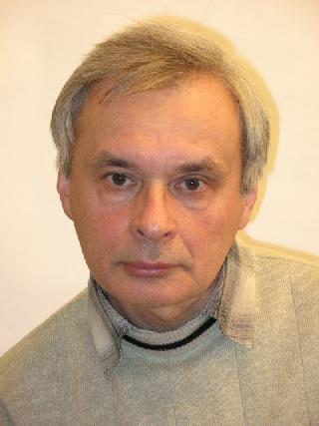

Personal information
Family name: | Desnenko
Given name: | Vladimir
Date of birth: | 19 November 1949
Prof. address: | ILTPE - B.Verkin Institute for Low Temperature Physics & Engineering  47 Nauky Ave., 61103 Kharkiv, Ukraine
Phone number: | +380 (57) 340-50-11
E-mail: | desnenko@ilt.kharkov.ua
Hirsch factor (h-index) | 13

Scientific degree & rank
2006  ILTPE Kharkiv, Ukraine | Senior Researcher Diploma (Solid State Physics)
1986  Kharkiv, Ukraine | Dr.rer.nat. - Ph.D. degree in physics and mathematics  Ph.D. thesis: “Investigation of low temperature deformation of metals and alloys in magnetic fields.”

Education
1966 – 1972 | Master, Physics | Kharkiv State University,  Kharkiv, Ukraine

Academic career
2005 – present | Senior Research Scientist | ILTPE, Kharkiv, Ukraine
2000 – 2005 | Research Scientist | ILTPE, Kharkiv, Ukraine
1992 – 1999 | Leading Engineer | ILTPE, Kharkiv, Ukraine
1973 – 1992 | Leading Engineer | Special Design & Technology Bureau at ILTPE, Kharkiv, Ukraine

Publication Activity (total published papers – about 120: articles* – 63, conference papers – about 60)

*All published articles can be found at http://ilt.kharkov.ua/bvi/structure/d05/en/publications.html

