 | CURRICULUM VITAE | 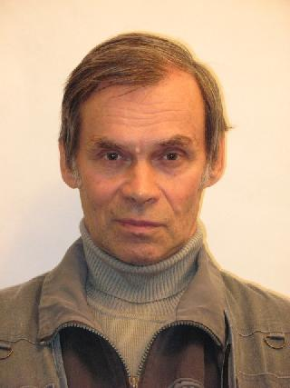

Personal information
Family name: | Panfilov
Given name: | Anatoliy
Date of birth: | 30 July 1939
Prof. address: | ILTPE - B.Verkin Institute for Low Temperature Physics & Engineering  47 Nauky Ave., 61103 Kharkiv, Ukraine
Phone number: | +380 (57) 341-08-28
E-mail: | panfilov@ilt.kharkov.ua
Hirsch factor (h-index) | 19

Scientific degree & rank
1995  ILTPE, Kharkiv, Ukraine | Senior Researcher Diploma (Solid State Physics)
1973  ILTPE, Kharkiv, Ukraine | Dr.rer.nat. - Ph.D. degree in physics and mathematics  Ph.D. thesis: “Effect of hydrostatic pressure on magnetic susceptibility of transition metals.”

Education
1957 – 1962 | Master, Physics | Kharkiv State University,  Kharkiv, Ukraine

Academic career
1974 – present | Senior Research Scientist | ILTPE, Kharkiv, Ukraine
1962 – 1974 | Junior Research Scientist | ILTPE, Kharkiv, Ukraine

Publication Activity (total published papers – about 210: articles* – 81, conference papers – about 130)

*All published articles can be found at http://ilt.kharkov.ua/bvi/structure/d05/en/publications.html

