Bilych Igor

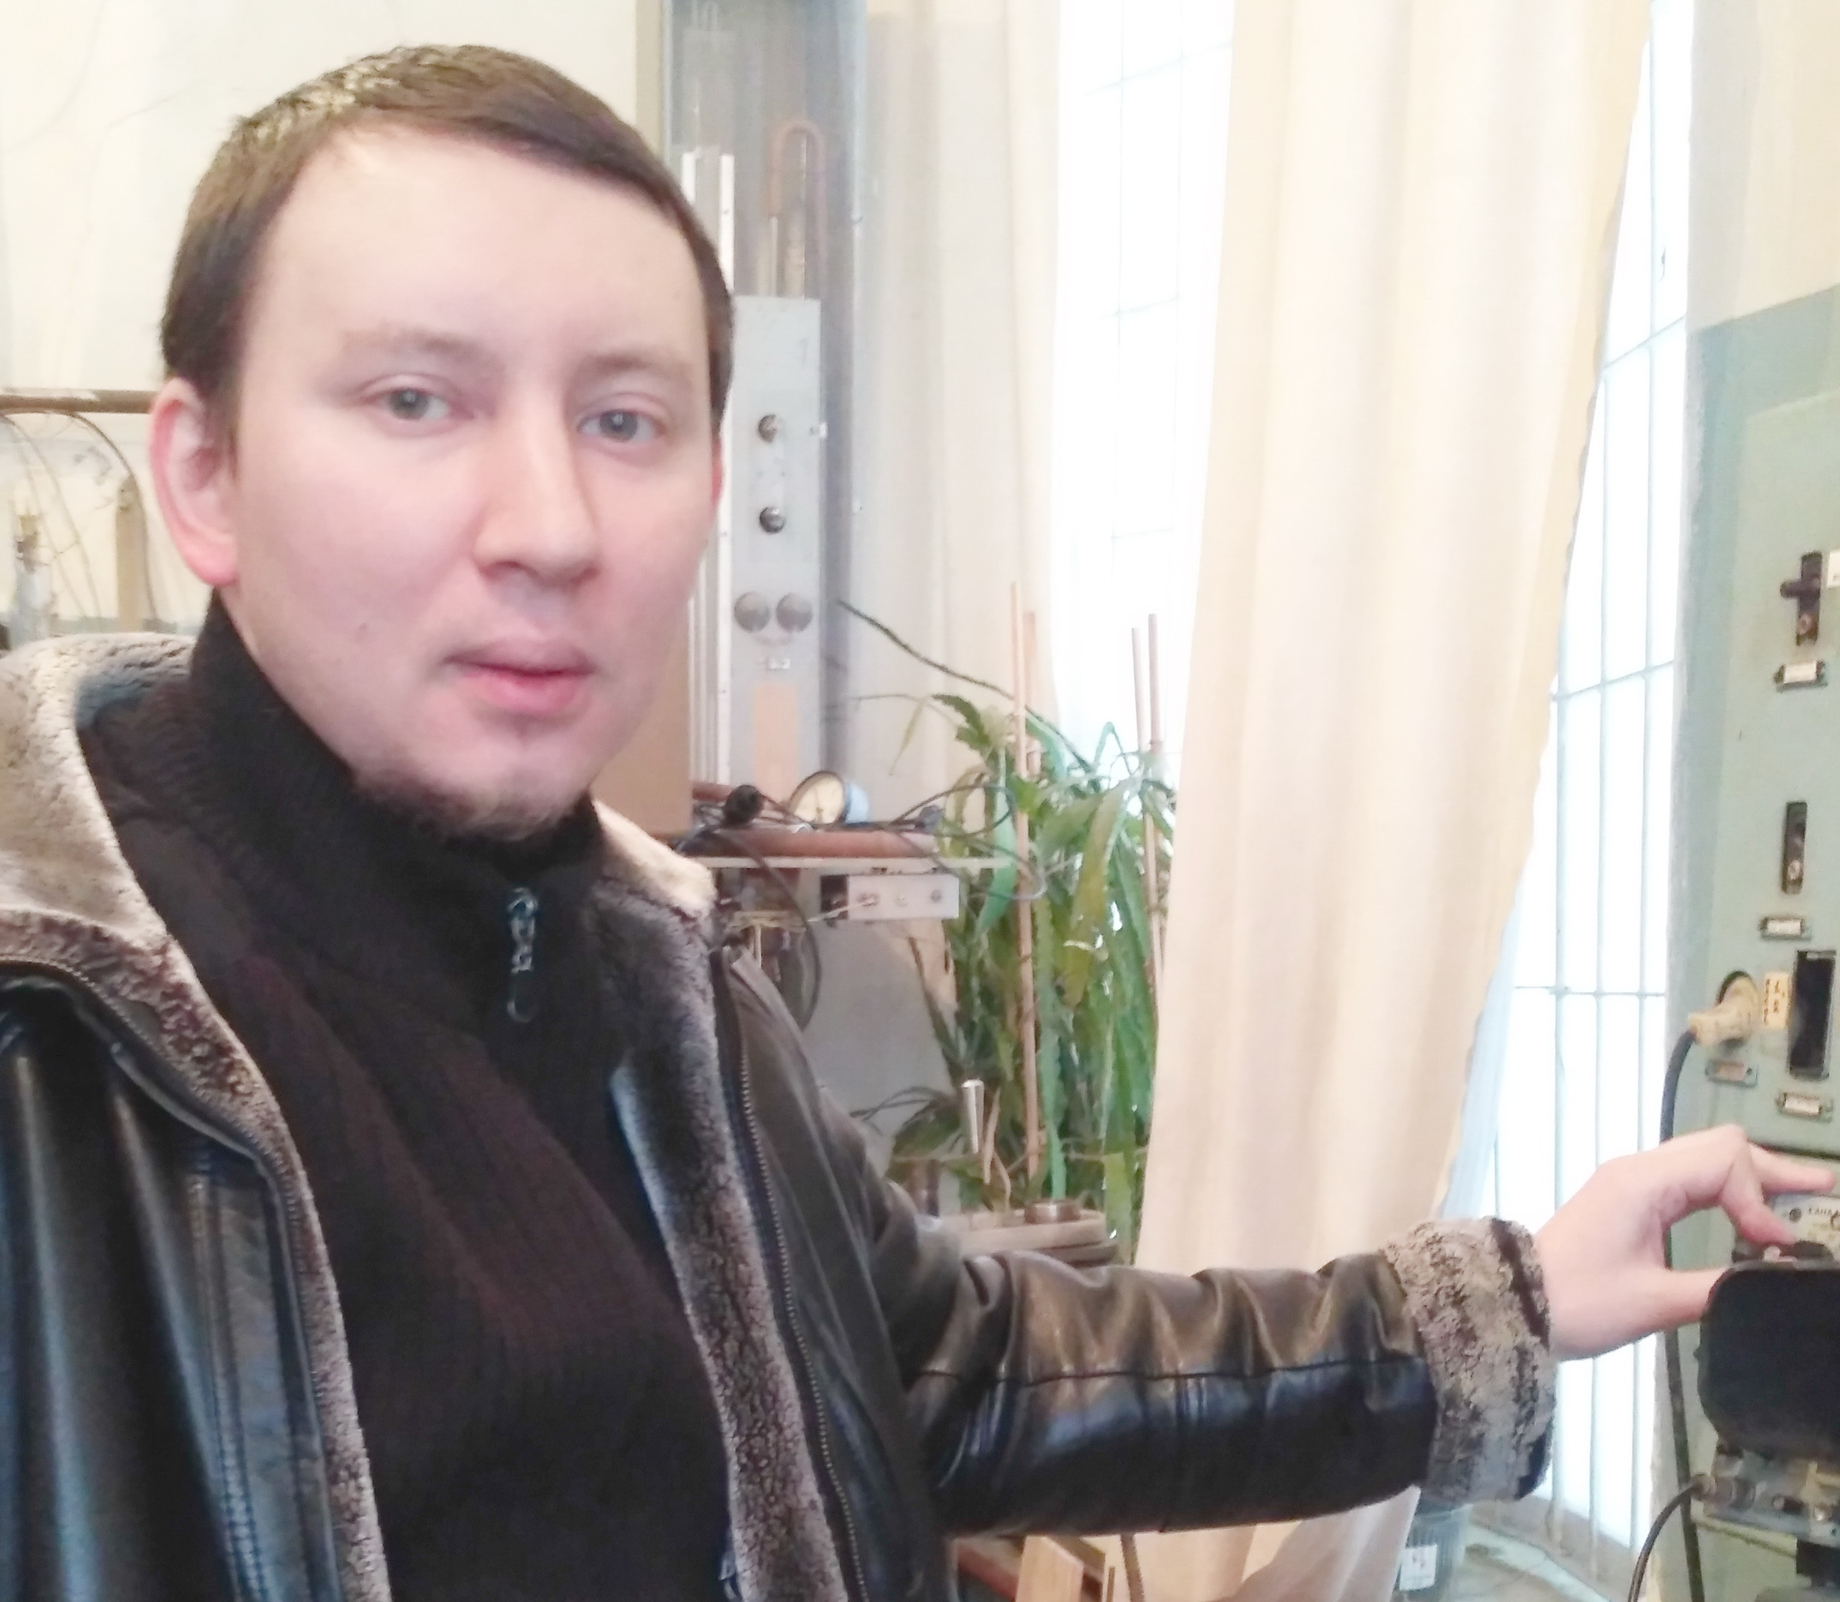
E-mail: bilich@ilt.kharkov.ua
Phone.: +(380) 57 341 0959
References available upon request: B.Verkin Institute for Low Temperature Physics and Engineering NASU,47 Nauky Ave., Kharkiv, Ukraine ,61103

EXPIRIENCE:
2016-present Junior Research Scientist B.Verkin Institute for Low Temperature Physics and Engineering, Kharkiv, Ukraine
2007-2016 Engineer, B.Verkin Institute for Low Temperature Physics and Engineering of the National Academy of Sciences of Ukraine, Kharkiv, Ukraine
EDUCATION:
2017- present Ph. D. student, B.Verkin Institute for Low Temperature Physics and Engineering, Kharkiv, Ukraine
2006 Magister of Physics, V.N. Karazin Kharkiv National University, Ukraine
2005 Bachelor of Physics, V.N. Karazin Kharkiv National University, Ukraine

AREA OF EXPERTISE: Magneto elasticity; physics of magnetic phenomena; phase transitions of different nature in solids; precision measurements of the elastic modules of single crystals.

List of recent relevant publications:
1. Fil.V.D., Kolodyazhnaya, M.P., Zvyagina, G.A., Bilych,I.V., Zhekov, K.R. Phys. Rev. B, 2017, 96, pp. 180407(R)-1-4
2. Kolodyazhnaya, M.P., Zhekov, K.R., Bilych, I.V., Zvyagina, G.A., Zvyagin, A.A. Low Temperature Physics, 2017, 43, N11, pp. 1276-1282
3. Kolodyazhnaya, M.P., Zvyagina, G.A., Bilych, I.V., Zhekov, K.R., Kharchenko, N.F., Fil, V.D.Low Temperature Physics, 2017, 43, N10, pp. 1240-1242
4. Kolodyazhnaya, M.P., Zvyagina, G.A., Gudim, I.A., Burma N.G, Zhekov, K.R., Fil, V.D. Low Temperature Physics , 2017, 43, N8, pp. 924-929
5. Bilych, I.V., Zhekov, K.R., Gaydamak, T.N., Gudim, I.A., Zvyagina, G.A., Fil, V.D Low Temperature Physics, 2016, 42, N12, pp. 1112-1119
6. Gaydamak, T. N., Gudim, I. A., Zvyagina, G. A., Bilych, I. V., Burma, N. G., Zhekov, K. R., & Fil, V. D. Low Temperature Physics, 2016, 41, N8, pp. 614-618

G.A. Zvyagina, K.R. Zhekov, I.V. Bilych, I.A. Gudim, V. D. Fil. Magnetopiezoelectric effect and magnetocapacitance in SmFe3(BO3)4 "Physical Review B" Vol.92 , В. 21-1
С 214428-1-7 (2015)
• G.A. Zvyagina, K.R. Zhekov, I.V. Bilych, A.A. Zvyagin, A.N. Bludov., V.A., Pashchenko, I.А. Gudim. Magnetic field-induced phase transitions in the antiferromagnetic Nd0.6Dy0.4Fe3(BO3)4 [Low Temp. Phys. 40, 146, (2014)]
• G.A. Zvyagina, K.R. Zhekov, I.V. Bilych, A.A. Zvyagin, I.A. Gudim, V.L. Temerov, E.V. Eremin. Magnetoelastic studies of Nd0.75Dy0.25Fe3(BO3)4 in the external magnetic field: Magnetic phase transitions [Low Temp. Phys. 39, 936454 (2013)].
Magnetic phase transitions in the NdFe3(BO3)4 multiferroic [Low Temp. Phys. 37, 1010 (2011)]
• G.A. Zvyagina, K.R. Zhekov, A.A. Zvyagin, I.A. Gudim, and I.V. Bilych [Low Temp. Phys. 38, 446 (2012)].
• G.A. Zvyagina, K.R. Zhekov, A.A. Zvyagin, I.V. Bilych, L.N. Bezmaternykh, and I.A. Gudim [Low Temp. Phys. 36, 279 (2010)]
• G.A. Zvyagina, K.R. Zhekov, I.V. Bilych, A.A. Zvyagin, I.A. Gudim, and V.L. Temerov

CONFERECES:
• VII International Conference for Young Scientists “Low Temperature Physics” - ICYS LTP 2016. Kharkiv, Ukraine (2016)
• VIII International Conference for Professionals and Young Scientists “Low Temperature Physics” - ICPYS LTP 2017. Kharkiv, Ukraine (2017)

