Vyacheslav D. Fil
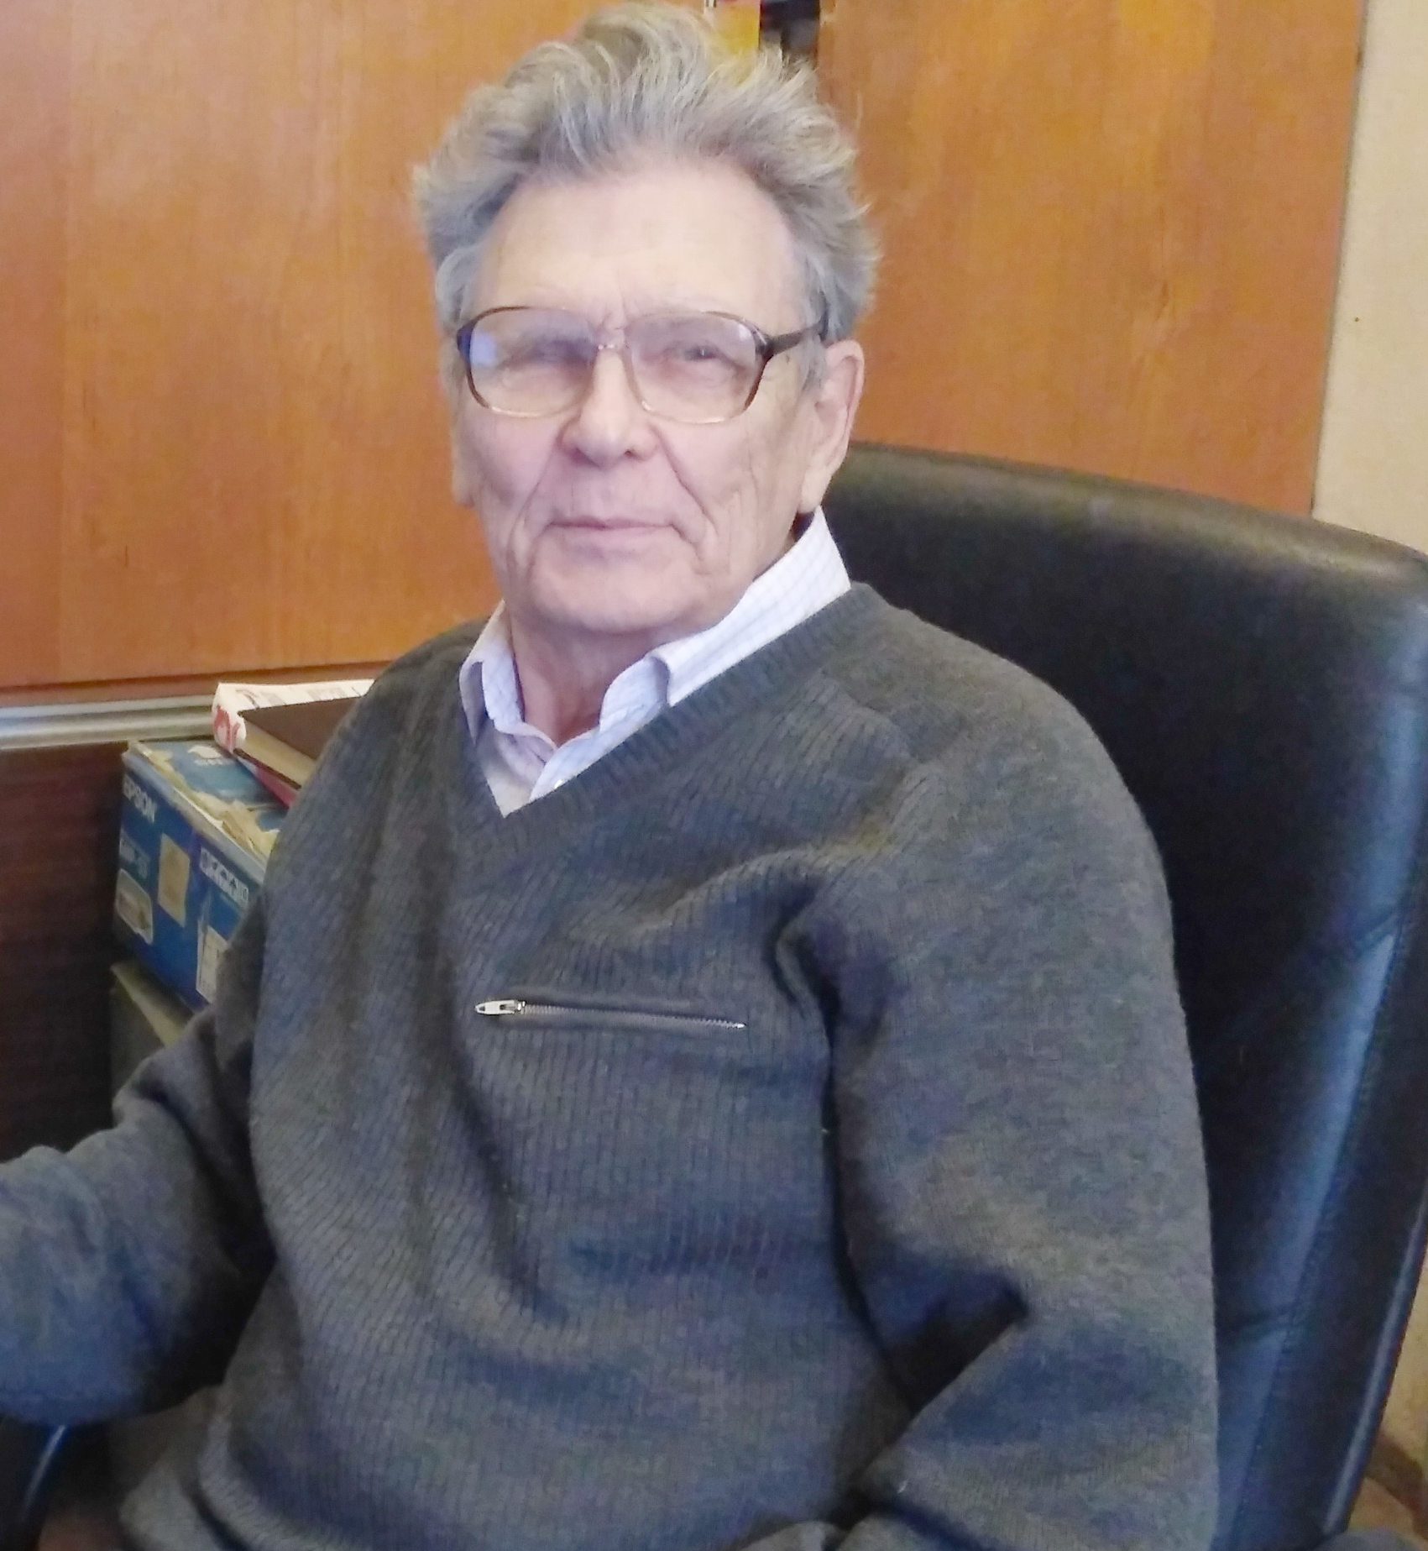

E-mail:: fil@ilt.kharkov.ua
Phone.: +(380) 57 341 0871
Name: Vyacheslav Fil
Business Address:
B.I.Verkin Institute for Low Temperature Physics & Engineering,
47 Nauky Ave., Kharkov 61103 Ukraine

Title: Professor, Principal Scientific Researcher, DSc

Date and place of birth: 30.11.1939, Kursk region, USSR

Education, academic degrees and titles

Graduated: Kharkov State University, Ukraine, 1961.

1961 - 1965, post-graduate, Institute for Low Temperature Physics and Engineering (Kharkov, Ukraine)

Ph.D. (Solid State Physics), Institute for Low Temperature Physics and Engineering, Kharkov, Ukraine, 1969.
Dr.Sc. (Solid State Physics), B.Verkin Institute for Low Temperature Physics and Engineering, Kharkov, Ukraine, 1983.
Senior Researcher Diploma (Solid State Physics), B.I. Verkin Institute for Low Temperature Physics & Engineering NASU, Kharkov, Ukraine, 1982
Professor (Solid State Physics), 1992.
Institutional Affiliations: Principal Scientific Researcher, Head of Department of Acoustic Properties of Solids, Senior Research Fellow, Junior Research Fellow, Institute for Low Temperature Physics and Engineering, Kharkov, Ukraine
Awarded - The Shubnikov Prize (V. V. Eremenko, V. A. Sirenko, V. D. Fil): Magnetoelastic phenomena in the Shubnikov phase of superconductors (2003)
Area of Expertise: Magnetoelasticity; Piezomagnetic and Piezoelectric effects in solids, Electron properties of metals, Phase transitions, Ultrasonic in superconductors; Precision measurements of the elastic modules of single crystals.

I have supervised 9 PH.D. students.

List of recent relevant publications

1. Fil.V.D., Kolodyazhnaya, M.P., Zvyagina, G.A., Bilych,I.V., Zhekov, K.R. Phys. Rev. B, 2017, 96, pp. 180407(R)-1-4
2. Kolodyazhnaya, M.P., Zhekov, K.R., Bilych, I.V., Zvyagina, G.A., Zvyagin, A.A. Low Temperature Physics, 2017, 43, N11, pp. 1276-1282
3. Kolodyazhnaya, M.P., Zvyagina, G.A., Bilych, I.V., Zhekov, K.R., Kharchenko, N.F., Fil, V.D.Low Temperature Physics, 2017, 43, N10, pp. 1240-1242
4. Kolodyazhnaya, M.P., Zvyagina, G.A., Gudim, I.A., Burma N.G, Zhekov, K.R., Fil, V.D. Low Temperature Physics , 2017, 43, N8, pp. 924-929
5. Bilych, I.V., Zhekov, K.R., Gaydamak, T.N., Gudim, I.A., Zvyagina, G.A., Fil, V.D Low Temperature Physics, 2016, 42, N12, pp. 1112-1119
6. Gaydamak, T. N., Gudim, I. A., Zvyagina, G. A., Bilych, I. V., Burma, N. G., Zhekov, K. R., & Fil, V. D. Low Temperature Physics, 2016, 41, N8, pp. 614-618
7. Gaydamak, T.N., Gudim, I.A., Zvyagina, G.A., Bilych, I.V., Burma N.G., Zhekov, K.R., Fil, V.D. Physical Review B" 92, В. 21-1 P. 214428-1-7, 2015
8. G. A. Zvyagina, Fiz. Nizk. Temp. 40, 585 (2014) [Low Temp. Phys. 40, 454, (2014)]
9. V. D. Fil, D. V. Fil, K. R. Zhekov, T. N. Gaydamak, G. A. Zvyagina, I. V. Bilich, D. A. Chareev and A. N. Vasiliev, EPL, 103, 47009 (2013)
10. G.A. Zvyagina, Zhekov K.R, Bilych I.V., Zvyagin A.A., Gudim I.A., Temerov V.L. , Eremin E.V Fiz. Nizk. Temp. 39, 1202 (2013) [Low Temp. Phys. 39, 936454 (2013)].
11. G. A. Zvyagina, Gaydamak T. N, Zhekov K.R., Bilich I.V., Fil V.D., Chareev D.A. and Vasiliev A N., EPL, 101, 56005 (2013)
12. Avramenko, Y.A., Bezuglyi, E.V., Burma, N.G., Fil, V.D. YA Avramenko, EV Bezuglyi, NG Burma, VD Fil, Physical Review B 84 (21), 214504 (2011)
13. VD Fil, TV Ignatova, NG Burma, AI Petrishin, DV Fil, NY Shitsevalova
Low Temperature Physics 33 (12), 1019-1022 (2007)
14. VD Fil, DV Fil, AN Zholobenko, NG Burma, YA Avramenko, JD Kim, EPL (Europhysics Letters) 76 (3), 484 (2006)
15. VD Fil, A Knigavko, AN Zholobenko, EM Choi, SI Lee, Physical Review B 70 (22), 220504 (2004)
16. E.A.Masalitin, V.D.Fil, K.R.Zhekov, A.N.Zholobenko, T.V.Ignatova, S.I.Lee, Elastic constants of borocarbides. New approach to acoustic measurement technique, Low temp. Phys. 29, N1, (2003).
17. TV Ignatova, GA Zvyagina, IG Kolobov, EA Masalitin, VD Fil’, Yu V Paderno, AN Bykov, VN Paderno, VI Lyashenko, Low Temperature Physics 28, 190, (2002)
18. E.V.Bezuglyi, A.L.Gaiduk, V.D.Fil, S.Zherlitsyn, W.L.Johnson, G.Bruls, B.Lüthi, B.Wolf, Electron renormalization of sound interaction with two-level systems in superconducting metallic glasses, Phys.Rev., B62, 6656, (2000).

Number of papers published: about 150.

