Maryna P. KOLODYAZHNA
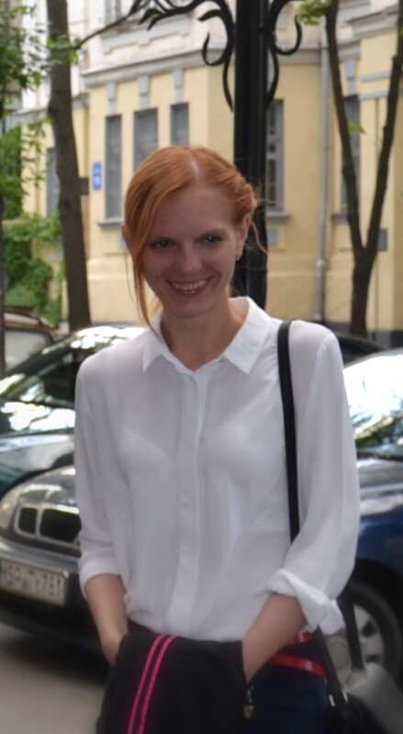
Name: Maryna Kolodiazhna

Date of birth: 23 June 1991

Phone: +(380) 57 341 0959

E – mail: kolodyazhnaya@ilt.kharkov.ua

Business Address: B. Verkin Institute for Low Temperature Physics & Engineering National Academy of Sciences of Ukraine, 47 Nauky Ave., 61103 Kharkiv, Ukraine.

Education:
- Master (Phycical Material Science), National technical university “Kharkiv Polytechnic Institute”, Kharkiv, Ukraine, 2013 - 2015.
- Bachelor (Engineering Material Science), National technical university “Kharkiv Polytechnic Institute”, Kharkiv, Ukraine, 2009 - 2013.
- Postgraduate study (Solid State Physics), B. Verkin Institute for Low Temperature Physics & Engineering National Academy of Sciences of Ukraine, Kharkiv, Ukraine,
2015 – 2018.

Professional Career:
- Engineer, B. Verkin Institute for Low Temperature Physics & Engineering National Academy of Sciences of Ukraine, Kharkiv, Ukraine, 2013 – 2015.
- Junior Reseacher, B. Verkin Institute for Low Temperature Physics & Engineering National Academy of Sciences of Ukraine, Kharkiv, Ukraine, since 2018.

Fields of Activity: Magneto elasticity; piezomagnetic and piezoelectric effects in solids, physics of magnetic phenomena; precision measurements of the elastic modules of single crystals.

Publications:
- V.D. Fil, M.P. Kolodyazhnaya, G.A. Zvyagina, I.V. Bilych, K.R. Zhekov, Piezomagnetoelectric effect in LiCoPO₄, Phys. Rev. B 96 (18), 180407, 2017.
- M.P. Kolodyazhnaya, G.A. Zvyagina, I.A. Gudim, I.V. Bilych, N.G. Burma, K.R. Zhekov, V.D. Fil, Piezoelectric response in SmFe₃(BO₃)₄, a non-piezoactive configuration. The surface piezoelectric effect., Low Temperature Physics 43 (8), 924-929, 2017.
- M.P. Kolodyazhnaya, K.R. Zhekov, I.V. Bilych, G.A. Zvyagina, A.A. Zvyagin, Reentrant low-temperature phase transition in an “orbital nematic”, Low Temperature Physics 43 (11), 1276-1282, 2017.
- M.P. Kolodyazhnaya, G.A. Zvyagina, I.V. Bilych, K.R. Zhekov, N.F. Kharchenko, V.D. Fil, Is LiCoPO4 a pyroelectric?, Low Temperature Physics 43 (10), 1240-1242, 2017
- M.P. Kolodyazhnaya, G.A. Zvyagina, I.V. Bilych, K.P. Zhekov, N.G. Burma, V.D. Fil', I.A. Gudim Magnetocapacitance, magnetoelasticity, and magnetopiezoelectric effect in HoFe₃(BO₃)₄, Low Temperature Physics 44 (12), 1341-1347, 2018.

