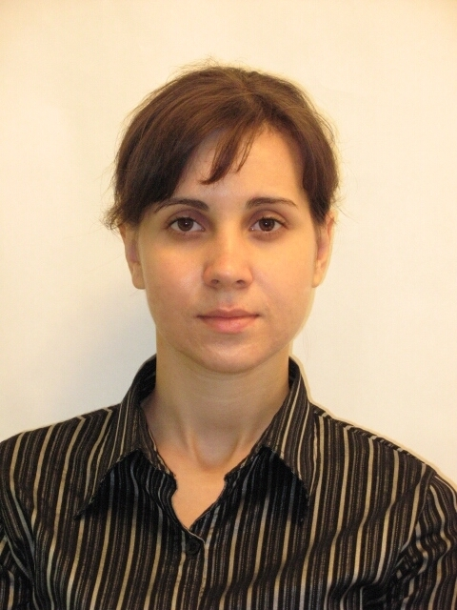 | CURRICULUM VITAE

Personal information
Family name: | Legenka (Family name used in publications: Lyogenkaya)
Given name: | Anastasiya
Date of birth: | 17 July 1987
Place of birth: | Velikaia Novoselkovka, Ukraine
Prof. address: | ILTPE - B.Verkin Institute for Low Temperature Physics & Engineering  47 Nauky Ave., 61103 Kharkiv, Ukraine
Phone number (mobile): | +380 (95) 146-26-03
E-mail: | lyogenkaya@ilt.kharkov.ua  alyogenkaya@gmail.com
Hirsch factor (h-index) | 3

Scientific degree
Feb 2018  ILTPE, Kharkiv, Ukraine | Dr.rer.nat. - Ph.D. degree in physics and mathematics  Ph.D. thesis: “Manifestations of the features of the electronic structure in the magnetic and superconducting properties of layered compounds of transition metals with metalloids.”

Education
Nov 2009 – Oct 2012 | Ph.D. student  (certificate summa cum laude) | ILTPE - B.Verkin Institute for Low Temperature Physics & Engineering,  Kharkiv, Ukraine
Sep 2008 – Jul 2009 | Magister, Physics  (diploma summa cum laude) | V. N. Karazin Kharkiv National University, Kharkiv, Ukraine
Sep 2004 – Jul 2008 | Bachelor, Physics  (diploma summa cum laude) | V. N. Karazin Kharkiv National University, Kharkiv, Ukraine

Academic career
Jan 2019 – present | Research Scientist | ILTPE, Kharkiv, Ukraine
Nov 2012 – Dec 2018 | Junior Research Scientist | ILTPE, Kharkiv, Ukraine

Awards & Scholarships
Mar 2018 | Scholarship: President of Ukraine for young scientists  Committee of the State prizes of Ukraine in science and technology, Kyiv, Ukraine
Mar 2015 | Scholarship: National Academy of Sciences of Ukraine for young scientists  Presidium of the National Academy of Sciences of Ukraine, Kyiv, Ukraine

Skills & Activities
Languages | English, Ukrainian (native), Russian (native)
Personal qualities | Responsibility, Ability to work independently

Research experience
Jan 2017 – Dec 2021 | Functional properties of the newest superconducting compounds and metal-containing spins and charge-ordered structures | ILTPE,  Kharkiv, Ukraine
Nov 2016 – Dec 2017 | Spin transitions and colossal magnetoresistance in cobaltites | ILTPE,  Kharkiv, Ukraine
Jan 2014 – Dec 2015 | Investigation of new magnetic and magnetoelectric phenomena in single-crystal oxide magnets with competing interactions | ILTPE,  Kharkiv, Ukraine
Jan 2012 – Apr 2015 | Spectroscopic, transport, magnetic and elastic properties of new low-dimensional structures and superconducting compounds | ILTPE,  Kharkiv, Ukraine

Publication Highlights (total published papers – 38: articles* – 13, conference papers – 25)
- Panfilov A.S., Grechnev G.E., Lyogenkaya A.A., et al / Magnetic properties of RCoO₃ cobaltites (R=La, Pr, Nd, Sm, Eu). Effects of hydrostatic and chemical pressure // Physica B: Condensed Matter - Vol. 553. - pp. 80-87 (2019).
- Zhuravleva I.P., Grechnev G.E., Panfilov A.S., Lyogenkaya A.A. / Magnetovolume effect in the exchange-enhanced itinerant paramagnet YCo₂: Theory and experiment // Low Temperature Physics. - Vol. 43. №. 5. - pp. 597-602 (2017).
- Logosha, A.V., Grechnev G.E., Lyogenkaya A.A., et al. / Features of the electronic structure of the layered superconductors RNi₂B₂C, RFe₄Al₈, and FeSe // Low Temperature Physics. - Vol. 40. №. 4. - pp. 311-319 (2014).
- Grechnev G.E., Panfilov A.S., Fedorchenko A.V., Lyogenkaya A.A., et al. / Anisotropy of magnetic properties of Fe_{1+y}Te // J. Phys.: Cond. Mat. - Vol.26, №43. - pp. 436003-1 - 436003-7 (2014).
- Grechnev G.E., Lyogenkaya A.A., et al. / Electronic structure and magnetic properties of graphite intercalated with 3d-metals // Low Temperature Physics. - Vol. 40. №. 5 - pp. 450-454 (2014).

*All published articles can be found at https://www.scopus.com/authid/detail.uri?authorId=56150103700

