**Computer Organisation – Lab 1**

Preparation

2a)

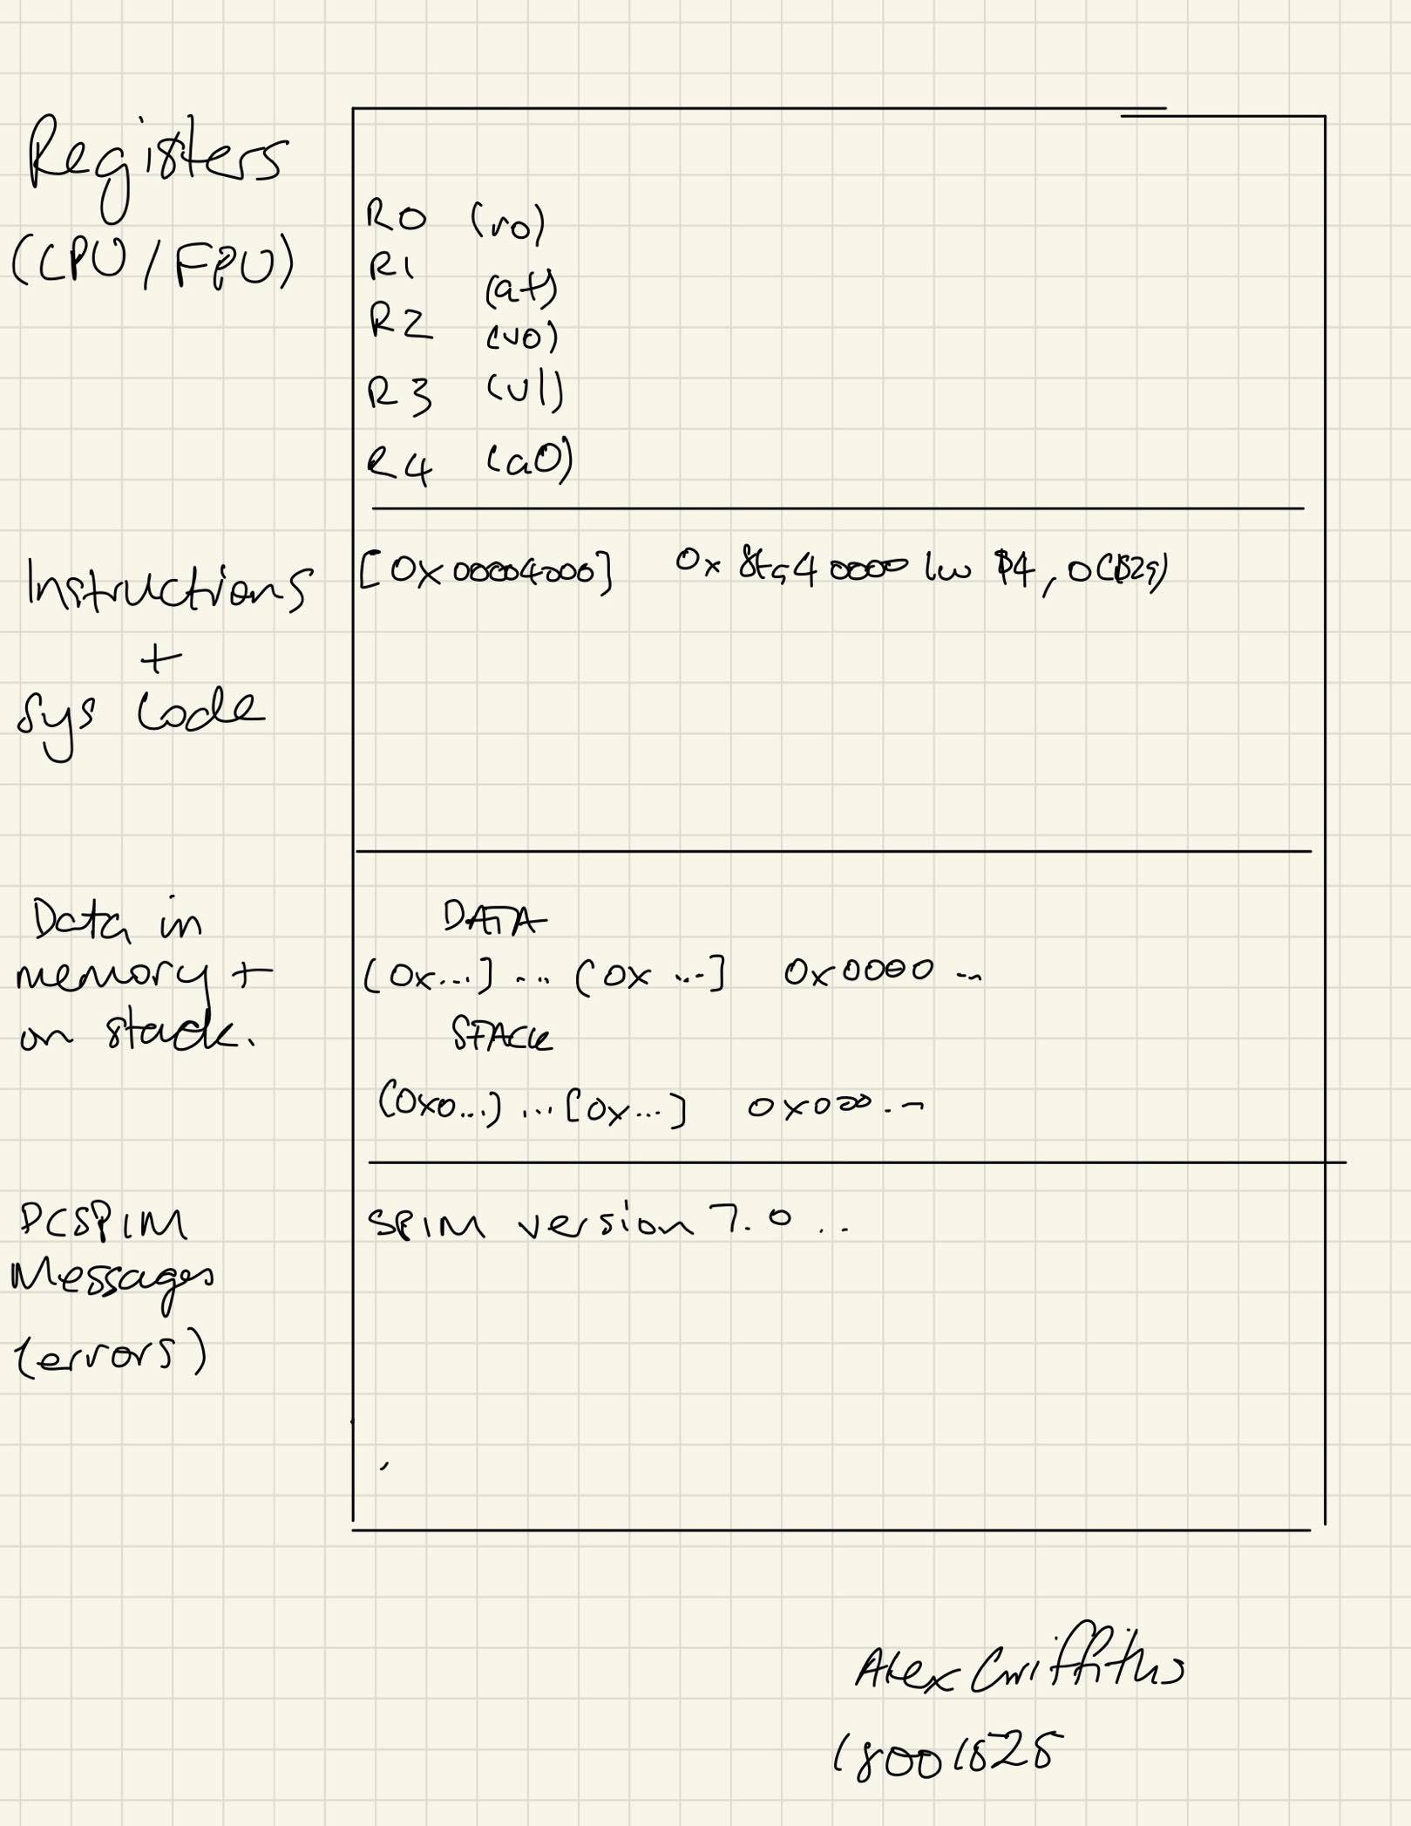2b)

Row One: Shows the available registers. There are registers for 32 bit integers, and registers for 32bit floating point numbers (In the FPU)

Row Two: Shows the instructions from a loaded program as well as the assembled instructions and machine code.

Row Three: Shows the data currently in memory as well as data on the stack.

Row Four: This section shows an error messages from PCSpim.