Name:
Calculating angles
- This is an octagon
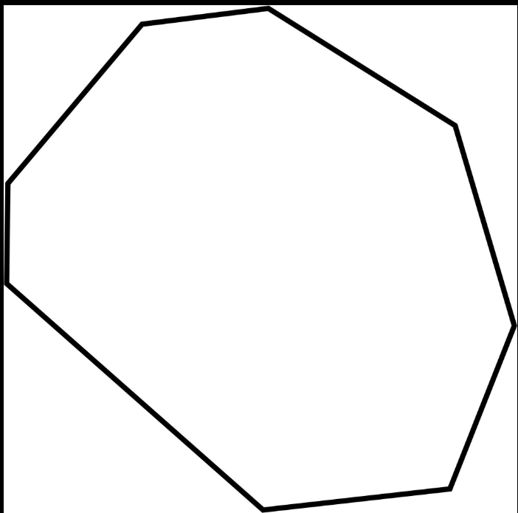
a Show that the sum of the interior angles is 1080°.

b Work out the interior angle of a regular octagon.

- A nonagon has 9 sides.
Work out the exterior angles of a regular nonagon

Work out the interior angle of a regular nonagon.

- Calculate the measure of angle a.
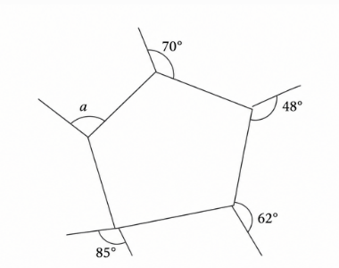

A=
- PQRS is a parallelogram. T is a point on the extension of QR. The angle at S is 70 degrees and angle RST = 110 degrees.
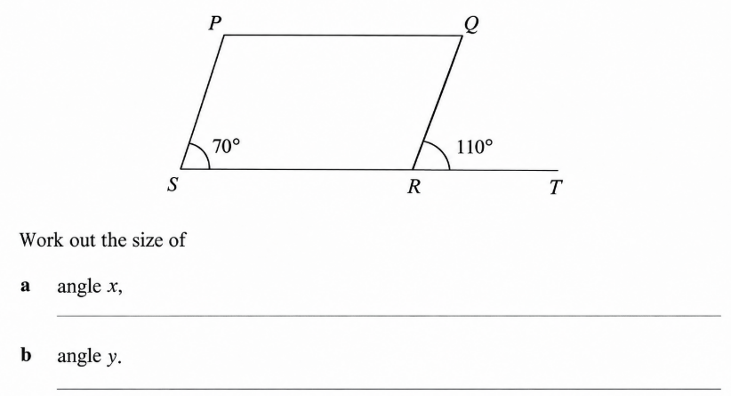
CONSTRUCTIONS
- The sides of a triangle are 5 cm, 8 cm and 9 cm.
a Make an accurate drawing of the triangle.
b Draw the perpendicular bisector of the longest side.

- The sides of a cube are 5 cm.
- Sketch the cube, show the lengths of the sides.

- How many planes of symmetry does the cube have?
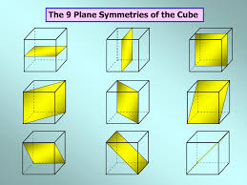
PYTHAGORAS THEOREM
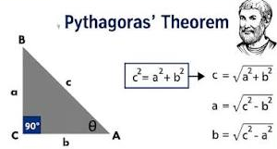
- Solve for the missing measure of the triangle.

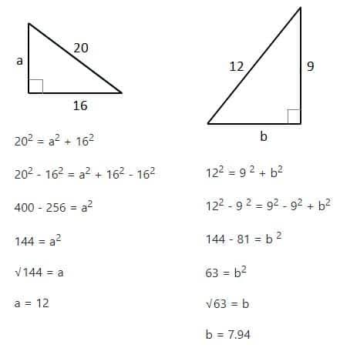

- Find the length of the diagonal of this rectangle
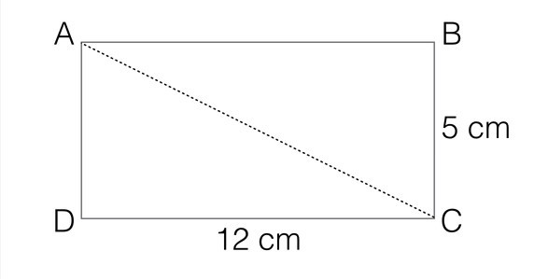

AREAS AND CIRCUMFERENCE OF CIRCLES
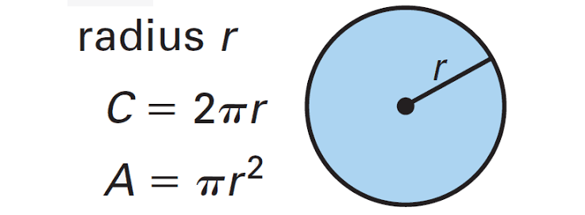
- A circular garden has a diameter of 14 cm.
- Find the circumference of the garden.
- Find the area of the garden.

- Calculate the area of the compond shape
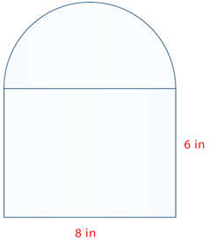

LARGE AND SMALL UNITS
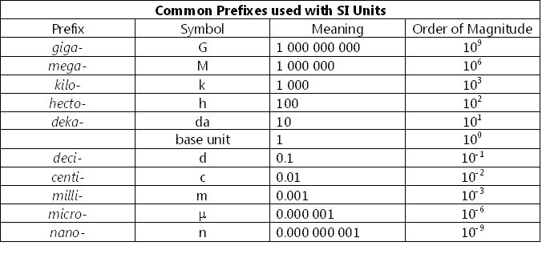
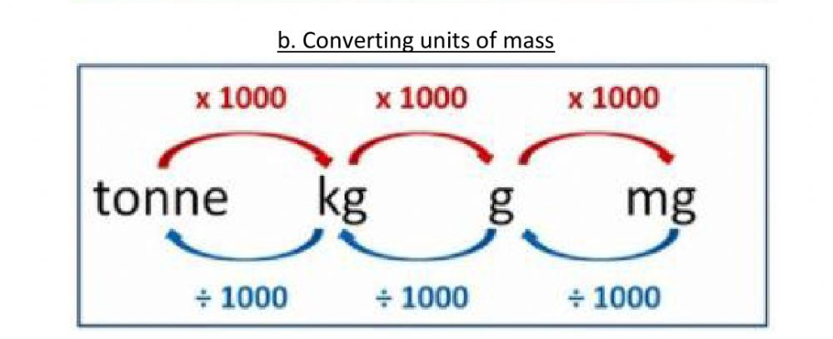
- a The mass of a cargo ship is 64.8 tonnes.
Write the mass in kilograms.

- The diameter of a bacterium is 350 nm…
Write the diameter in metres in standard form.

