|  |
| --- |
| Fralysis  Freudian Dream Analysis Chatbot |
|  |
| 164870  PROJECT SUPERVISOR  Chris Thornton  Computing for Digital Media BSc  2018/2019 |

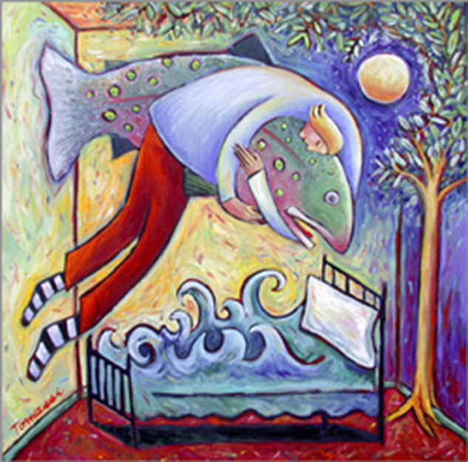

# Statement of Originality

# Acknowledgements

Project Supervisor: Chris Thornton

# Abstract

Mobile devices are our interface with the world. They enable us to shop, buy services, find help and recommendations. How we interact with computers is becoming increasingly sophisticated.

This paper investigates the feasibility of developing a mobile application that provides an insight into the meaning of an individual’s dreams based on Freudian dream analysis.

The project will:

* Evaluate current techniques used for natural language processing.
* Explore possible virtual environments to best simulate a therapy session.
* Document the process of developing a mobile application that provides Freudian dream analysis, covering:
  + Classifying user’s dreams from their input.
  + Provide a back-end application to perform dream analysis
  + Maintain a human aspect throughout the session

By the end of this report, you will have a basic understanding of Freud and his view on dreams, as well as an understanding of natural language processing. These ideas will be used to implement a mobile app named Fralysis which can conversate with a user and diagnose their dream.

Fralysis app can be found on github [_]

# 1. Introduction

## 1.1 Project Aim and Objectives

The aim of my project is to simulate Freudian dream analysis using Fralysis – a mobile application. The analysis is focused on experiment, education and fun. Fralysis is not intended as a treatment for serious psychological issues.

A user will engage in a conversation with Fralysis. Over the course of the conversation, key elements of a user’s dream will be collected. The user’s dream will then be analysed using a store of historic dream data. The results of the analysis will be feed back to the user. Users can retrieve dreams from past session and compare them. They can then take this further with online research or seek professional guidance should they choose to.

## 1.2 Problem area and Needs of Intended Users

There are many types of dreams [1]. Not all of them require analysis. 4 common types are:

* Normal dreams: a dream where the dreamer is not aware they are dreaming and where the experience of the reality of the dream does not provoke fear or anxiety.
* Night terrors: a dream where the dreamer screams, experiences great fear, and flails while they are asleep. This type of dream is more common in children.
* Night mares: a disturbing dream that is comprised of negative emotions, such as fear or anxiety.
* Lucid dreams: a dream where the dreamer knows they are dreaming and can control the experiences within the dream.

A normal dream omitting any fear or anxiety poses no harm to the user. Dream analysis for these types of dreams would be for curiosity as opposed to resolving an unconscious confliction. Going to a therapist would be a major investment for curiosity. This app would certainly appeal to this criterion.

The same can be said for people who experience lucid dreams. There may not be any lasting benefits of having lucid dreams analysed professionally, but this app can provide a fun, cheap experience for those who are curious.

For people who have experienced night terrors or nightmares and feel that interpreting their dreams will have significant benefits on their health could start with this app, but any real desire to unravel unconscious burdens should be taken to a qualified therapist.

As everyone has dreams of some kind, the intended user should have an interest in the Freudian meaning behind their dreams. It should be usable to anyone.

The intended user should be provided with an easy to understand Freudian analysis of their dream, enabling the user to perform further reading if required.

## 1.3 Motivation

The motivation for this project comes from an interest in psychology. This is a subject which effect everybody to some extent, especially in relation to dreams.

Developing an app that automates an otherwise expensive service will have the potential to widen the audience involved in this outdated, historic area. Although there are many dream interpretation apps, none target Freudian psychology with a focus on learning about his ideas and applying the latest natural language processing ideas.

# 2. Professional Considerations

Although this project is intended for fun, it tightly relates to simulating therapy. Therefore, it will refer to the professional and ethical standards a clinic will follow.

My project aims to provide an external interpretation on a person’s dreams. Given the nature of Freudian psychology, this can disturb some people, especially if they are particularly suggestable.

Below I will go through the BCS Code of Conduct, and state how I will ensure my project meets the required guidelines.

## 2.1 Public Interest

To maintain due regard for public health, privacy, security and wellbeing of others and the environment, I will have to make the purpose of the app very clear: to simulate the response a therapist may provide when interpreting one’s dreams in a fun, educational and experimental way.

These interpretations are by no means scientifically proven, they are filtered from many other interpretations surrounding a similar theme. This should not be taken as a conclusion but allow a user to take interest in the subject and decide whether they should follow up their concerns with a real therapist.

A cap on the sensitivity can be introduced. This would lead the application to become somewhat of an introduction to dream analysis. For example, a leading female character in the dream may refer to the Oedipus Complex. The interpretation should mention how this can translate into a representation of a mother, without going into exclusive details.

A major issue to consider is what information is stored from the user. As this app is responsible for comparing dreams from past sessions, a name is required. As this is only to reference a database, it can be made up.

However, the content of the dream is valuable in creating a database of anonymous dreams linked to Freudian meanings to create better results. This will be stated in the terms and conditions of the application.

There is a degree of social influence that can affect the results provided by the application. There is a large difference in how cultures interpret subjects. For example, eastern cultures are typically far more family orientated than the west, which has an autonomous approach. Freud’s ideas are western. This means these influences can make some interpretations invalid depending on the culture. This is something participant research should cover.

From background research, Google play store hosts several apps relating to dream interpretation from ‘Persian dream interpretation’ to ‘Biblical dreams’. These would provide different interpretations for the same stimulus. As my project is based around Freud, this will be the root of all interpretations.

## 2.2 Professional Competence and Integrity

As this project can contains sensitive information, complete classification is guaranteed. No information outside of dream analysis will be kept on the participants. This is to comply with all legislations.

By evaluating multiple cultures, this aims to reduce any social biases that may offend users. Constant reference to the Freudian root of interpretation will ensure validity. These can be found in the appendix.

## 2.3 Duty to Relevant Authority

The research I conduct will only relate to the subject area. This will be done with care and diligence. The ensure containment of my project, all research will be conducted on Sussex university campus under the circumstances mentioned above.

## 2.4 Duty to the Profession

As this is a project which aims to promote interest in dream analysis, I aim to uphold its reputation by reflecting the outcomes of traditional therapy.

The reputation of the BSc will be considered and maintained throughout the project.

As this field has not exact answer, results should only stand as possible interpretations based previous diagnosis. Should any interpretation result in upset, this will be changed until there are no further issues.

## 2.5 Ethical Issues

Validity of the success of this project can only be acknowledged using human test users. This will involve the participant playing with Fralysis. They will be informed that the primary purpose of this is not to leave an impact on their lives but refer to Freud’s ideas.

To comply with the ethical standards, it will be made clear that any interpretation of a dream (positive or conflicting) should only be received as a reference, and by no means a conclusion. This removes any harm or distressing thoughts to users.

To ensure the app remains ethical throughout, participants may be asked about what they find discouraging and what ideas should be left to further research if the user wishes to investigate further.

# 3. Related Work

## 3.1 Dream Analysis

The idea of dream analysis goes back to early civilisations, where dreams were associated to prophetic visions.

Freud’s ideas were thrown into fruition with his book ‘The Interpretation of Dream’ [40] in 1899. This introduced his unconventional ideas of Wish Fulfilment, Psychosexual Development, the Oedipus Complex, the Psyche and the Unconscious Mind [4].

Freud believed dreams were the ‘*royal road to the unconscious’* [2]and provide the best means of understanding the mind’s activities. Dream content has two forms: Manifest – literal object in the dream, and Latent – underlying meaning of symbol [3].

Symbols play a key part in Freuds ideas. He was against universal relationships between manifest and latent content: ‘*Every patient has their own personal interpretation’* [4].

The purpose of dream analysis is to determine the latent meaning and use this to address a patient’s concerns.

Freudian analysis is no longer mainstream, and a typical course of psychoanalysis can take many years. Therapy sessions involve 1 – to – 1 conversation between a patient and a therapist.

If dream analysis is to be implemented as a mobile app, an understanding of chatbots is required, and the limitations of implementing a historic idea outside the technological domain.

## 3.2 Chatbots

The first major publishing of the idea of Chatbots was by Alan Turing in 1950’s, where he published an article: ‘Computer Machinery and Intelligence’ [5], which spawned the breakthrough idea of ‘The Turing test’.

The aim of the Turing test was to distinguish whether a person was either conversing with a person, or a computer. This idea gave birth to AI when trying to answer: ‘Can machines think?’.

Between 1960 – 2000 there were many chatbots with varying specialties from Natural language processing, therapist impersonations and simulating patients with mental health symptoms [6].

Joseph Weizenbaum developed one of the first chatbots [7.1]: ELIZA (1962) with the purpose of helping people explore feelings and emotions in a therapeutic (free association) fashion: ‘*it has a crucial psychological utility in that it serves the speaker to maintain his sense of being heard and understood*’ [7.2].

Although having some success as being interpreted as a human by some users, it did not pass the Turing test. It did leave its legacy: ‘*principles used in ELIZA laid a foundation for the structures of chatbots, such as keywords, specific phrases, and preprogrammed responses’* [7.2].

Contrary to ELIZA, PARRY (1972) [8.1] developed by Kenneth Colby was a chatbot which simulates a paranoid schizophrenic. Results showed that only 48% of psychiatrist correctly identified PARRY as a chatbot. PARRY and ELIZA can chat together, and the advancement in PARRY clearly affects results [8.2].

ALICE [9] succeeded ELIZA with better natural language capabilities and received three lorem awards. It still did not pass the Turing test.

Since the 21st century chatbot’s have progressed substantially, with big companies providing big investment. Sophisticated bots of our era include Apple’s Siri, Microsoft’s Cortana and Amazon’s Alexa. However, these are not developed for conversational purposes, but as agents of convenience – Play music, organize calendars and interface with the web.

Recently, Amazon have shown a large dominance in this field, with a desire to expand Alexa to a ‘socialbot’ [10]. This very much involves a machine learning approach, where the program is exposed to conversational data sets and human neural models of cognition and conversation [29].

The bot responds in a way that is most appropriate to the user’s message. This is done by finding patterns in the data set which resembles the context best.

As of now, there are still no chatbots which pass the Turing test [11]. If this were to be successful, it would be a significant advancement in AI.

Based on above factors and commercial needs, there is strong relevance for chatbots to be used, especially in therapy. From the preliminary examples, factors of successful chatbots involve:

* Efficient use of natural language processing.
* Applied human characteristics.
* Ability to recognize patterns.

## 3.3 Natural Language Processing

Natural language processing and chat bot evolution are complimentary [12]. Data is taken and compared against a data set (Figure 1). An output is based on the best match.

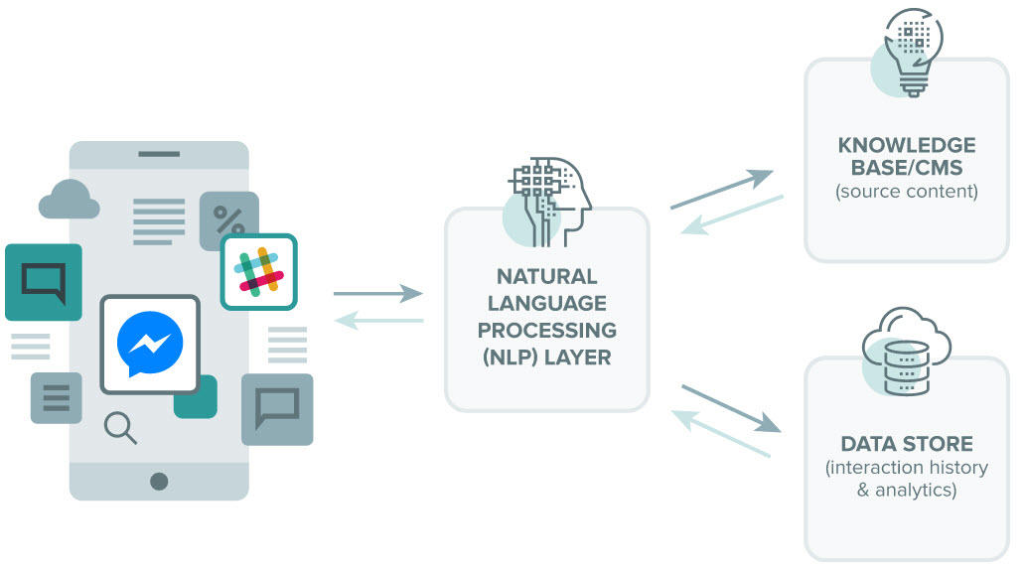

Figure 1 – General NLP Model

responses are generated by using a similar idea to manifest and latent content [3]. The literals are identified by comparing the message to a database containing references to possible contexts.

For example, a user may ask a chatbot about ‘Donald Trump’. The database should have references to ‘Donald Trump’ as a ‘President’ and ’Businessman’. To give this meaning, context should be considered. This is done via a heuristic data store, which looks at the latent meaning regarding the conversation.

For example, ‘I really don’t like Donald Trump’ might have a response: ‘Yes. He seems to be a bad president and a bad businessman’. For the above response to be generated, an emotion – ‘really don’t like’, and direct object – ‘Donald Trump’ must be identified.

In the past, there have been two techniques to do this: Rule-based and Statistical [13]. Rule based traditionally uses nested if-else statements. Even on automating NLP, decision tree algorithms still produced complex conditional rule-based statements.

Statistical models reinvent this by finding the probability of a given context. By analyzing a corpus of business documents, references to Trump’s business ventures are likely to appear in a negative context [14].

From above, it’s possible extract a feature from a user’s input and find its emotion by looking at its dependencies. This is vital for dream analysis.

As mentioned in [13]: ‘*Two main issues that affect accuracy are unknown words and ambiguity’.* In chatbots, ambiguity is a product message structure. The advantage of using a chatbot is the ability to lead a user’s input. For this, sentence structure and patterns must be understood.

## 3.4 Sentence Structure

Assuming we can successfully pre - process a user’s input with an NLP toolkit, there needs to be a process of identifying features within the sentence. This requires an understanding of sentence structure and common patterns which are likely to contain features that need to be extracted.

### 3.4.1 Sentence features

In the context of dream analysis, the required features which need to be identified are: Subjects, Direct objects and Compliments [15].

#### 3.4.1.1 Subject

The Subject of a sentence is defined as ‘*a noun phrase that functions as the topic of the sentence*’ [15].

For dream analysis, there are three subject classifications that can be made: The user themselves, someone they know or something meaningful like a car or pet. This means every dream will have a subject, regardless of how complex the sentence structure is.

#### 3.4.1.2 Direct Object

Direct Objects represent the manifest content of a dream.

For a Freudian analysis, a latent content must be attributed to identify the symbolism it represents in user’s unconscious [3].

For example: Little Hans [16] was a patient of Freud’s who had a fear of horses. After some analysis, Freud concluded that Little Hans was suffering from the Oedipus Complex, where the Horse resembled his father. Little Hans was afraid the horse would castrate him.

Using this example, we can identify a subject: Little Hans, a subject compliment: fear - giving a negative sentiment and the direct object: horse. In the given example, horse is symbolic of the Oedipus Complex.

In the context of dream analysis, a direct object in a dream should be any noun which references Freudian dream symbolism. In the example above, the horse is symbolic of the Oedipus complex.

#### 3.4.1.3 Compliments

Compliments are adjectives which provide sentiment to a sentence. These can either be directed at the subject or direct object.

For dream analysis, compliments hold information about the sentiment expressed by the subject towards the direct object, which can be applied to its symbolism. This means we can identify whether a symbol in the user’s dream is seem positive or negative context.

For a given sentence with a subject, verb and direct object, it can be said that: ‘the subject does the verb to the direct object.

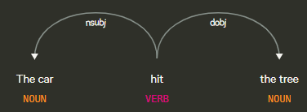

Figure 2 – DisplaCy’s Dependency Visualization Example I

Figure 2 shows an example: The car hit the tree’. The subject is the car. The verb is hit. This is often used in a negative context. The direct object is the tree. We can re-phrase the above sentence to say: The subject shows a negative sentiment towards the direct object. This is fine for simple sentences with standalone verbs like hit.

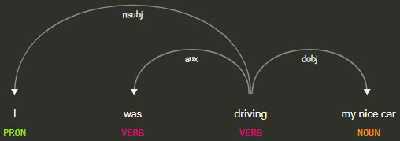

Figure 3 – DisplaCy’s Dependency Visualization Example II

However, let’s take Figure 3: I was driving my nice car. The subject is the user, the verb is driving, and the direct object is car. Driving doesn’t provide a sentiment - it’s a neutral verb. The direct object has an object compliment – nice, describing the direct object in a positive context.

For dream analysis, identifying verbs and adjectives gives sentiment to the dream. This gives context to dream symbols.

### 3.4.2 Sentence Patterns

With an understanding of the key components we need from a sentence, we can look at how this can be achieved. Going back to [15], there are 7 common sentence patterns which are likely to be exploited by the user to convey a dream.

The first pattern is known as ’The Be Pattern’, where sentences have the following structure:

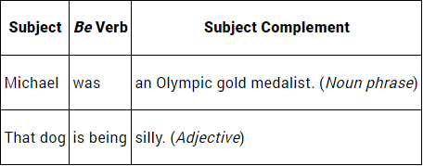

Figure 4 –The Be Pattern

Figure 4 shows sentences start with a subject. This can either be a pronoun, proper noun or a noun. Pronouns which are most likely to appear in a user’s messages include: ‘I’, ‘I’m’, ‘we’, ‘he’ and ‘she’.

If a message begins with a first-person pronoun, it’s logical to assume the subject of the dream is the user.

If a message begins with a third-person pronoun, it probably isn’t the first message received from a user, but it does suggest the subject of that sentence is referring to someone else. To accurately identify if the subject of a dream is referring to someone else, we can identify if a proper noun is present, as its unusual to refer to yourself in third person.

This works in the case of a simple sentence structure like ‘The Be Pattern’ or ‘The Linking Verb Pattern’. However, it is possible that a ‘Transitive Verb Pattern’ is present Figure.

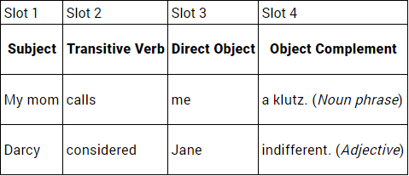 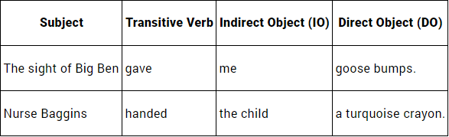

Figure 6 - The Transitive Verb + Two Complements

Verb Pattern

Figure 5 - The Basic Transitive Verb Pattern

For dream analysis, this gives the foundation of what information to extract from a sentence and how to classify it. It suggests that the implementation of the chatbot logic layer must recognize required features despite the message structure of the user. Furthermore, it suggests how to structure the chatbot’s responses to lead the user to provide specific information in their input.

## 3.5 Interface Design Considerations

Mobile applications primarily take two inputs from users: strings and triggered events. Conversational UI [17] tries to simplify this further.

With the possibilities of NLP, there must be considerations into how best to interact with the user to simulating a therapy session as accurately as possible. This enhances data validity. Although chatbots have traditionally used a message interface [18], VR and robotics are the future of UI, and will likely produce different results.

For the given scenario: A user wishes to analyse their dream from the comfort of their home. Requiring the user to type inputs will certainly take way from the importance of free association [19]. Speech – to – text would be more suitable.

Furthermore, VR can be used to better immerse the user into the dream analysis. This would give better quality input data.

This isn’t always the case. Jeff Hawkins [20], founder of ‘Palm, inc.’ and now involved in applying neuroscience to computing, found ‘voice control is unsatisfactory and uncompelling’. Having users speak to their phone about sentimental information can be uncomforting and detract from its validity.

Considering the above, the app development stage will have a strong focus around User Centred Design and explore the best means of allowing a user to provide information to try draw a valid interpretation.

An MVC architecture means the same Freudian data model and NLP controller can be applied to various views. The preferred view for development would be through the terminal. The MVP could be a standard messenger interface to enable a user to converse with the chatbot. Given more time and technology, a VR domain can be implemented to focus on user immersion.

This architecture promotes privacy when using the app in various environments. Encapsulating the logic layer in a controller means you can easily update the NLP resources as they evolve. This is the same for the Freudian model, which can be expanded over time using machine learning. Testing confirms the controller is behaving as it should based on ideas from sections 3.3 - 3.4.