**Appendix for “Beyond 60 Days: The Effect of Postpartum Medicaid Eligibility on Continuity of Insurance Enrollment”**

**Appendix 1. Description of Data Linkage**

**Appendix 2. Study Sample Flow Chart**

**Appendix 3. Covariate Scatter Plots as a Function of Income**

**Appendix 4. Regression Discontinuity Design Specifications**

**Appendix 5. Comparison of Estimation Strategies for Regression Discontinuity Design**

**Appendix 6. Scatter Plots for Other Continuity of Coverage Outcomes**

**Appendix 7. Placebo Tests**

**Appendix 8. Sensitivity Analysis Results Excluding those Enrolled in Medicaid for Delivery Month Only as Proxy for Emergency Medicaid Status and Excluding non-U.S. Born Mothers**

**Appendix 9. Exclusion of Incomes Between 133-138% of the Federal Poverty Level**

**Appendix 10. Type of Enrollment and Other Continuity of Enrollment Outcomes the Postpartum Year by Income-Based Pregnancy-Related Medicaid Eligibility**

**Appendix 1. Description of Data Linkage**

***Data Sources***

Data for this study were obtained from three sources: the Colorado All Payer Claims Database which includes a supplemental file with information about Marketplace plans, individual-level income information for Health First Colorado enrollees (Colorado’s Medicaid program), and birth records for all Colorado births. The APCD was obtained from the Center for Improving Value in Health Care (CIVHC), a non-profit organization which manages the APCD on behalf of the state. Individual-level income data were obtained from the Department of Health Care Policy and Financing, the state agency which oversees the Medicaid program. Birth records were obtained from the Colorado Department of Public Health and Environment.

The Colorado APCD receives health care claims from the state’s largest commercial health insurers, Health First Colorado (Colorado’s Medicaid Program), CHIP, non-ERISA commercial self-insured plans, and commercial ERISA self-insured plans that submit claims on a voluntary basis. While the APCD includes all Medicaid-financed births in the state from 2014-2019, we may be unable to observe some transitions to commercial insurance after childbirth due to the exclusion of ERISA self-insured plans in the APCD. Under the Gobeille versus Liberty Mutual Supreme Court Ruling in March of 2016, self-insured ERISA plans cannot be mandated to submit their claims to the database. Self-insured claims represent approximately 30% of insured lives in Colorado. However, the majority of enrollees in these plans work at larger firms and are typically high-earners, which may limit the extent to which women below 265% FPL transition to these unobserved plans.(1,2)

***Data Linkages***

The linkage of the Colorado APCD with individual-level Medicaid enrollee income as a percentage of the federal poverty level was conducted in-house by the Colorado Department of Health Care Policy and Financing (HCPF). Income and eligibility variables are standard fields in Medicaid claims data prior to submission to the APCD. HCPF personnel added these fields back into the claims data using identified Medicaid enrollee numbers, which were then deidentified and returned to the research team linked with the APCD. The match rate between the sample of women with Medicaid-financed births identified in the APCD and the income file was 98.9%.

The linkage of the Colorado APCD with the birth records was conducted by CDPHE vital records staff using a deterministic matching process based on identifiable fields unique to APCD and the birth record: social security number (SSN), dates of birth (DOB), first name, and last name. CDPHE has used this approach to link other vital records data to administrative billing data. 96.1% of births identified in the APCD were matched with a corresponding birth record.

When member records in APCD had more than one variant of last name, first name, birth date or SSN, up to three distinct fields for each identifier were created to use in the linkage to birth certificate. The first step applied a ‘blocking’ strategy to identify all possible matches. This involved the following comparisons between the APCD (member) data and maternal information on the birth certificate (maternal), conducted as independent passes:

1. Truncated (first 3 characters) of member last name to maternal current last name or maiden last name, and complete member date of birth to maternal date of birth
2. Truncated (first 3 characters) of member first name to maternal current first name or maiden first name, and complete member date of birth to maternal date of birth
3. Truncated (first 3 characters) of member last name to maternal current last name or maiden last name, and truncated (first 3 characters) of member first name to maternal current first name or maiden first name, and 2 of 3 matching components of member date of birth and maternal date of birth (month and year, day and year, month and day)
4. Matching member Social Security Number and maternal Social Security Number

The second step applied a ‘scoring’ strategy to each possible match identified, represented as a 4-digit code. The third step applied a ‘selection’ strategy to select from the possible matches identified only those considered correct matches, using both the ‘score’ assigned and other comparisons. Matching records were retained when the following criteria were met:

1. ‘Score’ = 1111, 1110, 1101, 1011 (indicating an exact match across 3 of 4 principal identifiers: SSN, DOB, last name and first name)
2. ‘Score’ = 0111, and no more than 2 digits differed between member SSN and maternal SSN or member or maternal SSN was missing (indicating an exact match of last name, first name, DOB and partial/close match of SSN). Prior assessments conducted by the Colorado Department of Public Health have found a strong inflection point at ≤2 versus 3+ SSN discrepancies for records which agree on maternal DOB. When records agree on DOB but SSNs disagree for 3 or more digits, it is generally indicative of a unique person altogether and an incorrect match, whereas a difference in SSN digits ≤2 are generally true matches subject to minor transcription or transposition errors. Thus, records that had <=2 SSN discrepancies were retained and SSN discrepancies with 3+ were excluded.
3. ‘Score’ = 0011, and no more than 2 digits differed between member SSN and maternal SSN or member or maternal SSN was missing, and difference between member DOB and maternal DOB difference by no more than 366 days or member DOB or maternal DOB was missing (indicating an exact match of last name and first name, and partial/close match of available SSN and DOB).

**Appendix 2. Study Sample Flow Chart**

We generated our initial sample by identifying delivery hospitalizations in the Colorado APCD that were financed by Medicaid from 2014-2018. We excluded births that occurred in 2019 so that we could observe a 12-month postpartum follow-up period for all births. We identified birth payer using administrative billing data rather than the birth record as prior research has demonstrated poor accuracy for some birth record fields.(3,4) In contrast, fully adjudicated claims in the APCD reflect completed financial transactions which enhances payer accuracy.

We excluded births to women 18 and under, as those in this age group qualify for Medicaid as children and are thus subject to distinct Medicaid eligibility criteria from adult postpartum women. We excluded records with missing income data and records for which the date that income was recorded fell outside the dates of Medicaid eligibility provided by the state Medicaid agency.

We then merged this file with the birth record data, retaining all matches as described in Appendix 1. Finally, for the local polynomial regression model estimation, we applied the “optimal” bandwidth approach to limit the sample to those incomes with a narrow income bandwidth above and below 138% FPL. Because the procedure for selectin this bandwidth is data-dependent, the range of this income bandwidth varied depending on the outcome, ranging between +/-24.4 to +/-53.7 percentage points of FPL.

**Colorado Births CONSORT Flow Diagram, 2014-2018**

*Sample sizes refer to unique births in each data set. Optimal income bandwidth varied by outcome, varying from 24.4 and 53.7 percentage points on either side of the cutoff. Therefore, we present the range of sample sizes included in the optimal bandwidth used in local polynomial regression models.

Excluded:

-Missing income data (n=1,724)

-Date of delivery fell outside of eligibility period (n=1,434)

Medicaid Income Data

(n=879,091)

## Income Data from State Medicaid Agency

Excluded:

Income between 133-138% FPL

(n= 908)

Merged Deliveries, Income, and Birth Record

Final Analytic Sample

0-138% FPL (n=133,683)

139-265% FPL (n=23,983)

Merged Deliveries and Income

(n=157,666)

Inpatient Delivery Hospitalizations

(n=159,390)

## APCD Inpatient Claims

Medicaid-Enrolled Women in APCD under 19

(n=617,743)

## Birth Records

Unique Colorado Births

(n=268,567)

Income within optimal bandwidth*

(n=15,003 to 33,557)

**Appendix 3. Covariate Scatter Plots as a Function of Income**

Table A3.1. Covariate Definitions

|  |  |
| --- | --- |
| Descriptive Characteristics | Description and Units |
|  |  |
| Age, Mean | Age of mother, measured in years (continuous) |
| Race and Ethnicity, % |  |
| White | Discrete variable, mother race is coded as white |
| Black | Discrete variable, mother race is coded as Black |
| Asian | Discrete variable, mother race is coded as Asian |
| Hispanic | Discrete variable, mother is identified as being Hispanic |
| Other Race | Discrete variable, mother race is coded as neither white, Black, or Asian |
| Born outside US, % | Discrete variable, maternal birthplace is coded as being outside of the U.S. |
| Education, % |  |
| High School | Discrete variable, mother completed high school |
| College | Discrete variable, mother completed any college degree (including Associate’s degrees or higher) |
| Married, % | Discrete variable, mother is reported as being married and living with their spouse |
| Number of Prenatal Visits, Mean | Continuous count variable, number of visits for prenatal care billed to Medicaid during mother’s pregnancy |
| Prenatal Care Initiated in First 3 Months of Pregnancy, % | Discrete variable, mother billed a visit for prenatal care to Medicaid during the first 3 months of pregnancy |
| Pre-Existing Chronic Conditions Prior to Pregnancy, % | Discrete variable, mother had pre-existing hypertension, diabetes, or obesity prior to becoming pregnant |
| Preterm Birth, % | Discrete variable, birth occurred prior to 37 weeks gestational age |
| Pregnancy Complications, % | Discrete variable, birth is reported as having complications (gestational hypertension and gestational diabetes) |
| Delivery Complications, % | Eclampsia, HELLP syndrome (hemolysis, elevated liver enzymes, low platelet count), multiple births, admission to the ICU, blood transfusion, 3rd or 4th degree perineal laceration, ruptured uterus, or unplanned hysterectomy |
| Cesarean-Section Births, % | Discrete variable, birth is reported with a Cesarean-section delivery method |

Figure A3.1. Average Maternal Age by Income as a Percentage of the Federal Poverty Level (FPL)

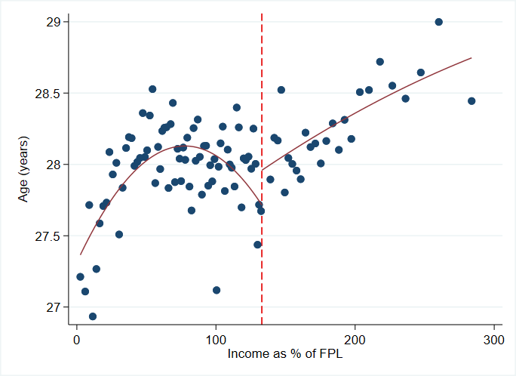

Notes: Dotted vertical line indicates 138% of the federal poverty level, the income threshold for Medicaid eligibility for low-income adults in Colorado. Each dot represents a binned average of values along the income distribution; each bin includes 2,732 births on average. Red line indicates quadratic curves fit through average points, potentially differing on either side of the cutoff.

Figure A3.2. Probability of Mother Being White, Black, Hispanic, or other Minority by Income as a Percentage of the Federal Poverty Level (FPL)

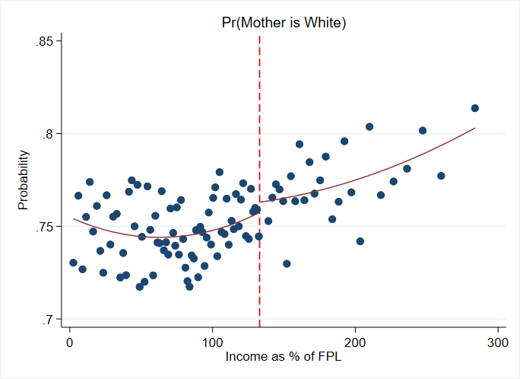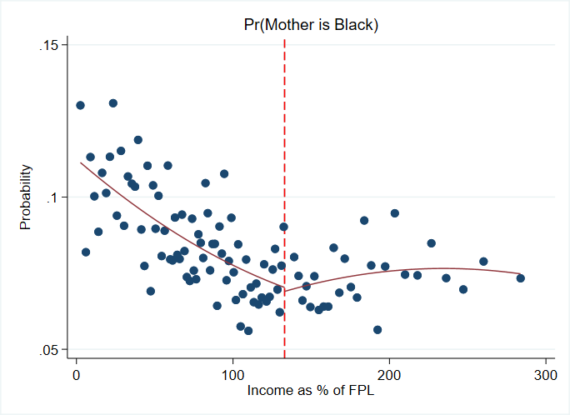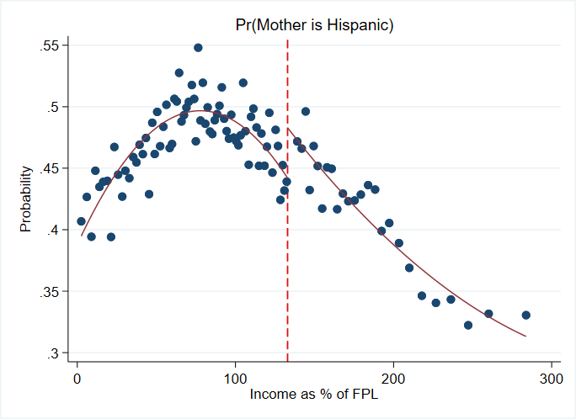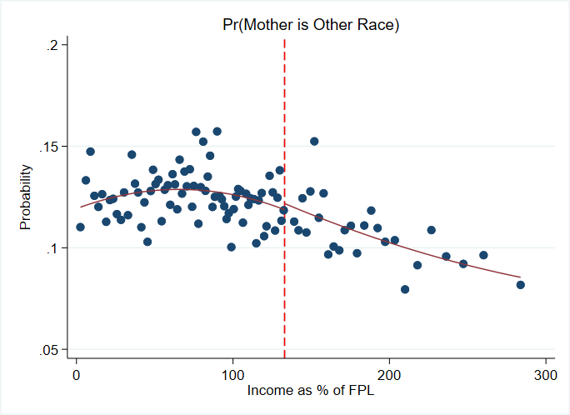

Notes: Dotted vertical line indicates 138% of the federal poverty level, the income threshold for Medicaid eligibility for low-income adults in Colorado. Each dot represents a binned average of values along the income distribution; each bin includes 2,732 births on average. Red line indicates quadratic curves fit through average points, potentially differing on either side of the cutoff.

Figure A3.3. Probability of Mother Being Born Outside the U.S. by Income as a Percentage of the Federal Poverty Level (FPL)

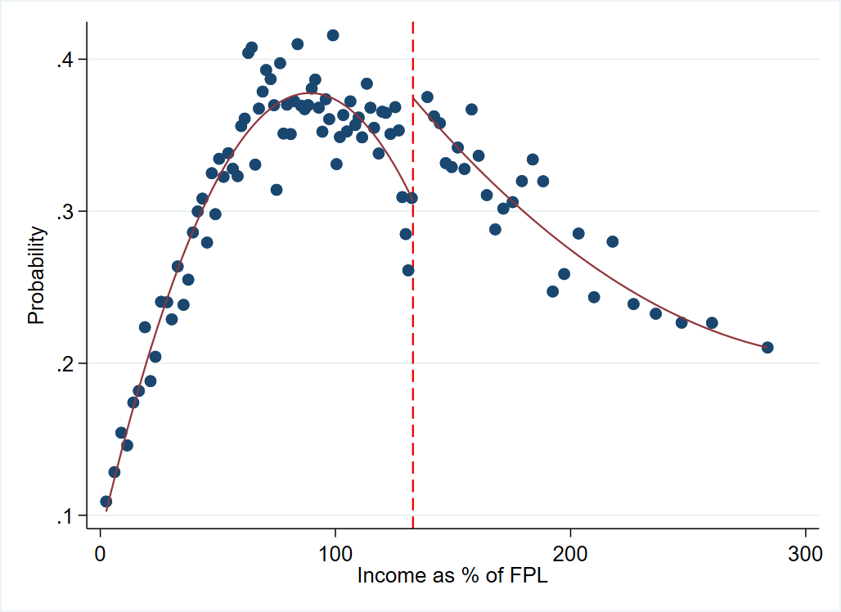

Notes: Dotted vertical line indicates 138% of the federal poverty level, the income threshold for Medicaid eligibility for low-income adults in Colorado. Each dot represents a binned average of values along the income distribution; each bin includes 2,732 births on average. Red line indicates quadratic curves fit through average points, potentially differing on either side of the cutoff.

Figure A3.4. Probability of Mother Being a High School, College Graduate by Income as a Percentage of the Federal Poverty Level (FPL)

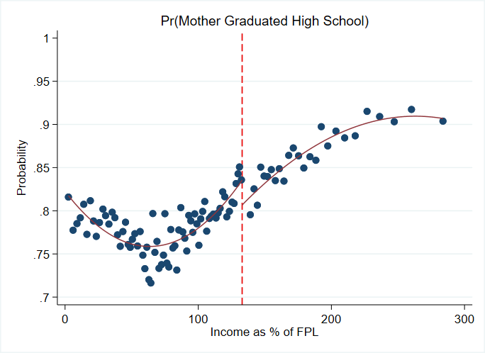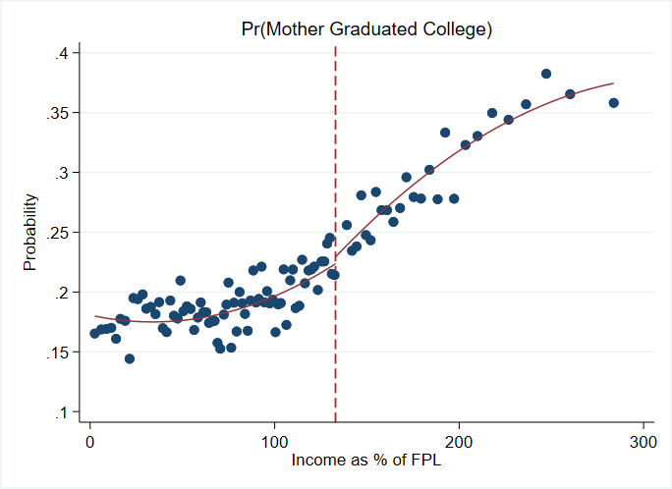

Notes: Dotted vertical line indicates 138% of the federal poverty level, the income threshold for Medicaid eligibility for low-income adults in Colorado. Each dot represents a binned average of values along the income distribution; each bin includes 2,732 births on average. Red line indicates quadratic curves fit through average points, potentially differing on either side of the cutoff.

Figure A3.5. Probability of Mother Being Married by Income as a Percentage of the Federal Poverty Level (FPL)

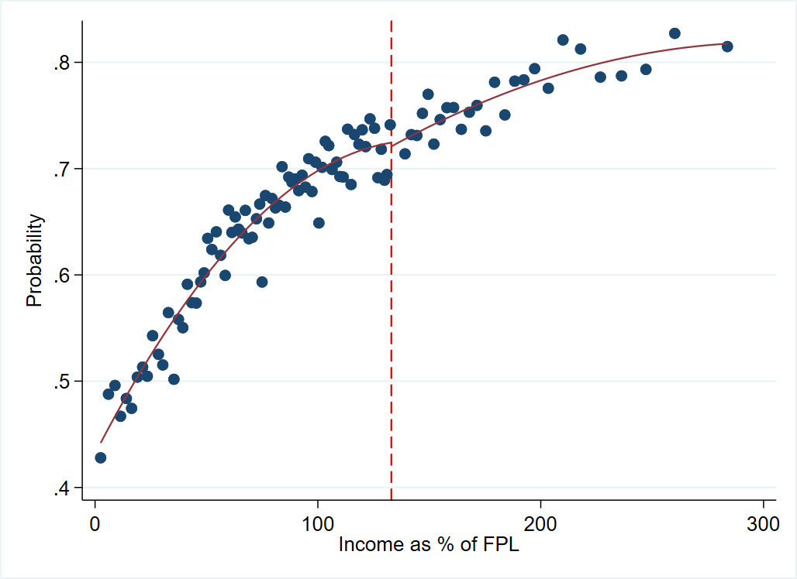

Notes: Dotted vertical line indicates 138% of the federal poverty level, the income threshold for Medicaid eligibility for low-income adults in Colorado. Each dot represents a binned average of values along the income distribution; each bin includes 2,732 births on average. Red line indicates quadratic curves fit through average points, potentially differing on either side of the cutoff.

Figure A3.6. Prenatal Care Quality Measures by Income as a Percentage of the Federal Poverty Level (FPL)

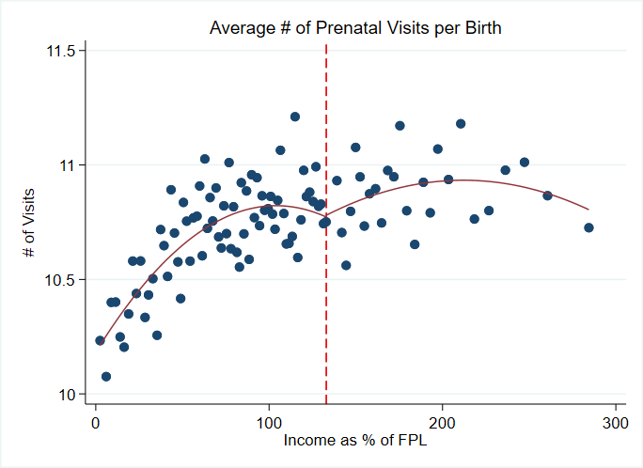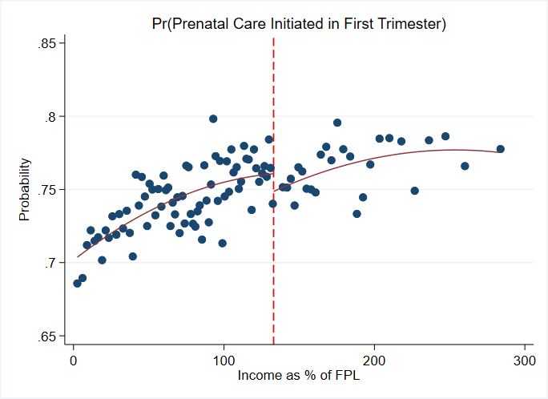

Notes: Dotted vertical line indicates 138% of the federal poverty level, the income threshold for Medicaid eligibility for low-income adults in Colorado. Each dot represents a binned average of values along the income distribution; each bin includes 2,732 births on average. Red line indicates quadratic curves fit through average points, potentially differing on either side of the cutoff.

Figure A3.7. Probability of Adverse Health and Birth Outcomes by Income as a Percentage of the Federal Poverty Level (FPL)

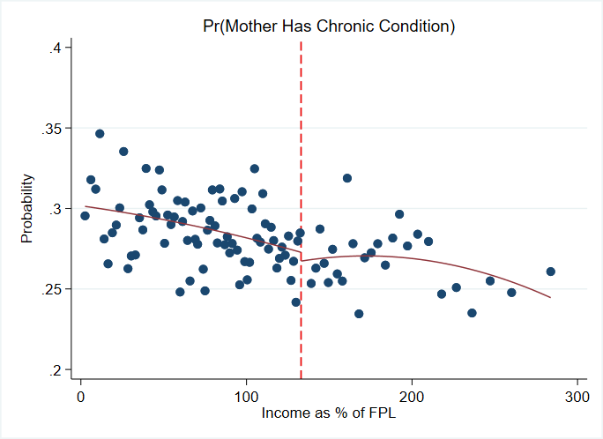 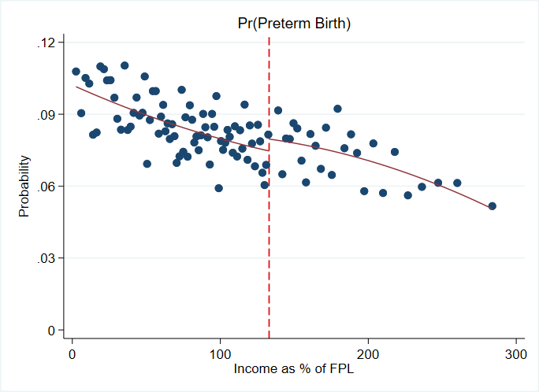

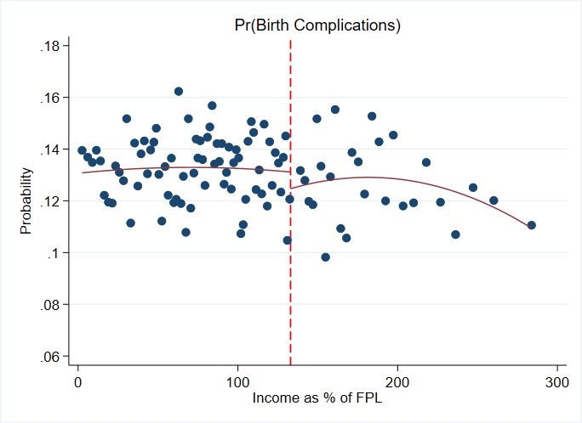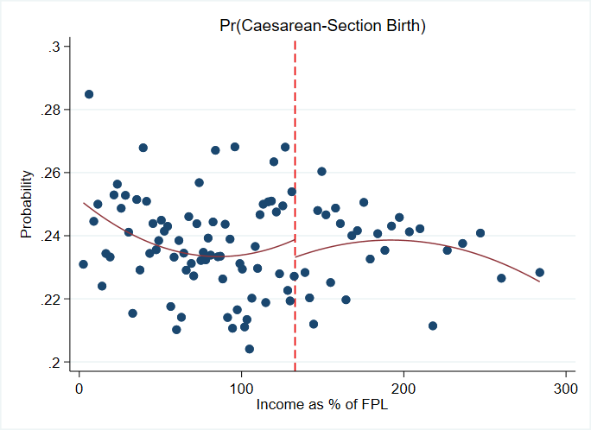

Notes: Dotted vertical line indicates 138% of the federal poverty level, the income threshold for Medicaid eligibility for low-income adults in Colorado. Each dot represents a binned average of values along the income distribution; each bin includes 2,732 births on average. Red line indicates quadratic curves fit through average points, potentially differing on either side of the cutoff.

**Appendix 4. Regression Discontinuity Design Specifications**

We used the two regression specifications across our various outcomes: a parametric approach using the full income sample and a local, polynomial approach within a narrow, “optimal” bandwidth.

*Parametric RDD.* We implemented a parametric regression discontinuity model as our primary specification. This approach uses the full range of available incomes in our sample (recentered around the cutoff of 138% FPL). These equations took the form:

Where is the outcome variable of interest, is a dummy variable indicating treatment (income greater than the cutoff), and represents the selected functional form used to approximate the nonlinear relationship between the rating variable (income) and the outcome variable. In this specification, represents the treatment effect. The matrix includes demographic covariates presented in Table 1.

We estimated a series of functional forms for , including polynomials up to order 3 that differed on either side of the income threshold. Our preferred specification used two second-order polynomials, estimated as:

*Local Polynomial RDD.* As an alternative specification, we used nonparametric estimation of the local polynomial regression discontinuity treatment effect within a data-driven bandwidth, *h*. We used a local polynomial model as this estimation strategy has been shown to produce more accurate confidence intervals compared to alternative specifications in the regression discontinuity literature.(5) We identified *h* independently for each regression equation using the “rdrobust” package in Stata.(6) The estimating equation for the sample contained within *h* is given by:

Where is the outcome variable of interest, is a dummy variable indicating treatment (income greater than the cutoff), and represents the selected functional form used to approximate the nonlinear relationship between the rating variable (income) and the outcome variable on either side of the cutoff. In our preferred specification, and are fourth-order polynomials. Observations within the bandwidth are weighted according to their proximity to the bandwidth, with those closer to the cutoff weighted more heavily than observations farther from the cutoff. Throughout, we report the robust bias-corrected confidence intervals for each estimation.

**Appendix 5. Comparison of Estimation Strategies for Regression Discontinuity Design**

Table A5.1. Comparison of Strategies for Estimating Effect of Postpartum Medicaid Eligibility on Type of Insurance Coverage and Continuity of Enrollment during the Postpartum Year

|  |  |  |  |  |
| --- | --- | --- | --- | --- |
| Outcome | Local Polynomial RD | Linear Interaction RD | **Quadratic Interaction RD** | Cubic Interaction RD |
| **Type of Enrollment** |  |  |  |  |
| Any Commercial | 0.02* [0.00,0.03] | 0.03*** [0.02,0.04] | **0.02*** [0.01,0.03]** | 0.02* [0.00,0.03] |
| Any Marketplace | 0.02*** [0.01,0.03] | 0.04*** [0.03,0.04] | **0.02*** [0.02,0.03]** | 0.02*** [0.01,0.03] |
| Only Medicaid | -0.04*** [-0.06,-0.03] | -0.06*** [-0.07,-0.05] | **-0.04*** [-0.06,-0.03]** | -0.04*** [-0.06,-0.02] |
|  |  |  |  |  |
| **Continuity of Coverage** |  |  |  |  |
| Mean enrollment duration (months) | -1.27*** [-1.58,-0.96] | -1.36*** [-1.48,-1.25] | **-1.54*** [-1.69,-1.39]** | -1.35*** [-1.55,-1.14] |
| Probability of Coverage Disruption (gap or switch) | 0.06*** [0.03,0.09] | 0.16*** [0.15,0.17] | **0.12*** [0.10,0.13]** | 0.09*** [0.07,0.11] |
| Mean number of coverage disruptions (gap or switch) | 0.05** [0.02,0.08] | 0.33*** [0.30,0.36] | **0.22*** [0.18,0.26]** | 0.16** [0.11,0.21] |
| Mean number of coverage gaps | 0.02*** [0.01,0.03] | 0.03*** [0.02,0.03] | **0.02*** [0.01,0.02]** | 0.01* [0.00,0.02] |
| Mean duration of coverage gaps (months) | 0.07** [0.02,0.12] | 0.13*** [0.10,0.16] | **0.08*** [0.04,0.11]** | 0.06* [0.01,0.11] |
| Mean number of coverage switches | 0.04** [0.01,0.06] | 0.07*** [0.06,0.09] | **0.04*** [0.02,0.06]** | 0.03* [0.01,0.06] |
| Probability of any coverage switch | 0.04*** [0.03,0.06] | 0.06*** [0.05,0.07] | **0.04*** [0.03,0.06]** | 0.04*** [0.02,0.05] |
| Probability of any coverage gap | 0.01** [0.00,0.02] | 0.03*** [0.02,0.03] | **0.02*** [0.01,0.02]** | 0.01* [0.00,0.02] |

Notes: 95% confidence intervals are shown below regression coefficients in brackets. Preferred specification shown in bold. Triangular kernel weights are used in regressions. * *p* < 0.05; ** *p* < 0.01; *** *p* < 0.001.

**Appendix 6. Scatter Plots for Other Continuity of Coverage Outcomes**

Figure A6.1. Probability of Any Commercial Insurance Enrollment during the Postpartum Year by Income as a Percentage of the Federal Poverty Level (FPL)

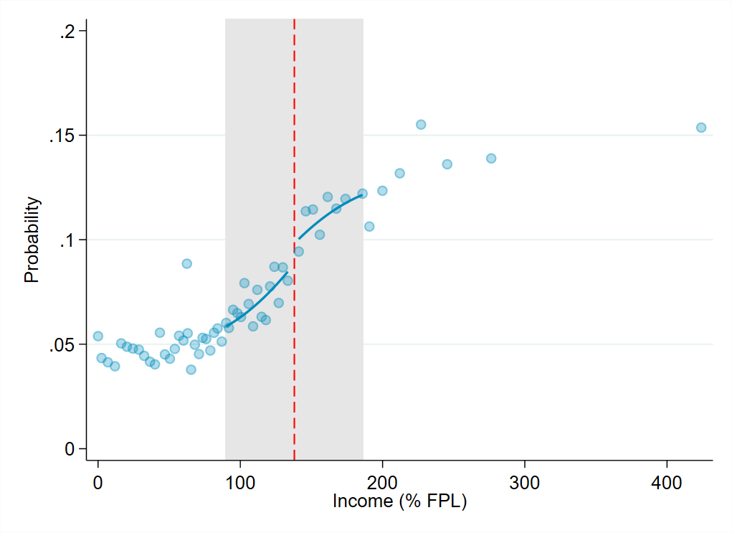

Notes: Dashed vertical line indicates 138% of the federal poverty level, the income threshold for Medicaid eligibility for low-income adults in Colorado. Each dot represents a binned average of values along the income distribution; each bin includes 2,732 births on average. Shaded region indicates data-driven optimal bandwidth selected to minimize bias of the local polynomial regression discontinuity estimator, which is plotted as the blue curve.

Figure A6.2. Average Number of Insurance Coverage Disruptions during the Postpartum Year by Income as a Percentage of the Federal Poverty Level (FPL)

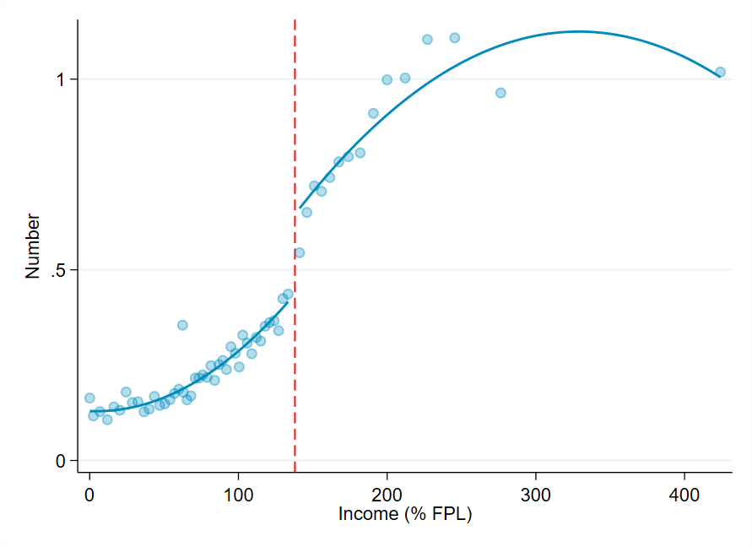

Notes: Dashed vertical line indicates 138% of the federal poverty level, the income threshold for Medicaid eligibility for low-income adults in Colorado. Each dot represents a binned average of values along the income distribution; each bin includes 2,732 births on average. Shaded region indicates data-driven optimal bandwidth selected to minimize bias of the local polynomial regression discontinuity estimator, which is plotted as the blue curve.

Figure A6.3. Average Number of Insurance Coverage Gaps during the Postpartum Year by Income as a Percentage of the Federal Poverty Level (FPL)

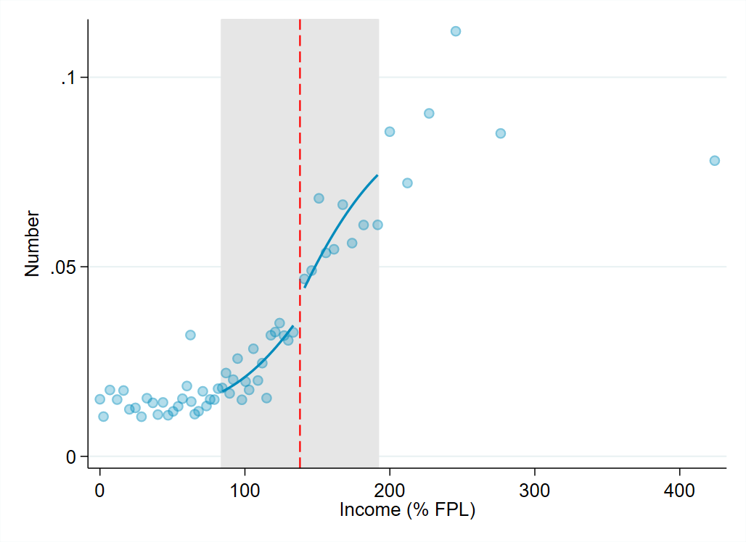

Notes: Dashed vertical line indicates 138% of the federal poverty level, the income threshold for Medicaid eligibility for low-income adults in Colorado. Each dot represents a binned average of values along the income distribution; each bin includes 2,732 births on average. Shaded region indicates data-driven optimal bandwidth selected to minimize bias of the local polynomial regression discontinuity estimator, which is plotted as the blue curve.

Figure A6.4. Average Duration of Insurance Coverage Gaps during the Postpartum Year by Income as a Percentage of the Federal Poverty Level (FPL)

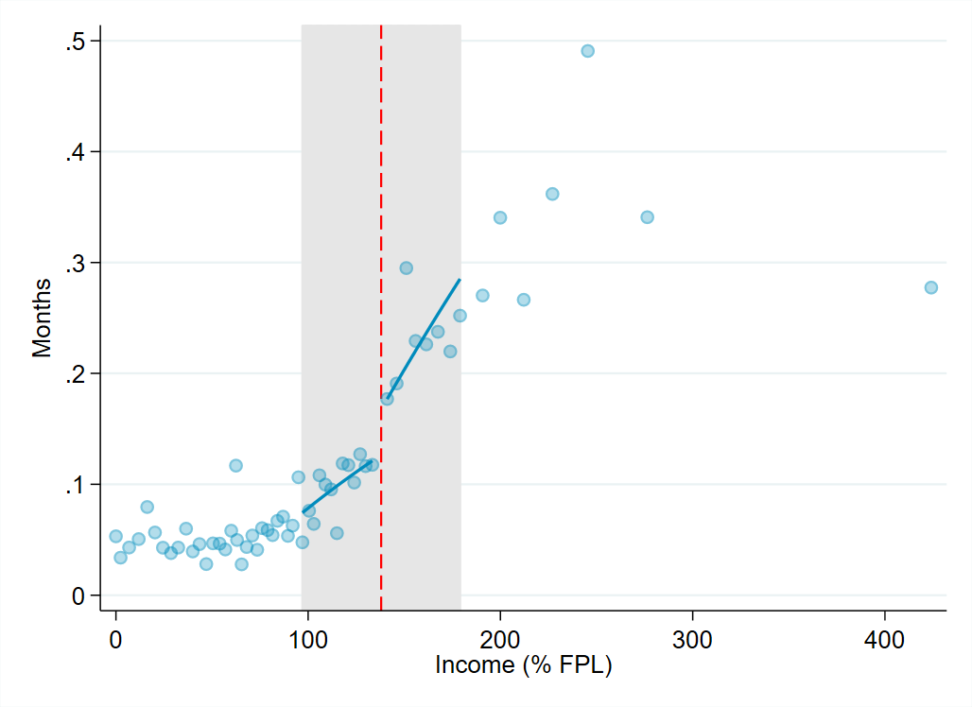

Notes: Dashed vertical line indicates 138% of the federal poverty level, the income threshold for Medicaid eligibility for low-income adults in Colorado. Each dot represents a binned average of values along the income distribution; each bin includes 2,732 births on average. Shaded region indicates data-driven optimal bandwidth selected to minimize bias of the local polynomial regression discontinuity estimator, which is plotted as the blue curve.

Figure A6.5. Average Number of Insurance Coverage Switches during the Postpartum Year by Income as a Percentage of the Federal Poverty Level (FPL)

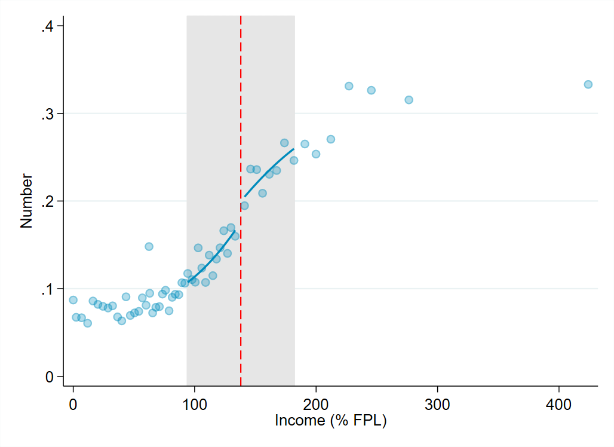

Notes: Dashed vertical line indicates 138% of the federal poverty level, the income threshold for Medicaid eligibility for low-income adults in Colorado. Each dot represents a binned average of values along the income distribution; each bin includes 2,732 births on average. Shaded region indicates data-driven optimal bandwidth selected to minimize bias of the local polynomial regression discontinuity estimator, which is plotted as the blue curve.

Figure A6.6. Probability of Any Insurance Coverage Switch during the Postpartum Year by Income as a Percentage of the Federal Poverty Level (FPL)

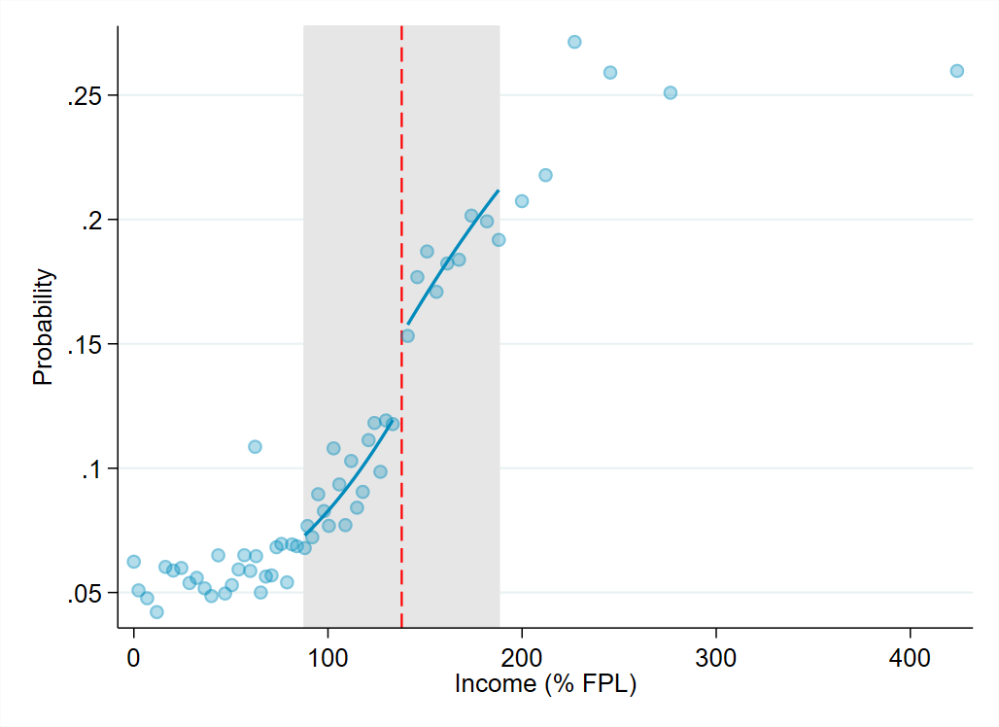

Notes: Dashed vertical line indicates 138% of the federal poverty level, the income threshold for Medicaid eligibility for low-income adults in Colorado. Each dot represents a binned average of values along the income distribution; each bin includes 2,732 births on average. Shaded region indicates data-driven optimal bandwidth selected to minimize bias of the local polynomial regression discontinuity estimator, which is plotted as the blue curve.

Figure A6.6. Probability of Any Insurance Coverage Gap during the Postpartum Year by Income as a Percentage of the Federal Poverty Level (FPL)

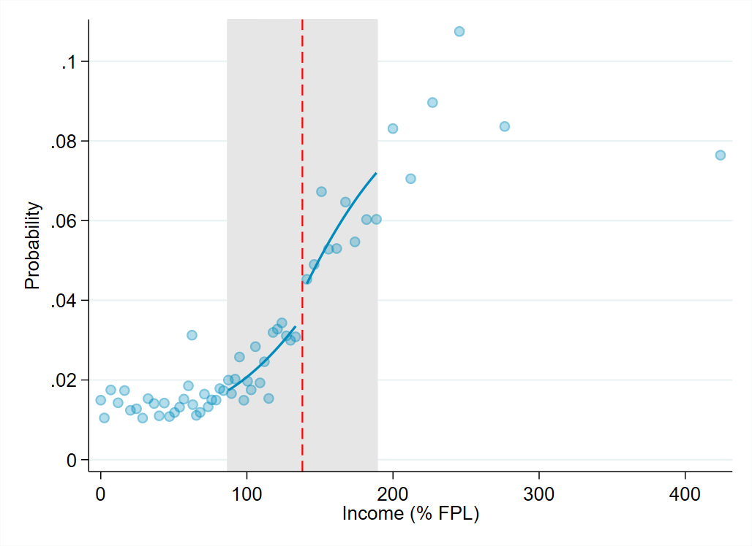

Notes: Dashed vertical line indicates 138% of the federal poverty level, the income threshold for Medicaid eligibility for low-income adults in Colorado. Each dot represents a binned average of values along the income distribution; each bin includes 2,732 births on average. Shaded region indicates data-driven optimal bandwidth selected to minimize bias of the local polynomial regression discontinuity estimator, which is plotted as the blue curve.

**Appendix 7. Placebo Tests**

Table A7.1. Falsified Treatment Effects of Postpartum Medicaid Eligibility on Type of Insurance Coverage and Continuity of Enrollment during the Postpartum Year

|  |  |  |  |
| --- | --- | --- | --- |
| Outcome | 138% FPL (true effect) | 90% FPL | 200% FPL |
| **Type of Enrollment** |  |  |  |
| Any Commercial | 0.02* [0.00,0.03] | 0.01 [-0.00,0.02] | 0.00 [-0.02,0.03] |
| Any Marketplace | 0.02*** [0.01,0.03] | -0.00 [-0.01,0.01] | -0.01 [-0.03,0.02] |
| Only Medicaid | -0.04*** [-0.06,-0.03] | -0.01 [-0.03,0.00] | 0.02 [-0.02,0.05] |
|  |  |  |  |
| **Continuity of Coverage** |  |  |  |
| Mean enrollment duration (months) | -1.27*** [-1.58,-0.96] | -0.17 [-0.46,0.12] | -0.03 [-0.45,0.40] |
| Probability of Coverage Disruption (gap or switch) | 0.06*** [0.03,0.09] | 0.01 [-0.01,0.03] | -0.00 [-0.05,0.04] |
| Mean number of coverage disruptions (gap or switch) | 0.05** [0.02,0.08] | 0.01 [-0.01,0.04] | -0.02 [-0.08,0.04] |
| Mean number of coverage gaps | 0.02*** [0.01,0.03] | 0.00 [-0.01,0.01] | 0.01 [-0.02,0.03] |
| Mean duration of coverage gaps (months) | 0.07** [0.02,0.12] | 0.01 [-0.02,0.04] | -0.04 [-0.14,0.06] |
| Mean number of coverage switches | 0.04** [0.01,0.06] | 0.02 [-0.01,0.04] | -0.03 [-0.08,0.02] |
| Probability of any coverage switch | 0.04*** [0.03,0.06] | 0.01 [-0.00,0.03] | -0.01 [-0.05,0.02] |
| Probability of any coverage gap | 0.01** [0.00,0.02] | 0.00 [-0.01,0.01] | 0.00 [-0.02,0.02] |

Notes: Throughout, regression results based on the local polynomial regression approach are presented. 95% confidence intervals are shown below regression coefficients in brackets. * *p* < 0.05; ** *p* < 0.01; *** *p* < 0.001.

**Appendix 8. Sensitivity Analysis Results Excluding those Enrolled in Medicaid for Delivery Month Only as Proxy for Emergency Medicaid Status**

Table A8.1. Comparison of Results Excluding those Enrolled in Medicaid for Delivery Month Only and Mothers Born Outside of U.S. as Proxies for Emergency Medicaid Status

|  |  |  |  |
| --- | --- | --- | --- |
| Outcome | Full Sample (N=130,029) | Excluding Births Enrolled in Medicaid for Delivery Month Only  (N=118,198) | Excluding Mothers Born Outside of U.S.  (N=94,879) |
| **Type of Enrollment** |  |  |  |
| Any Commercial | 0.02* [0.00,0.03] | 0.02* [0.00,0.03] | 0.02*  [0.00,0.04] |
| Any Marketplace | 0.02*** [0.01,0.03] | 0.03*** [0.01,0.04] | 0.03***  [0.02,0.05] |
| Only Medicaid | -0.04*** [-0.06,-0.03] | -0.05*** [-0.07,-0.03] | -0.06***  [-0.09,-0.04] |
|  |  |  |  |
| **Continuity of Coverage** |  |  |  |
| Mean enrollment duration (months) | -1.26*** [-1.58,-0.95] | -0.92*** [-1.14,-0.70] | -0.64***  [-0.91,-0.36] |
| Probability of Coverage Disruption (gap or switch) | 0.06*** [0.03,0.09] | 0.08*** [0.05,0.11] | 0.07***  [0.04,0.11] |
| Mean number of coverage disruptions (gap or switch) | 0.05** [0.02,0.08] | 0.06** [0.02,0.09] | 0.08***  [0.03,0.12] |
| Mean number of coverage gaps | 0.02*** [0.01,0.03] | 0.02*** [0.01,0.03] | 0.02***  [0.01,0.03] |
| Mean duration of coverage gaps (months) | 0.07** [0.02,0.12] | 0.08** [0.02,0.13] | 0.10**  [0.03,0.16] |
| Mean number of coverage switches | 0.04** [0.01,0.06] | 0.04** [0.01,0.07] | 0.05**  [0.02,0.09] |
| Probability of any coverage switch | 0.04*** [0.02,0.06] | 0.04*** [0.02,0.06] | 0.06***  [0.03,0.08] |
| Probability of any coverage gap | 0.01** [0.00,0.02] | 0.02** [0.01,0.03] | 0.02***  [0.01,0.04] |

Notes: Standard errors are shown below means in parentheses; 95% confidence intervals are shown below regression coefficients in brackets. * *p* < 0.05; ** *p* < 0.01; *** *p* < 0.001. Standard errors are clustered at the person-level.

**Appendix 9. Exclusion of Incomes Between 133-138% of the Federal Poverty Level**

Figure A9.1. Full Distribution of Incomes Assigned to Sample Births as a Percentage of the Federal Poverty Level

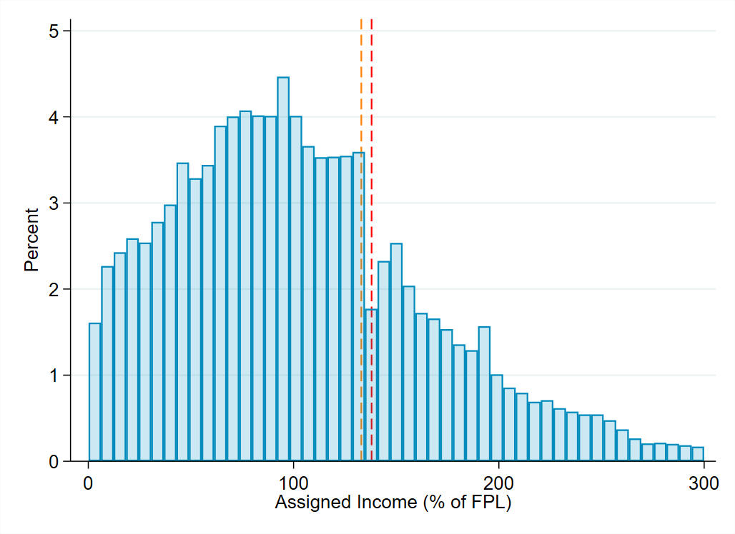

Notes: Orange dashed line indicates 133% of FPL, while red dashed line indicates 138% of FPL.

Table A9.2. Comparison of Treatment Effects by Inclusion versus Exclusion of Births to Mothers with Incomes Between 133-138% FPL

|  |  |  |  |  |  |
| --- | --- | --- | --- | --- | --- |
|  | Local Regression, Excluding 133-138% FPL | | Local Regression, Including 133-138% FPL | | Full Sample Parametric (Quadratic), Including 133-138% FPL |
| Outcome | Coefficient | Bandwidth | Coefficient | Bandwidth | Coefficient |
| **Type of Enrollment** |  |  |  |  |  |
| Any Commercial | 0.02* [0.00,0.03] | 47.945 | 0.01  [-0.00,0.03] | 34.857 | 0.02*** [0.01,0.03] |
| Any Marketplace | 0.02*** [0.01,0.03] | 38.766 | 0.03***  [0.01,0.03] | 37.737 | 0.02*** [0.02,0.03] |
| Only Medicaid | -0.04*** [-0.06,-0.03] | 49.289 | -0.04***  [-0.05,-0.02] | 37.838 | -0.04*** [-0.06,-0.03] |
|  |  |  |  |  |  |
| **Continuity of Coverage** |  |  |  |  |  |
| Mean enrollment duration (months) | -1.27*** [-1.58,-0.96] | 24.372 | -0.43*  [-0.81,-0.04] | 16.441 | -1.54*** [-1.69,-1.39] |
| Probability of Coverage Disruption (gap or switch) | 0.06***  [0.03,0.09] | 36.020 | 0.04  [-0.00,0.07] | 18.957 | 0.12*** [0.10,0.13] |
| Mean number of coverage disruptions (gap or switch) | 0.05** [0.02,0.08] | 47.426 | 0.05**  [0.02,0.08] | 36.013 | 0.22*** [0.18,0.26] |
| Mean number of coverage gaps | 0.02*** [0.01,0.03] | 53.612 | 0.01**  [0.01,0.02] | 52.486 | 0.02*** [0.01,0.02] |
| Mean duration of coverage gaps (months) | 0.07** [0.02,0.12] | 41.002 | 0.06*  [0.01,0.11] | 38.489 | 0.08*** [0.04,0.11] |
| Mean number of coverage switches | 0.04** [0.01,0.06] | 43.744 | 0.04**  [0.01,0.07] | 36.868 | 0.04*** [0.02,0.06] |
| Probability of any coverage switch | 0.04*** [0.03,0.06] | 49.984 | 0.04***  [0.02,0.06] | 36.679 | 0.04*** [0.03,0.06] |
| Probability of any coverage gap | 0.01** [0.00,0.02] | 50.658 | 0.01*  [0.00,0.02] | 39.222 | 0.02*** [0.01,0.02] |

Notes: Standard errors clustered at the mother-level are shown below means in parentheses; 95% confidence intervals are shown below regression coefficients in brackets. * *p* < 0.05; ** *p* < 0.01; *** *p* < 0.001

**Appendix 10. Additional Outcomes and Regression Information**

Table A10.1. Type of Enrollment and Other Continuity of Enrollment Outcomes the Postpartum Year by Income-Based Pregnancy-Related Medicaid Eligibility.

|  |  |  |  |  |  |
| --- | --- | --- | --- | --- | --- |
|  | Unadjusted Means by Income Category | | | Adjusting for Income and Other Covariates | |
| Outcome | <138% FPL | 139-265% FPL | Unadjusted Difference | Adjusted Difference  [95% CI] | P-Value |
| **Average Enrollment Duration, (months)** |  |  |  |  |  |
| Any coverage | 10.67  (0.011) | 8.88  (0.032) | -1.79 | -1.54****  [-1.69,-1.39] | 0.000 |
| Commercial/Marketplace | 0.46  (0.006) | 1.56  (0.025) | 1.10 | 0.47****  [0.36,0.58] | 0.000 |
| Medicaid | 10.19  (0.012) | 7.31  (0.036) | -2.88 | -2.01****  [-2.19,-1.83] | 0.000 |
| Coverage disruption, % | 11.92  (0.098) | 43.24  (0.355) | 31.32 | 11.68****  [9.98,13.38] | 0.000 |
| Coverage switch rate, % | 6.72  (0.076) | 20.64  (0.290) | 13.92 | 4.44****  [3.13,5.78] | 0.000 |
| Coverage gap rate, % | 1.66  (0.039) | 6.73  (0.180) | 5.07 | 1.61****  [0.85,2.38] | 0.000 |
| Mean number of coverage disruptions (gap or switch) | 0.20  (0.002) | 0.85  (0.009) | 0.65 | 0.22****  [0.18,0.26] | 0.000 |
| Mean duration of coverage gaps (months) | 0.06  (0.002) | 0.28  (0.009) | 0.22 | 0.08****  [0.04,0.11] | 0.000 |
|  |  |  |  |  |  |
| **Continuity of Coverage** |  |  |  |  |  |
| Mean number of coverage gaps | 0.02  (0.000) | 0.07  (0.002) | 0.05 | 0.02****  [0.01,0.02] | 0.000 |
| Mean number of coverage switches | 0.09  (0.001) | 0.26  (0.004) | 0.17 | 0.04****  [0.02,0.06] | 0.000 |
| **Type of Enrollment** |  |  |  |  |  |
| Any commercial, % | 5.52  (0.069) | 12.24  (0.235) | 6.72 | 1.91**** [0.78,3.04] | 0.001 |
| Any Marketplace, % | 1.38  (0.035) | 8.78  (0.203) | 7.40 | 2.47****  [1.63,3.31] | 0.000 |
| Only Medicaid, % | 93.21  (0.076) | 79.18  (0.291) | -14.03 | -4.45****  [-5.79,-3.11] | 0.000 |

Source: Authors’ analysis of linked all payer claims data, income, and birth records for Medicaid-financed births in Colorado from 2014-2018. Notes: Columns 1 and 2 display the mean values for continuity of coverage outcomes among women with incomes below 265% FPL. Coverage switch and gap rates do not sum to equal the total coverage disruption rate due to postpartum women who are lost to follow-up from the APCD. Adjusted differences obtained from regression discontinuity models with triangular kernel weights. *p<0.10, **p<0.05, *** p<0.01, ****p< 0.001.

1. Medical Expenditure Panel Survey (MEPS). ) Percent of private-sector enrollees that are enrolled in self-insured plans [Internet]. Agency for Healthcare Research and Quality. 2019 [cited 2021 Apr 15]. Available from: https://meps.ahrq.gov/data_stats/summ_tables/insr/national/series_1/2019/tib2b1.pdf

2. Oct 03 P, 2018. 2018 Employer Health Benefits Survey - Section 10: Plan Funding [Internet]. KFF. 2018 [cited 2021 Apr 15]. Available from: https://www.kff.org/report-section/2018-employer-health-benefits-survey-section-10-plan-funding/

3. Zollinger TW, Przybylski MJ, Gamache RE. Reliability of Indiana birth certificate data compared to medical records. Ann Epidemiol. 2006 Jan;16(1):1–10.

4. DiGiuseppe DL, Aron DC, Ranbom L, Harper DL, Rosenthal GE. Reliability of birth certificate data: a multi-hospital comparison to medical records information. Matern Child Health J. 2002 Sep;6(3):169–79.

5. Calonico S, Cattaneo MD, Titiunik R. Robust Nonparametric Confidence Intervals for Regression-Discontinuity Designs. Econometrica. 2014;82(6):2295–326.

6. Calonico S, Cattaneo MD, Farrell MH, Titiunik R. Rdrobust: Software for Regression-discontinuity Designs. The Stata Journal. 2017 Jun;17(2):372–404.