**Main panel**

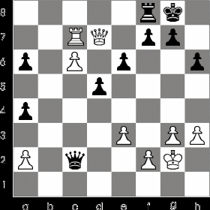

**Chess Player**

…

4.e4 e5

5.Nf3 d6

**6.d4 Bg4**

7.d4xe5 Bxf3

8.Qxf3 d6xe5

9.Bc4 Nf6

…



Prev.

Next

Stop

Play