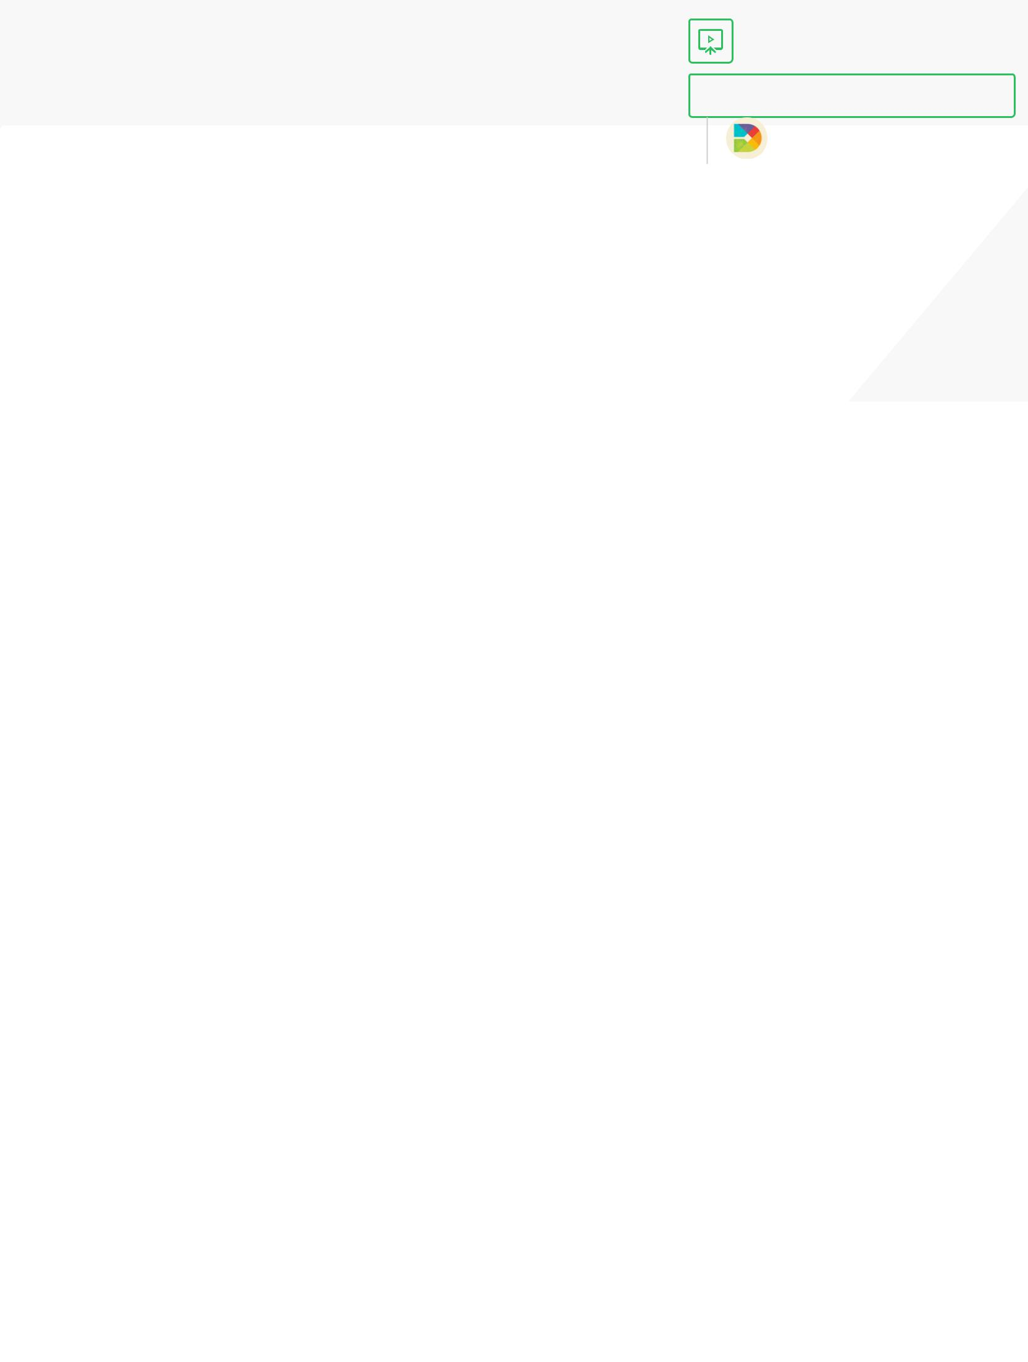

Save to Evernote

*Running BigDL (Python) on Spark on your Loca Machine*

Updated Aug 31, 2017

This tutorial will teach you how to set up BigDL on your Mac and run the MNIST digit recognition BigDL Python application.

Prerequisites:

-Mac/Linux OS

-Java latest version (if you don’t have it run: conda install java)

-Jupyter Notebook (your pyspark driver)

-Python 2.7

-scikit-learn, spicy, numpy, pandas, matplotlib (pip install these in your environment)

STEP 1: Set up your BigDL folder.

Create a new folder to store the necessary bigdl/spark requirements. We are going to put number of things in there:

1. BigDL 0.2.0 Package
2. Spark 2.1.1
3. start_notebook.sh
4. cnn.ipynb
5. utils.py

[#1: Download the built BigDL Package under Release 0.2.0, for Spark 2.1.1 here: https://big](https://www.evernote.com/OutboundRedirect.action?dest=https%3A%2F%2Fbigdl-project.github.io%2Fmaster%2F%23release-download%2F) [project.github.io/master/#release-download/. There is a version for Mac and Linux. This h](https://www.evernote.com/OutboundRedirect.action?dest=https%3A%2F%2Fbigdl-project.github.io%2Fmaster%2F%23release-download%2F) all BigDL dependencies and python files too.

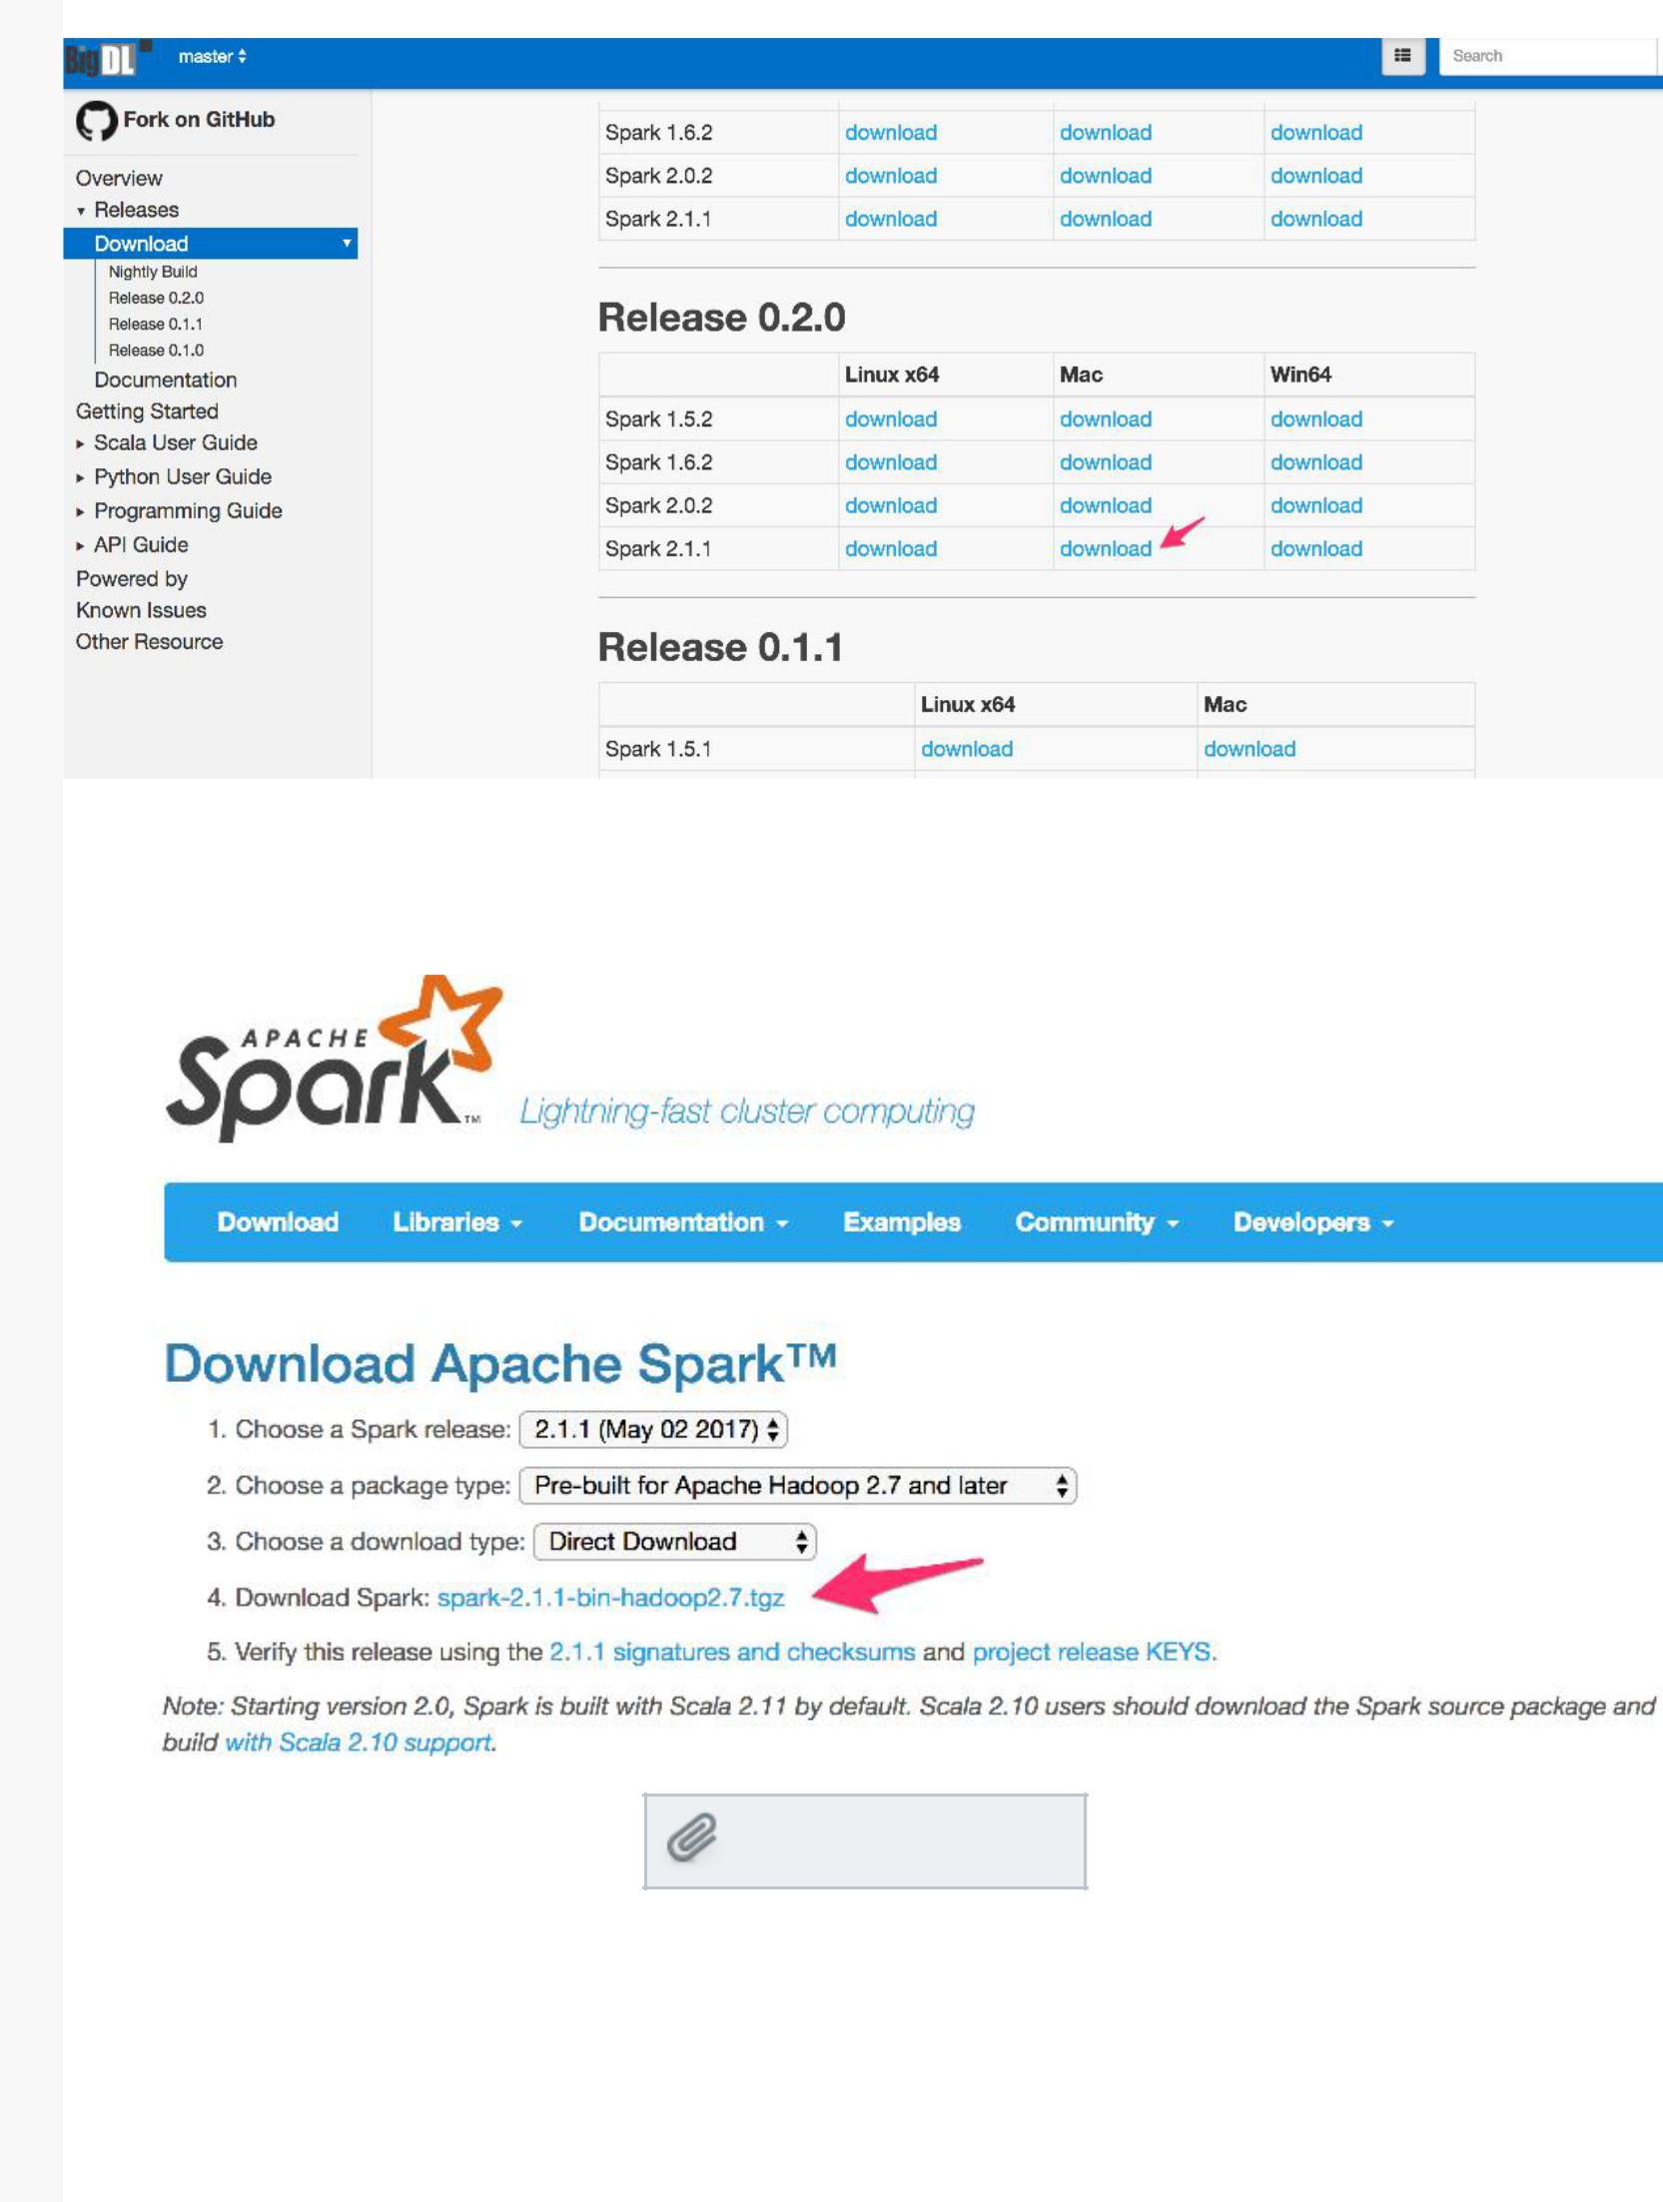

#2: Download Spark version 2.1.1 here: [https://spark.apache.org/downloads.html](https://www.evernote.com/OutboundRedirect.action?dest=https%3A%2F%2Fspark.apache.org%2Fdownloads.html) This unzip into a folder with all spark related contents.

#3: Download this starter script.

[start_notebook.sh](https://www.evernote.com/shard/s497/sh/dfc4ba20-0cbc-4c5f-a25d-d3c89a39525e/dc4c97548d75926e5c1195b517ac4be8/res/d3220e5d-a59c-402c-bca6-2c36fb0e223b/start_notebook.sh)

[912 bytes](https://www.evernote.com/shard/s497/sh/dfc4ba20-0cbc-4c5f-a25d-d3c89a39525e/dc4c97548d75926e5c1195b517ac4be8/res/d3220e5d-a59c-402c-bca6-2c36fb0e223b/start_notebook.sh)

Note: Remember to change <path to folder you created> after the SPARK_HOME and BigDL_HOME environment variables to the absolute path to your bigdl folder you just created. This is the script that you will run to start a spark session and use BigDL. It sets t correct parameters and environment for your spark session to run BigDL applications.

#4: Download cnn.ipynb here.

[cnn.ipynb](https://www.evernote.com/shard/s497/sh/dfc4ba20-0cbc-4c5f-a25d-d3c89a39525e/dc4c97548d75926e5c1195b517ac4be8/res/5b32491e-6f74-4d44-b5d1-50875f59dfa4/cnn.ipynb)

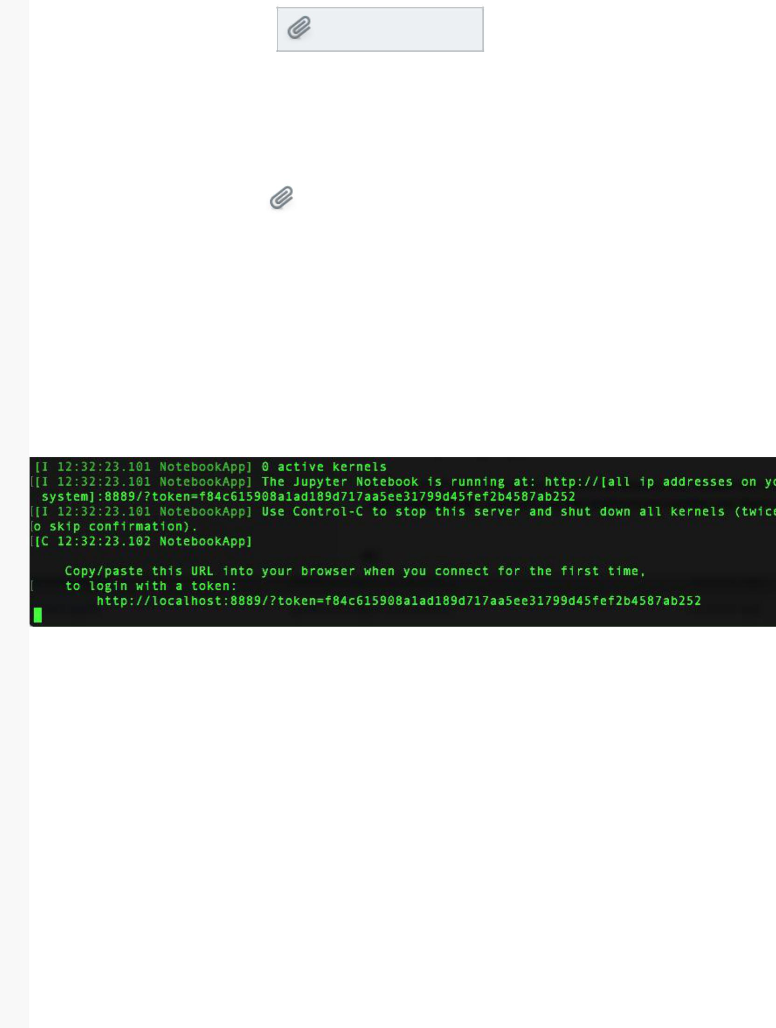

[132.7 KB](https://www.evernote.com/shard/s497/sh/dfc4ba20-0cbc-4c5f-a25d-d3c89a39525e/dc4c97548d75926e5c1195b517ac4be8/res/5b32491e-6f74-4d44-b5d1-50875f59dfa4/cnn.ipynb)

Note: There are more example notebooks in BigDL’s tutorial repository. Feel free to clone [and download these example notebooks here: https://github.com/intel-analytics/BigDL-Tutorials/tree/branch-0.2/notebooks/neural_networks](https://www.evernote.com/OutboundRedirect.action?dest=https%3A%2F%2Fgithub.com%2Fintel-analytics%2FBigDL-Tutorials%2Ftree%2Fbranch-0.2%2Fnotebooks%2Fneural_networks)

|  |  |  |
| --- | --- | --- |
| #5: Download utils.py here. | [utils.py](https://www.evernote.com/shard/s497/sh/dfc4ba20-0cbc-4c5f-a25d-d3c89a39525e/dc4c97548d75926e5c1195b517ac4be8/res/35d717a5-34b4-4fa4-8c68-1eec98d41d5e/utils.py) |  |
| [1.2 KB](https://www.evernote.com/shard/s497/sh/dfc4ba20-0cbc-4c5f-a25d-d3c89a39525e/dc4c97548d75926e5c1195b517ac4be8/res/35d717a5-34b4-4fa4-8c68-1eec98d41d5e/utils.py) |  |

#6 Verify that all items listed above are in your bigdl folder. You are ready to run your application now.

STEP 2: Run your BigDL application

#1: On your terminal, make sure you are in the directory you created and run the command ./start_notebook.sh. This starts Jupyter Notebook and creates your Spark Context (sc).

#2: Copy and Paste the URL into your browser to start Jupyter Notebook.

Note: If you need to, change the access permission of start_notebook.sh script using this

command: chmod +x <your path>/start_notebook.sh

#3: Run cnn.ipynb file in Jupyter Notebooks using a kernel that runs Python 2.7. It should match the output on the BigDL tutorials.

Note: If your default kernel in Jupyter Notebook is Python 3, you have to change it to Python 2. You can create a virtual environment that uses Python 2.7 by following this guid [https://uoa-eresearch.github.io/eresearch-cookbook/recipe/2014/11/20/conda/](https://www.evernote.com/OutboundRedirect.action?dest=https%3A%2F%2Fuoa-eresearch.github.io%2Feresearch-cookbook%2Frecipe%2F2014%2F11%2F20%2Fconda%2F)

Note: You can only run one .ipynb at a time because you have only one spark session, remember to shutdown the rest. Also make sure your kernel is running Python 2 (Python 3 is still being tested).

Thats it!



Add a save button to the internet

[Get Web Clipper](https://evernote.com/webclipper/)

|  |  |
| --- | --- |
| [Terms of Service](https://evernote.com/tos/) | [Privacy Policy](https://evernote.com/privacy/) |