Distribution and loss of slow-release polymer coatings in an agro-ecosystem
Alexander J Koiter
Aaron Glenn
Cameron Beaupre
Henry Wilson
Abstract
Abstract goes here

1 Potential journals
- Soil and Tillage Research
  - A Short Communication is a concise but complete description of a limited investigation, which will not be included in a later paper. Short Communications should be as completely documented, both by reference to the literature and description of the experimental procedures employed, as a regular paper. They should not occupy more than 6 printed pages (about 12 manuscript pages, including figures, tables and references).
  - Pretty sure BU has a publishing agreement so it should be free to publish

2 Introduction
Plastics are extensively used in all aspects of life, including residential, commercial, industrial, agricultural and institutional sectors. Through improper disposal, accidental and incidental releases, and intentional placement, plastics have become a widespread pollutant found in every ecosystem. This has resulted in global concern surrounding the effects of plastic pollution on ecosystem and human health (Zhang et al. 2022). Of particular concern, are micro-plastics (MPs) (<5mm) due to their movement and health impacts within the food chain and their rapid dispersion beyond their initial point of release. Despite the ubiquitous distribution of MP pollution across all ecosystem types, the focus has primarily been on marine and freshwater ecosystems (Anderson et al. 2017; Lenaker, Corsi, and Mason 2021) and with an emphasis on urban and industrial sources. A 2021 survey of the plastic pollution literature found that only 4% of publications specifically investigated MPs in soils (Weber et al. 2021). Agriculture and soil have received relatively less attention despite the prevalent use of plastics, including horticultural mulch, twine, bale wrap, product bags and containers, and polymer-coated slow-release fertilizers (Rillig, Ingraffia, and Souza Machado 2017).
There is currently little information on the concentration, distribution, or the types of plastic in agricultural soil, the effect they have on soil and plant health and the extent as to which agro-ecosytems are a net source of MPs to downstream ecosystems. Even within agriculture and soil science disciplines, the focus has largely been on assessing the risks associated with applying municipal biosolids as a soil amendment which have been shown to have higher concentrations of MPs (Crossman et al. 2020). There is a considerable gap in our understanding of nature of MPs in soils both in terms of the direct impact on the agro-ecosystem health and as a source of MPs to downstream ecosystems.
Soil erosion, including tillage and surface water runoff actively redistribute MPs across agricultural landscapes (Rehm and Fiener 2024; Wang et al. 2024). Due to their low density, these buoyant particles are easily transported beyond field boundaries into adjacent environments making agricultural soils a likely source of MPs (Leonard, Ravi, and Mohanty 2024). Given the lack of basic research on agricultural soil MPs, specifically in cold snowmelt dominated agricultural systems, this is a high-priority research area ((Environment, Climate Change Canada, and Health Canada 2020). The primary purpose of this pilot project was to investigate the fate of polymer coatings from slow-release fertilizers applied to agro-ecosystems in Manitoba, Canada. The objectives of this project were to: 1) characterize the lateral and vertical movement of polymer coatings within surface soils; and 2) quantify the export of polymer coatings from cropland in surface runoff during spring snowmelt.

3 Methods

3.1 Site description
The study site is located near the edge of the Manitoba Escarpment in the South Tobacco Creek Watershed (STCW), near the town of Miami, Manitoba, Canada (49.3711°N, 98.2439°W; 445 masl) (Figure 1). The mean annual temperature is ~4 °C, and the mean annual precipitation is ~530 mm, of which approximately 15% occurs as snow (Environment Canada, 2026; Morden MB, climate ID 5021849, 1991–2020 normals). The topography is hummocky to undulating, with slope gradients of approximately 5%. Soils are classified as Orthic Dark Grey Chernozems, predominantly of the Dezwood Series. The Dezwood Series developed on moderately to strongly calcareous, deep, uniform, loamy mixed shale, limestone, and granite till deposits. These soils are often slightly eroded and slightly stony, with medium available water-holding capacity, medium organic matter content, and medium to high natural fertility (Michalyna, Podolsky, and St. Jacques 1988).
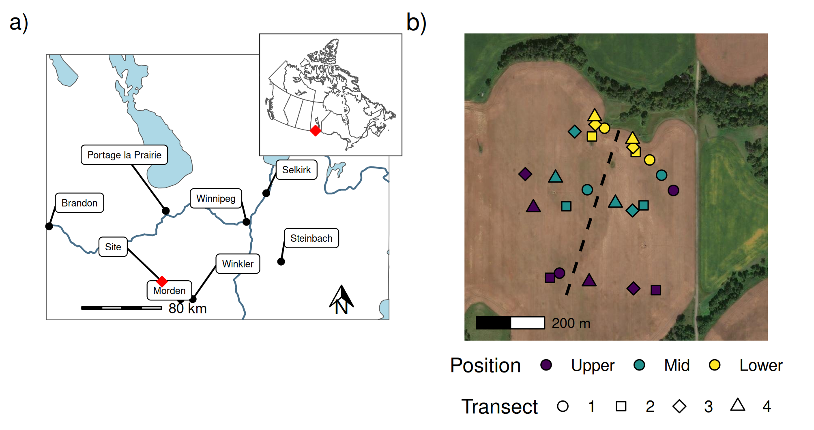
Figure 1: Showing a) the location of the study site in southern Manitoba with an inset map of Canada; and b) the locations of the four transects and three slope positions sampled in the East and West watersheds as separted by the dashed line.
_{Source: 01 Map of study area}
The STCW has a long history of being part of a national program aimed at assessing the economic and water quality impacts of different agricultural practices across Canada (Agriculture and Agri-Food Canada 2011). Within the STCW the research site comprises two small paired watersheds that drain to edge-of-field weirs: the east watershed (5.15 ha) and the west watershed (4.16 ha). Historically, these watersheds were used to compare runoff and nutrient loading from zero-tillage and conventionally tilled fields (Tiessen et al. 2010). Both watersheds are now managed under the same practices. Polymer-coated urea (Environmental Smart Nitrogen) was broadcast applied at a rate of 110 kg ha⁻¹ on 2022-05-24 using a spin spreader and incorporated into the surface soil with the seeding of canola on 2022- 05-25 using an air hoe drill. Following canola harvest, the field was tilled to a depth of 10 to 15 cm using a field cultivator on 2022-10-29. A conventional fertilizer blend was applied in the spring of 2023 and incorporated into the soil with a single pass of the field cultivator prior to the seeding of spring wheat using the air hoe drill on 2023-05-11 (Figure 2). ESN’s polymer coating is primarily composed of castor oil and polymethylene polyphenylene isocyanate (PPI), is reported to degrade over approximately 18-24 months in soil, yielding CO₂, NH₃, and water (Nutrien, 2018; ESN, 2023).
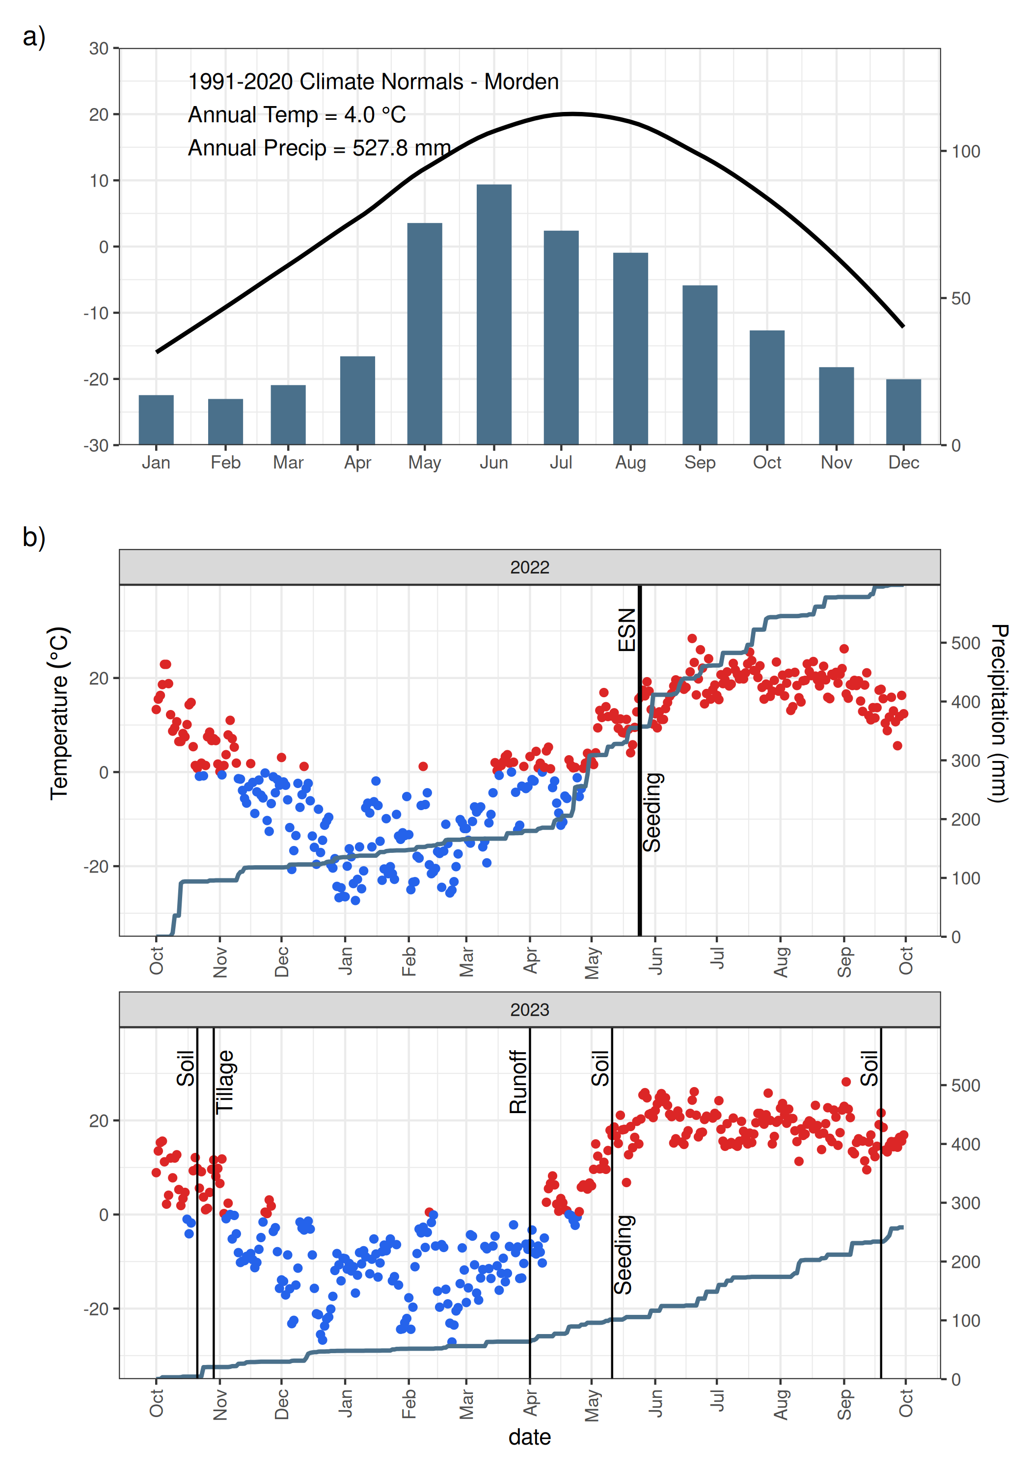
Figure 2: a) Climate Normals (1991-2020) for Morden, MB (Climate ID 5021849), located approximately 30 km from the field site. b) Weather conditions for the 2022 and 2023 water years (Oct 1 - Sept 30) for Deerwood, MB (Station ID 29886), located approximately 8 km from the field site. Vertical lines indicate the timing of (1) application of Environmental Smart Nitrogen (ESN) (polymer-coated slow-release urea); (2) seeding and tillage field operations; and (3) collection of soil and runoff samples. Red and blue points indicate average daily temperatures above and below 0 degrees Celsius, respectively.
_{Source: 02 Climate and weather}

3.2 Soil sampling and analysis
Soil sampling was conducted at locations established in previous research (Tiessen et al. 2010) along four transects in each of the watersheds, with each transect spanning three hillslope positions: upper, mid, and lower slope (Figure 1), giving 24 sampling locations in total. Samples were collected on three dates: 21 October 2022, 11 May 2023, and 19 September 2023 (Figure 2). Surface soil samples were excavated with a spade from a 25 cm × 25 cm square to a depth of 5 cm, yielding a sample volume of 3125 cm³. On 19 September 2023, an additional sample was collected at each location from the 5–10 cm depth interval. Two additional surface riparian samples were also collected from each watershed on this date.
Soil samples were disaggregated by hand into smaller aggregates and air-dried. Each sample was further manually disaggregated and sieved sequentially through 2-mm and 1.18-mm meshes. Polymer coatings were retrieved from the sieves using tweezers. The extracted coatings were cleaned by magnetic stirring in distilled water for 10 minutes at 500 rpm, then filtered and dried at 30 °C. The cleaned and dried polymer coatings were counted and collectively weighed using a balance with 0.1 mg resolution.

3.3 Runoff and water sampling
A v-notched weir was installed in the riparian area at the outflow of each watershed. The water depth at the weirs was recorded water depth at 5-min intervals using a pressure transducer (Onset HOBO Water Level Data Logger). The water depth were then used to calculate flow, based on a standard v-notched weir flow equation (Smith, 1985). Throughout the runoff event, staff gauges read manually and from time-lapse photography were used to verify the logger-collected water depth data. Measurement of polymer coatings exported by surface runoff occurred on 2023-04-13, and 2023-04-14. The weir filters were applied to each weir for a maximum duration of two hours each day and switched twice a day for a total of four measurement periods at each weir over the 2-day runoff event. Polymer coatings were collected using a simple filtration system consisting of 1-mm screening was across the upstream side of the v notch Polymers coatings were extracted from the screens using tweezers. The Polymers coatings were dried at 30° C, counted and weighed. An incremental volume of water was calculated based on the flow rate over a set interval time of 15 minutes. The total estimated number of polymer coatings was extrapolated from periodic measurements by multiplying the total accumulated volume of water by the volume-weighted mean concentration of polymer coatings. Polymer coating concentration was assumed to be independent of discharge.
$$PC=V×\frac{\sum_{i=1}^{n}{P}C_{i}}{\sum_{i=1}^{n}{V_{i}}} \left(1\right)$$
where $PC$ is the total estimated number of polymer coatings over the monitoring period, $V$ is the total accumulated volume of water over the monitoring period (m³), $PC_{i}$ is the number of polymer coatings counted during measurement period $i$, $V_{i}$ is the volume of water that passed during measurement period $i$ (m³), and $n$ is the number of measurement periods.

3.4 Statistical analysis
All statistical analysis, plotting, and mapping were undertaken using the R Statistical Software (v4.5.3); R Core Team (2026)), through the RStudio Integrated Development Environment (v2026.05.1; (RStudio 2026) ). All plots and maps were created using the R package ggplot2 (v4.0.3; Wickham (2016)). Country and regional maps were created using data from the rnaturalearth package (Massicotte and South 2023) and other maps using ESRI imagery and the OpenStreetMap package (Fellows and JMapViewer library by Jan Peter Stotz 2023) . Weather data and climate normal data was retrieved from ECCC using weathercan package (v1.0.0; E. LaZerte and Albers (2018)). Four Linear Mixed Models (R package glmmTMB v1.1.14; Brooks et al. (2017)) were used to investigate the effect of hillslope position and sampling date (including interaction) on the abundance (number of coatings) and areal density (mass of polymer per unit area). Sample location was included as a random factor to control for the repeated measures over time.

4 Results and Discussion

4.1 In-field abundance and distribution
In the statistical model investigating polymer abundance, the estimated variance for the random factor of sampling location was effectively zero, and this factor was removed from the model. No significant interaction between sampling date and hillslope position was detected for the abundance or density of polymer coatings in the 0-5 cm layer. Both slope position and sampling date had a significant effect (p < 0.05) on the abundance and density of polymer coatings (Figure 3). Post-hoc pairwise comparisons showed that lower slope positions had significantly higher abundance, exceeding the upper positions by 112 and the mid positions by 94 coatings (Figure 3 and Table 1). Density followed a similar pattern, with the lower slope exceeding the upper positions by 0.12 g m⁻² and the mid positions by 0.09 g m⁻² (Figure 3 and Table 2).
The downslope increase in polymer quantities could relate to movement via overland flow, as the buoyant nature of the coatings makes them easy to transport. Tillage erosion may also move coatings downslope with the soil. The overall reduction in polymer in surface soils over time may result from loss beyond the field boundary through overland flow. However, vertical movement below 5 cm likely accounts for much of this loss in surface MPs over time, as field operations including seeding and tillage mix the plow layer, resulting in downward movement despite surface application. This is supported by data showing similar polymer abundance and areal densities in both the 0-5 and 5-10 cm sampling depths (Figure 4). Lastly, the reduction in polymer density may also be attributed to decomposition of the polymer over time. The relatively small loss also suggests that the polymer coatings may be more persistent beyonf 24 months in the soil environment and repeat applications of polymer coated fertilizers are likely to lead to accumulation of coatings.
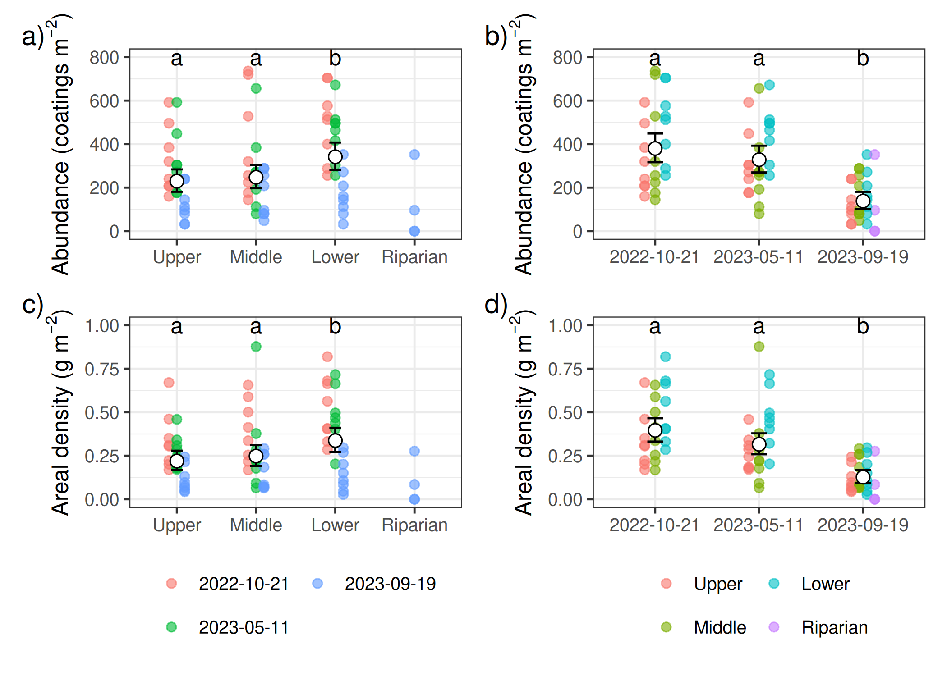
Figure 3: Surface (0-5 cm) polymer areal density (a and b) and abundance (c and d) by elevation and date. Points show raw observations; Points outlined in black and error bars show model predictions with 95% CIs from a model fitted to square-root transformed data, back-transformed to the original scale. Within each plot significant differences (p<0.05) between slope position or sampling dates are denoted with different letters. Because the riparian area had fewer sampling locations and was only sampled on 2023-09-19 it was excluded from the statistical analysis
_{Source: 03 Soil sampling}
Table 1: Results of the post-hoc pairwise comparisons with a Benjamini-Hochberg p value adjustment for differences in the abundance of polymer coatings ($coatings m^{−2}$) between the three slope poistions and sampling dates. Data were square-root transformed prior to analysis and back-transformed to the original scale for reporting.
Contrast | Estimate | SE | df | t ratio | p value
Slope Position
Upper - Middle | −18.06 | 37.07 | 66 | −0.49 | 0.628
Upper - Lower | −112.16 | 40.57 | 66 | −2.76 | 0.022
Middle - Lower | −94.10 | 41.20 | 66 | −2.28 | 0.038
Sampling Date
2022-10-21 - 2023-05-11 | 51.48 | 45.17 | 66 | 1.14 | 0.259
2022-10-21 - 2023-09-19 | 241.72 | 38.63 | 66 | 6.26 | <0.001
2023-05-11 - 2023-09-19 | 190.24 | 36.66 | 66 | 5.19 | <0.001

_{Source: 03 Soil sampling}
Table 2: Results of the post-hoc pairwise comparisons with a Benjamini-Hochberg p value adjustment for differences in the mass of polymer coatings ($g m^{−2}$) between the three slope poistions and sampling dates. Data were square-root transformed prior to analysis and back-transformed to the original scale for reporting.
Contrast | Estimate | SE | z ratio | p value
Slope Position
Upper - Middle | −0.03 | 0.04 | −0.69 | 0.492
Upper - Lower | −0.12 | 0.05 | −2.59 | 0.029
Middle - Lower | −0.09 | 0.05 | −1.91 | 0.083
Sampling Date
2022-10-21 - 2023-05-11 | 0.08 | 0.04 | 1.86 | 0.062
2022-10-21 - 2023-09-19 | 0.27 | 0.04 | 7.23 | <0.001
2023-05-11 - 2023-09-19 | 0.19 | 0.03 | 5.53 | <0.001

_{Source: 03 Soil sampling}
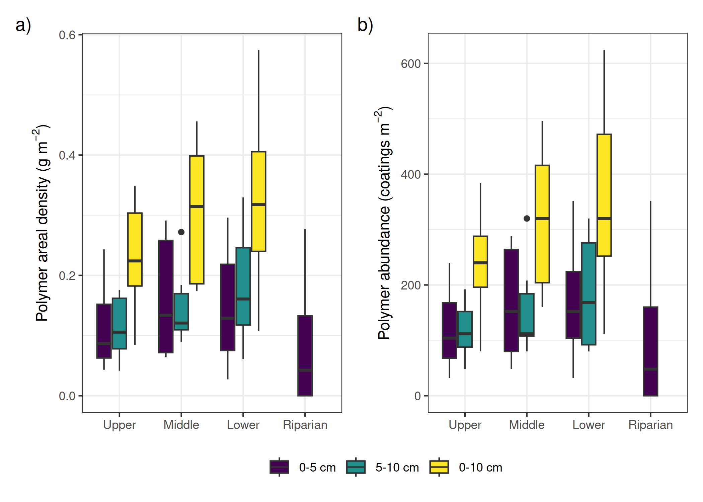
Figure 4: Polymer density (a) and abundance (b) for two sampling depths (0-5 and 5-10 cm) and the combined (0-10 cm) by slope position. Samples were collected on 2023-09-19 and no ploymer was detected below 5 cm in the riparian area
_{Source: 03 Soil sampling}
The distribution of MPs in soil within agro-ecosystems is dynamic in both space and time, and continued research in this area must account for both dimensions when developing research ideas and sampling strategies. Currently, few guidelines or established sampling protocols are in place. The results of this study suggest that a transect approach along the catena is likely to capture the topographically driven variability, yielding high informational value with lower effort compared to a grid or random sampling approach. The results also demonstrate the importance of sampling depth. While the surface layer (0-5 cm) is important for investigating loss through surface processes, a complete inventory is needed for long-term studies. At a minimum, sampling should extend to the depth of the deepest tillage operation, but preferential flow paths and bioturbation may carry MPs deeper into the soil profile. Ideally incremental depth sampling is used to characterize the concentration of MPs with depth. In this study, the fertilizer was broadcast applied, resulting in a relatively uniform horizontal distribution of MPs; however, where fertilizer is banded, sampling must span the full width of the bands to account for the concentrated horizontal distribution of MPs.
Beyond sampling strategy, additional work is needed to examine temporal and spatial patterns of other types and sources of agricultural MPs. Much of the literature on microplastics has focused on soils receiving biosolids, which often contain substantial amounts of plastics. On many farms in Manitoba, biosolids are not used as a soil amendment; however, the sources of MPs are instead on-farm uses (e.g., bale wrap, twine, bags/containers) or external sources through atmospheric deposition or overland flooding. In these cases, concentrations are likely to be very low, adding further challenges to quantifying and identifying MPs. Nonetheless, the dynamic nature observed with the polymer coatings in this study is likely transferable to a wide range of plastic types and sizes.

4.2 Runoff and loss
Agricultural soils can serve as a long-term source of microplastics (MPs) to downstream ecosystems. Although concentrations in agricultural soil may be low, the extensive area of farmland means the total load can be considerable. In snowmelt-dominated regions like Manitoba, the snowmelt period is when the greatest losses are likely to occur; however, during this time, riparian areas have frozen soils and dormant vegetation, reducing their filtering capabilities and making riparian buffers less effective as a management practice for mitigating MP loss. Quantifying MPs in agricultural runoff presents methodological challenges: low concentrations necessitate filtering large volumes of runoff, and traditional automatic water samplers are likely insufficient for this purpose. While the simple screens used in this study allowed for large volumes of water to be filtered, this method has some limitations. Clogging with organic debris (e.g., crop residues) and sediment is an issue, and freezing of water on the screen during frequent freeze-thaw cycles similarly impedes flow. Further, the large mesh size used only captures larger MPs, and smaller MPs are not represented. Better edge-of-field runoff sampling approaches are needed for these types of conditions and to capture the full range of MP sizes. Lastly, this study did not investigate the role of shorter-duration, high-intensity rain events during the summer months as a potential pathway for MP export.

5 Conclusions
Polymer coatings from slow-release fertilizers showed clear spatial and temporal dynamics, with evidence of downslope movement and export to downstream environments, demonstrating that agricultural soils can serve as a source of MPs. Soil sampling designs and research questions must account for this spatial and temporal variability, and developing best practices for sampling MPs in agricultural settings should be a research priority. The findings of this study are likely applicable to other types of agricultural plastics, which may show similar transport dynamics. Edge-of-field sampling in cold climates presents particular challenges, as low concentrations require filtering large volumes of runoff and freeze-thaw conditions and debris impede water flow through sampling equipment, highlighting the need for improved sampling approaches that can reliably quantify MP export under these conditions. As plastic inputs to agricultural landscapes continue to grow, whether from on-farm use or external sources, characterizing and managing MP movement through the landscape will be essential to effectively quantify and mitigate their broader environmental impact.

Acknowledgments
Special thanks and recognition for the field and technical support from …

Statements and declarations

Funding
This research was supported by …

Competing interests
The authors have no competing interests to declare that are relevant to the content of this article.

Data and code availability
Data and source code for analysis and manuscript available on GitHub: https://github.com/alex-koiter/soil-plastics
Additional information, including analytical notebooks with details of the analysis and intermediate steps, is available online: https://alexkoiter.ca/soil-plastics/

Author contributions
C Beaupre Methodology; Investigation; Data curation; Formal analysis; Writing - Original Draft; Writing - Review & Editing
A Glenn: Conceptualization; Funding acquisition; Methodology; Investigation; Data curation; Formal analysis; Writing - Original Draft; Writing – review and editing; Project administration
A Koiter: Conceptualization; Methodology; Investigation; Data curation; Formal analysis; Visualization; Writing - Original Draft; Writing – review and editing; Software
H Wilson: Methodology; Formal analysis; Writing - Review & Editing

References
Agriculture, and Agri-Food Canada. 2011. “South Tobacco Creek/Steppler Watershed Fact Sheet.” http://www.agr.gc.ca.
Anderson, Philip J., Sarah Warrack, Victoria Langen, Jonathan K. Challis, Mark L. Hanson, and Michael D. Rennie. 2017. “Microplastic Contamination in Lake Winnipeg, Canada.” Environmental Pollution 225 (June): 223–31. https://doi.org/10.1016/j.envpol.2017.02.072.
Brooks, Mollie,E., Kasper Kristensen, Koen,J.,van Benthem, Arni Magnusson, Casper,W. Berg, Anders Nielsen, Hans,J. Skaug, Martin Mächler, and Benjamin,M. Bolker. 2017. “glmmTMB Balances Speed and Flexibility Among Packages for Zero-Inflated Generalized Linear Mixed Modeling.” The R Journal 9 (2): 378. https://doi.org/10.32614/RJ-2017-066.
Crossman, Jill, Rachel R. Hurley, Martyn Futter, and Luca Nizzetto. 2020. “Transfer and Transport of Microplastics from Biosolids to Agricultural Soils and the Wider Environment.” Science of The Total Environment 724 (July): 138334. https://doi.org/10.1016/j.scitotenv.2020.138334.
E. LaZerte, Stefanie, and Sam Albers. 2018. “Weathercan: Download and Format Weather Data from Environment and Climate Change Canada.” The Journal of Open Source Software 3 (22): 571. https://doi.org/10.21105/joss.00571.
Environment, Climate Change Canada, and Health Canada. 2020. “Science Assessment of Plastic Pollution.” https://www.canada.ca/en/environment-climate-change/services/evaluating-existing-substances/science-assessment-plastic-pollution.html.
Fellows, Ian, and using the JMapViewer library by Jan Peter Stotz. 2023. OpenStreetMap: Access to Open Street Map Raster Images. https://doi.org/10.32614/CRAN.package.OpenStreetMap.
Lenaker, Peter L., Steven R. Corsi, and Sherri A. Mason. 2021. “Spatial Distribution of Microplastics in Surficial Benthic Sediment of Lake Michigan and Lake Erie.” Environmental Science & Technology 55 (1): 373–84. https://doi.org/10.1021/acs.est.0c06087.
Leonard, Jamie, Sujith Ravi, and Sanjay K. Mohanty. 2024. “Preferential Emission of Microplastics from Biosolid-Applied Agricultural Soils: Field Evidence and Theoretical Framework.” Environmental Science & Technology Letters 11 (2): 136–42. https://doi.org/10.1021/acs.estlett.3c00850.
Massicotte, Philippe, and Andy South. 2023. Rnaturalearth: World Map Data from Natural Earth. https://doi.org/10.32614/CRAN.package.rnaturalearth.
Michalyna, W, G Podolsky, and E St. Jacques. 1988. “Soils of the Rural Municipalities of Grey, Dufferin, Roland, Thompson and Part of Stanley.”
R Core Team. 2026. “R: A Language and Environment for Statistical Computing.” http://www.R-project.org.
Rehm, Raphael, and Peter Fiener. 2024. “Model-Based Analysis of Erosion-Induced Microplastic Delivery from Arable Land to the Stream Network of a Mesoscale Catchment.” SOIL 10 (1): 211–30. https://doi.org/10.5194/soil-10-211-2024.
Rillig, Matthias C., Rosolino Ingraffia, and Anderson A. de Souza Machado. 2017. “Microplastic Incorporation into Soil in Agroecosystems.” Frontiers in Plant Science 8 (October). https://doi.org/10.3389/fpls.2017.01805.
RStudio. 2026. “RStudio: Integrated Development Environment for r.” http://www.rstudio.org/.
Tiessen, K. H. D., J. A. Elliott, J. Yarotski, D. A. Lobb, D. N. Flaten, and N. E. Glozier. 2010. “Conventional and Conservation Tillage: Influence on Seasonal Runoff, Sediment, and Nutrient Losses in the Canadian Prairies.” Journal of Environmental Quality 39 (3): 964980.
Wang, Yanting, Siyuan Jing, Peiyu Hou, Rui Ni, Lili Niu, Thomas Cherico Wanger, Weiping Liu, and Kai Liu. 2024. “Soil Erosion Is a Major Drive for Nano & Micro-Plastics to Enter Riverine Systems from Cultivated Land.” Water Research 256 (June): 121597. https://doi.org/10.1016/j.watres.2024.121597.
Weber, Collin Joel, Christoph Weihrauch, Christian Opp, and Peter Chifflard. 2021. “Investigating Microplastic Dynamics in Soils: Orientation for Sampling Strategies and Sample Pre-Procession.” Land Degradation & Development 32 (1): 270–84. https://doi.org/10.1002/ldr.3676.
Wickham, H. 2016. Ggplot2: Elegant Graphics for Data Analysis. New York NY U.S.A: Springer-Verlag.
Zhang, Jinrui, Siyang Ren, Wen Xu, Ce Liang, Jingjing Li, Hanyue Zhang, Yanan Li, et al. 2022. “Effects of Plastic Residues and Microplastics on Soil Ecosystems: A Global Meta-Analysis.” Journal of Hazardous Materials 435 (August): 129065. https://doi.org/10.1016/j.jhazmat.2022.129065.

