Investigating the Spatial Variability in Soil Geochemical and Colour Properties Across Two Contrasting Land Uses

Maria Luna

Alexander J Koiter

Taras E Lychuk

Arnie Waddel

Alan Moulin

Abstract

Quantification and accurate assessment of the spatial variability and distribution of soil physical and biogeochemical properties are vital components of agri-environmental research and modeling, including sediment source fingerprinting. Understanding the distribution of soil properties is crucial in the development of appropriate, reliable, and efficient sampling campaigns. This study was aimed to investigate the spatial variability in soil geochemical and colour (i.e., spectral reflectance) soil properties (<63um) across two contrasting land uses. The main objectives of this study are to: 1) quantify the spatial variability of geochemical and colour properties at a field-scale (~ 40 ha) across agricultural and forested sites; 2) evaluate the spatial variability and distribution of soil properties and its relation to seven terrain attributes (e.g., catchment area, elevation). A combination of univariate analysis and geostatistical methods were applied to characterize the soil geochemistry and colour properties. This information was used to both quantify and assess the variability in soil properties. The variability and spatial autocorrelation were generally both site and soil property specific. For a selection of soil properties exhibiting some spatial autocorrelation, random forest regression was used to indentify the relative importance of terrain attributes on observed patterns of soil geochemical and colour properties. Elevation was found to explain the greatest amount of the variation in soil properties followed by the SAGA wetness index and relative slope position. These types of information can be used to help create efficient soil sampling designs by providing information that can inform sampling locations and number of samples collected in order to meet research needs and objectives.

## 1 Introduction

Variation in soil biological, chemical, and physical properties occurs across the landscape and in response to both regional and local (i.e., field-scale) variations in parent material, relief or topography, organisms, climate, time and land use/management (Mulla and McBratney, 2002). Understanding the patterns and drivers for this variation is an important component of many agri-environmental studies. For example, the spatial variability in soil properties is a key component for plant nutrient management plans as investigating the spatial variation influences how suitable producers sample their fields for fertilization and compliance with management practices and environmental regulations (Kariuki et al., 2009).

The spatial variability in soil properties is often caused by changes in topography that affect the storage and transport of water within the soil profile (Mulla and McBratney, 2002). The soil variability at a field-scale might be described by methods of geostatistics and soil mapping. Geostatistics is a technology used to estimate the soil property values in non-sampled areas or areas with sparse samplings and provides a set of statistical tools for a description of spatial patterns, quantitative modeling of spatial continuity, spatial prediction, and uncertainty assessment (Goovaerts, 1999). Geostatistical techniques that incorporate spatial information into predictions can improve estimation and enhance map quality (Zhang et al., 2007). Most applications of this statistical technique were estimated in small-scale areas or on a field-scale with minimal work completed in large land areas or soil regions even though standard geostatistical techniques have been suitable for describing the spatial distribution of soil and to successfully analyze spatial variability of soil properties (Zhang et al., 2007). Geostatistics is focused on spatial correlation, spatial interpolation, simulation, and visualization of values of random variables. Spatial interpolation is commonly used to predict a value of a variable of interest at unmeasured locations with the available measurements at sampled sites (Robertson, 2008). Kriging, for instance, is a multistep method of spatial interpolation, which assumes that the direction or distance between sample points reflects a spatial autocorrelation that can be used to explain variation in the surface (Oliver and Webster, 1990).

The use of semivariograms illustrate the spatial autocorrelation of the measured sample points at each field. To better understand semivariograms, three main characteristics are commonly used to describe these models. The range is the distance where the model first flattens. For instance, sample locations separated by distances closer than the range are spatially autocorrelated, whereas locations farther apart than the range are not. The sill is the value that the semivariogram model attains at the range (i.e., the value on the y-axis). The nugget refers to when at zero separation distance, the semivariogram value is zero. However, at a small separation distance, the semivariogram often exhibits a nugget effect, which is a value greater than zero (Oliver and Webster, 1990; Robertson, 2008). Spatial dependency or autocorrelation is often evaluated in terms of ratio of the nugget to sill expressed in percentage or proportion. For instance, a low ratio (less than 25%) means that a large part of the variance is introduced spatially, indicating a strong spatial dependency of the variable. A high ratio (more than 75%) generally indicates weak spatial dependency; otherwise, the spatial dependency is considered moderate (25% - 75%) (Cambardella et al., 1994).

From a sediment fingerprinting perspective, investigating the spatial variability of soil properties at a field-scale can be advantageous to identify, classify, and distinguish between potential sources of sediment (Boudreault et al., 2019). However, only some studies have explored fingerprint variability at individual sampling locations (e.g., Du and Walling, 2017; Pulley et al., 2017) as well as over larger scales (e.g., Wilkinson et al., 2015). Therefore, investigating spatial variability is not common in fingerprinting studies. The field-scale variability in fingerprint properties at different scales has been employed in sediment fingerprinting studies. For example, in a study conducted by Collins et al. (2019), determined that the main finding derives from reported observations on the variability of fingerprint properties (δ13C, δ15N, and total carbon and nitrogen) that were used at a field-scale. Observations of variability from the study are related to sites that present different climates, slopes, soils, and management characteristics. Because in this study the soil was relatively aerobic during the sampling period, it is determined that diffusion of gaseous products (e.g., N and O) thorough the soil profile might be the cause of having lack of variation in geochemistry between soil layers. Similarly, in order to estimate the variability of soils fingerprint properties, topsoil characteristics, such as texture, and organic matter (OM) content are important data to take into account (Miranda et al., 2006).

The degree of spatial variability in fingerprint properties can be described by the coefficient of variation (CV) and R2, which is associated with the semivariogram. A study conducted by Du and Walling (2017) used radionuclides and geochemistry as the main fingerprint properties in samples of surface soils that were collected. Results present a range CV between 10-30%. Due to the fact that 137Cs fallout to the study field occurred over a period of 25 years, it was reasonable to assume that the spatial variation of the 137Cs activity of the surface soil was reflected by systematic variation related with the effect of soil redistribution during the sampling period. In the case of the other fingerprint properties, the variability could be principally associated with soil redistribution and topography. This study suggests that erosional history and topography are important aspects of designing an appropriate sampling approach.

A different study by Zhang et al. (2007) determined spatial variability of nutrient properties in black soil of Northeast China. The spatial variability of organic matter content, total N, and total P was principally associated with climate and terrain and perhaps the most possible reason was cultivation and the difference in potassium fertilizer application. The difference in annual average temperature in black soil study area was reported to be more than 7°C, which indicated that temperature could be a significant factor that might influence soil nutrient mineralization and accumulation. Therefore, at larger spatial scales, land management history and climate variables are likely important aspects to consider when investigating variability and characterizing sources of sediment.

Methods of geostatistics have been developed to estimate spatial variability of fingerprint and soil physical properties (Goovaerts, 1999). The major application of geostatistics to soil physical properties include the variability of soil colour, texture, structure, density, and porosity. Another application of geostatistics includes the estimation and mapping of soil attributes in unsampled areas. Moreover, a significant contribution of geostatistics is the assessment of the uncertainty about unsampled values, which normally takes the form of a map of the probability of exceeding critical values, such as regulatory thresholds in soil pollution or soil quality.

Geostatistical analyses allow to quantify the spatial distribution and variability based on spatial field-scale of the site(s) and spatial pattern of modeling semivariograms. These models have been broadly applied to assess spatial correlation in soil properties, including physical and geochemical properties. The main objectives in this study are to: 1) quantify the spatial variability in soil geochemical and colour fingerprint properties at a field-scale across two contrasting land uses (agriculture and forest) using geostatistics and terrain analysis; and 2) identify patterns and sources of variability in fingerprint properties over a large spatial scale. The range of spatial scales/sampling designs presented are intended to capture variation in fingerprint properties as part of sediment source fingerprinting studies.

## 2 Methods

### 2.1 Site description

|  |
| --- |
| Figure 1: Map showing the location of the study sites within Canada, and the regional land use and topography. |

Source: [Research Site Locations](https://alex-koiter.github.io/spatial-variability-soil-manuscript/notebooks/location_map.qmd.html#cell-fig-location_map)

## 3 Results

### 3.1 Univariate summary

|  |  |  |  |  |  |  |  |  |  |  |  |  |  |  |  |  |  |  |  |  |  |  |  |  |  |  |  |  |  |  |  |  |  |  |  |  |  |  |  |  |  |  |  |  |  |  |  |  |  |  |  |  |  |  |  |  |  |  |  |  |  |  |  |  |  |  |  |  |  |  |  |  |  |  |  |  |  |  |  |  |  |  |  |  |  |  |  |  |  |  |  |  |  |  |  |  |  |  |  |  |  |  |  |  |  |  |  |  |  |  |  |  |  |  |  |  |  |  |  |  |  |  |  |  |  |  |  |  |  |  |  |  |  |  |  |  |  |  |  |  |  |  |  |  |  |  |  |  |  |  |  |  |  |  |  |  |  |  |  |  |  |  |  |  |  |  |  |  |  |  |  |  |  |  |  |  |  |  |  |  |  |  |  |  |  |  |  |  |  |  |  |  |  |  |  |  |  |  |  |  |  |  |  |  |  |  |  |  |  |  |  |  |  |  |  |  |  |  |  |  |  |  |  |  |  |  |  |  |  |  |  |
| --- | --- | --- | --- | --- | --- | --- | --- | --- | --- | --- | --- | --- | --- | --- | --- | --- | --- | --- | --- | --- | --- | --- | --- | --- | --- | --- | --- | --- | --- | --- | --- | --- | --- | --- | --- | --- | --- | --- | --- | --- | --- | --- | --- | --- | --- | --- | --- | --- | --- | --- | --- | --- | --- | --- | --- | --- | --- | --- | --- | --- | --- | --- | --- | --- | --- | --- | --- | --- | --- | --- | --- | --- | --- | --- | --- | --- | --- | --- | --- | --- | --- | --- | --- | --- | --- | --- | --- | --- | --- | --- | --- | --- | --- | --- | --- | --- | --- | --- | --- | --- | --- | --- | --- | --- | --- | --- | --- | --- | --- | --- | --- | --- | --- | --- | --- | --- | --- | --- | --- | --- | --- | --- | --- | --- | --- | --- | --- | --- | --- | --- | --- | --- | --- | --- | --- | --- | --- | --- | --- | --- | --- | --- | --- | --- | --- | --- | --- | --- | --- | --- | --- | --- | --- | --- | --- | --- | --- | --- | --- | --- | --- | --- | --- | --- | --- | --- | --- | --- | --- | --- | --- | --- | --- | --- | --- | --- | --- | --- | --- | --- | --- | --- | --- | --- | --- | --- | --- | --- | --- | --- | --- | --- | --- | --- | --- | --- | --- | --- | --- | --- | --- | --- | --- | --- | --- | --- | --- | --- | --- | --- | --- | --- | --- | --- | --- | --- | --- | --- | --- | --- | --- | --- | --- | --- | --- | --- | --- | --- | --- | --- | --- |
| Table 1: Summary univariate statistics of selected geochemical and colour soil properties for each site (n = 49).   | Property | Mean | SD | Max | Min | Skewness | CV | | --- | --- | --- | --- | --- | --- | --- | | Agriculture | | | | | | | | Ca | 4.00 | 2.19 | 8.78 | 0.95 | 0.28 | 54.66 | | Co | 8.76 | 0.83 | 10.60 | 7.50 | 0.52 | 9.48 | | Cs | 0.75 | 0.15 | 1.07 | 0.47 | 0.18 | 19.93 | | Fe | 1.92 | 0.09 | 2.11 | 1.71 | −0.25 | 4.70 | | Li | 15.62 | 1.42 | 19.80 | 12.80 | 0.62 | 9.11 | | La | 18.23 | 1.22 | 20.20 | 15.50 | −0.29 | 6.71 | | Nb | 0.59 | 0.06 | 0.73 | 0.46 | 0.45 | 9.67 | | Ni | 29.63 | 2.72 | 35.70 | 25.00 | 0.36 | 9.17 | | Rb | 18.43 | 4.33 | 26.70 | 10.20 | 0.24 | 23.48 | | Sr | 91.31 | 38.98 | 163.50 | 38.60 | 0.09 | 42.69 | | a* | 3.38 | 0.32 | 4.15 | 2.59 | −0.03 | 9.53 | | b* | 8.84 | 0.97 | 10.59 | 6.69 | −0.18 | 11.00 | | c* | 9.47 | 1.02 | 11.32 | 7.17 | −0.19 | 10.74 | | h* | 1.20 | 0.01 | 1.23 | 1.18 | 0.19 | 1.12 | | x | 0.47 | 0.00 | 0.48 | 0.47 | 0.06 | 0.46 | | Forest | | | | | | | | Ca | 1.89 | 1.53 | 5.46 | 0.47 | 1.07 | 81.12 | | Co | 6.76 | 1.39 | 9.60 | 4.00 | 0.03 | 20.62 | | Cs | 0.55 | 0.12 | 0.78 | 0.34 | 0.25 | 21.73 | | Fe | 1.18 | 0.13 | 1.46 | 0.83 | −0.58 | 11.24 | | Li | 6.47 | 0.90 | 8.60 | 4.30 | −0.02 | 13.89 | | La | 15.00 | 2.60 | 21.80 | 10.30 | 0.33 | 17.31 | | Nb | 0.37 | 0.06 | 0.56 | 0.17 | −0.68 | 17.10 | | Ni | 18.09 | 3.90 | 28.00 | 11.00 | 0.33 | 21.55 | | Rb | 13.83 | 1.85 | 18.10 | 9.90 | 0.27 | 13.40 | | Sr | 32.43 | 12.60 | 64.20 | 15.30 | 0.98 | 38.87 | | a* | 5.73 | 0.41 | 6.56 | 4.41 | −0.38 | 7.10 | | b* | 12.47 | 2.01 | 15.91 | 8.02 | 0.22 | 16.11 | | c* | 13.74 | 1.94 | 17.00 | 9.15 | 0.15 | 14.15 | | h* | 1.13 | 0.05 | 1.23 | 1.06 | 0.34 | 4.13 | | x | 0.49 | 0.00 | 0.49 | 0.48 | −0.21 | 0.47 | |

Source: [Univariate summary](https://alex-koiter.github.io/spatial-variability-soil-manuscript/notebooks/univariate_summary.qmd.html#cell-tbl-univariate-summary)

|  |  |  |  |  |  |  |  |  |  |  |  |  |  |  |  |  |  |  |  |  |  |  |  |  |  |  |  |  |  |  |  |  |  |  |  |  |  |  |  |  |  |  |  |  |  |  |  |  |  |  |  |  |  |  |  |  |  |  |  |  |  |  |  |  |  |  |  |  |  |  |  |  |  |  |  |  |  |  |  |  |  |  |  |  |  |  |  |  |  |  |  |  |  |  |  |  |  |  |  |  |  |  |  |  |  |  |  |  |  |  |  |  |  |  |  |  |  |  |  |  |  |  |  |  |  |  |  |  |  |  |  |  |  |  |  |  |  |  |  |  |  |  |  |  |  |  |  |  |  |  |  |  |  |  |  |  |  |  |  |  |  |  |  |  |  |  |  |  |  |  |  |  |  |  |  |  |  |  |  |  |  |  |  |  |  |  |  |  |  |  |  |  |  |  |  |  |  |  |  |  |  |  |  |  |  |  |  |  |  |  |  |  |  |  |  |  |  |  |  |  |  |  |  |  |  |  |  |  |  |  |  |  |  |  |  |  |  |  |  |  |  |  |  |  |  |  |  |  |  |  |  |  |  |  |  |  |  |  |  |  |  |  |  |  |  |  |  |  |  |  |  |  |  |  |  |  |  |  |  |  |  |  |  |  |  |  |  |  |  |  |  |  |  |  |
| --- | --- | --- | --- | --- | --- | --- | --- | --- | --- | --- | --- | --- | --- | --- | --- | --- | --- | --- | --- | --- | --- | --- | --- | --- | --- | --- | --- | --- | --- | --- | --- | --- | --- | --- | --- | --- | --- | --- | --- | --- | --- | --- | --- | --- | --- | --- | --- | --- | --- | --- | --- | --- | --- | --- | --- | --- | --- | --- | --- | --- | --- | --- | --- | --- | --- | --- | --- | --- | --- | --- | --- | --- | --- | --- | --- | --- | --- | --- | --- | --- | --- | --- | --- | --- | --- | --- | --- | --- | --- | --- | --- | --- | --- | --- | --- | --- | --- | --- | --- | --- | --- | --- | --- | --- | --- | --- | --- | --- | --- | --- | --- | --- | --- | --- | --- | --- | --- | --- | --- | --- | --- | --- | --- | --- | --- | --- | --- | --- | --- | --- | --- | --- | --- | --- | --- | --- | --- | --- | --- | --- | --- | --- | --- | --- | --- | --- | --- | --- | --- | --- | --- | --- | --- | --- | --- | --- | --- | --- | --- | --- | --- | --- | --- | --- | --- | --- | --- | --- | --- | --- | --- | --- | --- | --- | --- | --- | --- | --- | --- | --- | --- | --- | --- | --- | --- | --- | --- | --- | --- | --- | --- | --- | --- | --- | --- | --- | --- | --- | --- | --- | --- | --- | --- | --- | --- | --- | --- | --- | --- | --- | --- | --- | --- | --- | --- | --- | --- | --- | --- | --- | --- | --- | --- | --- | --- | --- | --- | --- | --- | --- | --- | --- | --- | --- | --- | --- | --- | --- | --- | --- | --- | --- | --- | --- | --- | --- | --- | --- | --- | --- | --- | --- | --- | --- | --- | --- | --- | --- | --- | --- | --- | --- | --- | --- | --- | --- | --- | --- | --- | --- | --- | --- | --- | --- | --- | --- | --- | --- | --- | --- | --- | --- | --- | --- | --- | --- | --- | --- | --- | --- | --- | --- | --- | --- |
| Table 2: Summary statistics for the interpoloated values (10m resolution) for slected geochemical and colour soil properties and terrain attributes for each site.   | Property | Mean | SD | Max | Min | Skewness | CV | | --- | --- | --- | --- | --- | --- | --- | | Agriculture | | | | | | | | Ca | 4.12 | 2.10 | 8.76 | 0.918 | 0.0727 | 51.0 | | Co | 8.75 | 0.664 | 10.6 | 7.52 | 0.431 | 7.59 | | Cs | 0.729 | 0.123 | 1.07 | 0.458 | 0.376 | 16.9 | | Fe | 1.92 | 0.0644 | 2.10 | 1.73 | −0.450 | 3.36 | | Li | 15.7 | 1.16 | 19.3 | 13.2 | 0.551 | 7.38 | | La | 18.2 | 0.817 | 19.8 | 16.5 | −0.268 | 4.49 | | Nb | 0.593 | 0.0550 | 0.740 | 0.459 | 0.569 | 9.27 | | Ni | 29.9 | 2.23 | 34.5 | 26.3 | −0.0100 | 7.46 | | Rb | 18.0 | 3.94 | 26.1 | 11.5 | 0.498 | 21.8 | | Sr | 93.4 | 38.6 | 167 | 36.3 | 0.00105 | 41.3 | | a* | 3.34 | 0.211 | 3.83 | 2.88 | 0.0621 | 6.33 | | b* | 8.73 | 0.707 | 10.2 | 6.98 | −0.162 | 8.10 | | c* | 9.34 | 0.762 | 11.0 | 7.41 | −0.158 | 8.15 | | h* | 1.20 | 0.00977 | 1.23 | 1.18 | −0.0603 | 0.811 | | x | 23.1 | 1.31 | 26.6 | 18.6 | −0.501 | 5.68 | | Plan Curvature | 1.65 × 10−6 | 1.36 × 10−4 | 6.57 × 10−4 | −5.07 × 10−4 | 3.54 × 10−1 | 8.24 × 103 | | Profile Curvature | −7.64 × 10−6 | 1.53 × 10−4 | 5.83 × 10−4 | −6.47 × 10−4 | 9.51 × 10−2 | −2.00 × 103 | | SAGA Wetness Index | 9.64 | 0.704 | 11.2 | 7.77 | −0.122 | 7.30 | | Catchment Area | 475 | 1,010 | 10,100 | 4.35 | 4.76 | 213 | | Rel. Slope Position | 0.718 | 0.288 | 1.20 | 0.0221 | −0.946 | 40.1 | | Vert. Dist. Channel | 5.98 × 10−2 | 4.10 × 10−2 | 2.92 × 10−1 | 4.25 × 10−3 | 1.21 | 6.85 × 101 | | Elevation | 310 | 0.593 | 312 | 309 | 0.615 | 0.191 | | Forest | | | | | | | | Ca | 1.88 | 0.769 | 3.61 | 0.787 | 0.202 | 40.8 | | Co | 6.80 | 0.632 | 8.66 | 4.93 | −0.200 | 9.30 | | Cs | 0.551 | 0.0737 | 0.714 | 0.423 | 0.297 | 13.4 | | Li | 6.43 | 0.694 | 8.46 | 4.39 | −0.136 | 10.8 | | La | 15.0 | 1.57 | 18.5 | 11.5 | −0.0324 | 10.4 | | Nb | 0.370 | 0.0356 | 0.440 | 0.278 | −0.436 | 9.64 | | Ni | 18.2 | 2.49 | 24.9 | 14.3 | 0.314 | 13.7 | | Sr | 31.6 | 8.50 | 53.1 | 18.1 | 0.716 | 26.9 | | h* | 1.13 | 0.0371 | 1.22 | 1.06 | 0.257 | 3.27 | | x | 19.7 | 3.92 | 30.5 | 10.8 | 0.362 | 19.9 | | Plan Curvature | 3.97 × 10−4 | 3.27 × 10−3 | 2.89 × 10−2 | −2.62 × 10−2 | 7.91 × 10−1 | 8.22 × 102 | | Profile Curvature | −1.83 × 10−4 | 9.47 × 10−3 | 6.37 × 10−2 | −7.37 × 10−2 | −5.31 × 10−1 | −5.18 × 103 | | SAGA Wetness Index | 6.00 | 0.988 | 8.48 | 2.21 | −0.430 | 16.5 | | Catchment Area | 571 | 1,940 | 25,400 | 3.44 | 6.60 | 339 | | Rel. Slope Position | 0.222 | 0.232 | 0.993 | 0.00617 | 1.56 | 105 | | Vert. Dist. Channel | 4.15 × 10−1 | 4.43 × 10−1 | 3.66 | 2.02 × 10−2 | 2.96 | 1.07 × 102 | | Elevation | 369 | 3.34 | 377 | 359 | −0.184 | 0.904 | |

Source: [Univariate summary](https://alex-koiter.github.io/spatial-variability-soil-manuscript/notebooks/univariate_summary.qmd.html#cell-tbl-univariate2-summary)

### 3.2 Spatial analysis

|  |  |  |  |  |  |  |  |  |  |  |  |  |  |  |  |  |  |  |  |  |  |  |  |  |  |  |  |  |  |  |  |  |  |  |  |  |  |  |  |  |  |  |  |  |  |  |  |  |  |  |  |  |  |  |  |  |  |  |  |  |  |  |  |  |  |  |  |  |  |  |  |  |  |  |  |  |  |  |  |  |  |  |  |  |  |  |  |  |  |  |  |  |  |  |  |  |  |  |  |  |  |  |  |  |  |  |  |  |  |  |  |  |  |  |  |  |  |  |  |  |  |  |  |  |  |  |  |  |  |  |  |  |  |  |  |  |  |  |  |  |  |  |  |  |  |  |  |  |  |  |  |  |  |  |  |  |  |  |  |  |  |  |  |  |  |  |  |  |  |  |  |  |  |  |  |  |  |  |  |  |  |  |  |  |  |  |  |  |  |  |  |  |  |  |  |  |  |  |  |  |  |  |  |  |  |  |  |  |  |  |  |  |  |  |  |  |  |  |  |  |  |  |  |  |  |  |  |  |  |  |  |  |  |  |  |  |  |  |  |  |
| --- | --- | --- | --- | --- | --- | --- | --- | --- | --- | --- | --- | --- | --- | --- | --- | --- | --- | --- | --- | --- | --- | --- | --- | --- | --- | --- | --- | --- | --- | --- | --- | --- | --- | --- | --- | --- | --- | --- | --- | --- | --- | --- | --- | --- | --- | --- | --- | --- | --- | --- | --- | --- | --- | --- | --- | --- | --- | --- | --- | --- | --- | --- | --- | --- | --- | --- | --- | --- | --- | --- | --- | --- | --- | --- | --- | --- | --- | --- | --- | --- | --- | --- | --- | --- | --- | --- | --- | --- | --- | --- | --- | --- | --- | --- | --- | --- | --- | --- | --- | --- | --- | --- | --- | --- | --- | --- | --- | --- | --- | --- | --- | --- | --- | --- | --- | --- | --- | --- | --- | --- | --- | --- | --- | --- | --- | --- | --- | --- | --- | --- | --- | --- | --- | --- | --- | --- | --- | --- | --- | --- | --- | --- | --- | --- | --- | --- | --- | --- | --- | --- | --- | --- | --- | --- | --- | --- | --- | --- | --- | --- | --- | --- | --- | --- | --- | --- | --- | --- | --- | --- | --- | --- | --- | --- | --- | --- | --- | --- | --- | --- | --- | --- | --- | --- | --- | --- | --- | --- | --- | --- | --- | --- | --- | --- | --- | --- | --- | --- | --- | --- | --- | --- | --- | --- | --- | --- | --- | --- | --- | --- | --- | --- | --- | --- | --- | --- | --- | --- | --- | --- | --- | --- | --- | --- | --- | --- | --- | --- | --- | --- | --- | --- | --- | --- | --- | --- | --- | --- | --- | --- |
| Table 3: Geostatistical parameters of the fitted semivariogram models of selected colour and geochemical properties within the agricultural and forested sites.   | Property | Kriging Type1 | Nugget (Co) | Sill (Co + C) | C/(C + Co) (%) | Range (m) | r2 | Spatial Class2 | | --- | --- | --- | --- | --- | --- | --- | --- | | Agriculture | | | | | | | | | Ca | Universal | 0.0 | 7.2 | 100 | 580 | 0.9 | Strong | | Co | Simple | 0.0 | 0.7 | 100 | 208 | 0.4 | Strong | | Cs | Ordinary | 0.0 | 0.0 | 100 | 210 | 0.5 | Strong | | Fe | Ordinary | 0.0 | 0.0 | 100 | 185 | 0.2 | Strong | | Li | Universal | 0.3 | 1.5 | 81 | 185 | 0.6 | Strong | | La | Simple | 0.4 | 1.0 | 56 | 308 | 0.5 | Moderate | | Nb | Universal | 2.7 | 2.7 | 0 | 210 | 0.7 | Low | | Ni | Ordinary | 1.4 | 8.9 | 84 | 352 | 0.6 | Strong | | Rb | Ordinary | 1.4 | 27.6 | 95 | 551 | 0.9 | Strong | | Sr | Ordinary | 0.9 | 900.2 | 100 | 220 | 1.0 | Strong | | a* | Ordinary | 0.4 | 1.0 | 59 | 288 | 0.3 | Moderate | | b* | Simple | 0.2 | 0.9 | 83 | 199 | 0.3 | Strong | | c* | Simple | 0.1 | 0.9 | 87 | 199 | 0.3 | Strong | | h* | Simple | 0.0 | 1.1 | 100 | 185 | 0.2 | Strong | | x | Simple | 0.4 | 1.0 | 58 | 220 | 0.1 | Moderate | | Forest | | | | | | | | | Ca | Ordinary | 1.6 | 2.7 | 41 | 269 | 0.2 | Moderate | | Co | Ordinary | 0.0 | 2.1 | 100 | 298 | 0.1 | Strong | | Cs | Ordinary | 0.0 | 0.0 | 83 | 237 | 0.2 | Strong | | Li | Ordinary | 0.0 | 0.8 | 100 | 222 | 0.3 | Strong | | La | Ordinary | 3.1 | 7.4 | 59 | 176 | 0.1 | Moderate | | Nb | Ordinary | 0.0 | 0.0 | 51 | 224 | 0.2 | Moderate | | Ni | Universal | 6.7 | 15.8 | 57 | 187 | 0.2 | Moderate | | Sr | Simple | 0.4 | 1.0 | 65 | 229 | 0.4 | Moderate | | h* | Universal | 0.0 | 0.0 | 100 | 230 | 0.3 | Strong | | x | Ordinary | 0.0 | 39.2 | 100 | 312 | 0.2 | Strong | | 1 Models are all isotropic. | | | | | | | | | 2 Strong spatial dependency (C/(C + Co) % >75); Moderate spatial dependency (C/(C + Co) % between 75 and 25); Low spatial dependency (C/(C + Co) % <25). | | | | | | | | |

Source: [Semivariograms](https://alex-koiter.github.io/spatial-variability-soil-manuscript/notebooks/semivariogram.qmd.html#cell-tbl-geocol-semivariogram)

|  |
| --- |
| Figure 2: Kriged maps of select colour and geochemical properties and elevtion across the agricultural site. |

Source: [Soil property mapping](https://alex-koiter.github.io/spatial-variability-soil-manuscript/notebooks/property_maps.qmd.html#cell-fig-ag_map)

|  |
| --- |
| Figure 3: Kriged map of select colour and geochemical properties and elevation across the forested site. |

Source: [Soil property mapping](https://alex-koiter.github.io/spatial-variability-soil-manuscript/notebooks/property_maps.qmd.html#cell-fig-forest_map)

|  |
| --- |
| Figure 4: Heat map of the Random Forest regresssion results showing the ranking of the importance of terrain attributes (based on % increase in Mean Squared Error) in explaining the spatial variabilty of selected colour and geochemical properties within the agricultural and forested sites. Top panel shows an average ranking for each site and across both sites. |

Source: [Random Forest summary](https://alex-koiter.github.io/spatial-variability-soil-manuscript/notebooks/RF_summary.qmd.html#cell-fig-RF-results)

|  |  |  |  |  |  |  |  |  |  |  |  |  |  |  |  |  |  |  |  |  |  |  |  |  |  |  |  |  |  |  |  |  |  |  |  |  |  |  |  |  |  |  |  |  |  |  |  |  |  |  |  |  |  |  |  |  |  |  |  |  |  |  |  |  |  |  |  |  |  |  |  |  |  |  |  |  |  |  |  |  |  |  |  |  |  |  |  |  |  |  |  |  |  |  |  |  |  |  |  |  |  |  |  |  |  |  |  |  |  |  |  |  |  |  |  |  |  |  |  |  |  |  |  |  |  |  |  |  |  |  |  |  |  |  |  |  |  |  |  |  |  |  |  |  |  |  |  |  |  |  |  |  |  |  |  |  |  |  |  |  |  |  |  |  |  |  |  |  |  |  |  |  |  |  |  |  |  |  |  |  |
| --- | --- | --- | --- | --- | --- | --- | --- | --- | --- | --- | --- | --- | --- | --- | --- | --- | --- | --- | --- | --- | --- | --- | --- | --- | --- | --- | --- | --- | --- | --- | --- | --- | --- | --- | --- | --- | --- | --- | --- | --- | --- | --- | --- | --- | --- | --- | --- | --- | --- | --- | --- | --- | --- | --- | --- | --- | --- | --- | --- | --- | --- | --- | --- | --- | --- | --- | --- | --- | --- | --- | --- | --- | --- | --- | --- | --- | --- | --- | --- | --- | --- | --- | --- | --- | --- | --- | --- | --- | --- | --- | --- | --- | --- | --- | --- | --- | --- | --- | --- | --- | --- | --- | --- | --- | --- | --- | --- | --- | --- | --- | --- | --- | --- | --- | --- | --- | --- | --- | --- | --- | --- | --- | --- | --- | --- | --- | --- | --- | --- | --- | --- | --- | --- | --- | --- | --- | --- | --- | --- | --- | --- | --- | --- | --- | --- | --- | --- | --- | --- | --- | --- | --- | --- | --- | --- | --- | --- | --- | --- | --- | --- | --- | --- | --- | --- | --- | --- | --- | --- | --- | --- | --- | --- | --- | --- | --- | --- | --- | --- | --- |
| Table 4: Model summary and performance statistics for the random forest regression using the training, validation, and test data sets.   | Property | MSE Training1 | % Var Training2 | MSE Testing1 | % Var Validation2 | R2 Testing | | --- | --- | --- | --- | --- | --- | | Agriculture | | | | | | | Ca | 0.374 | 91.6 | 0.359 | 91.8 | 0.91 | | Co | 0.089 | 79.8 | 0.080 | 82.5 | 0.80 | | Cs | 0.002 | 85.7 | 0.002 | 86.4 | 0.85 | | Fe | 0.001 | 69.6 | 0.001 | 70.9 | 0.69 | | Li | 0.538 | 59.3 | 0.533 | 59.8 | 0.64 | | La | 0.048 | 93.0 | 0.044 | 93.1 | 0.93 | | Nb | 0.001 | 57.3 | 0.001 | 59.1 | 0.55 | | Ni | 0.338 | 93.1 | 0.335 | 93.7 | 0.93 | | Rb | 0.733 | 95.3 | 0.643 | 96.1 | 0.95 | | Sr | 97.221 | 93.5 | 93.970 | 93.6 | 0.93 | | a* | 0.007 | 85.0 | 0.006 | 86.9 | 0.85 | | b* | 0.136 | 72.5 | 0.120 | 75.3 | 0.72 | | c* | 0.155 | 73.2 | 0.136 | 75.9 | 0.73 | | h* | 0.000 | 58.3 | 0.000 | 58.6 | 0.56 | | x | 0.628 | 61.9 | 0.701 | 61.8 | 0.59 | | Forest | | | | | | | Ca | 0.231 | 61.1 | 0.231 | 60.7 | 0.63 | | Co | 0.244 | 39.1 | 0.234 | 42.9 | 0.48 | | Cs | 0.002 | 64.1 | 0.002 | 67.1 | 0.66 | | Li | 0.278 | 41.3 | 0.282 | 42.0 | 0.46 | | La | 1.401 | 43.3 | 1.323 | 47.5 | 0.48 | | Nb | 0.001 | 55.0 | 0.001 | 55.9 | 0.58 | | Ni | 2.819 | 55.2 | 2.806 | 56.0 | 0.55 | | Sr | 29.427 | 59.4 | 29.663 | 59.1 | 0.59 | | h* | 0.001 | 58.8 | 0.001 | 60.3 | 0.62 | | x | 5.646 | 62.6 | 5.810 | 63.4 | 0.64 | | 1 Mean square error | | | | | | | 2 Percent variance explained | | | | | | |

Source: [Random Forest summary](https://alex-koiter.github.io/spatial-variability-soil-manuscript/notebooks/RF_summary.qmd.html#cell-tbl-RF-summary)

## References

## Supplemental materials

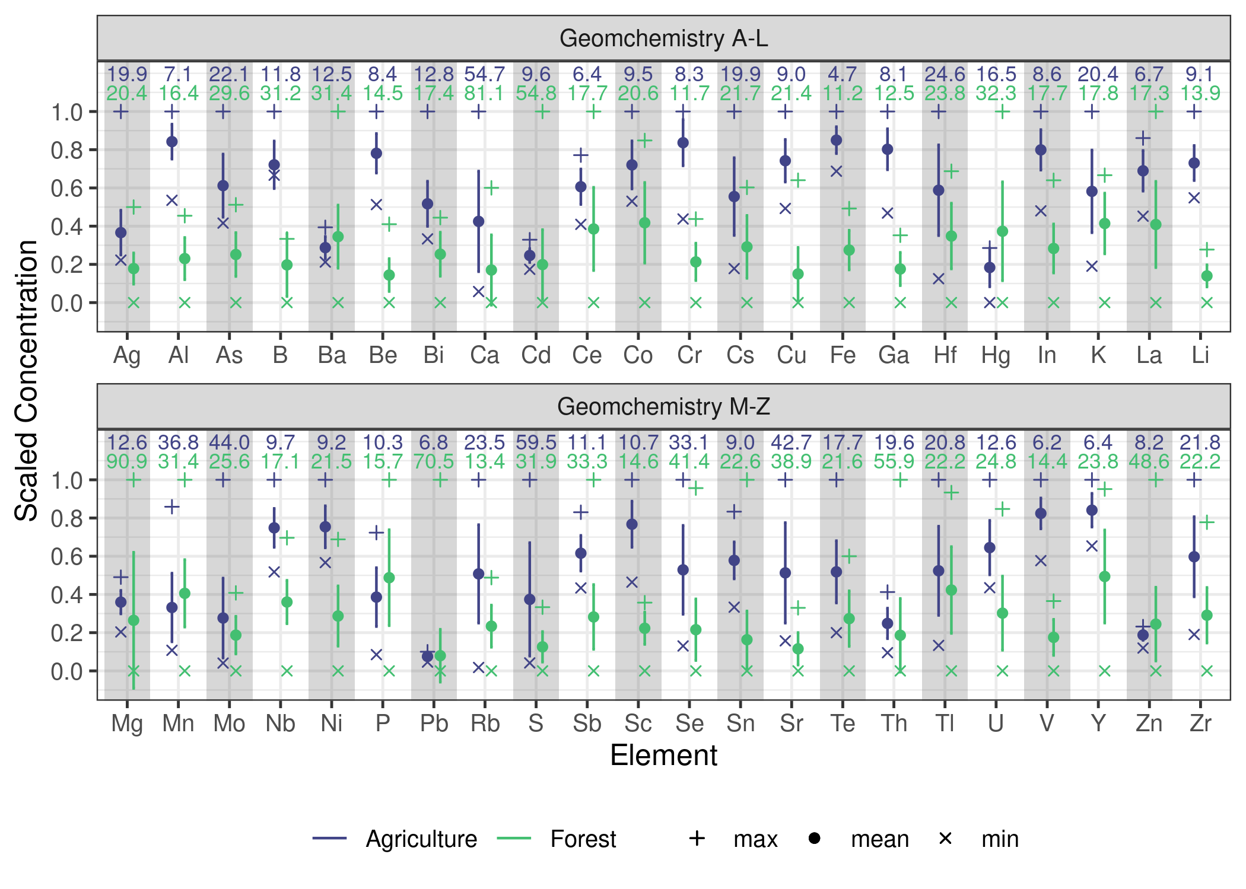

Summary statistics of all measured geochemical soil properties at both sites. Error bars represent 1SD and the numeric values indicate the CV.

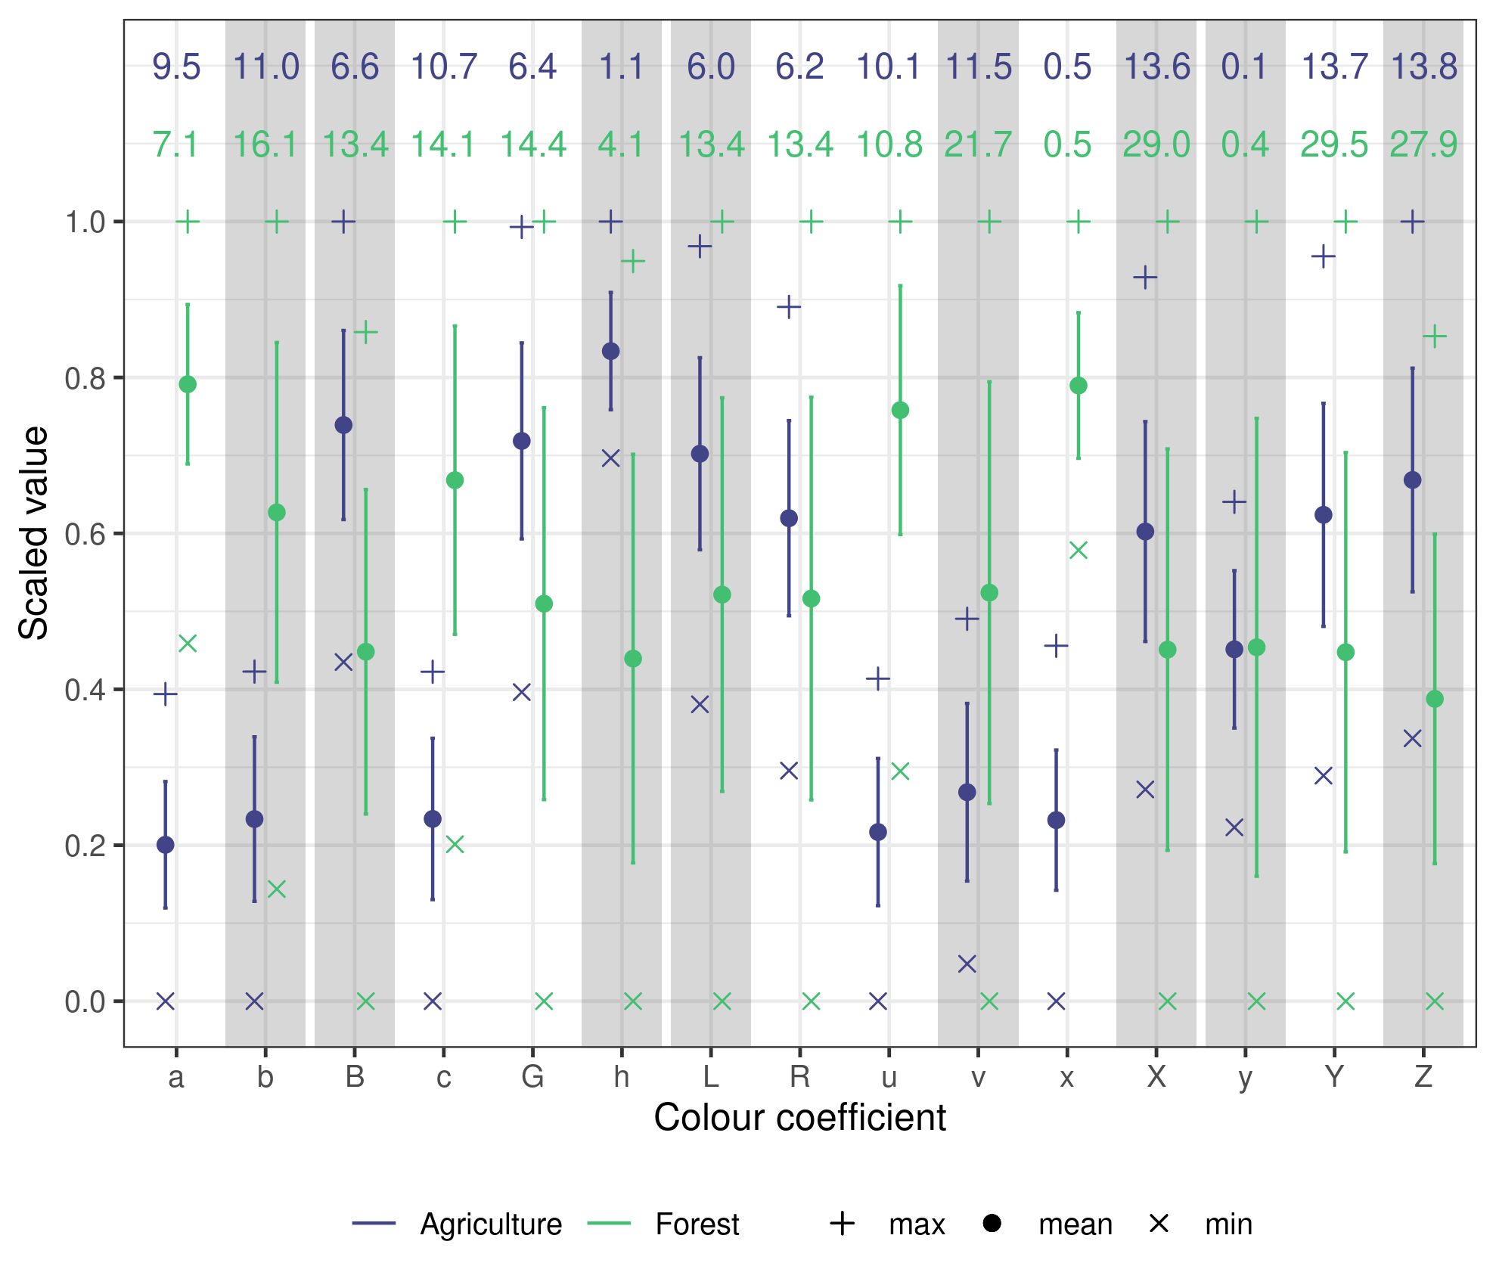

Summary statistics of all measured colour soil properties at both sites. Error bars represent 1SD and the numeric values indicate the CV.