**Preparing Model for Calibration**

This short tutorial will illustrate how to prepare the Manning’s n classes in the HEC-RAS model before a calibration procedure is run with Rasopt. This only needs to be carried out when the number of Manning’s n classes is changed.

**Step 1: Associating the Manning’s n raster with the model geometry.**

In the RAS Mapper window, right click on the Manning’s n layer to associate with the geometry and select “Associate with Geometry.” In the figure below, we’re associating the Manning_2veg raster with the model geometry.

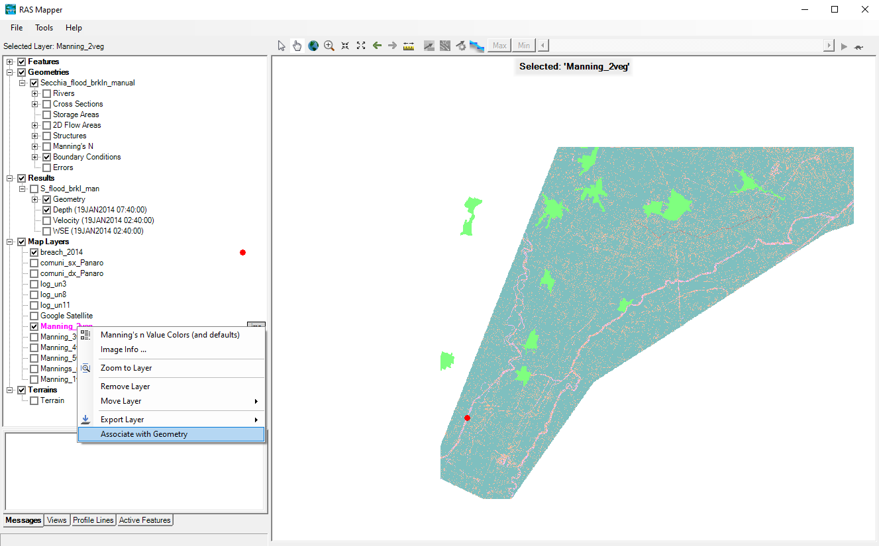

A new dialogue window will open. Select the Manning’s n raster from the dropdown menu in the “Geometry” row as shown in the figure below. Don’t worry about the “Results” row.

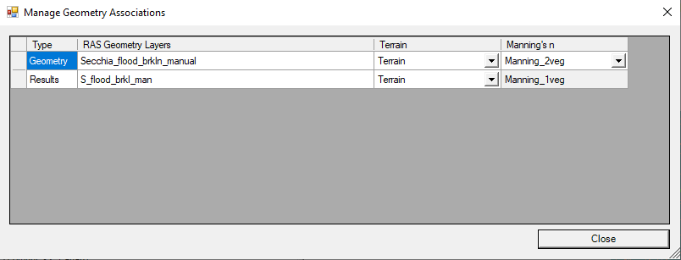

**Step 2: Assign Manning’s n values to the layers in the Geometric Data window.**

In the Geometric Data window, click on the Tables menu and select “Manning’s n by Land Cover.”

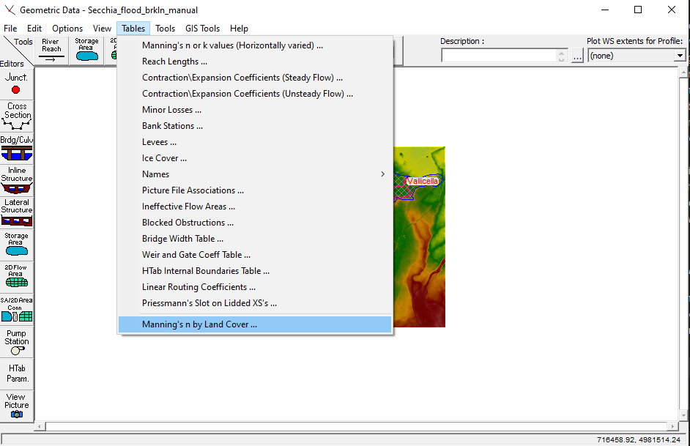

There are default Manning’s n values assigned to the classes, but you can also enter other desired values. These will be overwritten during the optimization process, so changing the values is not necessary. You will see that the Associated Layer should be the same as the layer you selected in the RAS Mapper window in Step 1.

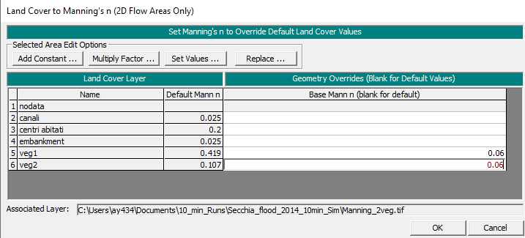

**Step 3: Perform an Unsteady Flow Model Run**

The model needs to be run to finalize the geometry association. Fortunately, this can be done relatively quickly by only running the simulation for a small amount of time. In the figure below, the model is run for 5 hours (02:40 to 07:40), which requires much less time than the full flood model simulation. Once this is completed, the rasopt calibration process can be performed.

