
APT1050UA DATABASE SYSTEMS
DATABASE PROJECT - FINAL
Design and Implementation of a Relational Database for
Green Valley Medical Centre
Individual Coursework
Student Name: Alex Njugi Karanja
Student ID: 676410
Lecturer: Jane Muchiri
Submission Date: 8 August 2026
GitHub Repository:
https://github.com/alex-njugi/APT1050UC_Project_676410

Table of Contents
1. Business Requirements Analysis
2. Phase 1: Database Design
3. Phase 2: Database Normalization
4. Phase 3: Database Implementation
5. Phase 4: Business Intelligence Queries
6. Phase 5: Transaction Management
7. Project Reflection
8. Conclusion
Appendix A: Repository and SQL Files

1. Business Requirements Analysis

1.1 Case Study Analysis
Green Valley Medical Centre is a growing private healthcare facility in Nairobi. Its patient records, doctor information, appointments, treatments and payments were previously maintained in separate spreadsheets. As the number of patients increased, this approach produced duplicate records, inconsistent information and difficulties when preparing operational and financial reports.

1.2 Business Problem
The central business problem is the absence of a single reliable source of information. Separate spreadsheets make it difficult to identify the current patient record, confirm a doctor’s schedule, connect a treatment to the correct appointment, calculate outstanding balances and generate accurate management reports. The medical centre therefore requires a relational database that integrates the data and enforces consistency.

1.3 Users of the System
User | Main responsibilities
Receptionists | Register patients and schedule, reschedule or cancel appointments.
Doctors | View assigned appointments and record treatments.
Accountants | Record payments, verify balances and prepare revenue reports.
Management | Review doctor workload, revenue, treatment income and upcoming appointments.
Database administrator | Manage access, security, backups, recovery and performance.

1.4 Functional Requirements
- The system shall register each patient and assign a unique patient identifier.
- The system shall store doctor details and specialisations.
- The system shall schedule appointments linking a patient to a doctor at a specific date and time.
- The system shall prevent a doctor from being double-booked in the same time slot.
- The system shall record the treatment and cost related to an appointment.
- The system shall record one or more payments for a treatment using a unique transaction reference.
- The system shall calculate charges, amounts paid and outstanding balances.
- The system shall generate reports for management decision-making.
- The system shall support transaction control using COMMIT and ROLLBACK.

1.5 Why a Database Is More Suitable Than Spreadsheets
A relational database stores related information in structured tables and uses primary keys, foreign keys and constraints to protect data integrity. SQL enables repeatable reporting, while transaction management supports safe multi-user updates. Databases also provide better access control, backup and recovery capabilities than separate spreadsheets.

1.6 Possible Implementation Challenges
- Data migration and cleaning: the existing spreadsheets may contain duplicate patients, missing fields and inconsistent formats that must be corrected before import.
- User adoption and training: receptionists, doctors and accountants require training and support when moving from spreadsheets to a database workflow.

2. Phase 1: Database Design

2.1 Entities and Attributes
Entity | Attributes
Patients | patient_id (PK), first_name, last_name, gender, date_of_birth, phone, email, address
Doctors | doctor_id (PK), first_name, last_name, specialization, phone, email
Appointments | appointment_id (PK), patient_id (FK), doctor_id (FK), appointment_date, appointment_time, status, reason
Treatments | treatment_id (PK), appointment_id (FK, Unique), treatment_name, description, treatment_cost
Payments | payment_id (PK), patient_id (FK), treatment_id (FK), payment_date, amount, payment_method, reference_number

2.2 Primary and Foreign Keys
Integer surrogate keys are used as primary keys because they are stable and independent of changing descriptive information. Foreign keys link appointments to patients and doctors, treatments to appointments, and payments to patients and treatments. Unique constraints protect contact details, payment references and doctor appointment slots.

2.3 Entity Relationship Diagram
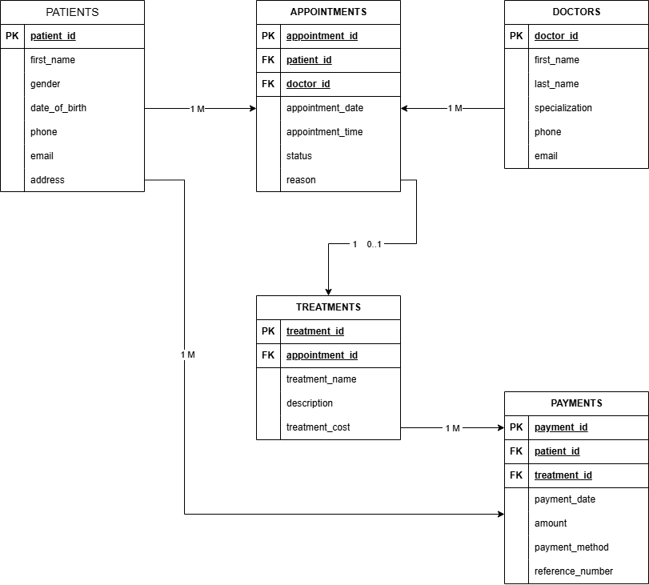
Figure 1: Entity Relationship Diagram created using draw.io

2.4 Relationship Explanation
- One patient can have many appointments, while each appointment belongs to one patient.
- One doctor can attend many appointments, while each appointment is assigned to one doctor.
- One appointment may produce zero or one treatment record.
- One patient can make many payments, while each payment belongs to one patient.
- One treatment can receive many payments, supporting partial or instalment payments.

3. Phase 2: Database Normalization

3.1 Unnormalized Form (UNF)
The initial structure combines patient, doctor, appointment, treatment and payment information in one record. Payments appear as a repeating group, so the values are not atomic.
Appointment | Patient | Doctor | Treatment | Payments (repeating group)
A001 | Brian Mwangi, 0712345601 | Dr. Alice Kariuki, General Medicine | Medical Consultation, KES 2,500 | (20-07-2026, KES 1,500, M-Pesa); (20-07-2026, KES 1,000, Cash)
A002 | Faith Wanjiku, 0712345602 | Dr. Mary Wambui, Dermatology | Dermatology Consultation, KES 4,200 | (21-07-2026, KES 4,200, Card)

The UNF structure contains repeating values and duplicates patient and doctor information. This creates update, insertion and deletion anomalies.

3.2 First Normal Form (1NF)
To achieve 1NF, each field is made atomic and each payment is stored in a separate row.
Appointment ID | Payment ID | Patient ID | Patient Name | Doctor ID | Doctor Name | Treatment | Cost | Paid
A001 | P001 | PT001 | Brian Mwangi | D001 | Dr. Alice Kariuki | Medical Consultation | 2,500 | 1,500
A001 | P002 | PT001 | Brian Mwangi | D001 | Dr. Alice Kariuki | Medical Consultation | 2,500 | 1,000
A002 | P003 | PT002 | Faith Wanjiku | D003 | Dr. Mary Wambui | Dermatology Consultation | 4,200 | 4,200

The repeating payment group is removed. However, patient, doctor and treatment information still repeats, and several attributes depend on only part of the composite key.

3.3 Second Normal Form (2NF)
To achieve 2NF, payment information is separated from appointment information so that every non-key attribute depends on the whole primary key.
APPOINTMENT_2NF
appointment_id (PK), patient_id, patient_name, patient_phone, doctor_id, doctor_name, specialization, appointment_date, appointment_time, treatment_id, treatment_name, treatment_cost

PAYMENT_2NF
payment_id (PK), appointment_id (FK), payment_date, amount, payment_method, reference_number

Partial dependencies are removed, but transitive dependencies remain because patient details depend on patient_id, doctor details depend on doctor_id and treatment details depend on treatment_id.

3.4 Third Normal Form (3NF)
To achieve 3NF, the remaining transitive dependencies are removed by creating separate Patients, Doctors, Appointments, Treatments and Payments tables.
Table | 3NF structure
Patients | patient_id (PK), first_name, last_name, gender, date_of_birth, phone, email, address
Doctors | doctor_id (PK), first_name, last_name, specialization, phone, email
Appointments | appointment_id (PK), patient_id (FK), doctor_id (FK), appointment_date, appointment_time, status, reason
Treatments | treatment_id (PK), appointment_id (FK, Unique), treatment_name, description, treatment_cost
Payments | payment_id (PK), patient_id (FK), treatment_id (FK), payment_date, amount, payment_method, reference_number

The 3NF design stores patient and doctor information once, prevents unnecessary duplication and ensures that every non-key attribute depends only on the key of its table.

4. Phase 3: Database Implementation

4.1 SQL Table Creation
The MySQL script creates the database and defines all five tables using primary keys, foreign keys, NOT NULL constraints, unique constraints, CHECK constraints and referential actions. The complete SQL script is included in the project repository and submitted separately.
CREATE TABLE Appointments (
appointment_id INT PRIMARY KEY AUTO_INCREMENT,
patient_id INT NOT NULL,
doctor_id INT NOT NULL,
appointment_date DATE NOT NULL,
appointment_time TIME NOT NULL,
status ENUM('Scheduled','Completed','Cancelled','No-show') NOT NULL,
reason VARCHAR(200) NOT NULL,
FOREIGN KEY (patient_id) REFERENCES Patients(patient_id),
FOREIGN KEY (doctor_id) REFERENCES Doctors(doctor_id),
UNIQUE (doctor_id, appointment_date, appointment_time)
);

4.2 Data Population
The initial database population contains 10 patients, 5 doctors, 15 appointments, 15 treatments and 15 payments. The successful transaction demonstration later adds one additional payment record.
Table | Initial records
Patients | 10
Doctors | 5
Appointments | 15
Treatments | 15
Payments | 15

4.3 Integrity Controls
- Primary keys uniquely identify all records.
- Foreign keys prevent orphan appointments, treatments and payments.
- Unique constraints prevent duplicate contact details, references and doctor time slots.
- CHECK constraints prevent negative treatment costs and invalid payment amounts.
- ON DELETE RESTRICT protects clinical and financial history.

4.4 GitHub Repository
The project repository provides a version-controlled location for the SQL script, ERD, report and supporting screenshots.
Repository: https://github.com/alex-njugi/APT1050UC_Project_676410

5. Phase 4: Business Intelligence Queries

5.1 Doctor Who Attended the Highest Number of Patients
This query joins Doctors and Appointments, counts distinct patients attended by each doctor, groups the results, orders them from highest to lowest and returns the first row. The result shows Dr. Alice Kariuki with three patients.
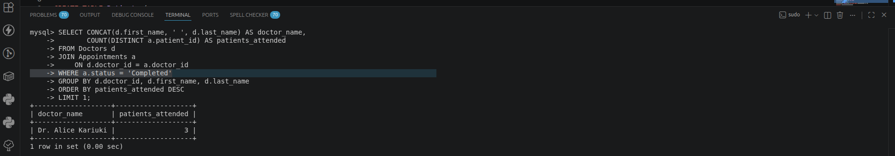
Figure 2: Genuine MySQL execution output for Phase 4 Query 1

5.2 Patients With Outstanding Payments
This query joins Patients, Appointments and Treatments. A correlated subquery calculates the total payments made by each patient, while HAVING returns only patients with a positive outstanding balance. After the committed payment transaction, six patients remain with outstanding balances.
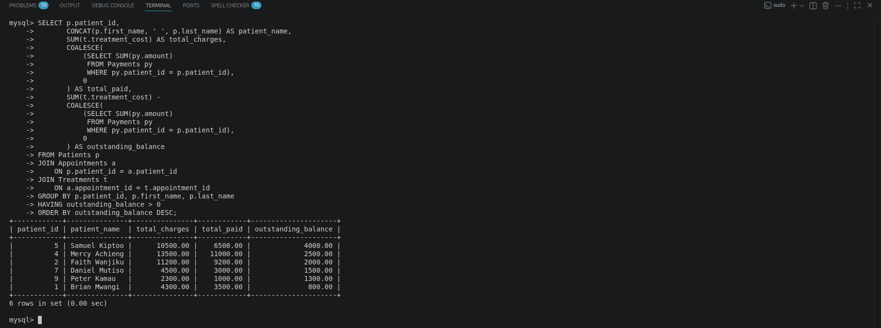
Figure 3: Genuine MySQL execution output for Phase 4 Query 2

5.3 Total Revenue Collected
The SUM aggregate function calculates the total value of all payment records. Because the successful transaction added KES 1,800 to the initial KES 49,900, the genuine execution output shows total revenue of KES 51,700.
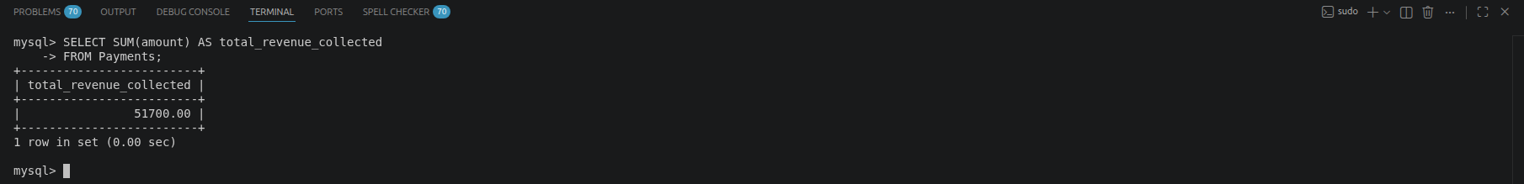
Figure 4: Genuine MySQL execution output for Phase 4 Query 3

5.4 Treatment That Generated the Highest Income
This query joins Treatments and Payments, groups payments by treatment name and orders the total income in descending order. Executive Check-up generated the highest recorded income of KES 6,000.
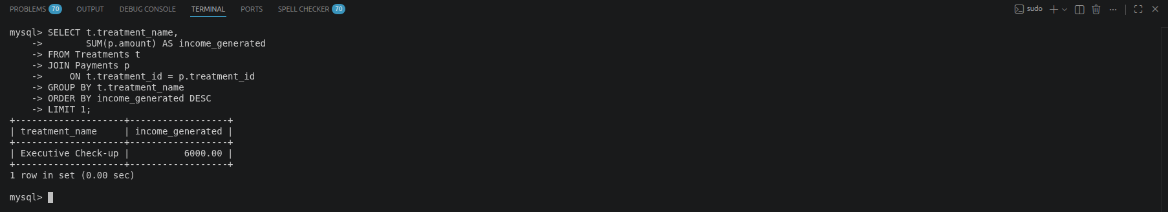
Figure 5: Genuine MySQL execution output for Phase 4 Query 4

5.5 Appointments Scheduled Within the Next Seven Days
This query joins appointments with patients and doctors, filters scheduled appointments using CURDATE() and DATE_ADD(), and orders the output by date and time. The screenshot shows six appointments scheduled within the relevant seven-day period.
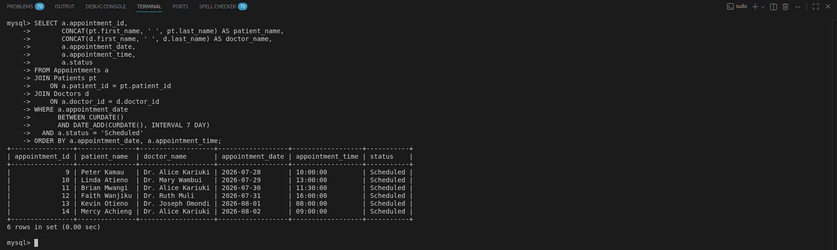
Figure 6: Genuine MySQL execution output for Phase 4 Query 5

5.6 Required SQL Features Demonstrated
Required feature | Where demonstrated
JOIN | Queries 1, 2, 4 and 5
GROUP BY | Queries 1, 2 and 4
ORDER BY | Queries 1, 2, 4 and 5
Aggregate function | COUNT and SUM
Subquery | Outstanding-payments query

6. Phase 5: Transaction Management

6.1 Successful Payment Transaction
START TRANSACTION;
INSERT INTO Payments
(patient_id, treatment_id, payment_date, amount, payment_method, reference_number)
VALUES (3, 3, CURDATE(), 1800.00, 'M-Pesa', 'MPESA-GV016');
UPDATE Treatments
SET description = CONCAT(description, ' - Fully paid')
WHERE treatment_id = 3;
COMMIT;
The transaction records a final payment of KES 1,800 and updates the related treatment. COMMIT makes both changes permanent. The genuine Phase 4 outputs confirm the effect: total revenue increases to KES 51,700 and Kevin Otieno no longer appears among patients with an outstanding balance.

6.2 Failed Transaction and ROLLBACK
START TRANSACTION;
INSERT INTO Payments
(patient_id, treatment_id, payment_date, amount, payment_method, reference_number)
VALUES (5, 5, CURDATE(), 2500.00, 'M-Pesa', 'MPESA-GV017');
UPDATE Treatments
SET description = CONCAT(description, ' - Payment processing')
WHERE treatment_id = 5;
ROLLBACK;
ROLLBACK reverses every uncommitted statement in the failed transaction. This protects atomicity by ensuring that either the complete operation succeeds or no part of it remains in the database.

6.3 Concurrency Problems and Locking Strategy
Problem | Example | Recommended control
Lost update | Two receptionists edit the same appointment and the later save overwrites the first change. | Use row-level exclusive locks such as SELECT ... FOR UPDATE inside short transactions.
Double booking | Two receptionists both see a doctor’s slot as free and attempt to create appointments at the same time. | Retain the UNIQUE doctor/date/time constraint and use suitable transaction isolation with duplicate-key error handling.

7. Project Reflection

7.1 Most Challenging Part
The most challenging part was designing the relationship between treatments and payments while allowing partial payments. Linking each payment to a treatment and a patient made the transaction history traceable and allowed several payment records to be associated with one treatment.

7.2 What I Learnt
I learnt how business requirements are translated into entities, attributes, keys, constraints and relationships. I also learnt how SQL queries turn operational data into information that management can use.

7.3 How Normalization Improved the Design
Normalization removed repeating groups, partial dependencies and transitive dependencies. Patient and doctor details are stored once, which reduces redundancy and prevents update, insertion and deletion anomalies.

7.4 Importance of Transaction Management
Transaction management is essential in a multi-user medical database because several users may update related records at the same time. COMMIT, ROLLBACK, isolation and locking prevent incomplete payments, overwritten appointments and inconsistent reports.

8. Conclusion
The implemented relational database replaces separate spreadsheets with an integrated and controlled system. It supports patient registration, doctor scheduling, treatment recording, payment processing and management reporting. Normalization reduces redundancy, constraints protect accuracy, SQL queries provide business intelligence and transactions preserve integrity in a multi-user environment.

Appendix A: Repository and SQL Files
GitHub repository:
https://github.com/alex-njugi/APT1050UC_Project_676410
- green_valley_medical_centre.sql - MySQL database creation, sample data, business queries and transaction demonstrations.
- Green Valley Medical Centre ERD.drawio.png - exported ERD diagram.
- Five MySQL screenshots for the Phase 4 queries.
- APT1050 database project report in Microsoft Word format.

