APT1050 DATABASE SYSTEMS
DATABASE PROJECT - FINAL
Design and Implementation of a Relational Database for
Green Valley Medical Centre
Individual Coursework
Student Name: Alex Njugi Karanja
Student ID: __________________________
Lecturer: ____________________________
Submission Date: _____________________

Table of Contents
1. Business Requirements Analysis
2. Phase 1: Database Design
3. Phase 2: Database Normalization
4. Phase 3: Database Implementation
5. Phase 4: Business Intelligence Queries
6. Phase 5: Transaction Management
7. Project Reflection
8. Conclusion
Appendix A: SQL Script Summary

1. Business Requirements Analysis

1.1 Case Study Analysis
Green Valley Medical Centre is a private healthcare facility in Nairobi whose operational data is currently distributed across separate spreadsheets. Patient details, doctor information, appointments, treatments and payments are therefore not centrally controlled. As the clinic grows, the spreadsheet-based approach creates duplicated records, inconsistent values, slow report preparation and a high risk of accidental loss or unauthorised alteration.

1.2 Business Problem
The main business problem is the absence of a single, reliable source of information. Separate spreadsheets make it difficult to verify the current patient record, confirm a doctor's schedule, connect a treatment to the correct appointment, calculate outstanding balances and produce management reports. The clinic needs a relational database that enforces data integrity while allowing authorised users to share accurate information.

1.3 Users of the System
User | Main responsibilities
Receptionists | Register patients, search patient records, schedule, reschedule and cancel appointments.
Doctors | View assigned appointments, review patient information and record treatments.
Accountants | Record payments, verify balances and prepare revenue information.
Management | Review activity, performance, revenue and outstanding-payment reports.
Database administrator | Manage user access, backups, security, performance and recovery.

1.4 Functional Requirements
- The system shall register each patient once and store a unique patient identifier.
- The system shall store doctor details and medical specialisations.
- The system shall create appointments that link one patient to one doctor at a particular date and time.
- The system shall prevent a doctor from being assigned two appointments in the same time slot.
- The system shall record the treatment and cost associated with an appointment.
- The system shall record one or more payments against a treatment and retain a unique transaction reference.
- The system shall calculate patient charges, amounts paid and outstanding balances.
- The system shall generate management reports on doctor workload, revenue, treatment income and upcoming appointments.
- The system shall support transaction control so that incomplete payment operations can be rolled back.

1.5 Why a Database Is More Suitable Than Spreadsheets
A database is more suitable because it stores related data in structured tables and uses primary keys and foreign keys to preserve relationships. Constraints can prevent invalid or duplicate information, while SQL provides fast, repeatable reporting. A database also supports concurrent access, transaction management, role-based security, backups and recovery. Spreadsheets provide limited control over these features and are therefore less reliable for a growing multi-user clinic.

1.6 Possible Implementation Challenges
- Data migration and cleaning: existing spreadsheets may contain duplicate patients, missing values and inconsistent formats. The clinic must clean, validate and map the old data before import.
- User adoption and training: receptionists, doctors and accountants may initially resist a new workflow. Practical training, user documentation and phased implementation will be required.

2. Phase 1: Database Design

2.1 Entities and Attributes
Entity | Attributes
Patients | patient_id (PK), first_name, last_name, gender, date_of_birth, phone, email, address
Doctors | doctor_id (PK), first_name, last_name, specialization, phone, email
Appointments | appointment_id (PK), patient_id (FK), doctor_id (FK), appointment_date, appointment_time, status, reason
Treatments | treatment_id (PK), appointment_id (FK, Unique), treatment_name, description, treatment_cost
Payments | payment_id (PK), patient_id (FK), treatment_id (FK), payment_date, amount, payment_method, reference_number

2.2 Key Selection
Surrogate integer primary keys are used because they remain stable even when names, telephone numbers or other descriptive information changes. Foreign keys connect appointments to patients and doctors, treatments to appointments, and payments to patients and treatments. Unique constraints are applied to patient/doctor contact details, payment references, treatment appointment identifiers and doctor time slots.

2.3 Entity Relationship Diagram
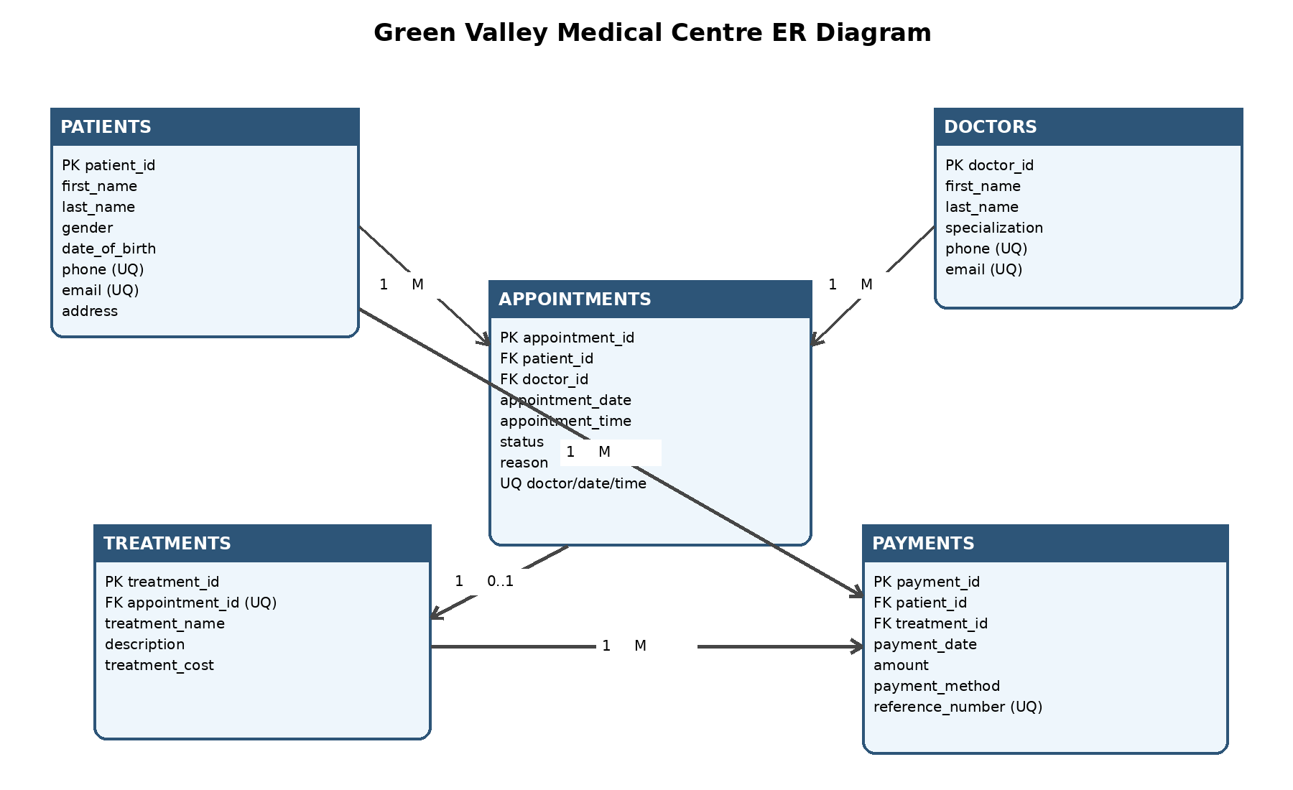
Figure 1: Entity Relationship Diagram for Green Valley Medical Centre

2.4 Relationship Explanation
- One patient can have many appointments, but each appointment belongs to one patient.
- One doctor can attend many appointments, but each appointment is assigned to one doctor.
- One appointment may produce zero or one treatment record. The unique appointment_id in Treatments prevents duplicate treatment records for the same appointment.
- One patient can make many payments, but every payment belongs to one patient.
- One treatment can receive many payments, which supports instalments or partial payments; each payment refers to one treatment.

3. Phase 2: Database Normalization

3.1 Unnormalized Form (UNF)
The initial record combines patient, doctor, appointment, treatment and a repeating group of payments in one structure. The repeating payment group means the record is not atomic.
Appointment | Patient | Doctor | Treatment | Payments (repeating group)
A001 | Brian Mwangi, 0712345601 | Dr. Alice Kariuki, General Medicine | Medical Consultation, KES 2,500 | (20-07-2026, KES 1,500, M-Pesa); (20-07-2026, KES 1,000, Cash)
A002 | Faith Wanjiku, 0712345602 | Dr. Mary Wambui, Dermatology | Dermatology Consultation, KES 4,200 | (21-07-2026, KES 4,200, Card)

Problems present: multiple values are stored in one payment field; patient and doctor information is repeated for every appointment; updates can create conflicting contact information; and deleting an appointment may remove the only stored details about a patient or doctor.

3.2 First Normal Form (1NF)
To reach 1NF, every field is made atomic and each payment is placed on a separate row. A composite key such as (appointment_id, payment_id) can uniquely identify each row.
Appointment ID | Payment ID | Patient ID | Patient Name | Doctor ID | Doctor Name | Treatment | Cost | Paid
A001 | P001 | PT001 | Brian Mwangi | D001 | Dr. Alice Kariuki | Medical Consultation | 2,500 | 1,500
A001 | P002 | PT001 | Brian Mwangi | D001 | Dr. Alice Kariuki | Medical Consultation | 2,500 | 1,000
A002 | P003 | PT002 | Faith Wanjiku | D003 | Dr. Mary Wambui | Dermatology Consultation | 4,200 | 4,200

Anomaly removed: repeating groups are eliminated and each payment becomes independently searchable. Remaining problem: many non-key attributes depend only on appointment_id rather than on the whole composite key, causing partial dependencies.

3.3 Second Normal Form (2NF)
To reach 2NF, attributes that depend only on part of the composite key are separated. Appointment data is stored independently from payment data. Patient and doctor details are still repeated between appointments, so transitive dependencies remain.
APPOINTMENT_2NF
appointment_id (PK), patient_id, patient_name, patient_phone, doctor_id, doctor_name, specialization, appointment_date, appointment_time, treatment_id, treatment_name, treatment_cost

PAYMENT_2NF
payment_id (PK), appointment_id (FK), payment_date, amount, payment_method, reference_number

Anomaly removed: payment data now depends on payment_id, while appointment-related information depends on appointment_id. A payment can be added or deleted without copying the full appointment record. Remaining problem: patient_name depends on patient_id, doctor_name and specialization depend on doctor_id, and treatment details depend on treatment_id.

3.4 Third Normal Form (3NF)
To reach 3NF, transitive dependencies are removed by creating separate Patients, Doctors, Appointments, Treatments and Payments tables. Every non-key attribute depends on the key, the whole key and nothing but the key.
Table | 3NF structure
Patients | patient_id (PK), first_name, last_name, gender, date_of_birth, phone, email, address
Doctors | doctor_id (PK), first_name, last_name, specialization, phone, email
Appointments | appointment_id (PK), patient_id (FK), doctor_id (FK), appointment_date, appointment_time, status, reason
Treatments | treatment_id (PK), appointment_id (FK, Unique), treatment_name, description, treatment_cost
Payments | payment_id (PK), patient_id (FK), treatment_id (FK), payment_date, amount, payment_method, reference_number

Anomalies removed: patient and doctor details are updated in one place; a doctor can be added before an appointment exists; a treatment or payment can be recorded without duplicating personal details; and deleting a payment does not delete the patient, doctor or appointment. This final design reduces redundancy and enforces referential integrity.

4. Phase 3: Database Implementation

4.1 SQL Table Creation
The SQL script creates a MySQL database and defines all tables, primary keys, foreign keys, unique constraints, NOT NULL constraints, CHECK constraints and referential actions. The complete executable script is submitted separately as green_valley_medical_centre.sql.
CREATE TABLE Appointments (
appointment_id INT PRIMARY KEY AUTO_INCREMENT,
patient_id INT NOT NULL,
doctor_id INT NOT NULL,
appointment_date DATE NOT NULL,
appointment_time TIME NOT NULL,
status ENUM('Scheduled','Completed','Cancelled','No-show') NOT NULL,
reason VARCHAR(200) NOT NULL,
FOREIGN KEY (patient_id) REFERENCES Patients(patient_id),
FOREIGN KEY (doctor_id) REFERENCES Doctors(doctor_id),
UNIQUE (doctor_id, appointment_date, appointment_time)
);

4.2 Sample Data Population
The database is populated with 10 patients, 5 doctors, 15 appointments, 15 treatments and 15 payments. The names, appointment dates, telephone numbers, payment values and references are realistic and internally consistent.
Table | Number of records
Patients | 10
Doctors | 5
Appointments | 15
Treatments | 15
Payments | 15

4.3 Integrity Controls
- Primary keys prevent duplicate rows and provide stable record identifiers.
- Foreign keys prevent orphan appointments, treatments and payments.
- Unique contact and reference fields prevent accidental duplication.
- The unique doctor/date/time constraint prevents double-booking.
- CHECK constraints reject negative treatment costs and non-positive payment amounts.
- ON DELETE RESTRICT protects clinical and financial history from accidental deletion.

5. Phase 4: Business Intelligence Queries

5.1 Doctor Who Attended the Highest Number of Patients
This query joins Doctors and Appointments, groups completed appointments by doctor, counts distinct patients, orders the result from highest to lowest and returns the first row.
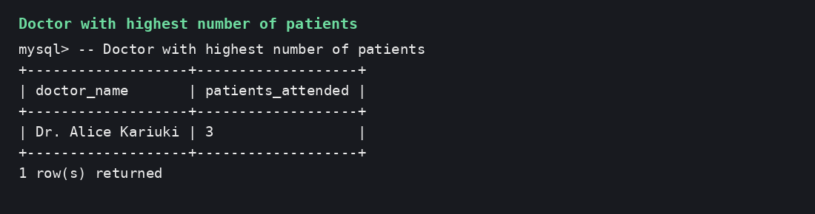

5.2 Patients With Outstanding Payments
This query joins patients, appointments and treatments. A correlated subquery calculates payments made by each patient. HAVING returns only positive balances.
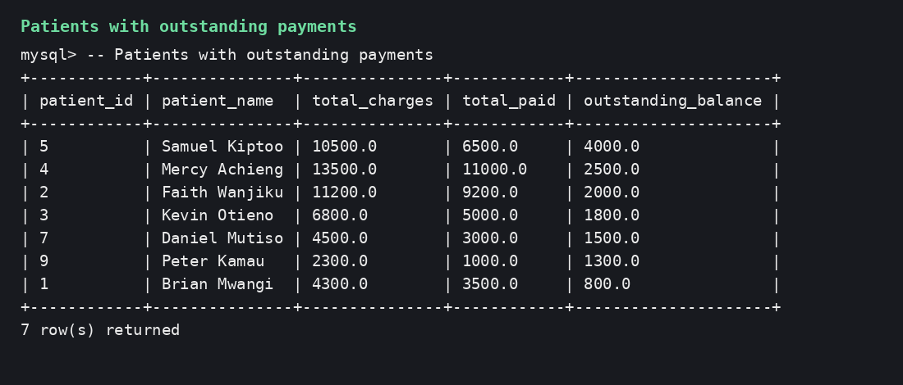

5.3 Total Revenue Collected
The SUM aggregate function calculates all successfully recorded payment amounts. The sample data produces total collected revenue of KES 49,900.
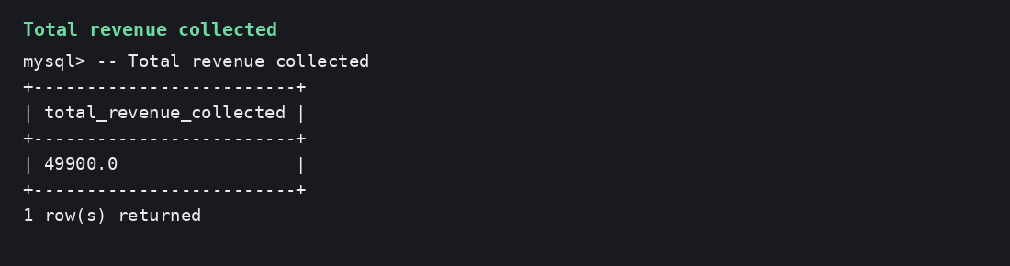

5.4 Treatment That Generated the Highest Income
The query joins Treatments and Payments, groups payments by treatment name and orders total income in descending order.
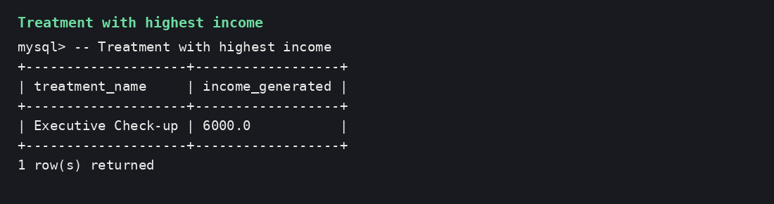

5.5 Appointments Scheduled Within the Next Seven Days
The query joins appointments with patients and doctors, filters scheduled dates from 27 July 2026 to 3 August 2026 for the demonstrated output, and orders by date and time. The submitted MySQL query uses CURDATE() and DATE_ADD().
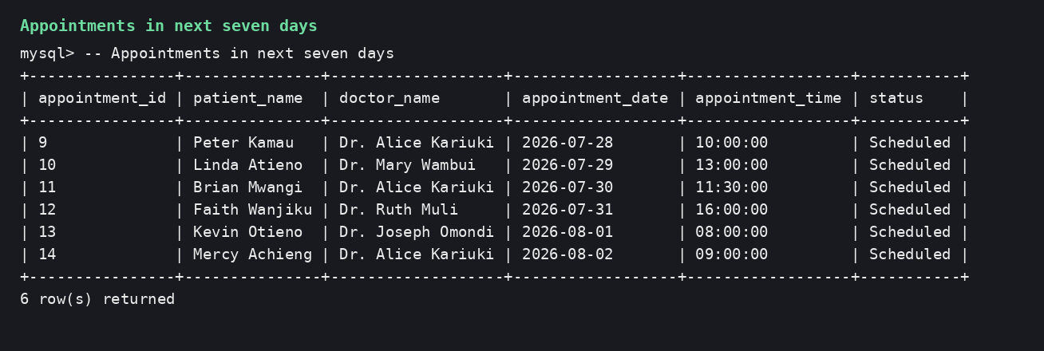

5.6 Required SQL Features Demonstrated
Required feature | Where demonstrated
JOIN | Questions 1, 2, 4 and 5
GROUP BY | Questions 1, 2 and 4
ORDER BY | Questions 1, 2, 4 and 5
Aggregate function | COUNT and SUM
Subquery | Outstanding-payments query

6. Phase 5: Transaction Management

6.1 Successful Payment Transaction
START TRANSACTION;
INSERT INTO Payments
(patient_id, treatment_id, payment_date, amount, payment_method, reference_number)
VALUES (3, 3, CURDATE(), 1800.00, 'M-Pesa', 'MPESA-GV016');
UPDATE Treatments
SET description = CONCAT(description, ' - Fully paid')
WHERE treatment_id = 3;
COMMIT;
The accountant begins a transaction, records the final payment, updates the related treatment description and commits both changes. COMMIT makes the changes permanent only after all statements complete successfully.

6.2 Failed Transaction and ROLLBACK
START TRANSACTION;
INSERT INTO Payments
(patient_id, treatment_id, payment_date, amount, payment_method, reference_number)
VALUES (5, 5, CURDATE(), 2500.00, 'M-Pesa', 'MPESA-GV017');
UPDATE Treatments
SET description = CONCAT(description, ' - Payment processing')
WHERE treatment_id = 5;
-- A failure occurs before completion
ROLLBACK;
ROLLBACK reverses every uncommitted change in the failed transaction. The payment row and temporary treatment update are therefore not retained. COMMIT and ROLLBACK protect atomicity: either the complete payment operation succeeds or none of it is applied.

6.3 Concurrency Problems and Locking Strategy
Problem | Example | Recommended control
Lost update | Two receptionists read the same appointment and save different changes. The later update overwrites the earlier one. | Use row-level exclusive locks during updates, for example SELECT ... FOR UPDATE within a short transaction.
Double booking / inconsistent schedule | Two receptionists check an apparently free doctor time and both insert appointments before either sees the other insert. | Keep the UNIQUE doctor/date/time constraint and use an appropriate isolation level. Handle duplicate-key errors by asking the user to select another slot.

Row-level locking is preferred because it protects only the appointment being changed and allows unrelated appointments to remain available. Transactions should be kept short to reduce waiting and deadlocks.

7. Project Reflection

7.1 Most Challenging Part
The most challenging part was deciding how payments should relate to treatments while still supporting partial payments. Linking every payment to a treatment and also to the paying patient made the financial history easy to trace, while allowing several payment rows for one treatment.

7.2 What I Learnt
I learnt how business rules become tables, keys and constraints. I also learnt that a good database design is not only about storing information; it must prevent invalid states, support reporting and remain understandable to different users.

7.3 How Normalization Improved the Design
Normalization separated repeating payment values and removed partial and transitive dependencies. Patient and doctor information is now stored once, which reduces update anomalies and makes the data more consistent.

7.4 Importance of Transaction Management
Transaction management is essential in a multi-user database because several users may change related records at the same time. COMMIT, ROLLBACK, isolation and locking prevent incomplete payments, overwritten appointments and inconsistent reports.

8. Conclusion
The proposed relational database replaces isolated spreadsheets with a controlled and integrated information system. The design supports patient registration, doctor scheduling, treatment recording, payment processing and management reporting. Normalization reduces redundancy, constraints protect accuracy, SQL provides useful business intelligence, and transactions preserve integrity during multi-user operations.

Appendix A: SQL Script Summary
The separate SQL file contains:
- Database creation and selection statements.
- Five CREATE TABLE statements with keys and constraints.
- INSERT statements for all required realistic data.
- Five management queries.
- Successful COMMIT and failed ROLLBACK demonstrations.

