Efficient and affordable thermoelectric measurement setup using
Arduino and LabVIEW for education and research
Alex J. Oh^{1,2}, Colby Stoddard^{1,3}, Craig Queenan², and Seongshik Oh^{1,3}
¹Department of Physics and Astronomy, Rutgers, The State University of New Jersey, Piscataway, NJ 08854, USA
²High Technology High School, Lincroft, NJ 07738, USA
³Center for Quantum Materials Synthesis, Rutgers, The State University of New Jersey, Piscataway, NJ 08854, USA

Thermoelectric materials can convert thermal energy into electricity, making them promising candidates for harvesting waste heat, an increasingly important challenge in the energy-intensive modern world. The search for improved thermoelectric materials is therefore an active area of research in materials physics. Despite their fundamental and practical significance, thermoelectric properties—such as the Seebeck coefficient and power factor—are rarely explored in student labs due to the complexity in measurement schemes and requirement for sophisticated equipment. In this work, we present a user-friendly, low-cost and efficient thermoelectric measurement system built with Arduino and LabVIEW, which can simultaneously measure Seebeck coefficients and power factors as a function of temperature. This was made possible by improving the resolution of Arduino over ~1000 times with amplifiers and noise reduction schemes. With a total cost of only ~$100 and simple measurement protocols, this setup is well suited not only for student labs but also for frontier research in thermoelectricity.

- INTRODUCTION
Thermal energy is the waste product of almost all processes on Earth. One good example is the huge amount of heat generated by large data centers managing all internet activities around the globe. Therefore, a way to efficiently capture waste heat and turn it back into usable energy, which in modern society is mainly electricity, can be a significant development. There are already ways to convert heat to usable energy, such as steam generators in power plants. However, these types of energy converters are impractical for capturing waste heat. An efficient solution is using thermoelectrics, which are materials that can create a substantial electrical voltage from a temperature difference. They can convert waste heat into electricity without any moving parts and make extremely lightweight energy conversion devices.¹
When a temperature difference is created within any material, a voltage forms due to the contrasting charge concentrations on the colder and hotter sides. Charge on the hotter side will have greater kinetic energy and will spread out, resulting in reduced charge density, and it will be opposite on the colder side. Such a charge imbalance leads to a voltage across the material, which can then be utilized as a source of electricity. This is known as the Seebeck effect, the main principle of thermoelectrics.² The opposite effect, called the Peltier effect, can be used to create a temperature difference from electricity. Devices that use the Seebeck effect to generate electricity are called thermoelectric generators, and devices that use the Peltier effect to cool are called thermoelectric coolers.^{1,3}
The thermoelectric power, or Seebeck coefficient, is a property that determines the relationship between the temperature difference and the voltage in a material. It is a major factor that contributes to the quality of the thermoelectric material. Expressed in an equation form, the Seebeck coefficient S is defined as $-\frac{ΔV}{ΔT}$, where ΔV is the voltage in (commonly) μV and ΔT is the temperature difference in K.² A high Seebeck coefficient means that the voltage generated by the material is large for a given temperature difference. It has been observed that better conductors typically have a lower Seebeck coefficient.⁴ However, the overall quality of a thermoelectric material is usually determined by the dimensionless figure of merit, $ZT=\frac{S^{2}σ}{κ}T$, where T is the material’s temperature (in K), S is the Seebeck coefficient, $σ$ is the electrical conductivity, and κ is the thermal conductivity. Practically, the power factor, S²σ, is used as a simpler measure of performance because thermal conductivity is much more difficult to measure, particularly for thin film materials.¹
Despite the conceptual simplicity of the thermoelectric properties and their wide uses in everyday applications such as thermocouples, measurement of thermoelectric properties usually requires sophisticated instruments and complex measurement geometries that cannot be easily incorporated into student labs.^{5–8} Recently, however, with the advent of low-cost microcontroller boards like Arduino, many advanced measurements, which were previously considered too complex to implement for a student lab, have become accessible with relative ease. Nonetheless, there is no report of utilizing Arduino to measure thermoelectric properties in the literature.
Here, we present an efficient thermoelectric measurement setup, simultaneously measuring both Seebeck coefficient and resistance, thus power factor, with an Arduino board and a LabVIEW user interface. This setup was verified on a Chromel wire, which has well-documented Seebeck coefficients in the literature.² Subsequently, it was used to measure a Bi₂Se₃ thin film over a range of temperatures and confirmed that the measured values are consistent with those in the literature,⁹ demonstrating that this setup can also be used for frontier materials research.
In order to use Arduino for thermoelectric measurement, several challenges need to be overcome. First is the poor resolution of the Arduino board. Because Arduino is a 10-bit system and operates on the 5 V scale, its resolution is 5 V / 2¹⁰ = ~5 mV,¹⁰ which is too large to measure thermoelectric voltages, which can be well below ~1 mV. Moreover, for temperature-dependent thermoelectric properties, we need to precisely control the temperature and its gradient across the sample while measuring the small thermoelectric signals. We also need to find a way to measure electrical resistance as well as the Seebeck coefficient for the power factor. Furthermore, for this setup to be effectively utilized for student labs, we need to find a simple way to make electrical contacts to the samples. With the setup described below, we have successfully addressed all these challenges.

- MATERIALS
Two thermoelectric heaters/coolers (model TEC1-12706) were used to heat the two sides of the sample (see Fig. 1 and 2). In this study, we used them as heaters, but they can also be used as coolers to study thermoelectric properties below room temperature. These heaters are flat plates that use thermoelectrics to heat one face and cool the other when electricity is supplied; thus, by reversing the current flow direction, they can be converted to coolers. They can cool or heat from below 0 ˚C to ~100 ˚C. A general-purpose power supply that can provide more than 10 volts and 3 amps was used to power the heaters, and two conducting aluminum Easycargo heat sinks (model 404010B10-8810) were used to equalize the temperature of the cooling side of the heaters to the ambient. K-type thermocouple wires that contain Chromel and Alumel with AWG 30 (0.254 mm diameter) from Minnesota Measurement Instruments were used for the temperature measurement. Copper tape held the wires together on the heaters (Fig. 1(b)). Three Adafruit Analog Output K-Type thermocouple amplifiers (model AD8495) measured and amplified the voltage signals from the thermocouple wires. Three ‎BOJACK N-MOSFET transistors (model RFP30N06LE) were used for the Proportional-Integral-Derivative (PID) temperature control system and the resistance measurement. An Aexit TO-3 transistor heat sink was used to dissipate heat from the transistors. One Arduino-UNO-Rev3 circuit board was used to receive the voltage input, control the setup, and communicate with a computer. Two EC Buying PWM-to-analog converters were used to turn the 0 – 5 V PWM (Pulse Width Modulation) signals on the Arduino into 0 – 10 V analog signals. A breadboard and jumper wires connected the Arduino circuit board to the thermoelectric amplifiers. Four 1 kΩ resistors were also used. The details on how these components were used are described below in Sec. III.
The software for data collection was made using the freely available community version of Laboratory Virtual Instrument Engineering Workbench or LabVIEW on a personal laptop computer. This software makes it easy to collect and organize data in real time and allows for the creation of a custom user interface. It is important to note that only version Rev3 of the Arduino UNO board is compatible with LabVIEW.
A Chromel wire (AWG 36, 0.127 mm diameter) and a 30 nm-thick Bi₂Se₃ thin film grown on a 10 $×$ 10 $×$ 0.5 mm³ Al₂O₃ (0001) substrate were used to test the measurement setup.
Except for the Bi₂Se₃ thin film, which was synthesized in the lab, all the other parts used in this setup can be purchased online at affordable prices. We did not have to purchase all the parts, because some of them were already available in the lab, but even if we did, the entire setup would have cost no more than ~$100. For example, an Arduino-UNO-Rev3 compatible board with accessories was purchased at a price below $10. Another notable point, as detailed below, is that the way electrical contacts are made is greatly simplified in this setup, compared to the common practices in research labs.^{5–7,11–13} Accordingly, this setup can be well incorporated not only for student labs but also for individual research.
- EXPERIMENTAL SETUP
- Seebeck coefficient measurement
The first part of the measurement setup is for the Seebeck coefficient. First, two thermoelectric heaters (lateral size of 40 × 40 mm²) were placed side by side as shown in Fig. 1 and 2, on top of heat sinks (not shown). Patches of copper tape were added at the four corners of the heaters nearest each other as shown in the sample area of Fig. 1 and 2. For Seebeck measurements, only the bottom two contact points in the sample area of Fig. 1 (the left two contacts of the sample area in Fig. 2) were used. Unless stated otherwise, all the position or orientation references below will be based on Fig. 1 instead of Fig. 2: the heater and sample configurations in Fig. 2 are rotated 90˚from those in Fig. 1. The top two contacts were used as current input for electrical resistance measurements, which will be explained below in Sec. C. Small pieces of thermally conducting tape (blue tape in Fig. 2) were put on top of the copper tape and carefully cut to form the border of a square with a small bit of copper tape at the corners. This is where the samples were placed, face down. One Chromel and one Alumel wire (AWG 30) were soldered together at one end, forming a K-type thermocouple, and this soldered side was attached with copper tape to a corner of the sample on the hotter side (see Fig. 1(b) and Fig. 2). The same was done on the colder side as well. The other ends of each thermocouple were connected to an AD8495 thermocouple amplifier on a breadboard. These two amplifiers (AmpH and AmpC) acted as thermometers and measured the temperatures (T_{H} and T_{C}) of the two sides of the sample, with the temperature difference ΔT = T_{H} - T_{C.} being used for the Seebeck coefficient calculation. A third amplifier (AmpV) was connected to the two Alumel wires of the thermocouples with two more Alumel wires, and this measured the voltage (ΔV) across the sample.
The Seebeck coefficient (S) can be calculated using the formula $S=-\frac{ΔV}{ΔT}$.² However, it is important to note that this is not the Seebeck coefficient of the sample (S_{S}), because we have to consider the effect of the probing wire, Alumel (S_{Al}), as follows. If we take into account the thermoelectric voltage developed across the Alumel wires, the voltage (ΔV) measured between the positive (+) and negative (-) ports of the amplifier (AmpV), is given by ΔV = -[T-TCSAlTdT+TCTHSS(T)dT+THT+SAl(T)dT].^{2,4} If we rightfully assume that the temperatures (T- and T+) at the ports of AmpV are the same, this equation reduces to ΔV = $-\int_{TC}^{TH}{[S_{S}}\left(T\right)-S_{Al}(T)]dT≡-\int_{TC}^{TH}{S\left(T\right)}dT$. In other words, the Seebeck coefficient of the sample can be found by adding the contribution of the probing wires to the measured value: S_{S} = S + S_{Al}.
The outputs of the three AD8495 amplifiers (AmpC, AmpV and AmpH in Fig. 1(a)) were connected to the input pins A0, A1, and A2 of the Arduino board (measuring T_{C}, ΔV, and T_{H}, respectively) using jumper wires, and the amplifiers were also connected to the 5 V and ground. These amplifiers are used to measure both the temperatures and the thermoelectric voltages across the sample. The amplifier multiplies the input voltage by 122.4 and adds an offset, determined by the ambient temperature, according to the data sheet of AD8495.¹⁴ Using the amplified voltage output (V_{T}) from the temperature-measuring amplifiers (AmpC and AmpH), each temperature (T_{H} and T_{C}) can be calculated with the formula $T=\frac{V_{T}-1.25}{0.005}$ ℃.¹⁴ We confirmed that the temperatures measured this way through the Arduino are consistent with the temperatures read by commercial K-type thermocouple readers. Considering that the resolution of the Arduino unit is ~5 mV and that the Seebeck coefficient of K-type thermocouple is about 41 μV/K, with the amplification of 122.4, AD8495 provides only 1 ˚C of temperature resolution in a single shot measurement.¹⁴ However, by averaging over 100 data points, we are able to achieve 0.1 ˚C of temperature resolution. With 10 ˚C of temperature difference between the hot and cold temperatures, this method guarantees 1% of uncertainty for the temperature measurement, which is sufficient for most purposes.
Although AD8495 is designed to measure temperatures of K-type thermocouples, we can also use this amplifier to measure the small thermoelectric voltages across the sample, with an amplification of 122.4. The only caveat is that its output voltage has an offset depending on the ambient temperature. Despite this issue, we figured that using the same amplifier would simplify the overall design rather than searching for and testing another amplifier to measure the thermoelectric voltage. The voltage across the sample can be obtained by $ΔV=\frac{V_{A}- V_{ref}(T_{ref})}{122.4}$, where V_{A} is the voltage measured at A1, amplified by AmpV, and $V_{ref}(T_{ref})={0.005T}_{ref}+1.25$ is the offset voltage, internally generated by AmpV, based on the ambient temperature T_{ref}.¹⁴ V_{ref} can be found by measuring ΔV_{A} when the sample temperature difference is zero, that is, when T_{C} = T_{H} = 40 ˚C, 50 ˚C, etc. Then, we subtract this offset voltage from V_{A} to find ΔV at each sample temperature, as shown above, to take into account any drift in the offset voltage of the amplifier during the measurement. The complete circuit diagrams and photo of the setup are shown in Fig. 1 and Fig. 2, respectively.

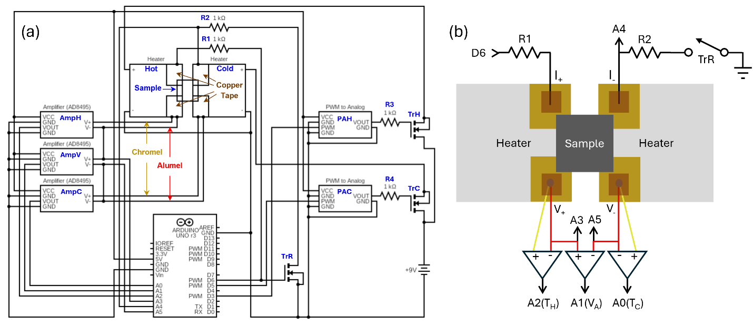
Fig. 1. Circuit diagrams of the setup: (a) Entire setup and (b) Simplified diagram, focusing on the sample area. Two heaters were used to heat and create a temperature difference across the sample, utilizing a 9 V power supply in combination with transistors (TrH and TrC) and PWM-to-Analog converters (PAH and PAC), through PWM outputs (D3 and D5) of the Arduino. Two thermocouple amplifiers (AmpC and AmpH) were used through A0 and A2 to measure the temperatures and their differences across the sample through K-type thermocouples (soldered Chromel and Alumel wires), thermally and electrically anchored to the two bottom corners of the sample via copper tapes as shown in (b). In (b), Chromel and Alumel wires are represented as yellow and red, respectively, following the industry convention; in addition, I₊, I₋, V_{+,} and V₋ represent the four-point contacts in the van der Pauw scheme. Note that in (a), the Chromel and Alumel wires on each copper tape are drawn as if they are separated from each other, but they are in fact soldered together and sandwiched between copper tapes as shown in (b). The voltage developed by this temperature difference was measured between the two Alumel wires through A1 after being amplified by another thermocouple amplifier, AmpV. D6 was used to apply 5 V between the two copper tapes on the upper corners of the sample for resistance (conductivity) measurement of the sample: the electric current was determined by measuring the voltage across R2 through A4, and the voltage across the sample was measured via A3 and A5 between the copper tapes on the bottom corners of the sample. R1 and R2 were used as part of the resistance measurement. R3 and R4 were used just to lower electrical noise and could be removed (shorted) without noticeable difference. Another MOSFET transistor (TrR) was used to isolate the resistance measurement circuitry from the sample during the Seebeck coefficient measurement. Also note that in the circuit diagram (a), the ground of the three amplifiers (AmpH, AmpV, and AmpC) on the left side was not directly shared with the noisy (digital) circuitry on the right: we found that this helps reduce the electrical noise of the small signals. Details of the measurement protocol can be found in the main text. Heat sinks for the transistors and heaters were also used but are not shown here.

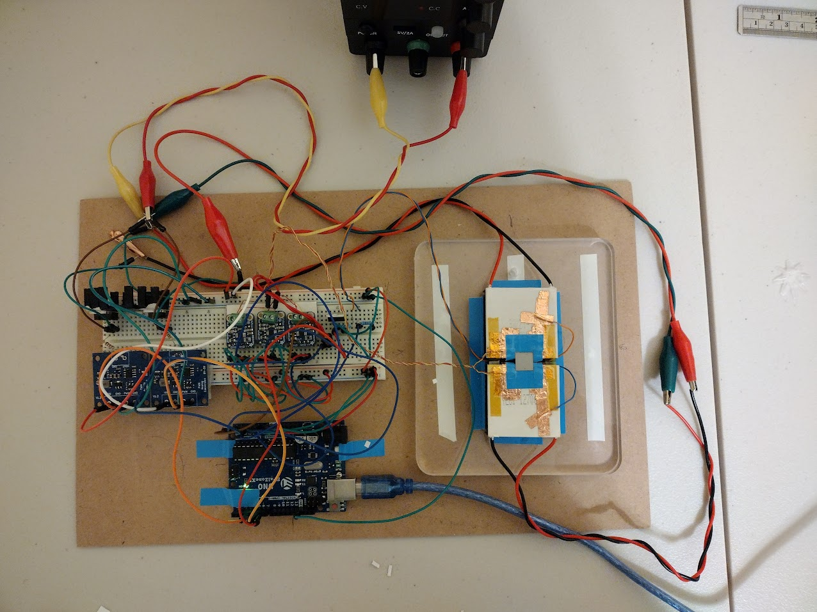
Fig. 2. Photo of the setup. Note that wires with sensitive signals such as the thermocouple wires, or with large currents (for the heaters) are twisted in pairs to minimize inductive noise pickup and noise generation, respectively. Without twisting wires, significant inductive noises could easily dominate the small thermoelectric voltages. Note also that the sample area on the right is rotated 90˚ clockwise relative to the one shown in the circuit diagram of Fig. 1. This setup is designed for a square sample with a 10 × 10 mm² lateral size, surrounded by the blue thermal tape on the two heaters. In the photo, a dummy sample is placed in the sample area with face down, so the four copper tape contacts underneath the sample are not visible. During the measurement, a rubber foot and a weight were placed on the back of the sample (see Fig. 5) to provide good electrical contacts between the sample and the copper tapes.

- Temperature control
To control and automate the temperature of the heaters, a PID controller was used. A PID controller, or Proportional-Integral-Derivative controller, is a commonly used negative feedback system that can keep a measured value close to a target value.¹⁵ An example of such a controller is a home temperature regulator. For the hardware portion of the PID controller, two N-channel MOSFET transistors (TrH and TrC in Fig. 1) were first placed on the breadboard; the software portion is described below in Sec. D. Then, a heat sink was attached to the two transistors in order to dissipate heat during operation. These transistors have three pins, Source, Gate, and Drain, and were configured in the source-follower mode, so the positive terminal of the power supply was directly connected to the Drain of the transistors. Then, the Sources were connected to the heaters in such a way that they would heat up (rather than cool down) the sample when the transistors (TrH and TrC) were turned on. In this mode, the voltage at the Source follows the voltage at the Gate (minus a small threshold voltage), as long as the voltage at the Gate is less than the voltage at the Drain but higher than the threshold voltage. We chose this source-follower mode instead of connecting the heater on the Drain side because the PID control worked much more stably with the almost linear response of the source-follower mode. Next, the remaining wire of each heater was connected to the negative terminal of the power supply and the digital ground of the Arduino.
Then, two Pulse Width Modulation, or PWM outputs (D3 and D5) from the Arduino were each connected to PWM-to-analog converters (PAH and PAC) on the breadboard, the outputs of which were connected to the Gate pins of the transistors. PWM simulates analog outputs through digital signals by rapidly alternating between 0 and 5 V such that the average matches the desired analog voltage between 0 and 5 V. The converters were used because using raw PWM signals to power the heaters resulted in substantial noise in Seebeck coefficient measurements due to electromagnetic induction caused by the alternating current intrinsic to the PWM mode. Furthermore, the PWM-to-analog converter had the option of converting PWM signal to 0 – 10 V (instead of 0 – 5 V) analog signal, and this allowed us to control the voltage across the heaters up to 10 V of the power supply voltage: 5 V of power supply voltage was insufficient to heat up the sample up to 100 ˚C. By utilizing the PWM-to-analog converters, PID controls, and the other circuitry, we were able to control the temperatures of the heaters without introducing much noise during the Seebeck coefficient measurement.

- Resistance and conductivity measurement
To create the setup for resistance measurement, a wire was first attached to each of the upper two copper patches of the sample area with copper tape as shown in Fig. 1, and these wires were connected to the breadboard. Together with the lower two contacts, which were also used for the Seebeck voltage measurement, these copper patches form the four-point van der Pauw geometry of the resistance measurement.¹⁶ Next, on the breadboard, a 1 kΩ resistor (R1) was connected between the hotter side of the sample and a digital output (D6) of the Arduino that could provide a current through the sample. Then another 1 kΩ resistor (R2) was connected between the colder side of the sample to the Drain of an N-channel MOSFET (TrR), with its Gate being controlled by the same digital output (D6) providing the current. The Source of the transistor was connected directly to the digital ground of the Arduino. This transistor (TrR), which disconnected the ground from the sample when the resistance was not being measured, was needed because the sample being directly connected to the ground interfered with the Seebeck measurement.
D6 is normally left in the floating mode, so that the current flow path of the resistance measurement is completely isolated from both the 5 V and the ground in order not to interfere with the Seebeck coefficient measurement. Then, when we want to measure the resistance, D6 is set to 5 V, which then turns on TrR and allows current to flow from 5 V → R1 → sample → R2 → TrR → ground. Because the (Drain-to-Source) voltage across TrR is negligible when turned on, the current (I) flowing through the sample can be determined by measuring the voltage across R2 using A4: that is, I = A4/R2. Considering that R1 = R2 = 1 kΩ in our setup, the maximum current that can flow through the sample is 5 V / 2 kΩ = 2.5 mA, much smaller than the Arduino limit (~20 mA), and the current decreases as the sample resistance grows.
Then, analog inputs A3 and A5 were connected to the Alumel wires of the thermocouples at the input of the voltage-measuring amplifier (AmpV): see Fig. 1(b). These are used to measure the voltage $V=A3-A5$ between the lower corners of the sample when D6 is set to 5 V. The resistance of the sample can then be calculated using the formula R = V/I. However, for low resistance (<~10 Ω) samples, because the voltage across the sample (A3 – A5) becomes too small to be reliable, the amplified signal at A1 (taking into account the 122.4 amplification factor) can be used instead for more accurate resistance measurement. For example, the resistance of the Chromel wire, which was only 1 ~ 2 Ω, was measured through A1 with amplification, whereas that of the Bi₂Se₃ film, which was a few hundred Ohms, was measured through A3 – A5 without amplification.
Finally, by measuring the resistances of two different orientations of the sample, one rotated 90˚ from the other, the sheet resistance R_{S} can be found approximately by $R_{avg}⋅\frac{π}{ln 2}$ according to the van der Pauw method.¹⁶ From the sheet resistance, the conductivity (σ) can be calculated based on the thickness (t) of the sample: σ = $\frac{1}{R_{S}t}$.

- Measurement software
A LabVIEW program (community version) was used for the software portion of the setup. The GUI (Graphical User Interface) was programmed to display and use the analog inputs from the Arduino to automatically calculate and show the Seebeck coefficient, the temperatures, the voltage, and the resistance. The front and back panels of the LabVIEW program with all the displays is shown in Fig. 3. For the software part of the PID controller, the PID function provided by the LabVIEW application was used so that the temperature of the thermoelectric heaters could be automatically set to a specific value, with input from the temperature measurement: the optimal values of P, I, and D parameters were determined manually.
Finally, an automated LabVIEW program was created that measures all six analog channels (A0 through A5), every 0.5 s, at temperatures from 40 ℃ to 100 ℃. The program first set the temperatures of the heaters to 40 ℃ and started measuring the temperatures and voltage (A0 for T_{C}, A2 for T_{H}, and A1 for ΔV). Then, current for the resistance measurement was supplied by applying 5 V through D6, and resistances were measured using the analog inputs on the Arduino: A4 for the current measurement, A3 and A5 for the unamplified voltage measurement, and A1 for the amplified voltage measurement.
Next, the temperature (T_{H}) of the one heater was increased by 10 ℃ to 50 ℃, at which point the program measured the Seebeck coefficient using the output (A1) from the amplifiers. During the Seebeck coefficient measurement, the current-flow path for the resistance measurement was disconnected from the circuitry in order not to interfere with the Seebeck coefficient measurement, by floating D6, which isolates the sample from 5 V as well as from the ground by turning off the transistor (TrR), as described in Sec. C. Then, the temperature (T_{C}) of the other heater was increased to 50 ℃, and the offset voltage and resistance were measured again.
This cycle continued until the temperatures reached 100 ℃, at which point the program terminated and saved the data into a CSV file: see Fig. 4 for an exemplary data sequence. During the post-data-processing, 100 data points of each signal were averaged at each temperature and used as the value corresponding to the temperature; this process reduces the uncertainty of the data by ten times and also provides the standard deviation as an estimate of the data uncertainty.

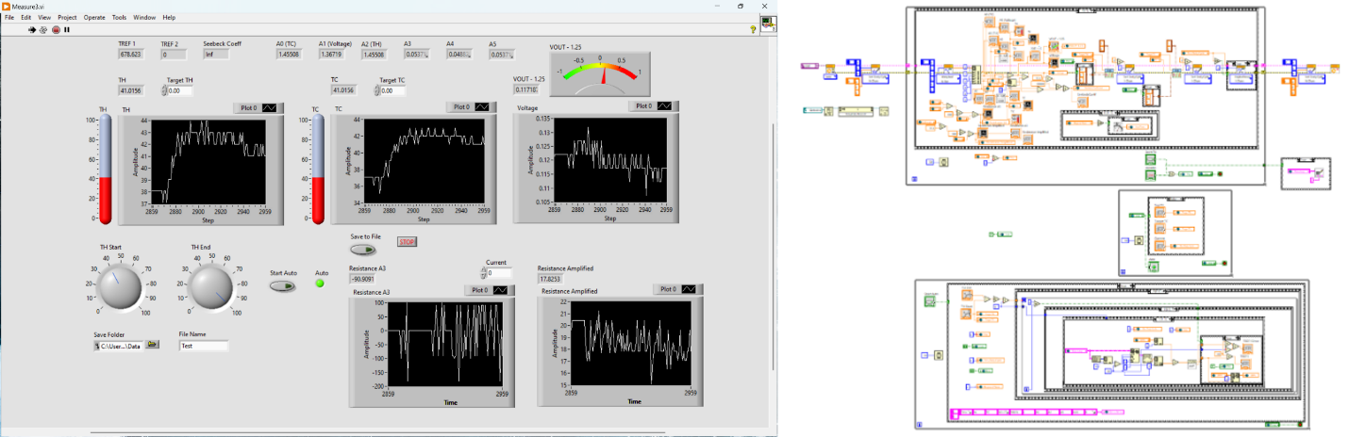
Fig. 3. LabVIEW Front Panel (left image) and Back Panel (right image). This program automates all the controls and measurements as described in the main text.

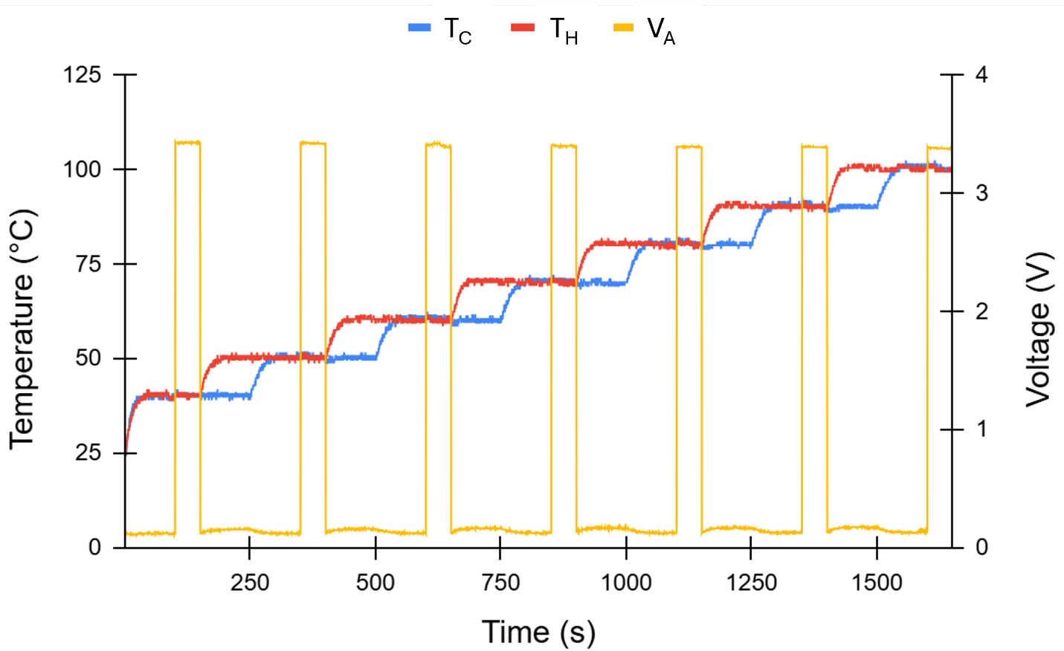
Fig. 4. Exemplary time sequence of temperatures and voltage data. This data shows a time sequence of the cold (T_{C}) and hot (T_{H}) temperatures - T_{C} from A0 and T_{H} from A2, ranging from 40 ˚C through 100 ˚C - and the amplified voltage (V_{A}) at A1. Voltage signals at A3, A4, and A5 were also recorded simultaneously but not shown here to avoid visual cluttering. Each signal was recorded every 0.5 sec. When the temperature difference was stabilized at 10 ˚C, the voltage values at A1 were used to calculate the Seebeck coefficient, and when the temperature difference was stabilized at zero, the resistances, thus conductivities and power factors, were evaluated based on the voltage values at A1, A3, A4 and A5.

- MEASUREMENT PROCEDURE
The measurement setup was first tested on a Chromel wire (AWG 36). Chromel has well-documented Seebeck coefficients as a function of temperature,² so by comparing the measured values of a Chromel wire with the literature, we confirmed the reliability of the setup. Then, both the Seebeck coefficient and resistance (thus conductivity) of a Bi₂Se₃ thin film (30 nm thick, grown on an Al₂O₃ substrate) were measured and compared with the values of similar samples available in the literature.⁹
Figure 5 shows how the measurement was done on the Bi₂Se₃ film. The sample was placed face down on the sample holder. A rubber foot was placed on the back of the sample, and a metal weight was placed on top to provide good electrical contact between the sample and the copper tapes. The power supply was then turned on, and the voltage output was set to 9 V. Then, the automated LabVIEW program shown in Fig. 3 was run and the data (A0 through A5) were recorded as shown in Fig. 4, every 0.5 s, as the temperatures swept from 40 ˚C to 100 ˚C with 10 ˚C steps as shown in Fig. 4. After the program finished running, the sample was then rotated 90˚ and the program was run again. The measured Seebeck coefficients and resistances were averaged between the two orientations, and the sheet resistance was calculated following the van der Pauw scheme, as described in Sec. III C.
For the measurement of the Chromel wire, we used the same setup by placing the wire on the four copper contacts in a U shape. The two end contacts were used for current input during resistance measurement, and the other two middle contacts were used for the temperature and voltage measurements for the Seebeck coefficient and resistance measurements as described in Sec. III A and C. The rubber foot and weight were also placed on top of the wire sample to keep good electrical and thermal contacts. We tested the Chromel wire first to confirm the proper operation of the setup and then moved on to measure the Bi₂Se₃ film.
In this setup, it is notable that we have greatly simplified the way electrical contacts are made. For any transport measurements, making reliable electrical contacts is one of the most critical steps, requiring significant effort and sophistication.^{4,7,12,13} Such complexity is another factor making it difficult to implement thermoelectric measurement in student labs. On the other hand, our method of making electrical contacts by simply using a weight to press the sample from above eliminates the complications involved in making good electrical contacts, lowering the barrier to incorporating thermoelectric measurements for inexperienced students.

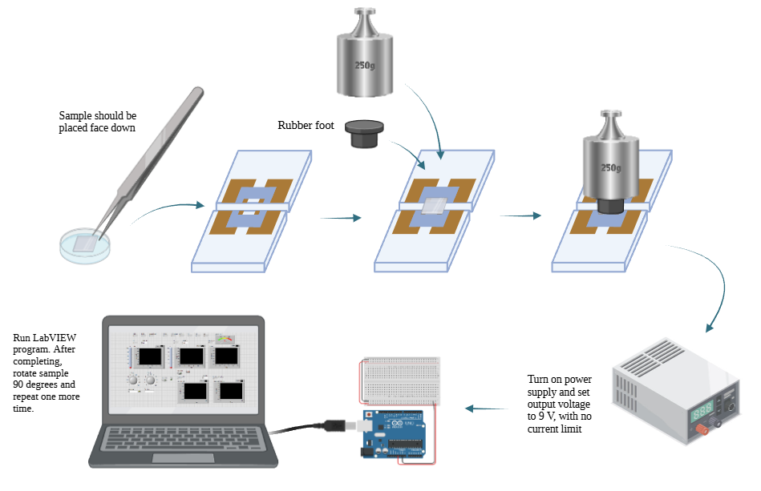
Fig. 5. Sample measurement procedure. This diagram outlines the steps to measure a thin film sample with the film face down. For the wire sample (Chromel), we placed the wire in a U shape on the four copper contacts so that the voltage and temperature were measured between the two middle copper contacts. The outer copper contacts were used for electric current injection in the standard four-point resistance measurement geometry. The wire sample was measured only with one orientation, whereas the thin film sample was measured with an additional 90° rotation in order to utilize the van der Pauw scheme for accurate resistivity estimation.

- TEST RESULTS AND DISCUSSION
Table 1. Seebeck coefficient measurement on a Chromel wire. Literature values of K-type thermocouple (S_{K_L}), Alumel wire (S_{Al_L}), and Chromel wire (S_{Ch_L}) were obtained from Ref. 2. The Seebeck coefficient of the measured Chromel wire (S_{Ch_M}) was obtained by adding S_{Al_L} to the measured S_{K_M} values (S_{K_M} = $-\frac{ΔV}{ΔT}$), because the voltage measurements were done through Alumel wires: S_{Ch_M} = S_{K_M} + S_{Al_L}. Error is defined as (S_{Ch_M} - S_{Ch_L})/S_{Ch_L} ⋅ 100%. 100 data points were measured and averaged at each temperature.
T (℃) | S_{K_M} (μV/K) | S_{K_L} (μV/K) | S_{Al_L} (μV/K) | S_{Ch_M} (μV/K) | S_{Ch_L} (μV/K) | Error (%)
45 | 38.2 ± 3.4 | 41.1 | -18.5 | 19.7 ± 3.4 | 22.6 | -13%
55 | 41.1 ± 3.4 | 41.3 | -18.4 | 22.7 ± 3.4 | 22.9 | -1.1%
65 | 39.4 ± 3.1 | 41.5 | -18.3 | 21.1 ± 3.1 | 23.2 | -9.1%
75 | 42.0 ± 3.6 | 41.6 | -18.1 | 23.9 ± 3.6 | 23.5 | 1.7%
85 | 40.9 ± 4.2 | 41.5 | -17.9 | 23.0 ± 4.2 | 23.6 | -2.4%
95 | 41.5 ± 3.1 | 41.4 | -17.7 | 23.8 ± 3.1 | 23.7 | 0.46%

Table 1 shows the Seebeck coefficients measured on the Chromel wire and compares them with the literature values in the temperature range from 40 ℃ to 100 ℃. As explained in Sec. III A, because we used Alumel wires to measure the voltage between the hot and cold sides of the sample, we need to add the Seebeck coefficient of the Alumel wire to the measured Seebeck coefficient to obtain the Seebeck coefficient of the sample (here, Chromel wire). So if T_{H} is 50 ℃ and T_{C} is 40 ℃, we took the midpoint (45 ℃) as the representative sample temperature, and added the known Seebeck coefficient (S_{Al_L}) of the Alumel wire at 45 ℃ to the measured Seebeck coefficient (S_{K_M}) to get the measured Seebeck coefficient (S_{Ch_M}) of the Chromel wire: that is S_{Ch_M} = S_{K_M} + S_{Al_L}. Uncertainty in S_{Ch_M} is estimated from the standard deviations of 100 data points at each temperature. One can see that the measured Seebeck coefficients (S_{Ch_M}) are all consistent with the literature values (S_{Ch_L}) within the standard deviations (~10%). As for the conductivity (resistance) measurement, because this setup is primarily designed for van der Pauw geometry of thin film samples, we did not try to get quantitatively reliable conductivity values for the wire sample. Nonetheless, we confirmed that the resistance measurement setup works as expected, providing resistance values reasonable for the Chromel wire, based on its known room temperature resistivity of ~0.7 μΩm.

Table 2. Thermoelectric property measurement on a Bi₂Se₃ thin film. S represents the Seebeck coefficient of the Bi₂Se₃ film after taking into account the effect of the probing wire (Alumel), as explained in Table 1 and in Sec. III A. R_{S} is the sheet resistance and was calculated from the equation $\frac{R_{vertical}+R_{horizontal}}{2}⋅\frac{π}{ln 2}$, based on the van der Pauw method.¹⁶ Conductivity was calculated with the formula $σ=\frac{1}{R_{S}t}$, where t is the thickness, 30 nm. Each value was averaged over 100 data points, and the error bar was estimated from the standard deviation.
T (°C) | S (μV/K) R_{S} (Ω/□) σ (kS/m) S²σ ($\frac{W}{m⋅K^{2}}$)
45 | -47.0 ± 2.0 | 347 ± 10 | 96.0 ± 2.9 | 212 ± 19
55 | -47.7 ± 2.1 | 361 ± 9.7 | 92.4 ± 2.5 | 210 ± 19
65 | -49.5 ± 2.1 | 380 ± 10 | 87.7 ± 2.3 | 215 ± 19
75 | -50.4 ± 2.2 | 397 ± 9.8 | 83.9 ± 2.1 | 213 ± 19
85 | -51.3 ± 2.1 | 405 ± 8.9 | 82.3 ± 1.8 | 216 ± 18
95 | -54.1 ± 2.1 | 414 ± 8.5 | 80.5 ± 1.7 | 236 ± 19

Now that we have confirmed that the setup works as expected with the standard Chromel wire, we report, in Table 2, a full set of thermoelectric properties, including Seebeck coefficient, sheet resistance, conductivity, and power factor, on a thin film, which this setup is designed for, using a 30-nm-thick Bi₂Se₃ thin film. Unlike the Chromel wire, which has well-defined Seebeck coefficients, the properties of Bi₂Se₃ thin films vary considerably depending on the exact growth details,^{17,18} so there do not exist standard Seebeck coefficient values of Bi₂Se₃ thin films. With this in mind, our Seebeck coefficient and sheet resistance values are about half of those reported by another group in the literature.⁹ Taking into account the difference in sample and measurement details, a factor of two difference seems reasonable. The wire and thin film test combined show that this setup is capable of measuring Seebeck coefficients with an uncertainty of a couple of μV/K and sheet resistance with an uncertainty of a couple of percents. These uncertainties are conservatively estimated considering that they are based on the standard deviation of the raw data. If we consider the averaging of many data points, the uncertainty of the averaged value will be much smaller.

- CONCLUSIONS
In this study, we developed an affordable (~$100) and easy-to-use thermoelectric measurement setup using Arduino and LabVIEW that can measure both the Seebeck coefficient and power factor simultaneously. By combining amplifiers and noise reduction schemes with the Arduino board, we were able to improve the resolution by over 1000 times, which thus allows measurement of sensitive thermoelectric signals. We tested this setup on a Chromel wire, which has well-defined Seebeck coefficient values available, and confirmed that the measured Seebeck coefficients are consistent with the literature values within ~10%. We then measured a more complete set of thermoelectric properties, including Seebeck coefficient, sheet resistance, electrical conductivity, and power factor, on a Bi₂Se₃ thin film, and confirmed that they are also consistent with previous results. In other words, this setup can provide quantitatively reliable thermoelectric measurements even without expensive research-grade equipment and complex electrical contact schemes. Moreover, although this setup was designed primarily for thin film samples, it can also be utilized for other sample geometries, as demonstrated on the Chromel wire. Altogether, this thermoelectric measurement setup has lowered the barrier to thermoelectric studies both financially and technically, such that experimental studies of thermoelectricity have become easily accessible not only to students but also to professional researchers.

REFERENCES
1. D’Angelo, M., Galassi, C. and Lecis, N. Thermoelectric Materials and Applications: A Review. Energies 16, 6409 (2023).
2. Bentley, R. Theory and Practice of Thermoelectric Thermometry. (Springer, 1998).
3. Ballard, J., Hubbard, M., Jung, S. J., Rojas, V., Ung, R., Suh, J., Kim, M. S., Lee, J., Pierce, J. M. and Venkatasubramanian, R. Nano-engineered thin-film thermoelectric materials enable practical solid-state refrigeration. Nat. Commun. 16, 1 (2025).
4. Auparay, N. Room Temperature Seebeck Coefficient Measurement: Metals & Semiconductors. (BS Thesis, Oregon State University, 2013).
5. Dörling, B., Zapata-Arteaga, O. and Campoy-Quiles, M. A setup to measure the Seebeck coefficient and electrical conductivity of anisotropic thin-films on a single sample. Rev. Sci. Instrum. 91, 105111 (2020).
6. Narjis, A., Elyaagoubi, M., Outzourhit, A. and Nkhaili, L. Design of a simple apparatus for the measurement of the Seebeck coefficient. Measurement 133, 433 (2019).
7. Fu, Q., Xiong, Y., Zhang, W. and Xu, D. A setup for measuring the Seebeck coefficient and the electrical resistivity of bulk thermoelectric materials. Rev. Sci. Instrum. 88, 95111 (2017).
8. Ahad, A. and Shukla, D. K. A setup for Seebeck coefficient measurement through controlled heat pulses. Rev. Sci. Instrum. 90, 116101 (2019).
9. Guo, M., Wang, Z., Xu, Y., Huang, H., Zang, Y., Liu, C., Duan, W., Gan, Z., Zhang, S. C., He, K., Ma, X., Xue, Q. and Wang, Y. Tuning thermoelectricity in a Bi₂Se₃ topological insulator via varied film thickness. New J. Phys. 18, 015008 (2016).
10. Arduino. Data Sheet: Arduino Uno R3. (2025).
11. Kumar, A., Patel, A., Singh, S., Kandasami, A. and Kanjilal, D. Apparatus for Seebeck coefficient measurement of wire, thin film, and bulk materials in the wide temperature range (80-650 K). Rev. Sci. Instrum. 90, 104901 (2019).
12. Liu, J., Zhang, Y., Wang, Z., Li, M., Su, W., Zhao, M., Huang, S., Xia, S. and Wang, C. Accurate measurement of Seebeck coefficient. Rev. Sci. Instrum. 87, 64701 (2016).
13. Wang, C., Chen, F., Sun, K., Chen, R., Li, M., Zhou, X., Sun, Y., Chen, D. and Wang, G. Contributed Review: Instruments for measuring Seebeck coefficient of thin film thermoelectric materials: A mini-review. Rev. Sci. Instrum. 89, 101501 (2018).
14. Data Sheet: AD8494/AD8495/AD8496//AD8497, Precision Thermocouple Amplifiers with Cold Junction Compensation. (2010).
15. Asraf, H. M., Dalila, K. A. N., Hakim, A. W. M., Muhammad, R. H. and Hon, F. Development of Experimental Simulator via Arduino-based PID Temperature Control System using LabVIEW. J. Telecommun. Electron. Comput. Eng. 9, 53 (2017).
16. Oliveira, F. S., Cipriano, R. B., da Silva, F. T., Romão, E. C. and dos Santos, C. A. M. Simple analytical method for determining electrical resistivity and sheet resistance using the van der Pauw procedure. Sci. Reports 10, 1 (2020).
17. Kim, Y. S., Brahlek, M., Bansal, N., Edrey, E., Kapilevich, G. A., Lida, K., Tanimura, M., Horibe, Y., Cheong, S.-W. W., Oh, S., Iida, K., Tanimura, M., Horibe, Y., Cheong, S.-W. W. and Oh, S. Thickness-dependent bulk properties and weak antilocalization effect in topological insulator Bi₂Se₃. Phys. Rev. B 84, 73109 (2011).
18. Bansal, N., Kim, Y. S., Brahlek, M., Edrey, E. and Oh, S. Thickness-independent transport channels in topological insulator Bi₂Se₃ thin films. Phys. Rev. Lett. 109, 116804 (2012).

Available at: https://en.wikipedia.org/wiki/Chromel.

