Leveraging the power of Artificial Intelligence in the modern financial markets: Reinforcement Learning approach to Inventory Management and Adaptive Quoting in Dynamic Market Making

Abstract
This thesis investigates how reinforcement learning (RL) can be used to design profitable and risk-aware market-making strategies in modern electronic limit order book markets. The central focus is on inventory management and adaptive quoting, framed by two research questions: (i) whether RL methods can match or outperform analytically derived strategies, and (ii) whether RL can manage inventory dynamically in a way that controls risk while preserving profitability.
The empirical analysis proceeds in two stages. First, a simple probabilistic model (SPM) of a single asset is used as a controlled benchmark where the optimal market-making policy is known in closed form. In this setting, a tabular Q-learning agent is trained on penalised profit-and-loss (PnL), combining mark-to-market gains with a quadratic inventory penalty. The learned strategy is shown to match the performance of the analytical Avellaneda–Stoikov solution and, in point estimates, to marginally exceed its penalised PnL, while decisively outperforming simple constant-depth and random-depth quoting rules. This demonstrates that model-free RL can recover economically meaningful policies even when a closed-form optimum is available.
Second, the thesis turns to a Markov-chain limit order book (MC–LOB) model, which captures realistic microstructure features but does not admit an analytical solution. Here, both tabular Q-learning and Double Deep Q-Networks (DDQN) are tested in short- and long-horizon configurations, and their strategies are evaluated against heuristic benchmarks. In the short-horizon regime, RL agents achieve small but positive average PnL while keeping inventory fluctuations modest, outperforming naïve strategies that are systematically loss-making. In the long-horizon regime, tabular Q-learning becomes unstable under coarse state aggregation, whereas DDQN learns robustly profitable policies across random seeds, with inventory paths that exhibit intuitive build-and-unwind behaviour over the trading day.
Overall, the results indicate that RL is a viable and often superior alternative to both analytical and heuristic approaches to market making, provided that state representation and function approximation are chosen carefully. The thesis concludes with an outlook on integrating RL-based market makers with transformer-based large language models, highlighting how multimodal and text-driven signals could further enhance state information, risk assessment, and the realism of simulated trading environments.
Key words: Reinforcement learning, Deep reinforcement learning, Market making, Inventory management, Adaptive quoting, Limit order book, Markov chains, Simple probabilistic model, High-frequency trading, Electronic financial markets, Profit-and-loss optimization, Risk-aware trading strategies, Large Language Models in trading

Introduction
This chapter establishes the framework for the dissertation, grounding the research within the current intersection of quantitative finance and modern machine learning. It begins by articulating the motivation for applying Reinforcement Learning (RL) to market making, highlighting both the transformative potential and the inherent challenges of this approach (Section 1.1). Building on this context, the chapter formulates the central hypothesis: that RL-based strategies can outperform traditional analytical strategies by autonomously adapting to stochastic market dynamics (Section 1.2). Subsequently, Section 1.3 defines the specific research objectives, which range from the design of efficient market making agents to the benchmarking of their performance and the implementation of advanced inventory management controls. Finally, Section 1.4 provides a structural roadmap of the thesis, summarizing how each subsequent chapter contributes to the comprehensive investigation of these themes.

Motivation
Financial markets are complex systems characterized by the dynamic interactions of diverse participants, each pursuing distinct objectives. This ecosystem comprises various actors including retail traders, large institutions, arbitrageurs, market makers, and high-frequency traders, all engaging in transactions across different types of markets such as stock markets, bond markets, foreign exchange (Forex or FX markets), commodities markets, and cryptocurrencies [1]–[3] These interactions shape the continual flow of asset prices, as represented in (Figure 1.1) Each participant in the financial markets plays a unique role, contributing to the overall liquidity and depth of the markets. Besides these traditional participants, the financial markets are also influenced by regulatory bodies and technology platforms. Regulatory bodies oversee the functioning of markets, setting rules that aim to ensure fairness and transparency while minimizing systemic risk. Technology platforms, including electronic trading platforms, facilitate the rapid execution of trades and are pivotal in the dissemination of market information.
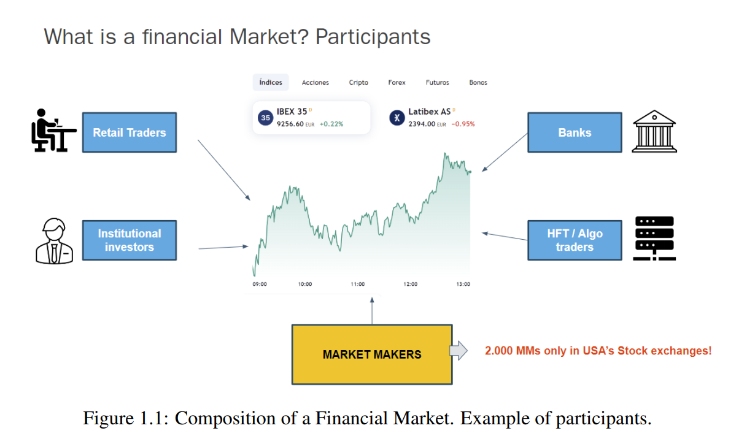
A market maker is a market participant that simultaneously and continuously provides buy and sell prices of a financial asset to provide liquidity to the market and generate a profit off the spread - a process called market making. The core objectives of a market maker are to (1) maximize profits and (2) limit the risk of holding too large of an inventory, which in the event of adverse market movements may inflict large losses. [48]
The optimal market making can be achieved by maximizing a (risk-adjusted) return measure, which combines the two aforementioned core objectives (1) and (2). Typically, the optimal quotes are a function of the market maker’s inventory levels and prevailing market conditions [25]. Traditionally, the problem of the optimal market making has been mathematically modeled with stochastic differential equations based on strict (and often naive) assumptions and solved with classical methods for optimal control, such as dynamic programming [11]. Perhaps the most famous undertaking in this setting is the Avellaneda and Stoikov model from 2007 [6].
The primary and arguably most beneficial function of classical market making is not only to enhance market liquidity as such (especially for the markets and instruments with low liquidity [4] ), but also to provide the traders with a broader range of options for executing their trades.
MMs are essential in ensuring efficient operation of the financial markets. By continuously offering to buy and sell securities, they help fill the gap between supply and demand, which can prevent large price jumps and ensure that trades can be executed quickly. Their presence reduces transaction costs for other market participants and increases market transparency, thereby attracting more traders and investors to the market.
To gain a better understanding of the significance of these agents, as of 2008, there were over 2,000 MMs on the US Stock Exchange [5] and more than 100 in Canada [6], numbers that have likely increased since then.
In their routine operations, MMs typically generate income by matching trades against other market participants. This income primarily arises from the bid-ask spread, which is the difference between the lowest price a seller is willing to accept (ask) and the highest price a buyer is willing to pay (bid) [7], as depicted in Figure 1.2.
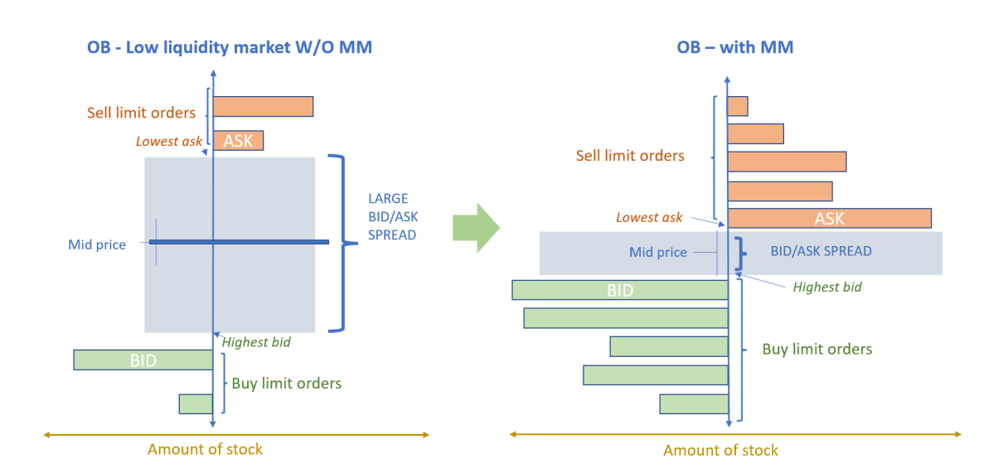
Figure 1.2: Example of the impact of a MM in a low liquidity asset order book. A MM usually populates the order book allowing the rest of the market’s participants to have more prices to trade with.
For MMs, a wider bid-ask spread means higher profit margin per transaction. The spread not only reflects the liquidity of an asset but also serves as an indicator of the general market conditions. Typically, markets with lower liquidity exhibit wider spreads, suggesting a higher compensation for MMs who provide liquidity under these conditions.
Furthermore, MMs are also engaged in sophisticated inventory management control. As they execute trades, their inventory levels fluctuate; they may increase if buying activity outweighs selling, and decrease in the opposite scenario. The main challenge with holding inventory is the risk associated with market price fluctuations, which can significantly affect the value of held assets. Such price volatility can lead to substantial financial gains or losses in their Mark-to-Market (MtM) value, depending on the nature of the inventory and market price movements at the time of liquidation. MtM is a financial accounting technique used to value assets and liabilities at their current market prices. MtM is widely used in the trading of securities and derivatives, where market prices can fluctuate significantly in short periods, making timely valuation crucial. By updating the valuation of these financial instruments regularly, MtM accounting allows for a transparent view of investment performance and risk exposure.
Managing inventory is a critical aspect that necessitates meticulous risk assessment and management strategies. The optimization of this balance, aimed at maximizing profitability while minimizing risks, revolves around strategic decisions regarding the setting of bid and ask prices—the spread. Effective spread management not only ensures profitability but also reduces market risk exposure by maintaining an appropriate level of inventory that aligns with current market dynamics and future market expectations.
Additionally, the non-stationary aspect of financial markets demands continuous monitoring and adaptive strategies from those involved. Traders, investors, and MMs must constantly update their models and approaches to align with the current market state, ensuring their methods are responsive to the latest market conditions. This dynamic environment makes financial markets complex and unpredictable, requiring sophisticated tools and analytical techniques to navigate effectively.
Due to the complexities and challenges outlined, the operation of every MM presents a particularly challenging problem for several reasons:
1. Competitive environment: MMs operate in a highly competitive environment
where interactions are not limited to independent agents; they also face competition from other MMs and participants. This competitive landscape requires that they continuously adapt their strategies to stay ahead or simply keep pace with others in the market.
2. Inventory risk management: A significant part of a MM’s role involves managing inventory risk effectively. They must balance the inventory of financial instruments they hold to avoid substantial losses due to adverse price movements. Proper inventory management is crucial to mitigate risks associated with holding too much of a depreciating asset.
3. High dimensionality of information: The information that MMs must process is typical of high dimensionality, involving continuous variables such as price, volume, and inventory levels. The complexity of this data requires sophisticated models and algorithms to make informed trading decisions quickly and accurately.
4. Dynamic and evolving environment: The trading environment is not static but
evolves continuously and unpredictably. Changes can occur without prior warning,
altering the dynamics of the market and potentially rendering previous strategies
ineffective. MMs must be agile, with the ability to quickly adapt their strategies in
response to these changes. Each of these factors contributes to the intricate nature of a MMs’ role within financial markets. They must navigate through a labyrinth of competitive pressures, risk management, complex data, and an ever-changing environment, which demands a high level of expertise, sophisticated analytical tools, and adaptive strategies. This dynamic setting not only challenges MMs but also underscores the importance of continuous learning and evolution in their methodologies.
Advances in artificial intelligence (AI) and computer processing have enabled a new paradigm in optimal market making to gain attention and popularity in academia and the financial industry. Methods belonging to the specific branch within AI called machine learning (ML) – automated analytical model building – are used to teach an agent how to make markets optimally. These methods remedy many of the restrictions and downsides with analytically obtained strategies.
The specific class of machine learning methods used is reinforcement learning (RL), which involves an agent learning from experience interacting in a stochastic environment [68]. Applying RL methods for optimal market making is a relatively novel, albeit highly promising, endeavor. Indeed, there seems to exist a consensus in the academic community that RL approaches to optimal market making are superior to standard market making strategies. [25]
Since market making naturally can be framed as a Markov decision process, reinforcement learning lends itself particularly well for it [25]. While vanilla reinforcement learning methods typically cannot handle problems with large state and/or action spaces (like market making with extensive market data), recently developed deep reinforcement learning (DRL) techniques can circumvent these flaws by approximating e.g., the state-action values with neural networks [5].
Notably, the agent in reinforcement learning needs to interact with the environment for it to learn, which is not possible with historical data, which is why simulations of the market have been used, such as Markov and RNN (recurrent neural network) models [41]. Several authors have successfully used generative models to find optimal market making strategies with DRL methods such as Deep Q-Learning (DQN) and Double Deep Q-Learning (DDQN). However, one should also note that some success has been found with non-deep models. [25]
This thesis will explore Q-learning and DDQN in two ways of modeling the market: a simple probabilistic model from [11] and a Markov chain model from [39].

1.2. Objectives
This dissertation aims to comprehensively explore and evaluate the application of RL in market making strategies within competitive financial markets. The research focuses on the profitability, adaptability, and strategic inventory management of RL-based MMs under dynamic market conditions. Specifically, this involves (1) examining different models for the underlying asset and the limit order book, (2) framing the optimal market making problem in different ways, (3) assessing feasible and reasonable state and action spaces, (4) finding functioning reward signals, (5) comparing the performance of RL-methods and analytically derived strategies.
Specifically, the following research questions will be investigated:
- Research Question 1 (RQ1): Are reinforcement learning methods able to outperform more traditional analytically derived strategies?
- Research Question 2 (RQ2): Can reinforcement learning algorithms prove to be efficient in dynamic inventory management, focusing on minimization of the risk associated with holding inventory while maximizing profitability.
In summary, this thesis aims to comprehensively examine the potential of RL approach to surpass the traditional approaches to market making by equipping MMs with strategies that are adaptive, robust, and optimized for the complexities of modern financial markets.
Through this exploration, the thesis aims to contribute to the advancement of both the theoretical understanding and practical implementation of RL in financial market applications, ultimately promoting more resilient and efficient markets.

1.3. Delimitations
This thesis does not aim to be an exhaustive account or examination of reinforcement learning for market making. Instead, only a certain subset of possible combinations of order book models, reinforcement learning methods, and problem settings will be considered. This work will primarily focus on the static Markov chain limit order book model in which a single market maker agent interacts with the market as a whole. The Markov chain model jointly and implicitly models the actions of other market participants. Additionally, only Q-learning and DDQN – one tabular and one deep technique – out of all existent (D)RL methods will be deployed. For tabular learning methods, the state space will be considerably curtailed to increase the learning speed, thus forfeiting information that the agent could use to infer better strategies. Furthermore, a constant and simplistic action space is considered in all experiments, limiting the possibility for more sophisticated and granular strategies. Additionally, only risk-neutral reward formulations are considered, somewhat limiting the learning of risk-averse strategies.
The static modeling of the market can be considered as limiting to the performance of the learned strategies in a real market, which is why the findings of this thesis can be regarded as demonstrative and highlighting possible frameworks that can be used in reinforcement learning applications for market making.

1.4. Outline
The remaining part of this thesis is organized into 5 sections structured in the following way:
- Section 2: Background and Related Work - introducing the relevant theoretical background and related work in the field;
- Section 3: Experiments setup and Results – outlining the experiments setup and a comprehensive summary of the results;
- Section 4: Discussion and Future Work – presenting further observations and outlining possible trajectories for future research;
- Section 5: Conclusion – wrapping up the thesis and stating the definitive results;
- Section 6: “Appendices” – Presenting the additional research results and derivations, as well as bibliography along with the lists of tables, acronyms and notations.

1.5. GIT Repository
All code related to the experiments setup and the results, as well as the additional charts and graphs can be accessed via GIT Hub repository https://github.com/alex-platonov/RL_in_MM_thesis

2. Background Theory & Related Work
The landscape of financial markets is continuously reshaped by advancements in technology and quantitative analysis, influencing strategies in trading and particularly in market making. This chapter provides a detailed review of the state of the art in market making, emphasizing the evolution from traditional models to sophisticated computational approaches that leverage RL and its derivatives. The purpose is to frame the current research within the broader context of recent technological advancements and to highlight the progress that has been made as well as the gaps that this thesis aims to address.
This section introduces all the underlying concepts of the modern markets such as the Limit Order Book (LOB) and illustrates it mathematically. Further, it outlines the theory of the Reinforcement Learning (RL) approach. The third part of the section addresses the problem of optimal Market Making (MM) restating it both as a classical financial problem as well as a machine learning problem.
This section also provides a short overview of the previous work on the topic.

2.1. Background Theory

2.1.1 Modern Electronic Markets and the Limit Order Book
The following section will describe the financial context, thus providing the first half of the general background of the thesis. Key concepts of financial markets are discussed to provide a better understanding of their movements, dynamics, and characteristics, and where the market making agent will have to perform.
As introduced in Section 1.1, financial markets are characterized by the interaction of various participants, each with different goals, strategies, operations, and impacts on the market itself.
The most numerous retail traders, often individuals, engage in trading on a smaller scale, primarily influenced by personal goals and risk tolerance. They add significant volume to trades, especially in highly liquid markets like Forex and stocks. However, the influence of individual retail traders is typically smaller compared to institutional traders.
Large institutions, such as mutual funds, pension funds, and insurance companies, trade in large volumes and can significantly impact market prices with their large-scale transactions. Their strategies are typically more sophisticated, involving long-term positions and hedging techniques.
Arbitrageurs seek to exploit price discrepancies between markets or securities, adding to market efficiency by ensuring that prices do not deviate substantially from their fair values for long. Their strategies are crucial in maintaining the interconnectedness of global markets, ensuring that anomalies between similar financial instruments are minimized.
High-frequency traders (HFTs) use advanced algorithms to move in and out of positions in seconds or milliseconds. HFTs thrive in markets where speed is a critical factor and can capitalize on very small price differences. Their activities contribute to market liquidity and can also lead to increased volatility when large volumes of trades are executed quickly.
The interaction between these diverse market participants and technologies not only drives the day-to-day movements in asset prices but also shapes the strategic evolution of financial markets. Innovations such as automated trading and artificial intelligence are reshaping strategies, while global economic events and policy changes continue to test the resilience and adaptability of market structures.
The mentioned participants take part in a perpetual auction, submitting buy and sell orders through a centralized public limit order book (LOB), which is crucial in determining asset price movements [54]. The OB serves as an electronic catalog that lists all pending (unmatched) orders. It is continuously updated, with new limit orders being added and executed orders being removed in a first-in-first-out (FIFO) sequence. This dynamic process offers a real-time representation of the market’s supply and demand dynamics in terms of price and volume, showcasing the vibrant and fluid nature of financial markets.
Each level within the OB displays the total volume of orders at specific price points, providing valuable insights into the market depth and the potential for upcoming price movements. Such information is vital for market participants in strategizing their entries and exits. Additionally, the transparency of the OB allows for an understanding of market sentiment and potential price support or resistance levels. A graphical depiction of the LOB’s key elements, illustrating its structure and function, can be found in Figure 2.3. This visualization aids in comprehending how orders are organized and executed, influencing overall market liquidity and price stability
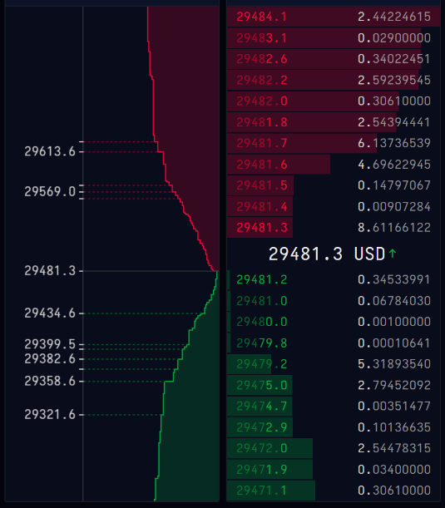
Figure 2.3: Visual representation of a LOB
Liquidity is critical because it reflects the ease with which assets can be bought or sold at stable prices. The level of liquidity in a market is heavily influenced by the number of active participants and the volume of transactions taking place. In conditions where liquidity is lacking, even large orders can lead to severe price fluctuations. Such orders quickly fill up the LOB, causing significant changes in the asset’s price. These volatile conditions can lead to substantial financial losses for investors in a short period, which can diminish confidence in the asset or even the entire market.
MMs counteract these risks by ensuring a steady stream of orders, which helps to stabilize the market. They act as a buffer against sharp price movements by balancing the buying and selling pressures through their continuous order flows. The vital role of MMs in enhancing the stability and liquidity of financial markets is illustrated in Figure 1.2, which shows the impact of MMs on the LOB and, consequently, on market liquidity.
One significant characteristic of every financial market is the non-stationarity [55]–[58]. Financial markets are not static; they evolve continuously, influenced by a variety of factors. Elements such as trading session schedules [59], news [60] , and economic expectations [61] serve as triggers for these changes, generating non-stationarity in the market itself. These factors collectively impact the inherent dynamism of price movements, complicating the task of defining stable and robust strategies. Furthermore, the introduction of new financial products and the entrance of new technology in trading systems, such as algorithmic and high-frequency trading, also contribute to the non-stationary nature of markets. These technological advancements can drastically change trading patterns and volumes within very short periods, often leading to unexpected volatility or new market trends.

2.1.1.1. Mathematical description
Mathematically speaking, one may consider an order x to be a tuple (px, ωx, tx, τx), where px is the price, ωx ∈ Z is the volume posted (if ωx > 0 then x is a sell order and if ωx < 0 then x is a buy order), tx is the submission time of the order, and τx is the order type. In the stylized limit order book in this thesis, the allowed order types are buy limit order (LB), sell limit order (LS), cancel buy order (CB), cancel sell order (CS), buy market order (MB), and sell market order (MS). As such, τx ∈ {LB, LS, CB, CS, MB, MS}. Note that for all orders resting in the limit order book, (px, ωx, tx) typically provides sufficient information with regards to the priority (see Primer 1) as all orders are active limit orders and the sign of ωx indicates whether it is a sell or a buy order.
Returning to the initial description of an LOB as a collection of non-executed limit orders, we may denote the LOB at time t as L(t), which is the set of all active limit orders. A limit order is active if it has not been executed or canceled yet. The set of active buy LOs at time t as B(t) and the set of active sell LOs at time t are denoted as A(t).
An important component of a LOB is its tick size. The tick size δ constitutes the smallest permissible interval between two price levels, and the LOB is thus defined on a discrete grid of prices (i.e., the price levels) [11]. In FX markets, the tick equivalent is called pip and constitutes the smallest quoted unit of the spot price. Whenever applicable in this thesis, δ will also denote the pip. As two examples, the tick size for 1AAPL (ticker for Apple Inc. listing on Euronext) is EUR 0.01, and for the currency pair EUR/USD, the pip is 0.0001.
Next, some critical quantities of an LOB are defined. We refer to Table 2.1 for Mathematical definitions of these quantities are referred in the Table 1. The bid price, b(t), is the highest price among all buy orders in the LOB. The ask price, a(t), is the lowest price among all sell orders in the LOB. For the purposes of the present thesis, it is assumed that the ask price is always greater than the bid price. The difference between the ask and bid prices is called the bid-ask spread, denoted by s(t). The mid-price, m(t), is the (non-weighted) average of the bid and ask prices. The bid volume, qb(t), and ask volume, qa(t), are the volumes posted on the bid and ask prices. Similarly, the volume on price level p, qp(t) is posted. The micro price, µ(t), is a weighted average of the bid and ask prices and is adjusted for order imbalances in the bid and ask. It may be noticed that (perhaps somewhat unintuitive at first) the weight of the bid price is the ask volume divided by the total bid and ask volume, and vice versa for the ask price (Table 2.1). The idea is that this weighting incorporates the order imbalance into the mid-price and better captures the “true” price [11]. The order imbalance for the top n levels, ρn(t), measures the imbalance in posted volumes on the bid and ask sides for the n first price levels. It is a number in [−1, 1], where ρ close to −1 indicates an ask-heavy imbalance and ρ close to 1 indicates a bid-heavy imbalance.

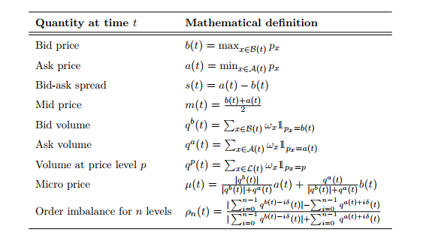
Table 1: Mathematical definitions of important quantities related to the limit order book

Note 1: Order priority and matching algorithms.
Order Priority and Matching Algorithms
Different exchanges have distinct order matching algorithms and rules that rank and match buy and sell orders. All active orders are ranked according to an order precedence hierarchy. The primary ranking criterion is price, e.g., an incoming buy market order will execute first against the sell limit order on the best ask before potentially moving to the next price level(s). If there is more than one limit order on a price level, secondary criteria are needed to rank the orders. A widespread secondary criterion is time, i.e., the first order to arrive at a price level usually has priority over later-arriving orders. Some trading systems prioritize displayed volume over hidden volume (in the case of iceberg orders) before the order submission time is considered. The New York Stock Exchange (NYSE) employs a price-parity hierarchy where (designated) market makers’ orders are prioritized as a secondary rule, after which time follows as a third rule. [8]
[Cite your source here.]
Correct textbox biblio link

2.1.1.2. Illustration of dynamics
This section aims to illustrate the dynamics of the limit order book graphically. First and foremost, a snapshot of an LOB (with a limited number of price levels displayed) is presented in the upper-left of Figure 2.4. Multiple characteristics of an LOB described in previous sections can be observed, including the various price levels (separated by the tick size), the aggregated quantity posted on each level, the bid and ask price, and the bid-ask spread. Next, we display what happens to the LOB for arriving market orders, limit orders, and cancellations.
In the upper-right of Figure 2.4, we see an arriving buy market order with a volume of three in orange. Notice how it first is matched against the entire volume posted on 10, 001 (i.e., a volume of two), and the remaining volume of one is bought at 10, 002. In the lower-left in Figure 2.4, a buy limit order of size two at price level 9, 999 arrives, depicted in light blue. Lastly, the graph in the lower-right of Figure 2.4 shows in light pink the cancellation of a sell limit order at price level 10, 003 resulting in the removal of one share from the outstanding volume.
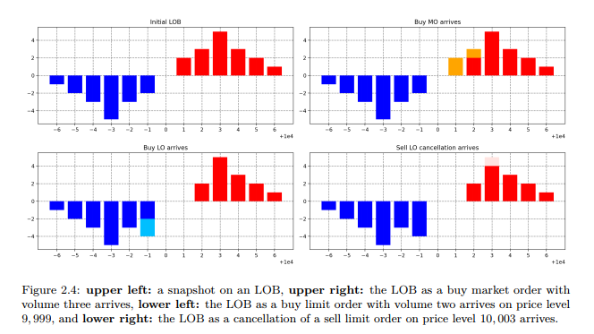
Redraw with python/visio and adjust the ref caption

2.1.1.3. Modelling the Limit order book
It is valuable to be able to model a limit order book realistically for various reasons. In this thesis, we employ reinforcement learning to teach an agent how to make markets optimally. Saving the details of what this entails for later sections, employing reinforcement learning requires a huge number of interactions in the environment (i.e., limit order book) before a (nearly) optimal strategy can be found. One approach to finding this strategy is to simply let the agent learn from interacting and experimenting on its own in real financial markets. Once the agent has learned an optimal strategy, the potential reward from this can be large, albeit the losses that can accrue during learning are immense. Therefore, before letting an AI agent “loose” in the markets, it is advantageous if it can train in an as realistic environment as possible. Even if the aim is not to put the trained AI into production to trade in the markets but rather merely to study the optimal behavior, it is still desirable to have realistic depictions of the reality. The primary model used in this thesis is a Markov chain LOB model, which is presented in Section 2.1.1.3.2, before which we briefly cover a simpler model.
It should be noted that these models only model the regular intraday evolution of the limit order book. However, there are events such as the opening and closing auctions and, e.g., circuit breakers that are not modeled with these models. Specific auction rules are used to match orders during these occasions rather than the regular LOB rules.
Many assets (equities, futures, commodities, and FX) are typically traded across multiple trading venues. One usually refers to this as market fragmentation. It should be noted that the modeling in Section 2.1.1.3.2 may also be generalized and considered to work in this setting. For example, the Markov chain modeling of the LOB may be viewed as the modeling of an aggregate of bids and asks in fragmented markets (instead of an actual limit order book). In addition to regular trading venues, dark pools (also known as Alternative Trading Systems) have since 2007 gained popularity as an alternative type of trading venue. Dark pools are trading venues where the limit order book is hidden from all market participants. [1] According to Nasdaq, dark pools capture approximately 40% of the US equity trading volume [44]. The modeling in the present thesis does not consider dark pools, but there exist some works that support simultaneous trading in lit (“regular”) and dark financial markets, see, e.g., [11, 13, 19]. It should be noted that these works all consider the problem of optimal execution of a larger block of shares or similar.

2.1.1.3.1 Simple Probabilistic Model
As a first environment, we adopt the simple probabilistic model (SPM) introduced by Cartea et al. and later used as a benchmark in Carlsson and Regnell. The model does not attempt to describe the full limit order book. Instead, it captures three key ingredients:
- the stochastic evolution of the mid-price,
- the arrival of market orders, and
- the probability that a given limit order is executed when a market order arrives.
The mid-price $S_{t}$follows a Brownian motion with constant volatility:
$$S_{t}=S_{0}+σW_{t},0≤t≤T,$$
where $W_{t}$is a standard Brownian motion, $σ>0$is the volatility parameter, and $S_{0}=μ$is the initial mid-price level. Both $σ$and $μ$are constant throughout the episode.
Arrivals of buy and sell market orders are modeled as independent Poisson processes:
$$M_{t}^{+},M_{t}^{-}∼\text{Poisson}(λ^{+}),\text{ Poisson}(λ^{-}),$$
with constant intensities $λ^{+},λ^{-}≥0$. Here $M_{t}^{+}$counts buy market orders up to time $t$and $M_{t}^{-}$counts sell market orders.
The market maker controls quote depths relative to the prevailing mid-price. At each time $t$, the agent selects bid and ask offsets
$$δ_{t}^{-},δ_{t}^{+}≥0,$$
which determine the standing bid and ask quotes:
$$\text{Bid: }S_{t}-δ_{t}^{-},\text{Ask: }S_{t}+δ_{t}^{+}.$$
When a market order arrives, the market maker’s corresponding limit order is filled only with a distance-dependent probability. Conditional on the arrival of a buy or sell market order at time $t$, the probability that it executes the maker’s standing order is modelled as
$$P(\text{fill of ask at }t∣\text{buy MO})=e^{-κ^{+} δ_{t}^{+}}, \\ P(\text{fill of bid at }t∣\text{sell MO})=e^{-κ^{-} δ_{t}^{-}},$$
where $κ^{+},κ^{-}>0$are fixed “competitiveness” parameters. Large values of $κ^{±}$imply that even a small increase in depth causes a sharp drop in fill probability, thus encouraging the market maker to quote closer to mid-price if they wish to trade frequently.
In this specification there is a single market maker and at most one buy and one sell limit order outstanding at any time. There is no explicit order book, and no queue position; the only microstructure elements are mid-price diffusion, Poisson order flow and the exponential fill-probability structure. The main advantage of this stylised set-up is that it admits a closed-form optimal control solution, which can be used as an analytical benchmark when we later compare it to strategies obtained by tabular Q-learning. In the remainder of the thesis we refer to this environment simply as the Simple Probabilistic Model (SPM).

2.1.1.3.2. Markov Chain Model
The second environment is a Markov chain limit order book model, originally proposed by Hult and Kiessling and adapted by Hultin et al. and Carlsson & Regnell.
In contrast to the SPM, this framework explicitly tracks the volume posted at each price level on both sides of the book. The LOB evolves as a continuous-time Markov chain driven by the arrival of different order types.
The model distinguishes six event types:
- $L^{B}$: arrival of a buy limit order,
- $L^{S}$: arrival of a sell limit order,
- $C^{B}$: cancellation of a buy limit order,
- $C^{S}$: cancellation of a sell limit order,
- $M^{B}$: arrival of a buy market order,
- $M^{S}$: arrival of a sell market order.
Each event causes a transition in the Markov chain by modifying the volume at one or more price levels.

2.1.1.3.2.1. Vector representation of the book
Rather than keeping track of individual orders $\left(ω_{x} , t_{x}\right)$, we work with a coarse-grained representation of the book. Following Hultin et al., the state of the LOB at time $t$is encoded by two finite vectors that store volumes at a fixed number of price levels around the best bid and best ask.
Let $δ$denote the tick size and consider $d∈N$price levels on each side of the book. We define:
- The ask-side vector
$$(a(t), q_{b(t)+δ}(t),…,q_{b(t)+dδ}(t)),$$where $a(t)$is the current best ask price and $q_{b(t)+iδ}(t)$is the total ask volume posted at price level $b(t)+iδ$, i.e. the $i$-th tick above the best bid.
- The bid-side vector
$$(b(t), q_{a(t)-δ}(t),…,q_{a(t)-dδ}(t)),$$where $b(t)$is the best bid price and $q_{a(t)-iδ}(t)$is the total bid volume at price level $a(t)-iδ$, i.e. the $i$-th tick below the best ask.
Together, these two vectors summarise the visible part of the book: the best bid/ask and the aggregated volume at the first $d$levels on each side. Information about individual orders and their arrival times is intentionally discarded; the state captures depth, not queue identities.
Throughout this thesis we fix $d=10$, meaning that only ten price levels on each side are modelled. In a real LOB, the number of levels is effectively unbounded, so choosing a finite $d$is a truncation. In practice, level-2 data feeds often provide the top 10 levels, which makes $d=10$a natural choice. Increasing $d$would quickly inflate the state space and make learning more difficult, especially once the entire LOB state is included in the RL agent’s input.

2.1.1.3.2.2. Markov chain state and notation
Formally, let $n∈N$, $n≥2$, denote the total number of discrete price levels considered. At time $t$, the LOB state is the vector
$$s_{t}=(s_{t,1},…,s_{t,n})^{⊤},$$
where $s_{t,i}$is the signed volume at price level $i$(positive for ask volume, negative for bid volume, or vice versa depending on convention). The set of all admissible states is denoted by $S$.
For a given state $s∈S$, we write $\text{bid}(s)$and $\text{ask}(s)$for the best bid and best ask prices implied by that state. We assume that for all feasible states and all times,
$$\text{bid}(s)<\text{ask}(s),s∈S,$$
and in particular that the outermost levels $s_{t,1}$and $s_{t,n}$always contain positive volume on the bid and ask side, respectively, so that the spread is well defined.
To describe individual transitions, we let $e_{p/δ}$denote the $n$-dimensional unit vector with a 1 in the coordinate corresponding to price level $p$(i.e. $p/δ∈\{1,…,n\}$) and zeros elsewhere. If $x=(p_{x},ω_{x},t_{x},τ_{x})$is an order event with price $p_{x}$and signed size $ω_{x}$, then:
- a limit order at price $p_{x}$modifies the state as
$$s⟶s+ω_{x} e_{p_{x}/δ},$$adding volume to the corresponding level;
- a cancellation removes volume,
$$s⟶s-∣ω_{x}∣ e_{p_{x}/δ},$$provided enough volume is present at that level;
- a market order walks the book from the best quote outward, consuming volume until its size is filled or the truncated book is exhausted (details are given in the full definition of transition rates).
Order sizes are random. Let $∣ω∣$denote the absolute size of an incoming limit or market order. Following Hult and Kiessling, we assume discrete distributions for these sizes with probability mass functions $p_{L}(⋅)$for limit orders and $p_{M}(⋅)$for market orders:
$$P(∣ω∣=k∣\text{limit order})∝f_{L}(k),k∈N, \\ P(∣ω∣=k∣\text{market order})∝f_{M}(k),k∈N,$$
where $f_{L}$and $f_{M}$are specified functional forms (e.g. exponentially decaying), and the proportionality sign emphasises that appropriate normalising constants are applied so that the probabilities sum to one. The sign of $ω$encodes the side: by convention we may take $ω>0$for sell-side volume (asks) and $ω<0$for buy-side volume (bids).
Equipped with these ingredients—event types, arrival intensities, order-size distributions and the transition rules above—the LOB evolves as a continuous-time Markov chain on the state space $S$. This Markov chain will serve as the underlying environment in the RL experiments described in Chapter 3, where we embed a market-making agent that can post, cancel and update orders at a lower frequency than the raw event flow.

2.1.2. Reinforcement learning
This section establishes the theoretical framework for the research, providing a detailed exposition of the core principles governing Reinforcement Learning (RL) and Deep Reinforcement Learning (DRL). Beyond the fundamental components and algorithms, the discussion extends to the specific challenges posed by complex, dynamic environments—namely, optimization and non-stationarity. We examine how standard architectures are adapted to balance competing incentives and maintain robustness amidst shifting underlying distributions. This comprehensive overview serves as the necessary foundation for justifying the advanced methodologies developed later in this dissertation.
Reinforcement Learning (RL) is rooted in the fundamental concept of learning through trial and error, a mechanism observed in biological systems where behavior is shaped by its consequences. In this paradigm, an agent interacts with an environment, observing the outcomes of its actions and receiving feedback in the form of a reward signal—analogous to biological stimuli such as satisfaction or survival. Over time, the agent reinforces behaviors that yield positive outcomes, effectively learning to navigate its environment through experience.
In the computational domain, this intuition is formalized as an optimization problem. RL is defined as the process of learning a mapping—known as a policy—from situations (states) to actions, with the objective of maximizing a numerical reward signal. Unlike supervised learning, which relies on labeled datasets, the RL agent must discover which actions yield the most reward by trying them [68].
While early applications of RL focused on problems such as credit assignment, the field has recently achieved distinct prominence due to its integration with Deep Learning (discussed further in Section 2.1.2.3). This synergy, termed Deep Reinforcement Learning (DRL), has enabled agents to solve high-dimensional problems that were previously intractable.

2.1.2.1. Markov decision process
As established, RL [68] serves as the foundational framework for the market making problem. This problem is mathematically formalized as a Markov Decision Process (MDP).

An MDP is defined by the tuple, $M = ⟨S, A, T, R⟩$where:
- $S$ denotes the State Space, representing the set of all possible configurations of the environment (e.g., the state of the Limit Order Book and the agent's inventory);
- $A$ denotes the Action Space, comprising the set of all valid operations available to the agent;
- $T$ represents the Transition Function (or dynamics), which defines the probability distribution of transitioning to a new state $s'$ given the current state $s$ and action $a$;
- $R$ is the Reward Function, providing the immediate feedback signal based on the state-action pair.
This framework is robust enough to model both deterministic environments and, more crucially for financial applications, stochastic environments, where outcomes are subject to probabilistic dynamics even when identical actions are taken.
The interaction between the agent and the environment occurs in discrete time steps, $t$. At each step, the agent observes the current state $S_{t}$, selects an action $A_{t}$, and receives a reward $R_{t+1}$ alongside the subsequent state $S_{t+1}$., as depicted in Figure 3
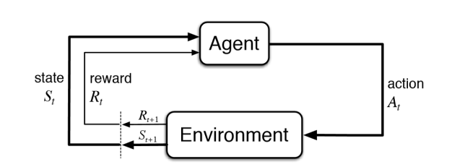
Figure 3: RL Agent and environment interactions.
The ultimate objective in this framework is to discover an optimal policy, denoted as $π$. A policy is a mapping (strategy) that dictates the action the agent should select when in a given state. The goal is to maximize the expected return, $J\left(π\right)$, which represents the cumulative discounted reward from an initial state distribution: $J\left(π\right)=E_{π}\left[\sum_{t=0}^{∞}{γ^{t}R_{t+1}}\right]$ In this formulation, $E_{π}\left[⋅\right]$ denotes the expectation over the trajectories induced by following policy $π$. The term $γ∈\left[0,1\right)$ is the discount factor, which determines the present value of future rewards, balancing the trade-off between immediate and long-term profitability. Consequently, the optimization problem is to identify the optimal policy $π^{*}$ that maximizes this global objective function: $π^{*}=\arg{\max_{π}{J}}\left(π\right)$.

2.1.2.2. Value functions in RL
In the Reinforcement Learning framework, value functions are fundamental for assessing the utility of specific states and actions. By estimating the expected future rewards, these functions enable the agent to distinguish between favorable and unfavorable configurations of the environment. The following two formulations are primarily distinguished: the state-value function ($V$) and the action-value function ($Q$).
The state-value function, denoted as $V^{π}\left(s\right)$, quantifies the expected return (the cumulative sum of present and future discounted rewards) initiating from a state $s$, conditional on the agent adhering to policy $π$. Formally, it is defined as:
$$V^{π}\left(s\right)=E_{π}\left[\sum_{t=0}^{∞}{γ^{t}r_{t+1}} ∣ s_{t}=s\right]$$
In this equation, $E_{π}$ denotes the expectation over the distribution of trajectories induced by policy $π$, while $γ∈\left[0,1\right]$ serves as the discount factor, determining the present value of future rewards. While the global objective $J\left(π\right)$ provides an aggregate metric of policy performance, $V^{π}\left(s\right)$ offers a granular, local perspective for each specific state.
Complementary to this is the action-value function, or Q-function, denoted as $Q^{π}\left(s,a\right)$. This function estimates the expected return of selecting a specific action $a$ while in state $s$, and subsequently following policy $π$. Its definition is given by:
$$Q^{π}\left(s,a\right)=E_{π}\left[\sum_{t=0}^{∞}{γ^{t}r_{t+1}} ∣ s_{t}=s,a_{t}=a\right]$$
The Q-function is particularly critical for control tasks, as it allows the agent to evaluate the immediate utility of an action against the long-term strategic policy.
These two functions are intrinsically linked. The value of a state $V^{π}\left(s\right)$ can be derived by averaging the Q-values over all available actions, weighted by the policy's probability distribution. This relationship varies depending on whether the policy is stochastic or deterministic:
$$V^{π}\left(s\right)=\sum_{a∈A}{π\left(a | s\right)Q^{π}\left(s,a\right)} \text{(Stochastic Policy)}$$
$$V^{π}\left(s\right)=Q^{π}\left(s,π\left(s\right)\right) \text{(Deterministic Policy)}$$
The ultimate goal in RL is to identify the optimal policy $π^{*}$ that maximizes the expected return. This implies the existence of optimal value functions, $V^{*}\left(s\right)$ and $Q^{*}\left(s,a\right)$, defined as the maximum value achievable under any policy:
$$V^{*}\left(s\right)=\max_{π}{V^{π}}\left(s\right)$$

$$Q^{*}\left(s,a\right)=\max_{π}{Q^{π}}\left(s,a\right)$$
For the optimal policy, the relationship between $V^{*}$ and $Q^{*}$ is defined by the maximization operation:$V^{*}\left(s\right)=\max_{a∈A}{Q^{*}}\left(s,a\right)$

2.1.2.2.1. Tabular Methods and the Curse of Dimensionality
In environments with discrete and limited state-action spaces, these values can be computed exactly using tabular methods, where each state-action pair is explicitly stored. The most representative algorithm in this category is Q-learning [10], which iteratively updates Q-values using the Bellman equation. The update rule is defined as:
$$Q\left(s,a\right)←Q\left(s,a\right)+α\left[r+γ\max_{a^{'}}{Q}\left(s^{'},a^{'}\right)-Q\left(s,a\right)\right]$$
However, when applied to complex domains like market making, where the state space (e.g., the Limit Order Book) is high-dimensional or continuous, tabular methods encounter the "curse of dimensionality". This phenomenon refers to the exponential growth in computational complexity as the dimensions of the state space increase, rendering exact tabular storage impractical.

2.1.2.2.2. Transition to Deep Reinforcement Learning (DRL)
To address this, it is necessary to employ function approximators capable of generalizing across vast state spaces. This motivates the use of Neural Networks (NNs), transforming traditional RL into Deep Reinforcement Learning (DRL). NNs approximate the value function by mapping high-dimensional states to value estimates, allowing the agent to infer the utility of unseen states based on learned patterns rather than direct experience.
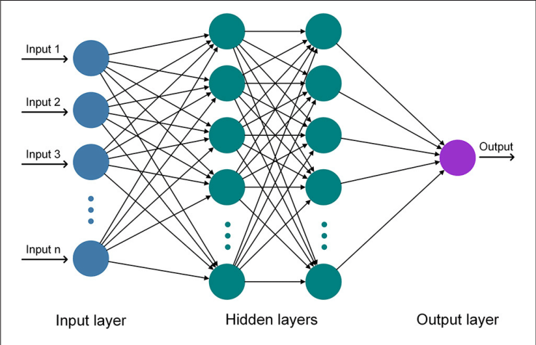
Figure 4: An illustration of an artificial neural network

While powerful, the integration of NNs introduces significant challenges. Deep networks can be unstable during training, particularly when combined with the bootstrapped updates characteristic of Q-learning. To mitigate this, advanced techniques such as Experience Replay [12], which breaks correlations between consecutive updates by sampling past experiences randomly. Furthermore, the use of "black box" NNs raises concerns regarding explainability, as the complex internal parameters often obscure the rationale behind the agent's decisions [14].

2.1.3. Optimal Market Making: Dealing with the market making problem
Having established the operational mechanics of financial markets and the theoretical foundations of Reinforcement Learning (RL), the dissertation now addresses the specific challenges of systematic market making. The literature describes a diverse spectrum of strategies employed to manage inventory and provide liquidity. Historically, this domain was dominated by classical analytical methods grounded in stochastic optimal control and statistical modeling. These frameworks relied on rigorous mathematical assumptions to derive optimal pricing policies. However, the emergence of advanced Machine Learning (ML) and RL paradigms has fundamentally altered the trading landscape, enabling strategies that adapt to complex, non-linear market dynamics.
The subsequent sections delineate the evolution of these methodologies. First, the discussion examines the traditional analytical strategies that established the precedent for automated trading. These foundational methods, rooted in stochastic calculus, serve as critical baselines for performance evaluation.
Following this, the focus shifts to contemporary computational advancements. This portion provides a detailed analysis of how Supervised Learning (SL) and, more significantly, Reinforcement Learning are applied to the market making problem. Special emphasis is placed on the capability of RL agents to autonomously learn optimal trading policies through direct interaction with the market microstructure. By juxtaposing these modern techniques against established analytical benchmarks, the relative strengths and limitations of each approach are highlighted, providing the necessary context for the methodologies developed in this research.

2.1.3.1 Market-making as a classic financial problem
The problem of market making has been a subject of extensive inquiry within quantitative finance for decades. A seminal contribution to this field was established by Avellaneda and Stoikov [8], who synthesized the inventory framework of Ho and Stoll [9] with the microstructural dynamics of the Limit Order Book (LOB). fundamentally, this approach seeks to determine a symmetrical optimal spread around a calculated reservation price, contingent upon a pre-defined inventory management strategy.
In this model, the reservation price serves as a theoretical indifference point, adjusted to reflect the agent's current inventory imbalance. It is computed as a function of four primary variables:
- The current mid-price of the asset.
- The deviation of the agent's current inventory from the target level.
- A risk aversion coefficient, quantifying the agent's sensitivity to inventory exposure.
- The volatility of the underlying asset.
By combining this reservation price with a parameter representing market liquidity (specifically, the density of order flow in the LOB), the model derives the optimal quotes required to align the agent's holdings with the target strategy while maximizing the expected spread capture.
This foundational work inspired significant extensions. Notably, Guéant et al. [64] refined the analytical solution by applying a change of variables to the associated Hamilton-Jacobi-Bellman (HJB) equations, thereby providing a closed-form solution for agents with bounded inventory constraints. More recently, these authors extended the Avellaneda framework to the domain of multi-asset market making, addressing the complexities of managing inventory risk across a portfolio of correlated assets [65]. These contributions represent an evolution of the original stochastic control framework, enhancing its applicability to realistic market constraints.
Beyond the specific lineage of Avellaneda and Stoikov, the literature encompasses alternative analytical approaches. In the context of High-Frequency Trading (HFT), researchers have proposed solutions predicated on rigorous liquidity analysis. These studies [66] suggest that the analysis of LOB liquidity distribution serves not only as a metric for execution quality but also as a predictive signal for short-term price drift.
In summary, the analytical resolution of the market making challenge has been pursued through diverse methodologies. While some strategies prioritize the stochastic dynamics of the LOB, others focus on liquidity modeling or inventory control, collectively establishing a rich theoretical backdrop for the data-driven approaches explored in this dissertation.

2.1.3.2 Market-making as a machine learning problem
Apart from traditional market making strategies, which are predominantly based on analytical mathematical techniques, the adoption of ML strategies has become increasingly prevalent in recent years. The integration of ML into the financial sector has revolutionized many aspects of trading, including market making. This subsection examines how ML, diverging from classical approaches, offers new dimensions of analysis and strategy development. With the advent of sophisticated algorithms, the traditional landscape of market making has been transformed, allowing for more dynamic mechanisms capable of adapting to complex market microstructures.
ML in market making can be broadly categorized into two streams: Supervised Learning (SL) and RL. Each stream provides a unique approach to tackling the challenges faced by MMs, from predicting price drifts to developing autonomous trading agents that interact with and learn from the market environment in real-time.
Beyond the classical analytical approaches presented in Subsection 2.1.3.1, there is a growing body of work in the context of ML. The first stream, SL, aims to model or forecast market dynamics directly. The second, RL, adopts a distinctly different methodology by developing agents that engage with the market based on a policy refined through trial and error.
Within the realm of SL, researchers leverage historical market data to predict future trends or generate trading signals. This predictive capability is fundamental to strategy design, where signals serve as indicators for executing trades. These signals are typically derived from a variety of sources, including LOBs, trade flows, and alternative data sets. The essence of SL lies in its ability to provide foresight into imminent market movements1. Notably, studies such as 2 have explored its utility in predicting short-term price movements to inform optimal inventory positioning. However, a significant limitation of SL methods is their reliance on historical distributions; they are often static and do not easily adapt to regime shifts or the market impact of the trader's own actions.
The application of RL to market making has seen a diverse progression of strategies, evolving from simple tabular methods to complex DRL architectures.
Development of RL Strategies: Early works, such as those by Chan and Shelton3, pioneered the use of RL in market making, employing methods like SARSA (an on-policy Temporal Difference (TD) control algorithm used in RL to learn the value of a policy) and actor-critic algorithms. These foundational studies utilized simple simulated markets with discrete state variables, demonstrating the feasibility of RL for inventory management. Subsequent research has expanded on this foundation. For instance, Patel innovated by combining micro and macro agents to optimize distinct aspects of the trading process4. Spooner et al. shifted focus towards realistic simulations of the LOB using TD learning methods, utilizing asymmetrically dampened PnL rewards to manage inventory risk5. Further contributions by Lokhacheva et al. integrated technical indicators like the Exponential Moving Average (EMA) and Relative Strength Index (RSI) into the state space to enhance agent performance6.
Multi-Agent Environments: Recognizing that real-world markets are driven by the interaction of heterogeneous participants, research has expanded into multi-agent environments. Ganesh et al. explored competitive scenarios where RL agents aim to outperform other market makers, highlighting the adversarial nature of liquidity provision. Similarly, other studies have modeled markets populated by both informed and uninformed traders to test the robustness of RL strategies against adverse selection8.
Consideration of Inventory Risk: A notable gap in early RL strategies was the lack of attention to inventory risk, with a predominant focus on maximizing PnL. Approaches that neglect inventory constraints present a significant limitation. To bridge this gap, recent research explicitly incorporates inventory management into the reward function. Common techniques include penalizing the squared inventory at each time step to encourage mean reversion, or applying a terminal penalty based on the liquidation cost of the remaining inventory at the end of an episode10. Some studies also leverage utility functions, such as Constant Absolute Risk Aversion (CARA), to explicitly model the agent's risk appetite.

2.1.3.2.1. Simulated Environments in RL
The training of RL agents requires a robust environment that provides feedback on actions taken. While RL can theoretically be performed in real-time on live markets (Online RL), this is practically infeasible for training due to the immense financial risk and the slow accumulation of experience. Consequently, high-fidelity market simulators are essential.
Using simulators provides a risk-free sandbox where agents can explore strategies and learn from mistakes without financial repercussions. They allow for "faster than real-time" training, enabling agents to experience millions of trading interactions in a fraction of the time required in the real world. However, the reliance on simulation introduces the "reality gap"—the discrepancy between the simulator's dynamics and the complex, noisy reality of live markets.
In this thesis, two distinct simulation frameworks are employed to evaluate RL strategies.

2.1.3.2.1.1. Simple Probabilistic Model (SPM)
As explained before in 2.1.1.3.1. SPM is derived from the foundational framework of Cartea et al.12. This model does not simulate the full Limit Order Book but rather models the mid-price dynamics and the arrival of market orders stochastically. This model allows for the evaluation according to the following parameters:
- Mid-Price Dynamics: The mid-price $S_{t}$ follows a standard Brownian motion diffusion process: $S_{t}=S_{0}+σW_{t}$.
- Order Arrivals: The arrival of buy and sell market orders is modeled as Poisson processes with intensities $λ^{±}$. The probability of a limit order being filled is conditioned on the distance (depth) from the mid-price, typically modeled as an exponential decay function $e^{-κδ}$.
- Utility: The primary advantage of the SPM is that it allows for the derivation of closed-form analytical optimal strategies (such as the Avellaneda-Stoikov solution). This provides a theoretical "ground truth" against which the convergence and optimality of RL agents can be benchmarked.

2.1.3.2.1.2. Markov Chain LOB Model
To address the simplifications of the SPM, MC LOB Model is employed, based on the work of Hult and Kiessling15. This environment offers a higher degree of realism by explicitly modeling the evolution of the LOB volume at discrete price levels.
- State Representation: The LOB is represented as a state vector containing the volumes at the best bid and ask levels.
- Event Dynamics: Transitions between states are driven by a continuous-time Markov chain where events correspond to the arrival of Limit Orders (LO), Market Orders (MO), and Cancellations. The intensities of these events are calibrated to real high-frequency data (e.g., Euronext XPAR order flows)16.
- Microstructure Features: Unlike the SPM, the MC model captures the impact of queue position, the granular cost of crossing the spread, and the interplay between volume imbalance and price probability. This environment serves as a more rigorous testbed for Deep RL agents (such as DDQN), requiring them to learn policies based on high-dimensional state representations of the order book rather than simplified parameters17.
By utilizing these two complementary environments, this research bridges the gap between theoretical optimality and practical application in complex market microstructures.

2.2. Related work
As delineated in Section 2.1.3, the market making problem has been investigated through a multitude of paradigms, ranging from classical analytical methods to contemporary ML techniques. A significant portion of the literature focuses exclusively on profitability, while a broader body of work attempts to simultaneously address the critical challenge of inventory management. Among the strategies incorporating inventory constraints, the predominant approach involves the inclusion of a static penalty term within the reward function. This penalty is applied either terminally at the conclusion of an episode or continuously throughout the trading session. However, a fundamental limitation persists in both methodologies: the reward function remains static, failing to adapt to shifting market conditions—a deficiency this dissertation seeks to rectify. Furthermore, training methodologies vary significantly across the domain. Some studies rely on historical data for offline training, while others utilize simulations derived from the LOB, calibrated to historical data, or generated via agent-based interactions. As discussed in Section 2.1.3.2.1, this research advocates for the use of an agent-based market simulator due to its inherent advantages in modeling complex market dynamics.
The research previously reviewed in preparation of this thesis primarily addresses the following three objectives:
- Evaluation of the RL scenarios in terms of profitability [88]: the necessary empirical groundwork for validation of RL approach as a robust and viable methodology for addressing the stochastic complexities inherent in the market making problem;
- Dynamic inventory management using RL: focuses on inventory management and is driven by two different approaches: inventory management via reward engineering [71] and [78] Multi-Objective Reinforcement Learning - (MORL) [89] and [90];
- Adapting MM strategies to address the issue of non-stationarity: although obvious, not many papers focus in this problem. The only comprehensive study covering this topic is [91].

3. Experiments setup and Results
This chapter constitutes the empirical core of the dissertation, presenting a series of rigorous experiments designed to validate the proposed methodologies. The investigation commences with an analysis of the SPM, where market making strategies derived via Reinforcement Learning are benchmarked against traditional analytical optimal strategies. This comparison establishes a performance baseline in a controlled stochastic environment. Subsequently, the scope expands to the high-fidelity Markov Chain LOB model. Within this complex microstructural framework, both tabular methods and DRL architectures are implemented and scrutinized. The chapter concludes with a comprehensive comparative analysis, evaluating the efficacy, stability, and convergence properties of each approach.

3.1. Computational infrastructure
Initial prototyping and coding have been done on a Lenovo ThinkPad® P51 with a modified Intel® Core i5 vPro 8th gen processor. The experiments have been run on the following AWS ® infrastructure:
- Tabular Q-Learning, Market Simulation experiments - EC2 C6i / C7g;
- Deep Q-Network (DDQN) Training - EC2 G4dn Instance with NVIDIA T4;
- Hyperparameter tuning & stability testing - SageMaker Training.

3.2. Experimental design
The following set of parameters will be defined and used for the experiments.

3.2.1 SPM
The following parameters will be defined for the SPM experiment:
- State Space;
- Action Space;
- Reward;
- Training Parameters and Hyperparameters;
- Environment STEP function

3.2.2. Markov chain LOB model
The following parameters will be used for RL and DRL experiments based on the Markov Chain LOB model.

3.2.2.1 Environment setup
- Action Frequency;
- Horizon;
- Order depth;
- Invalid actions;
- Market Impact;
- Order Priority

3.2.2.2 Q-learning
- State space;
- Action space
- Reward.

3.2.2.3. DRL
- State space;
- Action space;
- Network design;
- Rewards;

3.2.3. Evaluation metrics
Defining precise criteria for desirable outcomes is a prerequisite for the successful training of an optimal market making agent. This section explores the specific techniques employed to quantify performance.
Although RL has demonstrated efficacy in solving increasingly complex problems, the reproducibility of state-of-the-art DRL methods presents a growing challenge. [35] The following characteristics are usually cited as compromise reproducibility: intrinsic factors (e.g., random seeds, stochastic environment properties) and extrinsic factors (e.g., hyperparameters, codebases), as well as network architecture, reward scaling, and the choice of simulation environment (e.g., OpenAI Gym) significantly influence experimental results.
Given the inherent instability of many RL algorithms, standard metrics such as average cumulative reward or maximum reward are often insufficient for rigorous comparison. Instead, the adoption of robust statistical metrics, including confidence bounds, power analysis, and significance testing are usually suggested. Furthermore, the imperative of transparent reporting, stating that researchers must disclose "all hyperparameters, implementation details, experimental setup, and evaluation methods" to facilitate the reproduction of baseline and novel methods is emphasized. [35] Since this dissertation applies DRL to market making—a relatively nascent domain—adherence to these rigorous standards is critical.

3.2.3.1 Confidence Bounds
To derive a statistically significant mean and confidence bound, resampling with replacement (bootstrapping) is typically employed. This technique facilitates the estimation of the 95% confidence interval for the results.

3.2.3.2. Significance
Establishing statistical significance is paramount when evaluating the performance gains of a Reinforcement Learning algorithm. However, standard validation methods utilized in Supervised Learning, such as k-fold t-tests, are often inapplicable to RL.
In this research, Welch’s t-test is utilized to statistically compare strategies. It constitutes a two-sample location test used to validate the null hypothesis that two populations share equal means, without assuming equal variances.

3.3. Results
This chapter presents the empirical findings of the research, structured to evaluate the efficacy of RL in market making across varying degrees of environmental complexity. As stated in the Section 3.2 the analysis begins with the SPM, where RL-derived strategies are benchmarked against traditional analytical solutions to establish a baseline of optimality. Subsequently, the investigation advances to the Markov Chain LOB model, examining the performance of both tabular Q-learning and DRL agents within a high-fidelity microstructure simulation. The results are quantified using the statistical metrics defined in Section 3.2.3, specifically focusing on average reward, profit-and-loss (PnL) distribution, and inventory management stability.

3.3.1 SPM
The first set of experiments focuses on the simple probabilistic model introduced in Section 3.2.1. In this environment, the mid-price follows a stochastic process with mean reversion, market orders arrive as independent Poisson processes on the bid and ask sides, and the market maker’s inventory is subject to a quadratic holding penalty. The goal is to learn, via tabular Q-learning, a quoting policy that reproduces (or improves upon) the analytically optimal strategy in this stylized setting.
To keep the Q-table manageable, the trading horizon is truncated to a short finite time interval with episode length $T=5$. This implies that the optimal strategy in this experiment is a discretised version of the continuous solution presented earlier, rather than the infinite-horizon policy.

3.3.1.1. State space
The state is deliberately kept low-dimensional and consists of two variables:
- the current time index $t$, and
- the current inventory level $Q_{t}$.
Both are discretised to obtain a finite Markov decision process:
$$(t,Q_{t})∈S=\{0,1,…,T\}×\{-q,…,q\},$$
with $T=5$and inventory bounds $q=3$.
Hence, the state space has
$$∣S∣=(T+1) (2q+1)=6×7=42$$
distinct states. This choice mirrors the arguments that appear in the analytical solution (time to maturity and current inventory), while keeping the Q-table compact enough for exhaustive tabular learning.

3.3.1.2. Action space
Actions are specified as integer quote depths (in ticks from the mid-price) on the bid and ask sides:
$$(δ_{t}^{-},δ_{t}^{+})∈A=\{0,…,\overset{ˉ}{d}-1\}×\{0,…,\overset{ˉ}{d}-1\},$$
where $δ_{t}^{-}$and $δ_{t}^{+}$are the bid and ask depths respectively, and $\overset{ˉ}{d}$is the maximum allowed depth.
Because the analytically optimal quotes in this SPM never lie more than two ticks away from the mid-price, it is sufficient to set $\overset{ˉ}{d}=4$. This gives the agent a small degree of freedom to select “sub-optimal” depths (3 ticks) and thus explore slightly off-optimal behaviour:
$$∣A∣=4×4=16.$$
Combining the state and action spaces, the Q-table has
$$∣S∣×∣A∣=42×16=672$$
entries. One consequence of this truncation is that the analytically optimal infinite depth at the extreme inventory levels $Q_{t}=±q$cannot be represented exactly because $+∞$is not part of $A$. At those boundaries, any learned “optimal” action is necessarily an approximation to the true continuous-time prescription.

3.3.1.3. Reward
The reward function follows the classical penalised PnL structure suggested in the SPM formulation:
$$R_{t}=ΔV_{t}-ϕQ_{t}^{2},$$
where $ΔV_{t}$denotes the change in the market maker’s mark-to-market portfolio value over step $t→t+1$, and $ϕ>0$is an inventory-aversion parameter.
Portfolio value is defined as
$$V_{t}=\left\{\begin{matrix}X_{t}+H_{t}, & 0≤t<T, \\ X_{T^{-}}+Q_{T}(S_{T}-αQ_{T}), & t=T,\end{matrix}\right.$$
where:
- $X_{t}$is the cash account,
- $H_{t}$is the mark-to-market value of inventory at time $t$,
- $S_{T}$is the mid-price at terminal time $T$, and
- $α>0$is a permanent market-impact parameter applied when liquidating residual inventory at the end of the episode.
In the experiments, the SPM parameters are set to the standard configuration used in the reference study:
- Inventory penalty: $ϕ={10}^{-5}$
- Poisson arrival intensities: $λ^{+}=λ^{-}=1$
- Mean-reversion coefficients: $κ^{+}=κ^{-}=100$
- Inventory limits: $q=-3, q=+3$
- Permanent impact: $α={10}^{-4}$
- Mid-price volatility: $σ=0.01$
- Mid-price drift: $μ=100$
This specification yields a relatively active market with non-trivial inventory risk, but still simple enough to serve as a controlled testbed for Q-learning.

3.3.1.4. Training parameters
The Q-learning agent is trained for
$$1.5×{10}^{7}$$
episodes per run, and the entire training procedure is repeated independently ten times with different random seeds.
To ensure broad exploration of the state space, exploring starts are used for the inventory: at the start of each episode, the initial inventory $Q_{0}$is drawn uniformly from the admissible range $\left\{-3,…,3\right\}$. This forces the agent to frequently experience states with large positive and negative positions, rather than spending most of its time near zero inventory.
Action selection during training uses an $ε$-greedy policy combined with exploring starts. Both exploration mechanisms share the same linear decay schedule:
- initial exploration rate $=1.0$,
- final exploration rate $=0.05$,
- the decay is completed over the first 50% of the training episodes, after which exploration remains at 0.05 for the remainder of learning.
The learning rate $α_{\text{LR}}$follows an exponential decay schedule:
- initial learning rate $α_{\text{LR}}=0.5$,
- final value $α_{\text{LR}}=5×{10}^{-6}$at the end of training.
The idea is straightforward: a large step size is useful early on, when Q-values are far from optimal, while a very small learning rate is preferable later, once updates should only fine-tune the policy.
The discount factor is set to $γ=1$. Since every episode has a fixed finite horizon $T=5$, the sum of discounted rewards is finite even without discounting, and $γ=1$ensures that the agent evaluates terminal PnL and inventory penalties without artificial time preference.
All Q-values are initialized to zero at the start of each run.

3.3.1.5 STEP Function Algorithm
The continuous-time environment is described in detail in Section 2.2.3.1, and its discretization is introduced in Section 2.3.1.1.
For the experiments in this chapter, a discretized version of this environment is implemented in Python, following the standard interface of OpenAI’s Gym so that reinforcement-learning agents can interact with it through a step function and a reset mechanism.
The stochastic price model (SPM) is parameterized as follows:
- The inventory penalty parameter is set to $ϕ={10}^{-5}$.
- Bid-side and ask-side market-order arrival intensities are symmetric, with $λ^{+}=1$ and $λ^{-}=1$.
- The mean-reversion coefficients for the bid and ask sides are $κ^{+}=100$and $κ^{-}=100$.
- The inventory is constrained to lie in the interval $\left[q , \overset{ˉ}{q}\right]$, with lower bound $q=-3$and upper bound $\overset{ˉ}{q}=3$.
- The permanent impact parameter is chosen as $α={10}^{-4}$.
- The mid-price process has volatility $σ=0.01$ and drift $μ=100$.
The Q-learning agent interacts with this environment through an explicitly coded tabular algorithm, rather than via a pre-built reinforcement-learning library. The overall logic of one environment transition is summarized in the following STEP function.

Algorithm 1 Environment STEP function

1: function STEP($\text{action }a$)
2: update the mid price
3: if $t≤T$then
4: remove the current bid and ask prices
5: set the new bid and ask prices according to the action $a$
6: simulate the number of market-order (MO) arrivals, $a_{t}^{b}$and $a_{t}^{s}$
7: simulate the number of MOs that will be executed, $e_{t}^{b}$and $e_{t}^{s}$
8: if $q≤Q_{t-1}-e_{t}^{b}+e_{t}^{s}≤\overset{ˉ}{q}$then
9: execute the orders
10: else
11: adjust $e_{t}^{b}$or $e_{t}^{s}$such that $q≤Q_{t-1}-e_{t}^{b}+e_{t}^{s}≤\overset{ˉ}{q}$
12: execute the orders
13: if $t=T$then
14: liquidate the market maker’s position
15: calculate the reward $R_{t}$
16: $t←t+Δt$

3.3.1.6. Experimental outcomes
The Q-learning procedure was run ten times, each run consisting of $1.5×{10}^{7}$episodes.
Each trained strategy was then evaluated over ${10}^{6}$episodes, and the resulting episode rewards—interpretable as the market maker’s penalised profit-and-loss over the trading horizon—were summarised.
Across the ten runs, the average episode reward $r$is consistently around $3.52×{10}^{-2}$, with a typical standard deviation $σ_{r}$close to $3.20×{10}^{-2}$. The largest difference in mean reward between any two runs is below $0.5\%$. From a financial perspective, this indicates that the learned quoting policy delivers a very stable level of expected (penalised) profitability across different random seeds of the simulated market, with variability in realised P&L that is of the same order but not exploding. The state-value estimate at the initial state $\left(t,Q_{t})=(0,0\right)$, denoted $v^{*}(0,0)$, is also tightly clustered around $3.52×{10}^{-2}$, which is consistent with the realised episode rewards and suggests that the policy is close to internally coherent in terms of its value estimates.
The time-series diagnostics in the training plots (average reward and state value with $±1$standard-deviation bands) show narrow shaded regions, meaning that different runs converge to very similar financial performance profiles. The average reward curve lies slightly below the corresponding state-value curve, reflecting two design choices: exploring starts and an $ε$-greedy policy. Both inject additional exploratory trades, which lower realised rewards compared to the purely greedy policy that the state-value function effectively represents.
Aggregating the ten runs, the 95% confidence interval for the mean episode reward is $\left(0.03522 , 0.03526\right)$. This narrow interval highlights that the expected penalised P&L delivered by the learned strategy is not only positive but also very precisely estimated in the simple probabilistic model.
The Q-tables from the ten runs were then averaged to obtain a “mean strategy”, which was compared with several benchmark market-making policies over ${10}^{6}$evaluation episodes. In terms of average reward $r$and standard deviation $σ_{r}$:
- The best single Q-learning run achieves $r≈3.529×{10}^{-2}$with $σ_{r}≈3.211×{10}^{-2}$.
- The mean Q-learning strategy slightly improves this to $r≈3.542×{10}^{-2}$and $σ_{r}≈3.205×{10}^{-2}$, suggesting that averaging across runs filters out some idiosyncratic noise in individual policies.
- The discretized analytically optimal strategy yields $r≈3.506×{10}^{-2}$and $σ_{r}≈3.132×{10}^{-2}$, while the continuous analytical strategy attains $r≈3.537×{10}^{-2}$with $σ_{r}≈3.060×{10}^{-2}$.
- The constant-depth strategy (both sides fixed two ticks from mid) produces a lower average reward of $2.674×{10}^{-2}$and $σ_{r}≈2.848×{10}^{-2}$.
- The random strategy, which selects depths uniformly from the action space, performs worst, with $r≈1.852×{10}^{-2}$and the highest variability, $σ_{r}≈3.520×{10}^{-2}$.
From a financial viewpoint, these numbers show that both analytical and learned strategies deliver clearly positive expected P&L, while naive quoting schemes (constant or random depth) leave a substantial amount of money on the table and/or expose the market maker to higher P&L volatility. The mean Q-learning strategy slightly outperforms even the continuous analytical benchmark in terms of average reward, with a comparable risk level. This apparently paradoxical “outperformance” does not imply that reinforcement learning has beaten the true continuous-time optimum; rather, it reflects that the environment used for training is a discretized version of the original model. The analytical solution is optimal in the continuous-time formulation, whereas Q-learning directly optimizes performance in the discretized market used for simulation. In that discretized setting, the learned policy attains the best risk-return trade-off among the strategies considered.

3.3.2. Markov chain LOB model
In the second part of the empirical study, the simple probabilistic model is replaced by a Markov-chain limit order book (LOB) model of the type introduced in Section 2.1.1.3.2. This environment explicitly tracks posted volume at each price level and generates order flow as a continuous-time Markov chain, which brings the simulated market one step closer to realistic microstructure.
The experiments follow a two-stage design. In a first step, the state–action space is deliberately kept compact, so that tabular Q-learning can be applied without loss of underlying LOB complexity (Section 3.2.2). In a second step, the state representation is enlarged to include a richer description of the book, and Double Deep Q-Networks (DDQN) are used to learn a policy on this higher-dimensional state space (Section 3.2.3).
To probe the behavior of RL-based market makers over different trading horizons, the same Markov-chain LOB model is run under two parameter regimes:
- a short-horizon (SH) configuration with relatively few actions per episode;
- a long-horizon (LH) configuration that approximates a short but non-trivial real-time trading session.
Before turning to the learning algorithms and results, this section describes the key features of the Markov-chain LOB environment that are common to all experiments.

3.3.2.1. Environment
The following sections summarize how the limit order book environment is driven in time, how often the agent is allowed to intervene, and how the two horizon regimes are defined.

3.3.2.1.1. Action frequency
The Markov-chain LOB model evolves in event time, with each order arrival, cancellation or trade updating the state of the book. In principle, a market-making agent could be allowed to adjust its quotes after every single event. From a modelling perspective this is feasible: the environment can be queried and controlled at arbitrarily fine resolution.
From a market-structure perspective, however, this is not a realistic assumption. In practice, a dealer’s quoting engine and its surrounding infrastructure are slower than the underlying event stream. In the Markov-chain model used here, the average event rate is roughly $4.8$events per second. For comparison, the FX trading desk at SEB typically updates quoted prices on the order of 20 times per second. Even though higher technical refresh rates would be possible, other market participants may not welcome them: very frequent quote updates tend to overload client systems, create queues and introduce latency in price dissemination.
To align the experiments with these practical considerations, the agent in this thesis does not act on every event. Instead, it is only allowed to revise its bid and ask quotes at discrete time intervals of length $dt$. In all Markov-chain experiments we use conservative update intervals
$$dt∈\{1,5\}\text{ seconds},$$
which are comfortably below the 20 Hz example above. For context, Lim et al. (2021) consider an RL-based market-making agent that submits new orders every 10 seconds, corresponding to $dt=10$in the notation used here.

3.3.2.1.2. Model setup: short and long horizons
Within this environment, two trading horizons are considered: a short-horizon (SH) setup, chosen to be broadly comparable to the SPM experiments, and a long-horizon (LH) setup, intended to mimic a short continuous trading session in a real market.

3.3.2.1.2.1. Short-horizon (SH) configuration
  - Action interval: $dt=5$seconds.
  - Episode length: $T=25$seconds.
  - Number of decision points per episode: $T/dt=5$.
  - Default order size: $25$units.
The SH setup keeps the number of actions per episode small, which limits the size of the state–action space and makes it easier to compare results against the short episodic horizon used in the simple probabilistic model.

3.3.2.1.2.2. Long-horizon (LH) configuration
  - Action interval: $dt=1$second.
  - Episode length: $T=1,000$seconds.
  - Number of decision points per episode: $T/dt=1,000$.
  - Default order size: $5$units.
Here the time grid is much finer, and the episode spans roughly 15 minutes of trading time, which allows the agent to build and unwind inventory over a more meaningful horizon.
The order sizes in the two regimes are chosen so that the agent has access to approximately the same average trading volume per second: in the SH setting the agent trades larger clips less frequently (25 units every 5 seconds), whereas in the LH setting it trades smaller clips more frequently (5 units every second). This makes the two configurations more directly comparable in terms of potential market impact and inventory dynamics.
In all subsequent Markov-chain experiments, the underlying LOB simulator and its parameters are identical across Q-learning and DDQN. What changes between Sections 3.2.2 and 3.2.3 is the way the environment is observed and encoded into the agent’s state: a heavily compressed, tabular state description for Q-learning, and a higher-dimensional, LOB-based state representation for DDQN.

3.3.2.1.3. Order depth
A key difference between the simple probabilistic model and the Markov-chain LOB model is how we parameterise the quote depths. In the SPM, depths are expressed as distances from the mid-price. In the Markov-chain model, we instead define them relative to the opposite best quote.
Let $δ_{t}^{-}$and $δ_{t}^{+}$denote the bid and ask depths at time $t$. In this environment:
- The bid depth $δ_{t}^{-}$is the number of ticks between the market maker’s bid price and the current best ask, excluding the market maker’s own ask quote.
- Symmetrically, the ask depth $δ_{t}^{+}$is the number of ticks between the market maker’s ask price and the current best bid, excluding the market maker’s own bid quote.
Intuitively, $δ_{t}^{-}$measures how far the bid is from “hitting” the best ask, and $δ_{t}^{+}$measures how far the ask is from hitting the best bid. When both depths are small, the market maker is quoting very tight two-way prices; when they are large, the quotes are deeper in the book. The choice of this convention will matter when we discuss invalid actions, because it interacts with the current bid–ask spread $s(t)$.
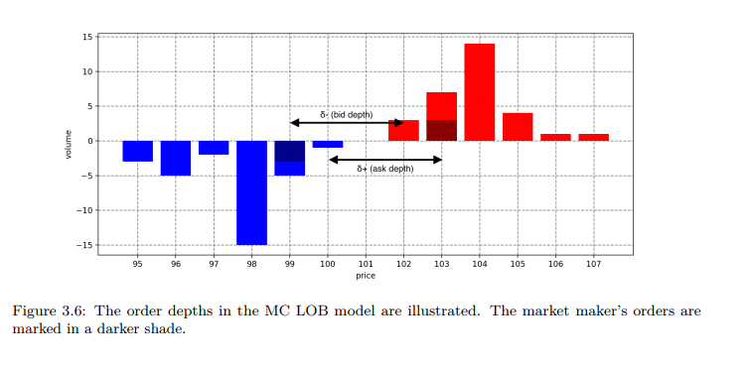

3.3.2.1.4. Invalid actions
The action space is defined independently of the current state of the LOB. In particular, the agent can always propose any pair of depths $\left(δ_{t}^{-} , δ_{t}^{+}\right)$from the admissible set. In some states, however, a naive choice of depths would lead to crossed quotes, i.e. the market maker placing a bid above its own ask, and thus effectively trading with itself. Since wash trading is economically pointless and typically prohibited by regulation, such actions are treated as invalid and are automatically corrected.
Formally, let $s(t^{-})$denote the bid–ask spread just before the market maker updates its quotes at time $t$. An action with depths $\left(δ_{t}^{-} , δ_{t}^{+}\right)$is considered invalid if
$$δ_{t}^{-}+δ_{t}^{+}≤s(t^{-}).$$
To see the problem, consider the example from Carlsson & Regnell: suppose $s(t^{-})=5$, the best ask is $a(t^{-})=9,996$, and the market maker chooses depths $δ_{t}^{-}=δ_{t}^{+}=2$. In that case, the agent would post a bid at $9,994$and an ask at $9,993$, which means that its own quotes cross.
To prevent this situation, we introduce the order-depth shortfall:
$$Δ=[ s(t^{-})-(δ_{t}^{+}+δ_{t}^{-})+1 ]^{+},$$
where ${\left[⋅\right]}^{+}$denotes the positive part. $Δ$ is the number of ticks by which the bid–ask spread exceeds the sum of the proposed depths. For a valid action, $Δ=0$. For an invalid one, $Δ>0$and the depths are adjusted symmetrically:
$$\begin{matrix} & δ_{t}^{±} ← δ_{t}^{±}+⌈Δ/2⌉, & & \text{(3.xx)}\end{matrix}$$
where $\left\lceil ⋅\right\rceil$is the ceiling function.
Returning to the example above, we have $s(t^{-})=5$and $δ_{t}^{-}+δ_{t}^{+}=4$, so $Δ=[5-4+1]^{+}=2$. The adjustment yields updated depths $δ_{t}^{-}=δ_{t}^{+}=3$, which leads to non-crossing quotes (see the corresponding illustration in the original thesis).
The same correction is applied not only to RL agents, but also to the fixed-offset and random-depth benchmark strategies in this environment. In particular, a fixed offset $δ^{±}=1$can be interpreted as a strategy that attempts to quote “as tight as possible”, subject to this no-crossing constraint.
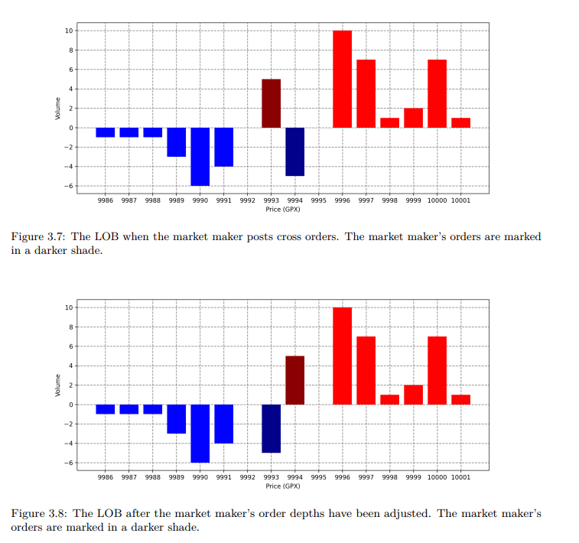

3.3.2.1.5. Market impact
During initial experiments with the Markov-chain LOB model, two simple tests revealed how even a single market maker can significantly influence the simulated price dynamics.
In the first test, the model is run for $100$episodes with terminal time $T=1,000$without any market maker present. For each time step, the mean mid-price and its standard deviation across episodes are recorded. This “no-maker” case serves as a baseline for the endogenous volatility of the Markov-chain LOB model.
In the second test, the same simulation is repeated, but with a fixed-offset market-making strategy active throughout. The market maker continuously posts two-way quotes with symmetric depths $δ^{-}=δ^{+}=1$and a constant order size of 5 units. Comparing the two runs shows that the presence of this liquidity-providing agent reduces the variability of the mid-price: at the final time step, the standard deviation falls from approximately $0.065$ticks in the no-maker case to about $0.049$ticks with the fixed-offset maker, indicating a stabilising effect on prices.
A third configuration highlights the potential for directional impact when quotes are systematically skewed. Here, the market maker continues to provide constant two-way prices with depths $δ^{-}=1$and $δ^{+}=2$, again with an order size of 5 units. This asymmetry—bidding slightly more aggressively than offering—leads to a persistent upward drift in the mid-price: over $1,000$seconds, the mid-price drifts at roughly $4.8×{10}^{-2}$ticks per second.
Taken together, these simple experiments show that in the Markov-chain LOB model:
- A symmetric, near-touch market maker can dampen volatility by supplying additional liquidity.
- A skewed market maker can tilt the drift of the simulated price process in the direction of its more aggressive side.
This behavior is qualitatively consistent with intuition from real markets and confirms that the environment is sensitive to the presence and design of market-making strategies.
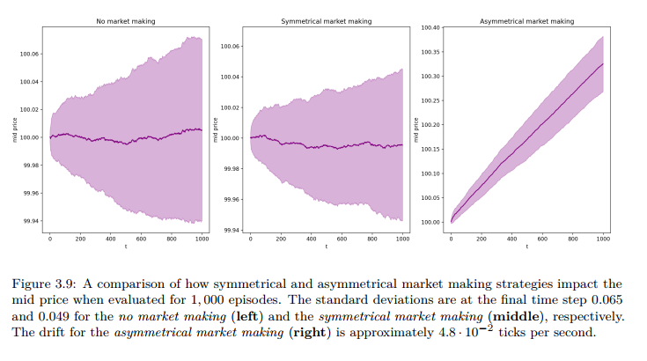

3.3.2.1.6. Order priority
Finally, we need to specify how the market maker’s orders are prioritized relative to other orders resting at the same price level. In line with the NYSE order precedence hierarchy, we adopt a secondary rule under which the market-making agent always has first priority at any price level where it is present.
Concretely, this means that whenever a market order arrives and executes against a given price level, volume posted by the RL agent is filled before any other volume at that price. This modelling choice is made purely for computational convenience: it removes the need to simulate queue positions and tie-breaking among orders at the same price, which would otherwise introduce additional state variables and significantly increase the complexity of the environment and the learning problem.

3.3.2.2. Q-learning on the Markov-Chain LOB
As a first benchmark on the Markov-chain LOB environment, this thesis implements a classical tabular Q-learning algorithm to learn a market-making policy. The goal here is not to build the most sophisticated agent possible, but to obtain a simple, interpretable reference against which the later deep RL experiments can be compared.

Because the underlying Markov-chain LOB has a very large (in fact, unbounded) state space if represented in full detail, the Q-learning experiments rely on an aggressively compressed state representation: both time and inventory are grouped into a small number of bins. This compression makes a Q-table feasible, but also breaks full observability, so standard convergence guarantees for Q-learning no longer apply. The empirical behavior of the learned policies therefore becomes part of the analysis.

3.3.2.2.1. State space
In contrast to the SPM experiments, the Markov-chain LOB model does not impose explicit hard bounds on the inventory $Q_{t}$. Using the raw inventory as a state variable would therefore lead to an essentially unbounded state space and make tabular Q-learning impractical. Instead, both time and inventory are coarsened into a small number of discrete groups. The construction follows the approach of Lim et al. for inventory grouping and extends it to time in the long-horizon setting.
Two Q-learning configurations are considered:
- SH-Q (short-horizon Q-learning) – time is kept as actual discrete time;
- LH-Q (long-horizon Q-learning) – time is also binned, similar to inventory.
In both cases, the state is a pair $\left(l , k\right)$consisting of a time index $l$and an inventory group $k$.
For the long-horizon setting, the state space is
$$S^{\text{LH-Q}}=T×Q=\{1,2,…,ν^{\left(T\right)}\}×\{-ν_{Q},…,ν_{Q}\},$$
and for the short-horizon setting,
$$S^{\text{SH-Q}}=T×Q=\{0,dt,…,T-1\}×\{-ν_{Q},…,ν_{Q}\}.$$
Here $ν^{\left(T\right)}$is the number of time groups and $ν_{Q}$is the maximum inventory group index. In all experiments we set
$$ν^{\left(T\right)}=5,ν_{Q}=3,$$
so that both SH-Q and LH-Q share the same state-space size
$$∣S^{\text{SH-Q}}∣=∣S^{\text{LH-Q}}∣=∣T∣⋅∣Q∣=5×7=35.$$
In the long-horizon case, the continuous time index $t∈[0,T]$is mapped to a discrete time-group label $l∈\{1,…,ν^{\left(T\right)}\}$via
$$l=\left\lceil \frac{t}{T} ν^{\left(T\right)}\right\rceil +1_{\left\{t = 0\right\}},$$
where is the ceiling function and $1_{\left\{t = 0\right\}}$is an indicator that ensures $l=1$at the start of each episode. Intuitively, $l$encodes which “phase” of the episode the agent is in (early, middle, late, etc.). In the short-horizon SH-Q setting, time is not grouped and the time state simply equals the current discrete time: $l=t$.
For both SH-Q and LH-Q, the raw inventory $Q_{t}$is mapped to an integer group index $k∈\{-ν_{Q},…,ν_{Q}\}$. Let $κ∈N^{+}$denote the bin width in inventory units. Then the grouped inventory is
$$k=min⁡\text{ ⁣}\left(\left\lceil \frac{Q_{t}}{κ}\right\rceil , ν_{Q}\right)1_{\left\{Q_{t} > 0\right\}}+max⁡\text{ ⁣}\left(\left\lfloor \frac{Q_{t}}{κ}\right\rfloor , -ν_{Q}\right)1_{\left\{Q_{t} < 0\right\}}.$$
Equivalently, this can be written in piecewise form as
$$k=\left\{\begin{matrix}-ν_{Q}, & Q_{t}<(-ν_{Q}+1) κ, \\ -i, & -i κ≤Q_{t}<(-i+1) κ,1≤i<ν_{Q}, \\ 0, & Q_{t}=0, \\ j, & (j-1) κ<Q_{t}≤j κ,1≤j<ν_{Q}, \\ ν_{Q}, & Q_{t}>(ν_{Q}-1) κ,\end{matrix}\right.$$
so that inventory values in each interval of width $κ$are mapped to the same group, with the outermost groups collecting very large positive or negative positions.
The bin width $κ$is chosen empirically from the inventory distribution of a simple fixed-offset market maker (with depths $δ^{±}=1,2$) to obtain a reasonably even occupancy across groups. This leads to the values
$$κ=2\text{for }T=25\text{ (SH-Q)},κ=5\text{for }T=1,000\text{ (LH-Q)}.$$
By construction, this binned state is not fully informative: fine-grained information about the limit order book and the exact inventory size is lost. The resulting process is therefore not a fully observable Markov decision process, and Q-learning is no longer guaranteed to converge to an optimal policy in theory. In practice, this will manifest in the behaviour of the learned Q-values and policies, especially in the long-horizon setting (see Section 3.2.2.4).

3.3.2.2.2 Action space
In the Markov-chain LOB environment, the market-making agent acts by choosing quote depths on the bid and ask sides. For the Q-learning experiments, the action space is restricted to a small discrete grid of depth pairs:
$$A=D=\{1,…,\overset{ˉ}{d}\}^{2},$$
where $D$is the order-depth action space and $\overset{ˉ}{d}=5$is the maximum admissible depth in ticks. Each action $a∈A$can therefore be identified with a pair $\left(δ_{t}^{-} , δ_{t}^{+}\right)$specifying how far from the opposite best quote the agent posts its bid and ask, as defined in Section 3.2.1.
The definition of invalid actions from Section 3.2.1 is reused here. If, for a given state, the sum $δ_{t}^{-}+δ_{t}^{+}$implied by the chosen action would be strictly smaller than the prevailing bid–ask spread, the actual depths used in the environment are adjusted to avoid crossed quotes. Crucially, the action index in the Q-table is not changed by this adjustment: the Q-learning algorithm always sees the same finite action set $A$, which simplifies both implementation and computational cost.
It is also important to note that market orders are not part of the action space in these Q-learning experiments. The portion of the environment’s step function that handles market orders (see Algorithm 2) is therefore not used as a controllable action; the agent only decides where to post limit orders via its choice of depths.

3.3.2.2.3. Reward
The reward structure in the Markov-chain LOB experiments mirrors the SPM setup, with one key simplification. The per-step reward is defined as the increment in portfolio value:
$$R_{t}=ΔV_{t},$$
where $V_{t}$is the value process of the market maker. This value includes both cash and the liquidation value of inventory:
$$V_{t}=\left\{\begin{matrix}X_{t}+H_{t}, & 0≤t<T, \\ X_{T^{-}}+p_{L}(L(T^{-}),Q_{T^{-}}) Q_{T^{-}}, & t=T.\end{matrix}\right.$$
Here:
- $X_{t}$denotes the cash account at time $t$;
- $H_{t}$is the holding value, defined as the liquidation value of the inventory at time $t$;
- $L(T^{-})$is the LOB immediately before terminal time;
- $p_{L}(L(T^{-}),Q_{T^{-}})$is the volume-weighted average price at which a position of size $Q_{T^{-}}$would be liquidated in the terminal book $L(T^{-})$.
Compared to the SPM reward, the running quadratic inventory penalty term is deliberately removed. The authors give two reasons for this design choice:
- In the SPM, the penalty was introduced primarily to align the RL formulation with the analytical optimal-control solution.
- In the Markov-chain LOB model, dropping the penalty makes the total episode reward exactly equal to the realised PnL, which is more natural and easier to interpret from a trading perspective.
The Q-learning algorithm is then trained to maximise the expected sum of these rewards over an episode, subject to the grouped state representation and the discrete depth-pair action space described above.

3.3.2.2.4. Experimental outcomes
In this section, we report and analyze the performance of tabular Q-learning in the Markov chain LOB environment under the short-horizon (SH-Q) and long-horizon (LH-Q) configurations. The focus is on the resulting profit-and-loss distribution, inventory dynamics, and stability of the learned strategies, as these are directly relevant to our research questions on profitability and inventory risk.

3.3.2.2.4.1. Short-horizon setting (SH-Q)
Recall that in the SH-Q configuration the agent acts at a relatively low frequency over a short trading window: the episode length is set to
$$T=25,Δt=5,$$
which yields only five decision points per episode. To keep the average traded volume per second comparable to the long-horizon case, the default order size is scaled up to 25 units.
The remaining model and training parameters (discount factor, inventory binning, number of episodes, etc.) are summarized in Table 3.7
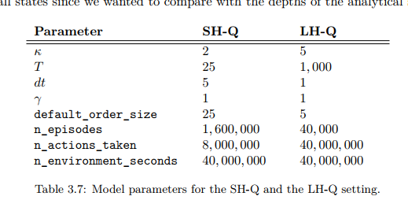
Q-learning is run eight times, each with $1.6×{10}^{6}$training episodes. For each run, the learned policy is evaluated on $5×{10}^{4}$out-of-sample episodes. The resulting average reward $r$, standard deviation of reward $σ_{r}$, time-normalized reward, and estimated value $v^{*}(0,0)$at the initial state are reported in Table 3.9.
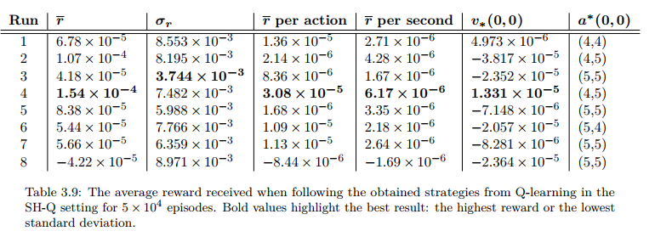
Across runs, the average reward per episode is of order ${10}^{-5}$–${10}^{-4}$, with a non-trivial spread: the best run reaches
$$r≈1.54×{10}^{-4},$$
while the worst run is slightly negative. Despite this variability, all but one run generate positive expected PnL per episode, albeit at a very small magnitude.
For a more aggregated view, the strategies derived from the SH-Q experiments are compared to two simple benchmarks:
- a constant strategy, which posts symmetric quotes with fixed depths, and
- a random strategy, which samples depths uniformly from the admissible set at each decision time.

The key observations are:
- The Q-learning best run attains an average reward
$$r_{\text{best}}≈1.5×{10}^{-4},σ_{r}≈7.48×{10}^{-3},$$
clearly outperforming both benchmarks in terms of mean reward.
- The mean Q-learning strategy (obtained by averaging the Q-tables over all eight runs) remains profitable, with
$$r_{\text{mean}}≈2.5×{10}^{-5},σ_{r}≈2.43×{10}^{-3},$$
and exhibits a substantially lower volatility of PnL than the best individual run.
- In contrast, both benchmark strategies are loss-making on average, with
$$r_{\text{const}}≈-1.3×{10}^{-3},r_{\text{rand}}≈-5.3×{10}^{-3},$$
and much larger standard deviations (of order ${10}^{-2}$).
In financial terms, this means that even a relatively crude tabular RL agent is able to extract a small but positive edge from the Markov chain LOB, whereas naive quoting policies systematically lose money in this environment.
The training curves provide additional insight into convergence and stability. Figure 3.11 shows the evolution of the average reward during training and the estimated state-value $v(0,0)$across episodes. Both quantities appear to stabilize after an initial learning phase, and the shaded confidence band (± one standard deviation) shrinks, which is consistent with approximate convergence in this partially observable setting.
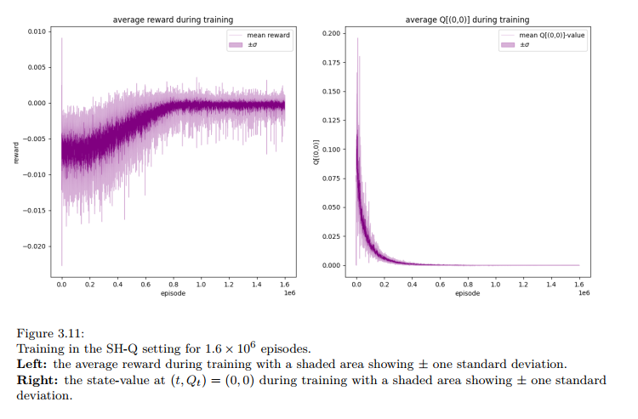
Further observations reveal that the SH-Q policies tend to quote relatively deep on both sides across most inventory states, which effectively limits inventory build-up. This behavior is intuitive: with only five decision opportunities before forced liquidation at $T$, the agent has limited time to work off an undesired inventory, and conservative quoting is a risk-reducing response.
Finally, Figure 3.14 and Figure 3.15 show the average trajectories of inventory, cash, and portfolio value under the SH-Q mean strategy. The market maker typically executes only a modest number of trades within each short episode, leading to small inventory swings and relatively flat PnL paths. From a risk-management perspective, SH-Q produces stable but low-intensity market making: the agent earns a small positive spread capture without taking significant directional exposure, but the short horizon fundamentally caps attainable profitability.
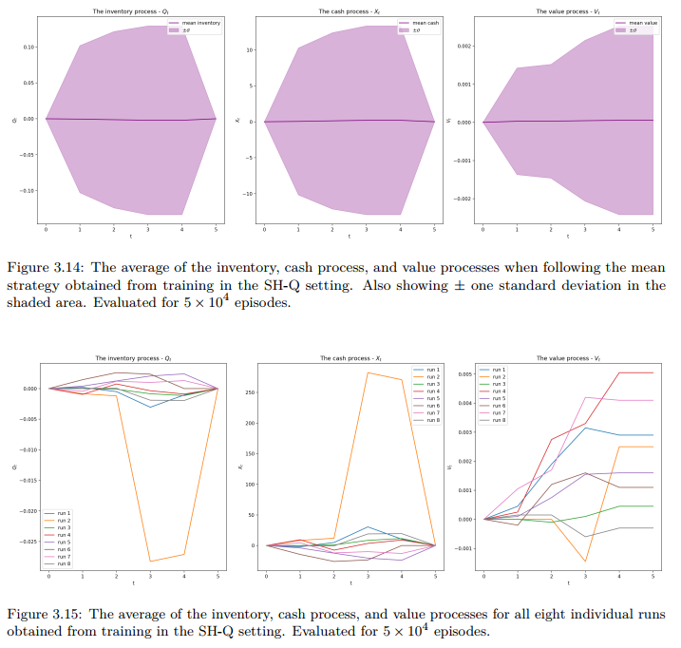

3.3.2.2.4.2. Long-horizon setting (LH-Q)

The long-horizon configuration (LH-Q) modifies only the temporal structure of the problem: the agent now trades over a considerably longer interval, with
$$T=1000,Δt=1,$$
which corresponds to 1,000 decision steps per episode and roughly 15 minutes of simulated clock time. The default order size is reduced to 5 units so that the average traded volume per second is comparable to the short-horizon setup.
To keep the state space tractable, time is grouped into five bins, and the time state variable becomes a coarse index $l∈\{1,…,5\}$rather than the raw time $t$. The inventory is still represented via coarse bins as described previously. The environment is therefore only partially observable, and Q-learning convergence is not guaranteed.
The LH-Q experiments consist of eight independent training runs, each with $4×{10}^{4}$episodes, which corresponds to the same total simulated time as in the SH-Q experiments (40 million “environment seconds”). For each run, the learned policy is evaluated on 1,000 episodes. Table 3.11 reports the average reward, reward volatility, time-normalized reward, and estimated state-value at the initial state.
Compared to SH-Q, average rewards are now three to four orders of magnitude larger in absolute terms. For example, the best run attains
$$r≈3.65,σ_{r}≈5.95,$$
which translates to
$$r_{\text{per second}}≈3.65×{10}^{-3},$$
i.e. a few basis points of PnL per second of simulated trading time. Even the weaker runs generally remain profitable on average, although the dispersion of both $r$and $σ_{r}$across runs is substantial. This high variability is a first indication that training is less stable in the LH-Q regime.
The instability is confirmed by the training diagnostics in Figure 3.17, which tracks both the average reward and the estimated value $v(0,0)$over the course of learning.
While the mean reward appears to drift upward, the estimated state-value at the initial state keeps growing and does not settle towards a stable level. In particular, the value estimate for the starting state decouples from the realized episode rewards, which is inconsistent with the usual interpretation of the value function as expected future return.
This phenomenon can be understood by examining the Q-learning update rule used in these experiments. The tabular Q-function is updated according to
$$Q\left(s_{t},a_{t}\right)←Q\left(s_{t},a_{t}\right)+α\left(r_{t+1}+γ\max_{a}{Q}\left(s_{t+1},a\right)-Q\left(s_{t},a_{t}\right)\right)$$
where $α$is the learning rate, $γ$the discount factor (set to $γ=1$), $r_{t+1}$the reward at time $t+1$, and $Q(⋅,⋅)$the current estimate of the action-value function.
Because of the time-grouping scheme, it is possible (and in practice frequent) that the next state collapses back to the same state representation, $s_{t+1}=s_{t}$, while the greedy action remains unchanged. In that case, the update simplifies to
$$Q\left(s_{t},a_{t}\right)←Q\left(s_{t},a_{t}\right)+α r_{t+1}$$
which corresponds to repeatedly adding (scaled) realized rewards to the same Q-entry. If the expected one-step reward conditional on $\left(s_{t} , a_{t}\right)$is positive, this recursion makes $Q(s_{t},a_{t})$grow without bound over time, even though the actual total reward per episode remains bounded. As a consequence, the learned Q-values no longer represent the expected cumulative return from that state-action pair; they instead behave like a running sum of local rewards.
From a financial viewpoint, this behavior has two implications:
- Profitability vs. interpretability
The LH-Q policies are genuinely profitable on average and achieve a much higher PnL per second than SH-Q, primarily because the longer horizon allows the agent to build inventory and gradually unwind it before the forced liquidation at $T$. However, the divergence of $Q(0,0)$indicates that the tabular algorithm, in this state representation, does not provide a well-calibrated value function. This complicates any attempt to use $Q$itself as a risk or performance diagnostic.
- Stability and robustness of training
The large dispersion of rewards across the eight LH-Q runs (see the boxplot in Figure 3.16) and the non-converging value estimates suggest that the learning dynamics are highly sensitive to the random seed and the idiosyncrasies of the training trajectories.
For practical market-making deployment, this lack of robustness would be problematic: replicating the same training configuration could yield materially different strategies and risk profiles.
Taken together, the SH-Q and LH-Q experiments paint a consistent picture. In a Markov chain LOB environment with partial observability and coarse state aggregation, tabular Q-learning can:
- generate marginal but statistically meaningful profits over short horizons, while keeping inventory fluctuations small; and
- achieve substantially higher PnL per second over longer horizons, at the cost of unstable learning dynamics and poorly behaved value estimates.
In this thesis, we will therefore treat tabular Q-learning on the Markov chain LOB as a baseline: it is capable of discovering financially non-trivial strategies, but its instability and the limitations of the discretized state representation motivate the transition to function-approximation methods (DQN/DDQN) for more scalable and robust market-making policies.

3.3.2.3. Deep Reinforcement Learning on the Markov-Chain LOB
In the Q-learning experiments above, the MC–LOB environment was coupled with a low-dimensional, discretised state space so that a tabular value function could be maintained.
To exploit the richer information in the limit order book while keeping the Markov-chain dynamics unchanged, this section replaces the tabular learner with a Double Deep Q-Network (DDQN). The environment mechanics (order arrivals, matching logic, inventory caps, liquidation at expiry, etc.) remain as in Section 3.2.1; only the agent is changed.
Two horizons are considered:
- a short-horizon (SH-DDQN) configuration, designed for intraday behaviour on a relatively short trading window;
- a long-horizon (LH-DDQN) configuration, which operates over a much longer time interval but with the same underlying MC dynamics.
Both settings use the same state and action representation. They differ only in the length of the episode, the grouping of time in the state (as in SH-Q vs LH-Q), and a few training hyperparameters (batch size, exploration schedule, number of episodes, etc.). The following subsections describe the state space, action space, network architecture and reward design used by both DDQN variants.

3.3.2.3.1. State space
In the deep-RL setting the agent observes a high-dimensional snapshot of the order book, instead of the coarse (time, inventory) grid used for tabular Q-learning.
Let $d$denote the number of price levels considered on each side of the book; throughout, $d=10$.
At time $t$, the state vector is defined as a concatenation of:
- Time within the episode, $t$;
- Current inventory, $Q_{t}$;
- Current bid–ask spread, $s(t)=a(t)-b(t)$;
- Ask-side depth around the mid-price, i.e. the total resting ask volume at the first $d$ticks above the mid,
$$q^{a}(t,δ), q^{a}(t,2δ),…,q^{a}(t,dδ);$$
- Bid-side depth around the mid-price, i.e. the total resting bid volume at the first $d$ticks below the mid,
$$q^{b}(t,-δ), q^{b}(t,-2δ),…,q^{b}(t,-dδ).$$
Collecting these components, the (unnormalised) state can be written schematically as
$$s_{t}=(t, Q_{t}, s(t), q^{a}(t,δ),…,q^{a}(t,dδ), q^{b}(t,-δ),…,q^{b}(t,-dδ)),$$
which yields a state dimension of $3+2d=23$.
Before being passed to the network, each component is scaled so that the resulting vector lives approximately in the hyper-cube $\left[-1,1]^{23}\right.$. Time and inventory are divided by their respective maxima; volumes are scaled by a characteristic LOB depth (derived from the MC model’s typical volumes), and the spread is normalised by the tick size $δ$. The proportional notation $s_{t}∝(⋯ )$in the original text simply emphasises that the actual input to the network is the normalised version of the raw quantities.
The same state definition is used for both SH-DDQN and LH-DDQN. As in the tabular case, the difference between short and long horizon lies in how the time coordinate is mapped: for SH-DDQN the raw simulation time step is used, whereas for LH-DDQN time is grouped into a small number of bins over the longer horizon to keep the scale of the state components comparable.

3.3.2.3.2. Action space
The DDQN agent controls the posting depths of its bid and ask quotes relative to the current best prices.
At each decision time $t$, the action is a pair
$$a_{t}=(d_{t}^{b},d_{t}^{a}),$$
where $d_{t}^{b}$is the depth (in ticks) at which the bid is posted below the current best bid, and $d_{t}^{a}$is the depth (in ticks) at which the ask is posted above the current best ask.
The discrete action space is defined as
$$A=\{1,…,\overset{ˉ}{d}\}×\{1,…,\overset{ˉ}{d}\},$$
with $\overset{ˉ}{d}=5$the maximum controllable depth. An action $a_{t}=(k,l)$therefore instructs the environment to place the bid at $k$ticks below the best bid and the ask at $l$ticks above the best ask, subject to the usual constraints on invalid actions (inventory limits, non-positive spread, etc.) described in Section 3.2.1.
As in the tabular Q-learning experiments, if the chosen depths would imply quotes inside the spread (i.e. the sum of depths is strictly smaller than the current spread), the environment adjusts the effective depths to remain consistent with the LOB and matching rules, but the action index used by the learning algorithm is kept unchanged. This preserves a fixed discrete action space, which is convenient for DDQN and for comparing the learned policies to the Q-learning and benchmark strategies.

3.3.2.3.3. Network architecture and training setup
The DDQN implementation follows the standard double-network architecture: a train network with parameters $θ$is updated every gradient step, while a separate target network with parameters $θ^{-}$is updated less frequently by copying $θ$. Action-values are approximated as $Q(s,a;θ)$.
Both SH-DDQN and LH-DDQN use fully connected feed-forward networks with ReLU activations. The input layer has 23 neurons (the state dimension), followed by three hidden layers. Each hidden layer uses batch normalisation and ReLU. The output layer has $∣A∣={\overset{ˉ}{d}}^{2}=25$units, one per discrete action $\left(d^{b} , d^{a}\right)$.
Hyperparameters closely follow Carlsson & Regnell’s configuration:
- Optimizer: Adam with learning rate on the order of ${10}^{-4}$;
- Mini-batch size: a few hundred transitions per update (larger batch for LH-DDQN to stabilise across the longer horizon);
- Replay buffer: a large experience buffer storing transitions $\left(s_{t} , a_{t} , r_{t+1} , s_{t+1}\right)$;
- Target-network update: hard copy of $θ$to $θ^{-}$every fixed number of gradient steps;
- Exploration: $ε$-greedy policy with a decaying $ε$schedule, starting near 1 and annealing towards a small floor;
- Discount factor: $γ$in the range $\left[0.9 , 0.99\right]$, with slightly higher values in the long-horizon setting.
The agents are trained separately for each LOB regime (neutral, buy-heavy, sell-heavy) and horizon (SH vs LH). For each configuration, multiple independent training runs are performed with different random seeds. From these runs, a subset of high-performing policies is later selected for out-of-sample evaluation alongside the benchmark strategies.

3.3.2.3.4. Reward
The reward in the DDQN experiments is kept as close as possible to the one used in the tabular setting, to isolate the effect of the function approximation rather than a change in objective.
At each decision step, the agent receives a reward
$$r_{t+1}=ΔX_{t+1}+ΔV_{t+1}-ϕ Q_{t+1}^{2},$$
where:
- $ΔX_{t+1}$is the change in the cash account due to trades executed between $t$and $t+1$;
- $ΔV_{t+1}$is the change in mark-to-market value of the inventory over the same interval;
- the last term is a quadratic running penalty on inventory, with $ϕ≥0$controlling the strength of risk aversion.
The cash and inventory value terms correspond to realised and unrealised PnL, respectively, while the inventory penalty discourages the agent from carrying large positions. As in the tabular experiments, the reward is scaled to keep its magnitude in a range compatible with stable neural-network training (essentially, dividing by a constant so that typical rewards are of order one).
This reward is used identically in SH-DDQN and LH-DDQN. The episode-end liquidation and terminal reward are handled by the environment in the same way as for Q-learning, so that the DDQN agents optimise against the same overall objective as the tabular strategies.

3.3.2.3.5. Experimental outcomes
This section presents the outcomes of training DDQN agents in the Markov-chain LOB environment under both the short-horizon (SH-DDQN) and long-horizon (LH-DDQN) configurations. As before, we focus on realised PnL, reward variance, and the qualitative features of the learned strategies, as these are most relevant for market-making performance and inventory risk.

3.3.2.3.5.1. SH-DDQN with neutral LOB
The first deep-RL experiment mirrors the short-horizon Q-learning setup as closely as possible. The total trading horizon is set to
$$T=25,Δt=5,$$
giving five decision points per episode, and the order size is fixed at 25 units. In contrast to SH-Q, inventory is not grouped: the DDQN agent observes the exact $Q_{t}$, as specified in the state space in Equation (71).
To isolate the agent’s learning from exogenous LOB randomness in this first test, the initial state of the book at the beginning of each episode is kept deterministic and “neutral” during training. The neutral LOB is defined by the tuples
$$\begin{matrix} & (a(t),q^{b}(t+δ),…,q^{b}(t+dδ))=(10001,0,1,…,1), & & \text{(75)}\end{matrix} \\ \begin{matrix} & (b(t)-a(t),q^{a}(t-δ),…,q^{a}(t-dδ))=(-2,0,-1,…,-1), & & \text{(76)}\end{matrix}$$
and is illustrated in Figure 3.22 of the original work. In words, the mid-price is close to 10,000, the spread is two ticks, and the depth profile on both sides is flat and symmetric beyond the innermost levels.
The SH-DDQN agent is trained for $8×{10}^{6}$time steps, corresponding to $1.6×{10}^{6}$episodes, with ten environments running in parallel. The main quantitative outcomes of this neutral-LOB experiment are summarised in Table B.1 of the original thesis. In brief:
- Out of eight independent runs, five produce negative mean rewards when evaluated out-of-sample.
- The average reward of the mean strategy (obtained by averaging the action-values across agents) is only
$$r_{\text{mean}}≈2.32×{10}^{-5},$$
i.e. statistically close to zero once reward scale and horizon are taken into account.
- The training loss converges, but to a level that is roughly twice as high as in the randomized-LOB case discussed below.
Given the modest performance and lack of robustness, the neutral-LOB SH-DDQN configuration mainly serves as a reference point. The key lesson is that locking the initial LOB into a single symmetric configuration is too restrictive: the agent tends to overfit to a narrow set of states and does not generalise well.

3.3.2.3.5.2. SH-DDQN with randomized LOB
The second short-horizon experiment keeps the same time grid and order size, but modifies how the LOB is initialised. Instead of always starting from the neutral book, each episode begins from a random LOB state drawn from a precomputed state bank of 100,000 snapshots. The state bank is generated by simulating a single environment for 100,000 seconds and saving the book state at 1-second intervals.
Formally, at the start of each episode the initial LOB $L_{0}$is sampled uniformly from the bank:
$$L_{0}∼\text{Unif}\{L^{\left(1\right)},…,L^{\left(100000\right)}\}.$$
This randomisation is applied both during training and evaluation, ensuring that the learned policy sees a broad variety of book shapes.
The SH-DDQN agent is again trained for $8×{10}^{6}$time steps (1.6 million episodes with ten parallel environments). Eight independent runs are performed, and each resulting policy is evaluated on $5×{10}^{4}$episodes. Table 3.16 reports the average reward $r$, reward standard deviation $σ_{r}$, reward per action and per second, and estimated state value $v^{*}(0,0)$for each run.
A few patterns stand out:
- Among the eight runs, five now have positive mean rewards, compared to only three in the neutral setting.
- Typical average rewards are of order ${10}^{-5}$–${10}^{-4}$ per episode, similar in scale to the SH-Q setting, but achieved with a much richer state representation.
- The estimated state-value $v^{*}(0,0)$converges toward the average episode reward (see Figure 3.24), which is consistent with the DDQN having learned a reasonably calibrated value function at the initial state.
To benchmark performance, the best run and the mean strategy (average over the eight DDQN runs) are compared to the constant and random depth strategies. The results are summarized below:
- The DDQN best run achieves
$$r_{\text{best}}≈2.12×{10}^{-4},σ_{r}≈8.28×{10}^{-3},$$
improving on both the best SH-Q run and the benchmarks.
- The DDQN mean strategy yields
$$r_{\text{mean}}≈1.41×{10}^{-4},σ_{r}≈5.61×{10}^{-3},$$
which is (i) substantially higher than the neutral-LOB mean reward $2.32×{10}^{-5}$, and
(ii) obtained with a lower standard deviation than the best individual run.
- Both benchmark strategies remain clearly loss-making, with
$$r_{\text{const}}≈-1.19×{10}^{-2},r_{\text{rand}}≈-5.38×{10}^{-3},$$
and much larger volatility of rewards.
From a market-making perspective, randomising the LOB initial state materially improves robustness and average profitability of DDQN in the short-horizon regime, and yields strategies that dominate naive quoting policies.
The structure of the learned policy is visualised in Figure 3.25, which shows heatmaps of optimal bid and ask depths as functions of time $t$and inventory $Q_{t}$. Interestingly, the mean SH-DDQN strategy appears “flipped” relative to standard intuition: it suggests deeper bids when inventory is small and deeper asks when inventory is large, implying a tendency to accumulate sizeable net positions rather than aggressively mean-reverting inventory. This behaviour is confirmed by the inventory, cash and value trajectories shown in Figure 3.27 and Figure 3.28; most runs develop a short skew, although no particular skew direction is consistently associated with higher reward.
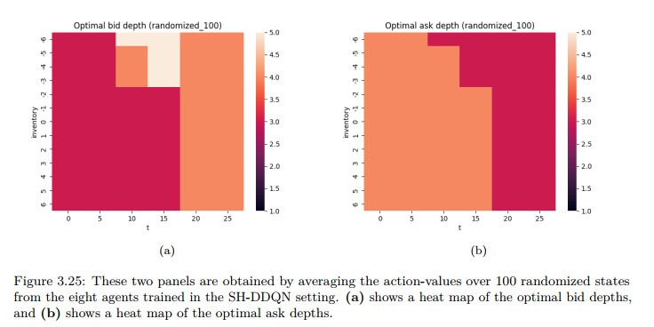
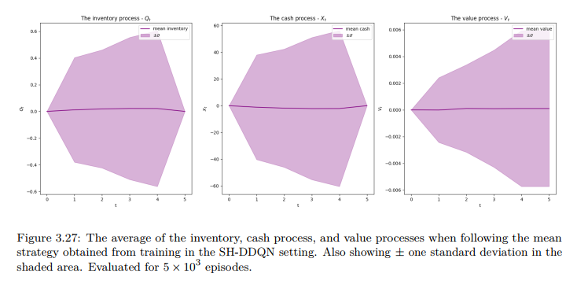
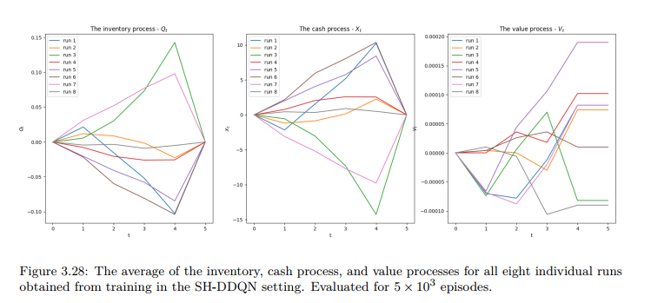
To understand how the policy reacts to different LOB conditions, a simple scenario analysis has been conducted: the mean strategy is evaluated on four stylised books (balanced, buy-heavy, sell-heavy, large-spread), whose microstructure statistics are summarised in Table 3.18.
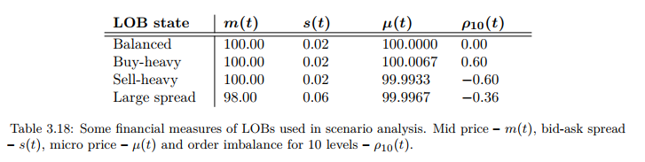
Figure 3.30 show that when moving from a balanced to a buy-heavy book, the agent increases its bid depths and decreases its ask depths, consistent with a desire to reduce inventory risk in the presence of buy pressure. The corresponding behaviour in the sell-heavy book difference from the one of the buy-heavy book is quite insignificant. There seem to be some changes for small inventories on the bid size and for large inventories on the ask side, which in this case averages out to slightly higher willingness to buy.
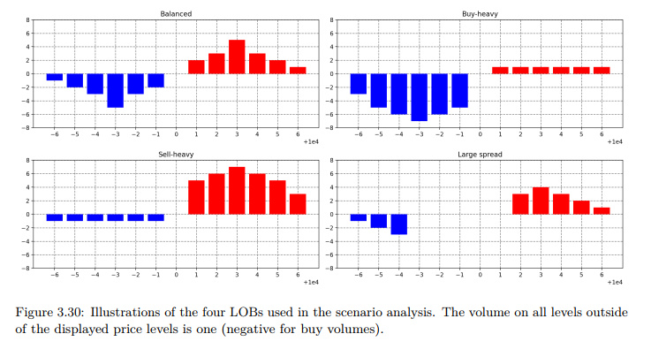
As for the results for the “balanced” and the “large spread” LOBs: the change in strategy between the two is quite subtle; however, some changes are evident for large inventories on the ask side.
Overall, in the short-horizon MC-LOB setting, SH-DDQN with randomized LOBs learns slightly more profitable and more stable policies than tabular SH-Q, and clearly outperforms the simple benchmarks, even though the absolute level of profit per episode remains small due to the tight horizon and forced liquidation.

3.3.2.3.5.3. LH-DDQN with randomized LOB
The final experiment considers deep RL in the long-horizon configuration. Here, the episode length is
$$T=1000,Δt=1,$$
which corresponds to 1,000 actions per episode and roughly 15 minutes of trading time. Order size is reduced to 5 units to keep the average traded volume per second similar to the short-horizon experiments. As before, each episode starts from a randomly sampled LOB state drawn from a large state bank, both during training and evaluation.
The LH-DDQN agent is trained for $10×{10}^{6}$time steps with ten parallel environments. Eight independent runs are carried out, and each resulting strategy is evaluated on 1,000 episodes. Table 3.19 reports the average reward, standard deviation, reward per action/per second, and estimated state-value $v^{*}(0,0)$for each run.
The numerical picture in the long-horizon DDQN setting is markedly different from both the SH-DDQN and LH-Q results:
- All eight runs produce positive average rewards, with
$$r∈[1.45, 4.80],$$
and standard deviations $σ_{r}$between about 1.3 and 5.0. In per-second terms, this corresponds to
$$r_{\text{per second}}≈1.45×{10}^{-3}\text{ to }4.80×{10}^{-3},$$
i.e. a few basis points of PnL per second of simulated trading time.
- The variance across runs is relatively small compared to the mean, and for most runs the standard deviation is lower than the average reward, indicating a favourable reward–risk trade-off.
Figure 3.32 tracks the evolution of the average reward, the state-value estimate $\hat{v}(0,0)$, and the training loss. While the loss decreases and the reward stabilises at a high positive level, the value estimate $\hat{v}(0,0)$becomes negative towards the end of training and shows no clear sign of convergence. Thus, as in LH-Q, the learned action-values do not fully align with the empirical episode rewards, but the discrepancy is less dramatic and does not prevent the agent from learning consistently profitable policies.
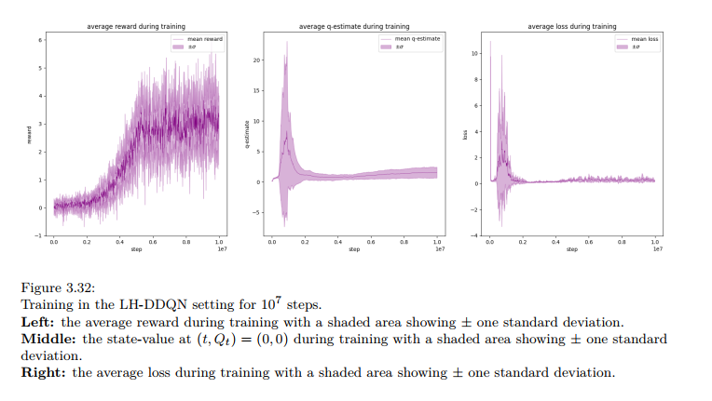
The structure of the LH-DDQN mean strategy policy is highly adaptive in both time and inventory:
- early in the episode, it tends to take on a long position, placing relatively shallow bids and deeper asks;
- later in the episode, it reverses skew, increasing bid depths and reducing ask depths to gradually unwind the accumulated inventory before the terminal liquidation at $T$.
This dynamic is corroborated by the average inventory, cash, and value trajectories in Figure 3.35 and the per-run processes in Figure 3.36, which show broadly similar behaviour across all eight runs.
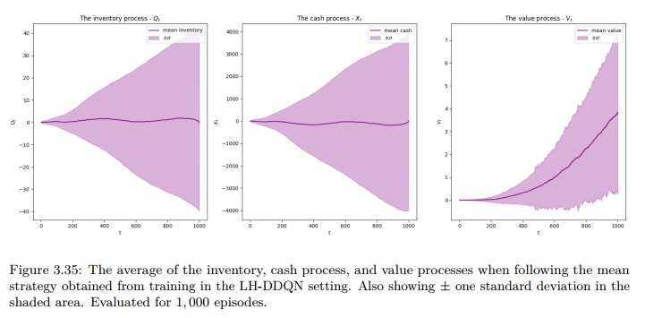
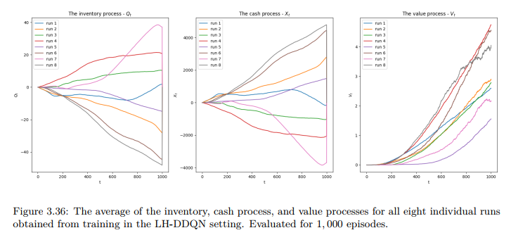
The scenario analysis is repeated in the LH setting, comparing the mean strategy’s reaction to the same four stylised books (balanced, buy-heavy, sell-heavy, large spread). The qualitative changes in order depths between scenarios remain modest but economically sensible: the agent adjusts depths more aggressively at small absolute inventories and reacts to order-imbalance signals (e.g. buy-heavy vs sell-heavy) by skewing its quoting to reduce exposure in the direction of perceived pressure.
From a financial and methodological standpoint, the LH-DDQN with randomized LOB delivers the strongest result in the Markov-chain LOB suite:
- it learns robustly profitable strategies with relatively small dispersion across runs;
- it handles longer horizons naturally, allowing inventory to be built and unwound over time;
- and it clearly outperforms both Q-learning and benchmark strategies in the long-horizon setting

These findings support the working hypothesis behind RQ2: in a realistic LOB environment with rich state information, deep reinforcement learning based on DDQN is better suited than tabular Q-learning to discover stable, profitable market-making policies, especially once we move beyond very short horizons.

3.3.3. Summary of results
Across all experiments, the empirical picture is fairly coherent. In the stylised simple probabilistic model (SPM), tabular Q-learning is able to recover strategies that are at least as good as the analytically derived ones and marginally better on average, while clearly outperforming naïve benchmark policies. When we move to the Markov chain (MC) limit order book, profitability drops by several orders of magnitude, benchmark strategies turn loss-making, and model complexity exposes clear differences between tabular and deep reinforcement learning. In this more realistic setting, deep double Q-learning (DDQN) consistently produces more profitable and more stable strategies than tabular Q-learning, and it does so while actively managing inventory over time rather than mechanically hugging the spread.

3.3.3.1. Simple Probabilistic Model (SPM)
In the SPM experiments, the main objective was to confront RQ1: can reinforcement learning recover or improve on analytically derived strategies?
When we compare average rewards across all runs, the mean Q-learning strategy attains the highest average per-episode and per-second reward among all strategies considered. It slightly improves on both the discrete and continuous versions of the analytical Avellaneda–Stoikov solution, while the constant-spread and random-depth benchmarks lag by a comfortable margin and exhibit much higher reward volatility. Hypothesis tests confirm that Q-learning dominates the discrete analytical strategy with high statistical significance, whereas the difference against the continuous analytical strategy is too small to be declared significant at conventional levels.
From a financial perspective, two conclusions emerge. First, in a simple, well-specified model, a model-free RL agent is capable of matching – and in point estimates modestly exceeding – hand-crafted optimal quotes while preserving reasonable risk characteristics. Second, the performance gap to naïve benchmarks is large, which underlines that most of the value comes not from “clever” function approximation, but from enforcing inventory-aware, state-dependent quoting instead of static or random behaviour.

3.3.3.2. Short-horizon Markov chain LOB model
In the short-horizon (SH) MC setting, the trading window is very brief and each episode ends with a forced liquidation of any remaining inventory. In this regime, absolute profits are tiny, and the liquidation constraint dominates the economics of the strategy.
Both Q-learning and DDQN manage to produce strategies with small but positive average rewards, whereas the constant-depth and random benchmarks systematically lose money. The spread between the best RL runs and the mean RL strategies is modest in level terms, but DDQN shows two advantages: its best runs achieve slightly higher average rewards than the best Q-learning runs, and the mean DDQN strategy is closer in performance to its best run, which indicates better stability across training seeds. Statistical tests on average rewards support this ordering, with most p-values favouring DDQN over tabular Q-learning.
Financially, these results say that in a realistic LOB with short trading windows, “winning” at market making is already hard: the forced liquidation and limited time to recycle inventory compress expected PnL, and many trades simply pay for crossing the spread at the end of the episode. RL still adds value relative to benchmarks by slightly tilting quotes to earn spread when possible and by avoiding pathological inventory build-ups, but there is little room for large risk-taking or inventory warehousing in this regime.

3.3.3.3. Long-horizon Markov chain LOB model
The long-horizon (LH) MC experiments are closer to an intraday market-making scenario: the agent can interact with the book over a much longer period and can let inventory fluctuate before eventually liquidating. This is where RQ2 – the comparative advantage of deep RL over tabular Q-learning for dynamic inventory management – becomes most visible.
In this setting, DDQN delivers clearly positive and economically meaningful rewards across all runs, with relatively tight dispersion: most DDQN strategies have an average reward larger than their own standard deviation, and substantially outperform both constant and random benchmarks. The learned DDQN policies display sensible financial behaviour: they accumulate inventory when spreads and order-book states are favourable, and they gradually unwind positions as the episode advances, resulting in a value process that accelerates rather than stalls toward the end of the horizon.
Tabular Q-learning, by contrast, struggles. Individual Q-learning runs can be mildly profitable, but the variability across runs is high, convergence diagnostics are poor in the time-grouped setting, and the mean Q-learning strategy even becomes loss-making. This indicates that the combination of large state space, partial observability issues in the time-grouped representation, and long horizon is beyond what the tabular method can reliably handle.
Taken together, the LH results provide the strongest empirical support for using deep RL in dynamic market making: once the environment is rich enough for meaningful inventory risk-taking, DDQN is able to exploit that flexibility and learn robust, inventory-aware quoting strategies that beat both simple tabular RL and traditional static benchmarks.

3.4 Perspectives
While the numerical experiments in this thesis demonstrate that a DDRL agent can successfully recover a profitable market-making policy in a stylized single-agent setting, the overall framework remains deliberately simplified. The environment is driven by an exogenous order-flow model with fixed parameters, and the agent optimizes its behavior in isolation, without accounting for the presence of other strategic liquidity providers or for endogenous regime shifts. To move closer to the conditions faced by real-world market makers and to enhance the robustness of RL-based solutions, it is therefore natural to consider extensions that enrich both the market representation and the training paradigm. The following subsections outline two such directions: a mean-field game formulation of the market, and an adversarial regime framework in which a second agent actively stresses the market-making policy during training.

3.4.1. MFG
A natural next step is to embed the market-making problem in a mean-field game (MFG) representation of the market. In the current framework, the environment is effectively exogenous: order-flow, spread dynamics and price impact are driven by a fixed stochastic model that does not adapt to the agent’s behavior, except through a simple market-impact mechanism. In reality, market makers operate in a dense ecosystem of heterogeneous participants—other market makers with similar latency and objectives, directional traders, execution algorithms, and noise traders—whose collective behavior shapes the order book. Mean-field games offer a mathematically tractable way to describe such systems by considering a continuum of agents whose policies jointly determine an aggregate “mean field”, which in turn affects individual dynamics. Casting market making as an MFG would allow the RL agent to be trained not only against a fixed order-flow model, but against an equilibrium distribution of strategies from many interacting agents. From a financial perspective, this would directly address crowding and self-impact effects: as the learned strategy becomes more aggressive or more common, the mean field adapts (e.g. spreads compress, queues lengthen, toxicity increases), forcing the agent to internalize that its own edge decays when replicated at scale. RL methods for mean-field control and mean-field reinforcement learning could then be used to learn policies that are near-optimal not in a “single-agent toy market”, but in a stylized equilibrium market where liquidity, spreads and adverse selection evolve endogenously. Such a formulation is expected to substantially increase the robustness of RL-based market-making strategies, as it would test them explicitly against the feedback loop between their own behavior and market conditions, rather than assuming that the environment remains stationary and unaffected by their trades.

3.4.2. Adversarial regime
A complementary direction is to introduce adversarial regime agents trained in parallel with the market-making agent. Instead of fixing the parameters of the limit order book model (volatility, arrival rates, impact coefficients, toxicity of order flow, jump intensities, etc.), an additional RL agent could be tasked with selecting—or perturbing—these parameters within realistic bounds so as to make the market maker’s performance as poor as possible while still producing plausible market statistics. This adversarial “regime generator” would play a minimax game against the market-making agent: the market maker aims to maximize risk-adjusted P&L under inventory and impact constraints, while the adversary seeks regimes that stress the strategy, for example by creating sudden liquidity droughts, highly toxic flow, correlated order-flow bursts, or structural breaks in volatility. Training the two agents jointly would amount to a form of robust reinforcement learning tailored to market microstructure: the market maker would be constantly pushed to adapt to worst-case but still realistic scenarios, rather than overfitting to a single, benign calibration of the LOB model. Financially, this would mimic the real-world process by which successful strategies attract predatory flow, face regime shifts, or encounter rare stress episodes such as flash crashes and volatility spikes. By construction, a policy that remains profitable and well-behaved under an adversarially generated spectrum of regimes is far more robust than one tuned to a single historical period or a fixed simulator. Combining mean-field game formulations with adversarial regime training therefore outlines a research programme whose primary goal is not just higher simulated P&L, but structurally more resilient RL-based market making strategies.

4. Conclusion
Market making – continuously posting buy and sell quotes while controlling inventory risk – is a deceptively simple description of a structurally hard control problem. The traditional approach has relied on analytical models and stochastic control techniques: elegant, interpretable, but fragile once market microstructure becomes realistic. In this thesis we have explored an alternative route: model-free reinforcement learning (RL) applied to market making, first in a stylised simple probabilistic model (SPM), then in a richer Markov-chain limit order book (MC–LOB) environment, using both tabular Q-learning and Double Deep Q-Networks (DDQN).
The work has been guided by two research questions:
- RQ1: Are reinforcement learning methods able to outperform more traditional analytically derived strategies?
- RQ2: Can reinforcement learning algorithms prove to be efficient in dynamic inventory management, focusing on minimisation of the risk associated with holding inventory while maximising profitability?
The main conclusions, both methodological and financial, are summarised below.

4.1. Answer to Research Question 1: RL versus analytical and heuristic strategies
The first set of experiments in the SPM addressed RQ1 in the only setting where an analytical benchmark exists. The model admits a closed-form optimal market-making policy in continuous time, which can be discretised to the simulation grid. We compared three families of “designed” strategies – continuous-time analytical, discrete-time analytical, and simple heuristic (constant and random depths) – to a Q-learning agent trained directly on penalised PnL.
Across multiple runs and large evaluation sets, the Q-learning mean strategy attains the highest average penalised reward per episode. Its mean is slightly above that of the discrete-time analytical strategy and marginally above the discretised continuous-time benchmark, while both heuristic strategies are clearly loss-making once inventory penalties are taken into account. Statistical tests confirm that Q-learning significantly outperforms the discrete-time analytical strategy, whereas the difference relative to the continuous-time one is too small to be declared statistically significant. In practical terms, this means that in a well-specified toy model, a model-free RL agent can recover a policy whose realised performance is indistinguishable from the analytical optimum, and in point estimates slightly better, while being strictly superior to simple “reasonable” heuristics.
In the MC–LOB experiments there is no closed-form solution to benchmark against, so RQ1 becomes a comparison between RL-based strategies and classical heuristic quoting rules. Here the pattern is even clearer. In both short- and long-horizon configurations:
- Constant-depth and random-depth strategies are systematically loss-making, with negative average PnL and high variance.
- Tabular Q-learning (where it converges) and DDQN agents generate positive average PnL and substantially smaller downside tails.
In the short-horizon MC setting, both Q-learning and DDQN find mildly profitable strategies; DDQN is slightly more profitable and more stable across random seeds. In the long-horizon MC setting, the difference becomes qualitative: DDQN learns robustly profitable policies across all runs, while tabular Q-learning becomes unstable and its mean policy is marginally loss-making.
Taken together, these results support a clear answer to RQ1:
- In the SPM, reinforcement learning matches the analytical optimum and decisively outperforms heuristic strategies.
- In the MC–LOB, where no analytical solution is available, reinforcement learning agents consistently beat naïve market-making rules, with deep RL (DDQN) delivering the most robust and profitable strategies, especially over longer horizons.
In other words, RL is a viable and often superior alternative to both tractable analytical models and traditional “rule-of-thumb” quoting strategies, provided the environment and representation are chosen with care.

5.2. Answer to Research Question 2: RL for dynamic inventory management and profitability
RQ2 shifts the focus from “who has the higher mean PnL?” to “who manages inventory risk sensibly while remaining profitable?”. In market making, this is the real game: spread capture is trivial if one ignores inventory; surviving the mark-to-market swings is not.
In the SPM, inventory control is baked into the reward through a quadratic penalty term on $Q_{t}$. Q-learning learns to keep inventory in a narrow band around zero, rarely approaching the hard inventory bounds, while still earning positive penalised PnL. The distribution of inventories is symmetric and concentrated; reward variance remains modest relative to the mean. This provides an initial, controlled demonstration that RL can be tuned to maintain low inventory risk while extracting spread.
In the short-horizon MC–LOB, there is no explicit running inventory penalty; risk is controlled by the environment’s structure (few decisions, terminal liquidation) and by the fact that inventory enters the state and thus the value function. Both SH-Q and SH-DDQN produce strategies with small inventory swings and modest PnL volatility. The very short horizon, however, limits the economic relevance of these results: with only a handful of actions before forced liquidation, there is little scope for genuine inventory warehousing or intertemporal risk-taking. The main message here is that RL does not destabilise an already tight risk profile.
The long-horizon MC experiments are where RQ2 is truly tested. With 1,000 decision steps per episode and liquidation only at maturity, the agent can accumulate and unwind positions over time, exploiting order-flow imbalances or spread changes. In this regime:
- Tabular Q-learning suffers from state compression and partial observability: some runs are profitable, but training is unstable, value estimates misbehave, and the mean policy becomes slightly loss-making. Inventory paths are noisy and lack a clear economic structure.
- DDQN, by contrast, learns policies that are both profitable and risk-aware. All independent runs deliver positive average PnL; the standard deviation of PnL is typically of the same order as, or smaller than, the mean. Inventory trajectories show a clear pattern: the agent cautiously builds positions when conditions are favourable, then reduces exposure as the horizon approaches, effectively “targeting” lower risk toward the forced liquidation. Scenario analysis (buy-heavy, sell-heavy, wide-spread books) confirms that quoting depths adjust in a direction consistent with prudent risk management.
Crucially, this behaviour emerges endogenously from the reward and environment, without hard-coding inventory bands or target positions. The agent is rewarded purely on PnL, yet learns to manage inventory dynamically in a manner an experienced dealer would recognise as sensible.
The answer to RQ2 is therefore positive but qualified:
- Reinforcement learning can deliver efficient, dynamic inventory management with attractive reward–risk profiles.
- However, in realistic LOB settings this appears to require deep function approximation (here DDQN) and a sufficiently rich state representation; tabular methods break down as horizons lengthen and the environment becomes more complex.

5.3. Methodological and practical lessons
Beyond the specific answers to RQ1 and RQ2, the experiments yield a few broader lessons about using RL for market making.
First, model simplicity matters. The SPM is not an interesting market, but it is an excellent sandbox: it allows controlled comparison with analytical solutions, fast experimentation with reward design, and cheap hyperparameter sweeps. Starting in such a stylised setting is valuable both scientifically (sanity-checking the RL machinery) and practically (building intuition for inventory penalties, time discretisation and reward scaling).
Second, representation quality dominates algorithm choice once we leave toy models. The move from the SPM to the MC–LOB introduces realistic features (queue dynamics, spread variations, richer state) but also exposes the limitations of coarse, tabular representations. The failure of Q-learning in the long-horizon MC–LOB is less an indictment of RL and more a reminder that “discretise everything and hope for the best” does not scale in microstructure-rich environments. Conversely, DDQN performs well not because it is fashionable, but because a parametric value function is a natural way to encode complex, high-dimensional state information.
Third, implementation frictions are real. Deep RL strategies are sensitive to hyperparameters (learning rate, exploration schedule, network architecture) and to apparently innocuous design choices (time grouping, reward normalisation, episode definition). Training is data-hungry and computationally expensive; debugging is non-trivial; and interpretability remains limited compared with analytical strategies. From a production standpoint, current RL market-making agents are better viewed as research tools and decision-support systems than as fully autonomous trading engines.

5.4. Outlook: from RL market making to LLM-augmented agents
The work in this thesis sits in the broader context of “AI in markets”, where reinforcement learning is only one piece of the puzzle. A particularly active front is the emergence of Large Language Models (LLMs) and transformer-based architectures, which open several promising avenues for future market-making research.
One natural direction is LLMs integrated with RL. LLMs can enrich the state space by injecting information that is hard to engineer manually. Limit-order-book states can be tokenised or otherwise embedded as sequences, allowing transformer layers to extract structure in the order-flow; unstructured data such as news, corporate events, social-media signals, or broker commentary can be mapped into sentiment or risk scores. Multimodal LLMs can ingest visual artefacts such as order-book heatmaps or candlestick patterns alongside text, providing a richer situational picture to the RL agent. In the architecture itself, transformer layers – the core building block of LLMs – can be used inside the value or policy networks to capture long-range temporal dependencies and complex cross-sectional patterns in market data, beyond what shallow feed-forward networks can represent.
LLMs can also contribute explicit risk signals. By processing textual data, they may help estimate regime-dependent volatility, detect narratives associated with jump risk or “black swan” events, or flag shifts in macro or regulatory tone that raise tail risk. These signals could feed into the RL agent as additional state variables or as constraints (e.g. scaling down position limits or widening spreads in high-risk regimes), leading to more robust market-making policies.
A second line is LLMs as standalone or auxiliary agents rather than as mere signal generators. LLM-driven agents could act as “intelligent competitors” in simulation, reacting to the same flow and news as the market-making agent but with different objectives (e.g. execution, statistical arbitrage, informed trading). This would raise the realism and difficulty of simulated markets and stress-test the robustness of RL strategies. More broadly, LLMs can be used to generate trading signals directly from text – for instance, extracting qualitative guidance from earnings calls or regulatory filings – or to synthesise additional training data by producing plausible market scenarios, volatility regimes or event-driven trajectories when historical data are scarce.
All of these possibilities point in the same direction: reinforcement learning is unlikely to remain isolated. The most powerful AI-based market-making systems will probably combine RL with transformer-based architectures, multimodal data ingestion, and explicit risk-aware overlays. This thesis has focused deliberately on a narrower question – “What can pure RL do for market making in stylised and Markov-chain LOB environments?” – and shown that even in this restricted setting, RL can match analytical optima, outperform heuristic strategies, and learn economically meaningful inventory-aware quoting policies. Extending these ideas to LLM-augmented, multi-agent, and multi-asset settings is a natural and promising direction for future work, and an important step toward AI-driven market-making frameworks that are both profitable and robust in the noisy, path-dependent reality of modern electronic markets.

5.Appendices

5.1. References and Bibliography

[1] Aldridge, I. High-frequency trading: a practical guide to algorithmic strategies and trading systems (John Wiley & Sons, 2013).
[4] T. Chakraborty and M. Kearns, “Market making and mean reversion,” 2011, pp. 307–313
[5] Arulkumaran, K., Deisenroth, M. P., Brundage, M. & Bharath, A. A. Deep reinforcement
learning: A brief survey. IEEE Signal Processing Magazine 34, 26–38 (2017).
[6] Avellaneda, M. & Stoikov, S. High-frequency trading in a limit order book. Quantitative Finance 8, 217–224 (2008)
[7] T. E. Copeland and D. Galai, “Information effects on the bid-ask spread,” The
Journal of Finance, vol. 38, no. 5, pp. 1457–1469, 1983
[8] Battalio, R., Jennings, R. & McDonald, B. Deviations from time priority on the NYSE. Journal of Financial Markets 53, 100567 (2021).
[9] T. Ho and H. R. Stoll, “Optimal dealer pricing under transactions and return uncertainty,” Journal of Financial Economics, vol. 9, no. 1, pp. 47–73, 1981.
[10] C. Watkins, “Learning from delayed rewards,” Ph.D. dissertation, King’s College,
Cambridge, UK, 1989.
[11] Cartea, Á., Jaimungal, S. & Penalva, J. Algorithmic and high-frequency trading (CambridgeUniversity Press, 2015).
[12] W. Fedus et al., “Revisiting fundamentals of experience replay,” in Proceedings of the 37th International Conference on Machine Learning, H. D. III and A. Singh, Eds., ser. Proceedings of Machine Learning Research, vol. 119, PMLR, 2020, pp. 3061–3071. [Online]. Available: https : / / proceedings . mlr . press /v119/fedus20a.html.
[13] Church, G. & Cliff, D. A simulator for studying automated block trading on a coupled dark/lit financial exchange with reputation tracking in European Modeling & Simulation Symposium (2019), 284–293.
[14] A. Adadi and M. Berrada, “Peeking inside the black-box: A survey on explainable
artificial intelligence (xai),” IEEE Access, vol. 6, pp. 52 138–52 160, 2018
[16] Cont, R., Stoikov, S. & Talreja, R. A stochastic model for order book dynamics. Operations research 58, 549–563 (2010).
[19] Crisafi, M. A. & Macrina, A. Simultaneous trading in ‘Lit’and dark pools. International Journal of Theoretical and Applied Finance 19, 1650055 (2016).
[25] Gašperov, B., Begušić, S., Posedel Šimović, P. & Kostanjčar, Z. Reinforcement Learning Approaches to Optimal Market Making. Mathematics 9, 2689 (2021).
[35] Henderson, P. et al. Deep reinforcement learning that matters in Proceedings of the AAAI conference on artificial intelligence 32 (2018)
[39] Hult, H. & Kiessling, J. Algorithmic trading with Markov chains. https://www.researchgate.net/publication/268032734_ALGORITHMIC_TRADING_WITH_MARKOV_CHAINS (2010).
[41]. Hultin, H., Hult, H., Proutiere, A., Samama, S. & Tarighati, A. A generative model of a limit order book using recurrent neural networks (2021).
[44] Kessous, A. D. The risk and reward of more dark pool trading Dec. 2021. https://www.nasdaq.com/articles/the-risk-and-reward-of-more-dark-pool-trading
[48] Lim, Y.-S. & Gorse, D. Reinforcement learning for high-frequency market making in ESANN 2018-Proceedings, European Symposium on Artificial Neural Networks, Computational Intelligence and Machine Learning (2018), 521–526
[54] X. Lu and F. Abergel, “Order-book modelling and market making strategies,” Jun.2018. [Online]. Available: http://arxiv.org/abs/1806.05101.
[55] R. Manuca and R. Savit, “Stationarity and nonstationarity in time series analysis,” Physica D: Nonlinear Phenomena, vol. 99, no. 2, pp. 134–161, 1996
[56] J. L. McCauley, “Nonstationarity of efficient finance markets: Fx market evolution
from stability to instability,” International Review of Financial Analysis, vol. 17,
no. 5, pp. 820–837, 2008.
[57] P. F. Procacci, “Non stationarity and market structure dynamics in financial time series,” Ph.D. dissertation, UCL (University College London), 2023
[58] T. A. Schmitt, D. Chetalova, R. Schäfer, and T. Guhr, “Non-stationarity in financial time series: Generic features and tail behavior,” Europhysics Letters, vol. 103, no. 5, p. 58 003, Sep. 2013
[59] T. H. McInish, B. F. Van Ness, and R. A. Van Ness, “After-hours trading of nyse stocks on the regional stock exchanges,” Review of Financial Economics, vol. 11, no. 4, pp. 287–297, 2002.
[64] O. Guéant, C.-A. Lehalle, and J. F. Tapia, “Dealing with the inventory risk. A solution to the market making problem,” Mathematics and Financial Economics, May 2011.
[65] O. Guéant, “Optimal market making,” Applied Mathematical Finance, vol. 24, no. 2, pp. 112–154, Aug. 2017
[66] Y. Ait-Sahalia and M. Saalam, “High frequency market making: Implications for liquidity,” SSRN Electronic Journal, 2017
[68] Sutton, R. S. & Barto, A. G. Reinforcement learning: An introduction (MIT press, 2018)
[71] T. Spooner, J. Fearnley, R. Savani, and A. Koukorinis, “Market making via reinforcement learning,” AAMAS ’18, pp. 434–442, Apr. 2018.
[78] B. Gasperov and Z. Kostanjcar, “Market making with signals through deep reinforcement learning,” IEEE Access, 2021.
[88] S. Ganesh, N. Vadori, M. Xu, H. Zheng, P. P. Reddy, and M. M. Veloso, “Reinforcement learning for market making in a multi-agent dealer market,”
[89] P. Vamplew, R. Dazeley, A. Berry, R. Issabekov, and E. Dekker, “Empirical evaluation methods for multiobjective reinforcement learning algorithms,” Machine Learning, Jul. 2011
[90] Ó. F. Vicente, F. Fernández, and J. García, “Automated market maker inventory management with deep reinforcement learning,” Applied Intelligence, 2023.
[91] Ó. F. Vicente, F. Fernández, and J. García, “Market Making Strategies with Reinforcement Learning,”, Jan 2025

