**TQS 20/21**

Nmec: 92951; Alexandre Rodrigues

1. Consegui que o projeto aparecesse no sonarqube. Passou o quality gate status com sucesso “Passed All conditions passed.”

2)

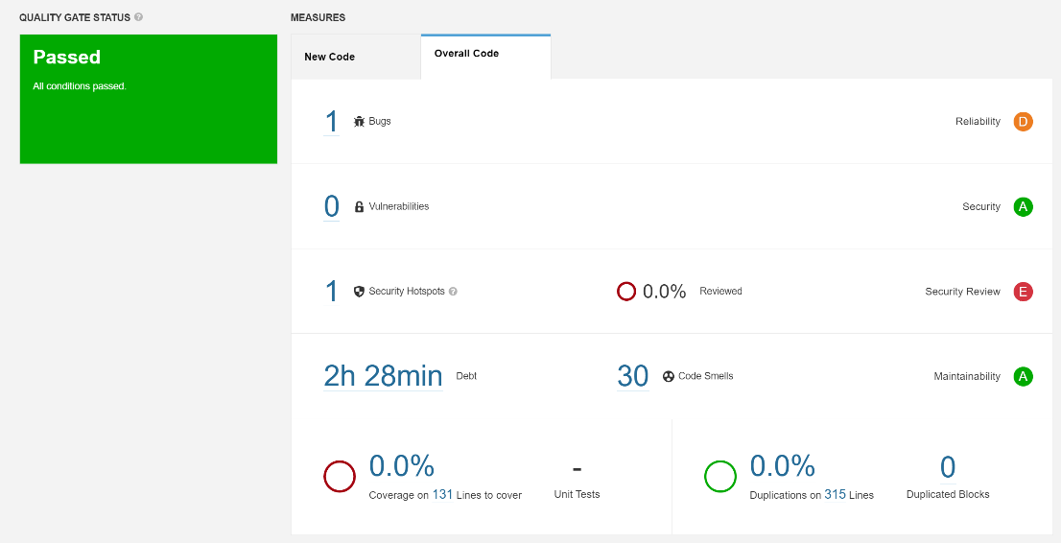

|  |  |  |
| --- | --- | --- |
| **Issue** | **Problem description** | **How to solve** |
| **Bug** | "Random" objects should be reused” | “For better efficiency and randomness, create a single Random, then store, and reuse it.” |
| **Vulnerability** | ------------------------------------- | --------------------------------------- |
| **Code smell (major)** | “Static non-final field names should comply with a naming convention” | “Shared naming conventions allow teams to collaborate efficiently. This rule checks that static non-final field names match a provided regular expression.” |
|  | “"static" members should be accessed statically” | “While it is possible to access static members from a class instance, it's bad form, and considered by most to be misleading because it implies to the readers of your code that there's an instance of the member per class instance.” |
|  | “"for" loop stop conditions should be invariant” | “A for loop stop condition should test the loop counter against an invariant value (i.e. one that is true at both the beginning and ending of every loop iteration). Ideally, this means that the stop condition is set to a local variable just before the loop begins.” |
|  | “Modifiers should be declared in the correct order” |  |
|  | “Declarations should use Java collection interfaces such as "List" rather than specific implementation classes such as "LinkedList"” | “Implementing classes must be used to instantiate new collections, but the result of an instantiation should ideally be stored in a variable whose type is a Java Collection interface.  “ |
|  | “The diamond operator ("<>") should be used” | “For instance, instead of having to declare a List's type in both its declaration and its constructor, you can now simplify the constructor declaration with <>, and the compiler will infer the type.” |
|  | “Unused method parameters should be removed” | “Unused parameters are misleading. Whatever the values passed to such parameters, the behavior will be the same.  “ |
|  | “Standard outputs should not be used directly to log anything” | “If a program directly writes to the standard outputs, there is absolutely no way to comply with those requirements. That's why defining and using a dedicated logger is highly recommended.  “ |
|  | “JUnit5 test classes and methods should have default package visibility” | “JUnit5 is more tolerant regarding the visibilities of Test classes than JUnit4, which required everything to be public.  “ |