# Section 1

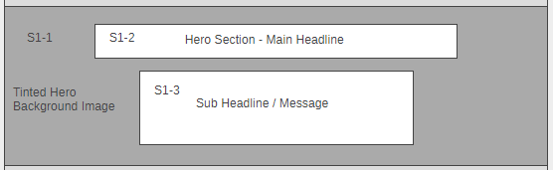

S1-1 – Microsoft Stock Image Hero Banner Background (This will have a black alpha tint over it similar to the other ones on Azure Marketplace) Examples:   
<https://azuremarketplace.microsoft.com/en-us/>  
<https://azuremarketplace.microsoft.com/en-us/sell>  
  
*Please copy here and send image as an attachment*

A group of people sitting at a table in front of a window

Description generated with very high confidence

S1-2 – Main Headline  
***Integrated Solutions to get you up and running***

S1-3 – Sub Headline  
*Empower your business and accelerate your transformation projects with Integrated Solutions. These offers bring together best-of-breed technologies from Microsoft partners, along with consultation, deployment, and support provided by expert systems integrators.*

*Discover the ease of a unified buying and implementation experience with Integrated Solutions today!*

# Section 2

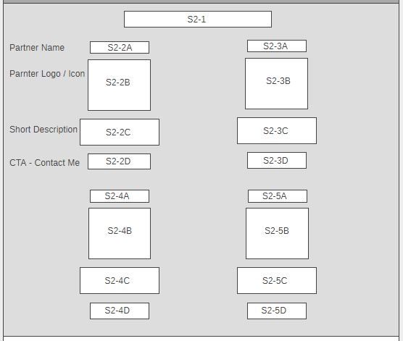

S2-1 – Main Headline  
***Featuring Integrated Solutions for Financial Services, Retail, and Healthcare Customers***

**First Bundle**

S2-2A – Partner / Bundle Name  
*Customer 360 Powered by Zero2Hero™*

S2-2B – Corresponding logo / image  
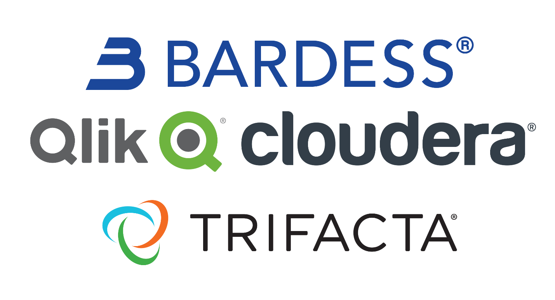

*Please copy here and send image as an attachment*

S2-2C – Offer description / information  
*A complete platform for customer 360 workloads that enables organizations to better understand their customers, learn from their behavior and deliver personalized interactions based on available data. Customer 360 powered by Zero2Hero™ builds a more comprehensive view of customers by leveraging data of all types, sizes, and velocities. It is designed to solve modern scale problems & deliver rapid value.*

S2-2D – CTA  
*Contact Me*

**Second Bundle**

S2-3A – Partner / Bundle Name  
*Rapid Commerce*

S2-3B – Corresponding logo / image  
*Please copy here and send image as an attachment*

A screenshot of a cell phone

Description generated with very high confidence

S2-3C – Offer description / information  
*Rapid Commerce is the first fully cloud-native, microservices and headless architecture-based digital commerce platform accelerator for modern retailers. It combines the power of Azure and microservices with a proven, Agile-based approach to align and establish priorities, translate strategy into a plan and deliver a detailed roadmap that streamlines implementation and shortens time-to-value.*

S2-3D – CTA  
*Contact Me*

**Third Bundle**

S2-4A – Partner / Bundle Name  
*Credit Analytics*

S2-4B – Corresponding logo / image  
*Please copy here and send image as an attachment*

A screenshot of a cell phone

Description generated with very high confidence

S2-4C – Offer description / information  
*Manage risk of loan portfolios with Credit Analytics to maximize risk-adjusted rate of return, minimize capital reserve requirements, and strengthen compliance. Interactive Credit Analytics provides transparency into the characteristics and risks associated with each loan and loan segment to support setting thresholds and limits on each risk pool, and facilitates in analysis of concentration and risk.*

S2-4D – CTA  
*Contact Me*

**Fourth Bundle**

S2-5A – Partner / Bundle Name  
*Healthcare Cloud Security Stack*

S2-5B – Corresponding logo / image  
*Please copy here and send image as an attachment*

A close up of a logo

Description generated with very high confidence

S2-5C – Offer description / information  
*Healthcare Cloud Security Stack (HCSS) is at the center of IT modernization helping entities use cloud services without losing focus on cybersecurity and HIPAA compliance. HCSS uses the Qualys Cloud Agent, Trend Micro Deep Security, and XentIT Executive Dashboard as a unified cloud threat management stack, eliminating the overhead of security automation and orchestration after migration to the cloud.*

S2-5D – CTA  
*Contact Me*

# Section 3

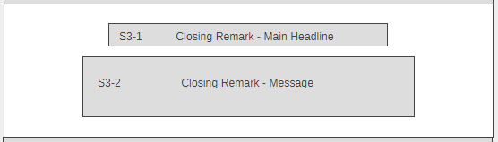

S3-2 – Closing Remark – Main Headline  
*Coming soon*

S3-3 – Closing Remark – Message

***Explore and discover more integrated solutions on the*** [***Azure Marketplace***](https://azuremarketplace.microsoft.com/en-us) ***coming soon!***