# Section 1

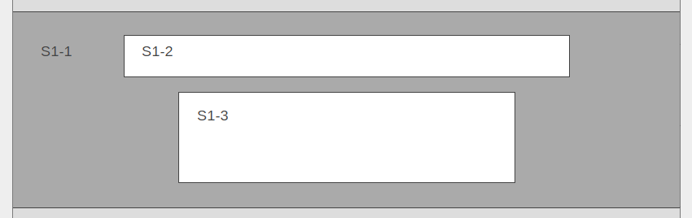

S1.1 – Microsoft Stock Image Hero Banner Background (This will have a black alpha tint over it similar to the other ones on Azure Marketplace)  
*Options available depending on how it looks in design (also attaching to email):*

[*https://microsoft.sharepoint.com/teams/BrandCentral/Pages/Bundles/MSC17_global_016.aspx*](https://microsoft.sharepoint.com/teams/BrandCentral/Pages/Bundles/MSC17_global_016.aspx)

https://microsoft.sharepoint.com/teams/BrandCentral/Pages/Bundles/MSC17_dataCenter_038.aspx

S1.2 – Main Headline  
Get Started with Azure

S1.3 – Sub Headline  
*Start your journey to the cloud with an assessment or briefing by Gold Microsoft migration partners and learn how you can get started with confidence on Azure.*

# Section 2

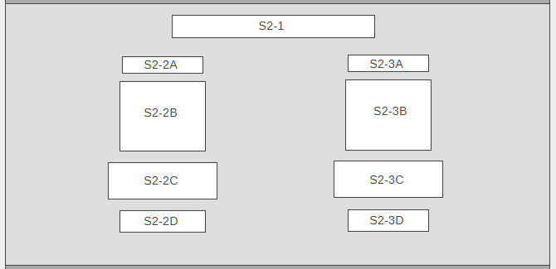

S2-1 – Main Headline  
*Free Migration Assessments*

**First Partner**

S2-2A – Partner / Publisher Name  
*Wipro*

S2-2B – Corresponding logo / image  
*Please send image as an attachment (attached to email)*



S2-2C – Offer description / information  
*Get a demo of how Wipro’s Cloud Migration platform can help you create an end-to-end migration method*

S2-2D – CTA  
*Contact Me*

**Second Partner**

S2-3A – Partner / Publisher Name  
*Wharfedale*



S2-3B – Corresponding logo / image  
*Please send image as an attachment (attached to email)*

S2-3C – Offer description / information

*Get an assessment of your needs and find out how Wharfedale can help you move SAP workloads to Azure with zero up front investment*

S2-3D – CTA  
*Contact Me*

# Section 3 – Current

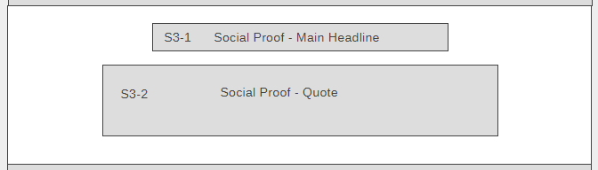

S3-1 – Main Headline (optional) for testimonial / quote  
*Microsoft Partners Help you migrate with speed and confidence*

S3-2 – Testimonial / quote content  
**“Our Zero Dollar Down program has helped our customers feel better about their decision to migrate to Microsoft Azure. We migrated their SAP software landscape with minimal downtime, and the cloud infrastructure provided a very resilient, dynamic and scalable environment. The customer has realized a nearly 53% performance improvement in their production environment.” - Mahesh Reddy, CTO of Wharfedale.**

# Section 3 - Deprecated

THE LAYOUT & CONTENT FOR THIS SECTION IS SUBJECT TO CHANGE – Based on images we can find and the # of partner testimonials acquired.

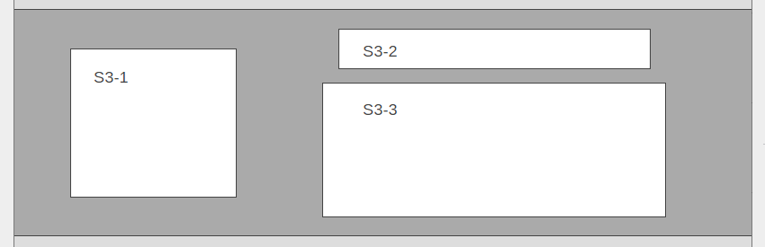

S3.1 – Corresponding Image / Logo for partner testimonial  
*Please send image as an attachment (attached to email)*

Also linked to here: https://microsoft.sharepoint.com/teams/BrandCentral/Pages/Bundles/MSC17_dataCenter_050.aspx

S3.2 – Main Headline (optional) for testimonial / quote  
*Microsoft Partners Help you migrate with speed and confidence*

S3.3 – Testimonial / quote content  
**“Our Zero Dollar Down program has helped our customers feel better about their decision to migrate to Microsoft Azure. We migrated their SAP software landscape with minimal downtime, and the cloud infrastructure provided a very resilient, dynamic and scalable environment. The customer has realized a nearly 53% performance improvement in their production environment.”**

**Mahesh Reddy, CTO of Wharfedale.**