# Section 1

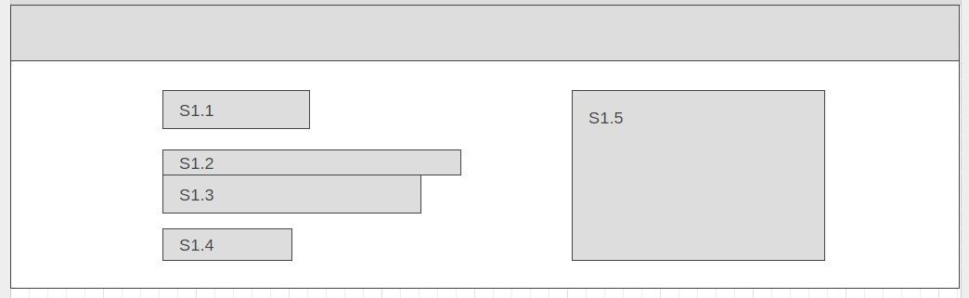

S1.1 - Chef Logo

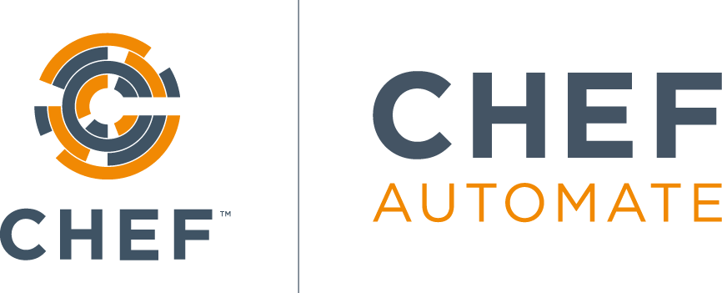

S1.2 – Main Headline  
Want to experience firsthand how DevOps works using Chef Automate?

S1.3 – Sub Headline  
Explore hands-on, guided scenarios in a live sandbox on Microsoft Azure today! Free. No set up or credit card required.

S1.4 – CTA Button  
Launch Test Drive

S1.5 – Hero Image or Video

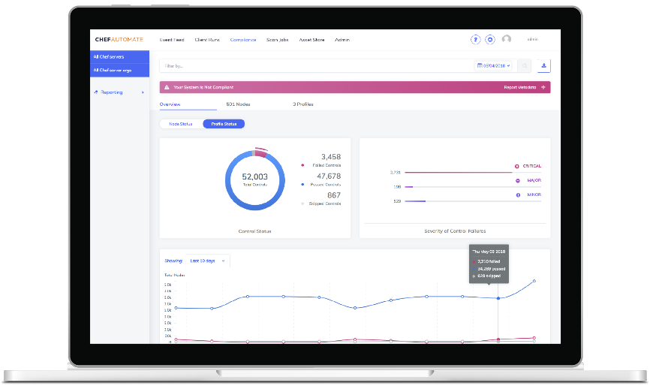

# Section 2

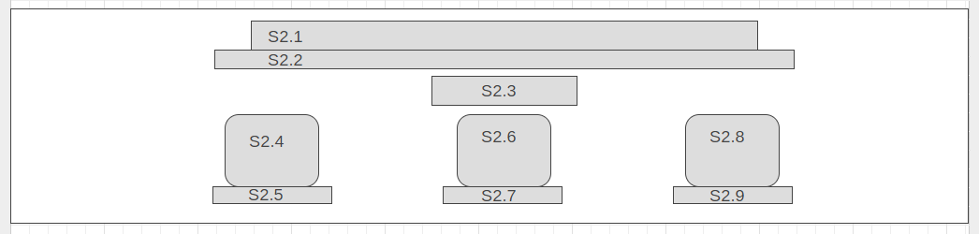

S2.1 – Main Headline  
Effortless infrastructure. Automatically.

S2.2 – Sub Headline  
With Automate, and its integrations with Chef’s open source engines InSpec, Chef, and Habitat, you have the tools to detect, correct, and automate your way to delivering software at the speed of business. *Don’t just take our word for it, though — download a trial license today and find out how Automate can help your organization deploy changes with unparalleled speed and efficiency, while ensuring updates are validated and safe. –* **Note:**We’re not including the CTA again here so the italicized section is not as relevant.

S2.3 – Header Logo



S2.4 – Icon 1  


S2.5 – Caption 1  
Infrastructure Automation

S2.6 – Icon 2



S2.7 – Caption 2  
Application Automation

S2.8 – Icon 3



S2.9 – Caption 3  
Compliance Automation

# Section 3

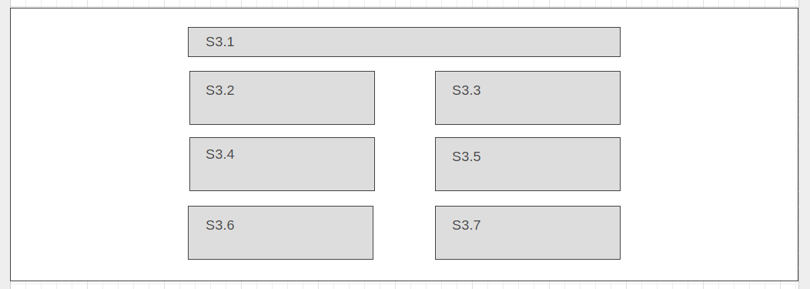

S3.1 – Main Headline  
A single source of truth for all your environments

S3.2 – Info 1  
Real-Time Data Across your Estate  
Chef Automate provides filterable dashboards collecting configuration and compliance details for every datacenter, cloud provider, and environment you manage in aggregated dashboards.

S3.3 – Info 2  
Collaborate Effortlessly Between Teams  
Your organization’s development, operations, security, and compliance teams are all responsible for ensuring you deliver software safely and efficiently, and with Chef Automate all stakeholders can share a consistent view of how your environments are built and validated.

S3.4 – Info 3  
Powerful Auditing Capabilities

Chef Automate lets you create agentless compliance scans directly in the Web UI. Scan traditional servers, VMs, cloud instances, and SaaS solutions all in one place

S3.5 – Info 4  
Intelligent Access Controls  
Chef Automate integrates with LDAP and SAML based authentication so you can ensure the right teams have the right access using your existing access control solutions.

S3.6 – Info 5  
Built-In Compliance Assets  
The Chef Automate asset store comes with a library of precreated InSpec profiles for validating software patches, system security, and evaluation against industry-standard frameworks like the CIS Benchmarks and DISA STIGs.

S3.7 – Info 6  
Actionable Insights at Any Scale  
The release of Chef Automate 2.0 brings with it a modernized architecture for the Automate Server, providing the most responsive, intuitive Automate experience yet!

# Section 4

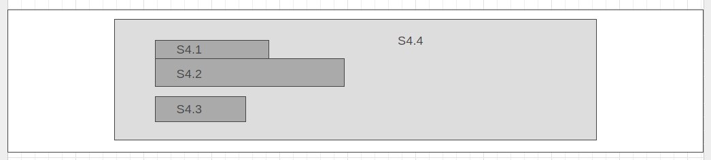  
  
S4.1 – Main Headline  
Build your skills

S4.2 – Sub Headline  
Take the Azure and Chef Automate Track on Learn Chef Rally in our self-paced learning center! Dive into small bite modules or multi-course tracks.

S4.3 – External Button (To Learn Chef on Microsoft Azure)  
START LEARNING

S4.4 – Image Background

# Section 5

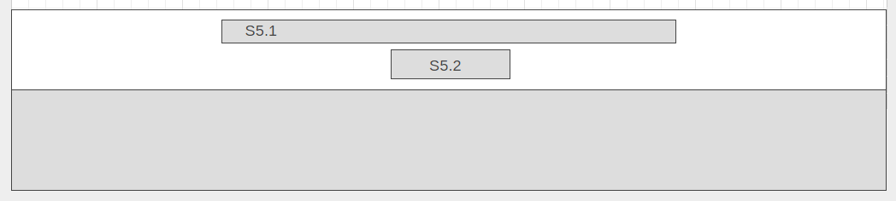

S5.1 – Closing Remark

With Chef Automate on Azure, you can enable continuous and compliance automation across your all of your infrastructure and application environments. Give [Chef Automate](https://www.chef.io/automate/) on Azure a test drive today by clicking below!

S5.2 - CTA Button  
LAUNCH TEST DRIVE