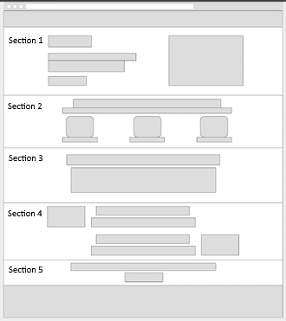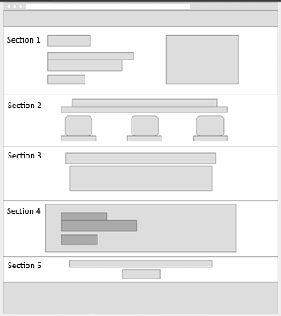

This is proposed Layout 1 w/ the following sections:

1. Hero Section w/ CTA
2. Highlights Section
3. Additional Info Section
4. Learn Chef Rally Section that redirects to: <https://learn.chef.io/tracks/chef-on-azure#/>
5. Closing Remark + CTA

This is proposed Layout 2

This layout simply swaps out Section 4, with a Consumer Quotes / Social Proof section which is popular in landing pages today.

Here is a screenshot of the current POC for reference to the sections and what the sections in the layouts could look like:

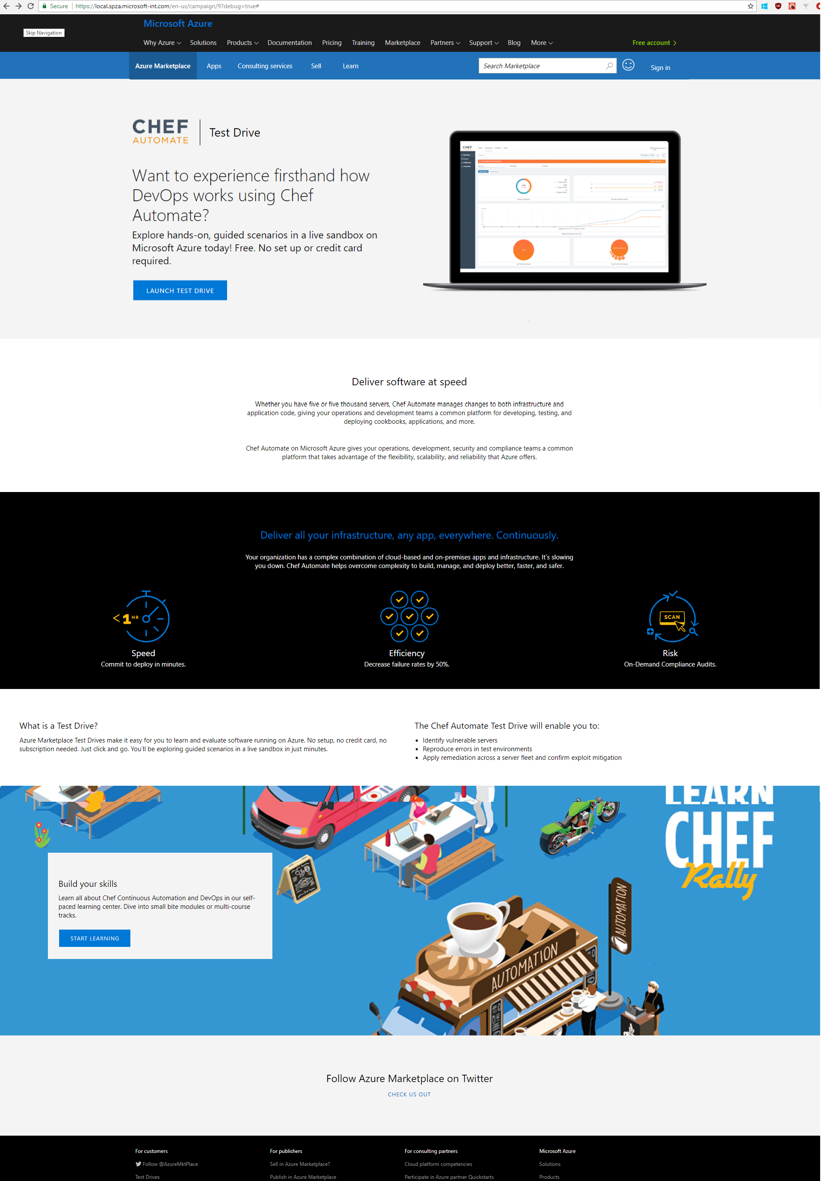

Sections 1-3 already exist in the POC and we can just swap out assets and content as needed. For section 5, we would just need to gather what closing remark Chef would like to use.

Section 4 would be dependent on the layout, so before we move forward with fully developing the page, we would love to confirm which layout you would like to use.

**Note:** I do believe Layout 2 would be a stronger page for driving the user to the Test Drive CTA. Featured below is some longer descriptions and reference to the purpose of each section and what they represent.

**Disclaimer:** All campaign landing pages will have either the AppSource or Azure Marketplace banners depending on where the linked offer is published.

# Single Offer Landing Page Sections

## Hero

This content goes at the top of the page and features essential information about the offer or process. This component should feature the offer proposition to the target market with the following features:

* Publisher Logo
* Main Headline
* Supporting Headline
* CTA (Call-To-Action) Button
* An embedded video player or embedded image

## Highlights

This content block lays out horizontally across the landing page and can contain 2 - 4 features that are being highlighted. This block can contain a sub headline a brief content message. The features listed should be concise and to the point. Each feature can include up to one embedded icon/image and a one-liner caption describing it provided it is consistent with each one. Features should also be equally spaced from each other and providing symmetry throughout the section.

## Additional Info

This is a standalone content block that can feature a reinforcement statement, or just more general information about the product. If this block contains a bulleted list, the list length must be no longer than 5 elements.

## Social Proof

This content block includes a quote or review from a user speaking to the offer. This block should not contain any images aside from the background. The background that the text lays on can be a solid color or a two-tone image that will be recolored into the correct palette.

## Closing Remark

This is the final section that will go right above the bottom Azure Marketplace banner. This section features a CTA again which should act the same as the CTA featured in the Hero section. The CTA is placed here for easier user access since they have scrolled away from the original button. The closing remark should be short, to the point, and drive the user to click.

Layout 1

Hero section: Attached Chef and Chef Automate Logo; Attached new screen shots

Highlight section – <https://www.chef.io/automate/> (section 4 of page)

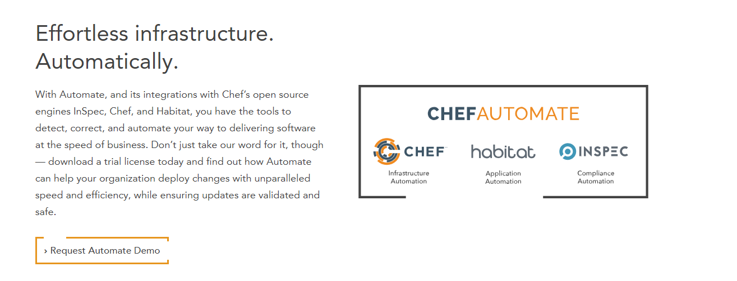

Additional info section – More than 5, can this still work?

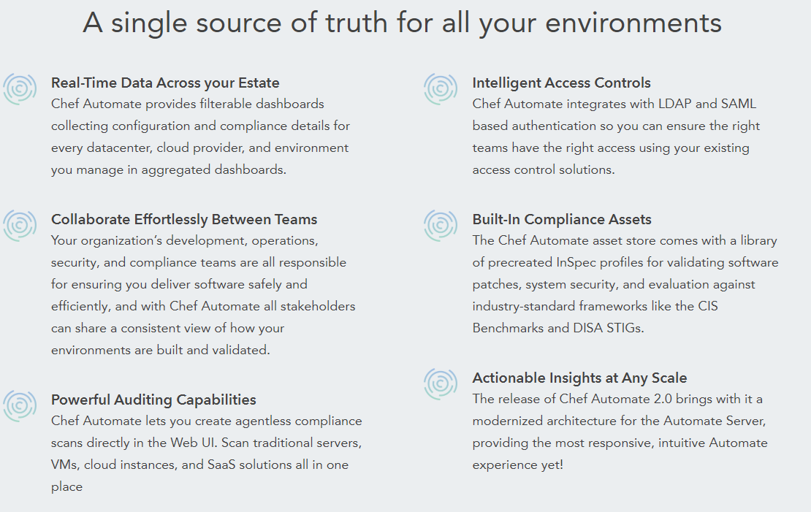

Take the Azure and Chef Automate Track on Learn Chef Rally! Free, self-paced hands on tutorials

<https://learn.chef.io/tracks/chef-on-azure#/>