ANONYMOUS MANUSCRIPT
For double-blind peer review — remove all author-identifying information
[ARTICLE TYPE: Research Article / Review Article]
[TITLE OF THE MANUSCRIPT]
Use a concise, informative title that reflects the main focus of the study.
ABSTRACT
Writing guide: Prepare a structured abstract of no more than 250 words. Do not include citations, unexplained abbreviations, or first-person pronouns. Use past tense for completed procedures and findings.
Importance of the work: Briefly explain the problem, research gap, or significance.
Objective: State the main purpose or research question using a direct and specific sentence.
Materials and Methods: Identify the research design, participants or data sources, instruments, procedures, and major analytical technique.
Results: Present the most important findings, including numerical results when applicable. Do not merely say “significant results were found.”
Main Finding: State the main conclusion and explain what the findings contribute or how they may be applied.
Keywords: Provide 3–5 specific terms, separated by commas, that represent the topic, method, population, or setting.

1. INTRODUCTION
Enter manuscript text here. The Introduction should establish the context of the study, synthesize relevant literature, identify the gap or unresolved issue, and end with the purpose, research questions, hypotheses, or objectives. Avoid presenting a long annotated bibliography. Each paragraph should contribute to the rationale for the study.
Recommended sequence: (1) broad context and importance; (2) current evidence and relevant literature; (3) gap, problem, or limitation; (4) rationale and novelty; and (5) objectives or research questions.

2. REVIEW OF RELATED LITERATURE [if applicable]
Enter manuscript text here. Organize the literature thematically or conceptually rather than by author-by-author summaries. Explain agreements, contradictions, trends, and limitations in previous studies. Use recent and authoritative sources where appropriate, while retaining seminal works that are necessary to explain theories or foundational concepts. Clearly show how the literature supports the present study.

2.1 Theoretical Framework
Present the theory or theories guiding the study, if applicable.
[Enter subsection text here.]

2.2 Related Studies
Synthesize relevant empirical studies and identify the research gap.
[Enter subsection text here.]

3. METHODOLOGY
Enter manuscript text here. Describe the study in enough detail that another researcher could understand or reproduce it. Depending on the design, include the research approach/design, setting, participants or data sources, sampling procedure, instruments, validity or trustworthiness procedures, data collection steps, data analysis, and ethical considerations. Report the actual procedures used. Do not describe procedures that were not performed.
For quantitative studies, report variables, measures, statistical tests, assumptions, and decision criteria. For qualitative studies, report the design, researcher role or reflexivity, participant selection, data collection, coding/analysis process, and strategies for credibility. For mixed-methods studies, explain how the quantitative and qualitative components were connected and integrated.

4. RESULTS
Enter manuscript text here. Present findings in the same order as the research questions or objectives. Begin with the most important result. Use tables and figures to improve clarity, not to repeat every value already stated in the text. Report sufficient descriptive or analytical evidence, including effect sizes, confidence intervals, or other relevant statistics when applicable. Do not interpret implications extensively in this section; reserve that work for the Discussion.

5. DISCUSSION
Enter manuscript text here. Explain what the findings mean, why they matter, and how they relate to previous studies, theories, or practice. Address unexpected or non-significant findings, possible explanations, limitations, and implications. Ensure that claims are proportional to the evidence and avoid introducing results that were not reported in the Results section.

6. CONCLUSION
Enter manuscript text here. Provide a concise synthesis of the main findings and directly answer the research problem or questions. Do not introduce new evidence or merely repeat the abstract. State the principal contribution and the scope or conditions within which the conclusion is valid.

7. RECOMMENDATIONS
Enter manuscript text here. Recommendations should be specific, feasible, and clearly grounded in the findings. Identify appropriate beneficiaries or users and, when relevant, propose directions for future research.

ACKNOWLEDGMENTS (OPTIONAL)
Enter manuscript text here. Acknowledge individuals, institutions, grants, technical assistance, or other support that materially contributed to the work. Do not include identifying information that could compromise anonymous peer review; detailed disclosures may be placed in the non-anonymous submission file if required.

REFERENCES
SKJEAT manuscripts should use the American Psychological Association (APA) 7th edition for in-text citations and the reference list. Authors are encouraged to use a reference manager such as Zotero, Mendeley, or EndNote to insert citations and generate the bibliography. The selected output style must be “APA 7th edition”.
In-text citation examples:
Parenthetical citation: (Santos, 2023)
Narrative citation: Santos (2023)
Two authors: (Garcia & Cruz, 2022)
Three or more authors: (Dela Cruz et al., 2021)
Multiple sources: (Garcia, 2022; Santos, 2023)
Direct quotation: (Santos, 2023, p. 15)
Reference-list requirements:
• Include only sources cited in the manuscript.
• Ensure every in-text citation has a matching reference-list entry.
• Arrange entries alphabetically by the surname of the first author.
• Use a hanging indent of 0.5 inch and double spacing in the final reference list.
• Use sentence case for article, book, and webpage titles; italicize journal titles and volume numbers.
• Include a DOI in URL format (https://doi.org/...) when available.
• Do not include database names or retrieval dates for ordinary journal articles unless specifically required by APA 7.
• Check author names, publication years, titles, volume/issue, page range or article number, and DOI/URL for accuracy.
Sample APA 7 references:
Journal article: Grady, J. S., Her, M., Moreno, G., Perez, C., & Yelinek, J. (2019). Emotions in storybooks: A comparison of storybooks that represent ethnic and racial groups in the United States. Psychology of Popular Media Culture, 8(3), 207–217. https://doi.org/10.1037/ppm0000185
Book: American Psychological Association. (2020). Publication manual of the American Psychological Association (7th ed.). American Psychological Association.
Webpage: World Health Organization. (2018, May 24). The top 10 causes of death. https://www.who.int/news-room/fact-sheets/detail/the-top-10-causes-of-death
Using Zotero, Mendeley, or EndNote
1. Create or open the reference library and import sources using DOI, ISBN, URL, or database export whenever possible.
2. Check and correct the metadata manually, especially author names, publication year, title capitalization, journal title, volume, issue, pages, and DOI.
3. Install the word-processing plugin for Microsoft Word.
4. Select APA 7th edition in the citation-style or document-preferences menu.
5. Insert citations while writing instead of typing them manually.
6. Insert the bibliography using the reference manager’s “Add Bibliography” or equivalent function.
7. Refresh the document before submission and verify that every cited source appears in the reference list.
8. Do not manually edit generated citation fields unless creating a final, unlinked production copy; correct the metadata in the reference manager instead.
Important: Reference managers assist with formatting, but authors remain responsible for the accuracy and completeness of all citations and references.

TABLES AND FIGURES
Writing guide: Place each table or figure near its first mention or at the end of the manuscript. Number items consecutively, provide a concise descriptive title or caption, explain abbreviations and symbols in notes, and ensure that every table or figure is cited in the text. Visual materials should be readable and should add information rather than duplicate the prose.

Tables: Format and Sample
Tables should be numbered consecutively in the order in which they are first mentioned. Refer to each table in the text (e.g., “As shown in Table 1…”). Provide a brief, informative title above the table. Use clear column headings, consistent decimal places, and notes below the table for abbreviations, statistical significance, or source information. Avoid vertical borders and unnecessary shading. Do not duplicate all table values in the narrative.
Table 1. Descriptive statistics of selected study variables
Variable | n | M | SD | Interpretation
Academic motivation | 120 | 3.84 | 0.56 | High
Learning engagement | 120 | 3.67 | 0.61 | High
Research self-efficacy | 120 | 3.42 | 0.68 | Moderate
Note. M = mean; SD = standard deviation. The values in this sample table are illustrative only.
Figures: Format and Sample
Figures may include graphs, diagrams, maps, photographs, models, or conceptual frameworks. Number figures consecutively and refer to each figure in the text. Use a clear figure title or caption, readable labels, appropriate units, and a legend when needed. Ensure that the figure is understandable in grayscale or when printed. Provide a note below the figure when explaining abbreviations, symbols, or adapted material.

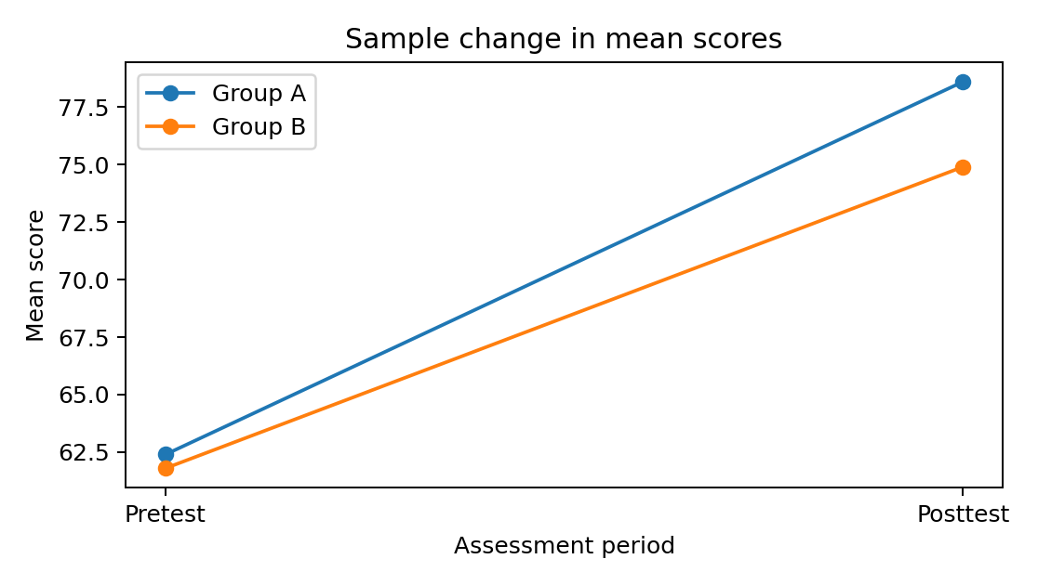
Note. The figure is an illustrative example only. Replace it with the study’s actual figure and report the data source when applicable.
Figure 1. Change in mean scores across assessment periods

GENERAL WRITING GUIDE
The manuscript should tell one clear story: why the study was needed, how it was conducted, what was found, and why the findings matter. Use clear, precise, evidence-based language. Define abbreviations at first use, maintain consistent terminology, cite sources appropriately, and ensure that claims match the evidence. Research articles generally follow the IMRaD logic: Introduction, Methods, Results, and Discussion, followed by Conclusion and other required statements as applicable.

