Analysis of demographic and environmental conditions near selected facilities

2025-02-10

Abstract

Abstract - Executive Order 14008 calls on EPA and other Agencies to make achieving environmental justice part of their missions, and EO 12989 directed EPA to make environmental justice part of their mission by identifying and addressing, as appropriate, disproportionately high and adverse human health or environmental effects of their programs, policies, and activities on minority populations and low-income populations in the United States. The United States Environmental Protection Agency (US EPA) analyzed baseline demographic and environmental conditions in communities living within 2 miles of analyzed sites. The analysis used EPA’s EJAM tool and EJScreen version 2.2 with demographic data based on the Census Bureau’s 2017-2021 American Community Survey (ACS). The analysis found that PLACEHOLDER.

Table of Contents

# 1 Executive Summary

Executive Order 14008 calls on EPA and other Agencies to make achieving environmental justice part of their missions, and EO 12989 directed EPA to make environmental justice part of their mission by identifying and addressing, as appropriate, disproportionately high and adverse human health or environmental effects of their programs, policies, and activities on minority populations and low-income populations in the United States.

EPA has conducted an analysis to characterize baseline environmental conditions faced by communities living near Example facilities of example category. The United States Environmental Protection Agency (US EPA) analyzed baseline demographic and environmental conditions in communities living within 2 miles of selected sites. The analysis used EPA’s EJAM tool and EJScreen version 2.2 with demographic data based on the Census Bureau’s 2017-2021 American Community Survey (ACS).

## 1.1 Summary of Findings

* Overall, ratio to state average Diesel PM, ratio to state average TSDF, ratio to state average UST are more than 1.5 times the state average, for the population within 2 miles.
* At 1% of these sites, at least 4 of the state ratio indicators are at least 2 times the statewide overall average. At 10% of these sites, at least 1 of the state ratio indicators is at least 3 times the statewide overall average. At 1% of these sites, at least 1 of the state ratio indicators is at least 5 times the statewide overall average.
* Weighted by population across all facilities, ratio to state average of percent People of Color has the highest ratio to state average across all demographic indicators at a value of 1.279 and ratio to state average TSDF has the highest ratio to state average across all environmental indicators at a value of 2.321.
* 1% of places account for 31% of the total population (1). 5% of places account for 49% of the total population (5). 10% of places account for 60% of the total population (10).

# 2 Introduction

Executive Order 12898 (59 FR 7629; February 16, 1994) established federal executive policy on environmental justice. Its main provision directed federal agencies, to the greatest extent practicable and permitted by law, to make environmental justice part of their mission by identifying and addressing, as appropriate, disproportionately high and adverse human health or environmental effects of their programs, policies, and activities on minority populations and low-income populations in the United States.

EPA defines environmental justice as the fair treatment and meaningful involvement of all people regardless of race, color, national origin, or income with respect to the development, implementation, and enforcement of environmental laws, regulations, and policies.

Executive Order 14008 (86 FR 7619; January 27, 2021) also calls on Agencies to make achieving environmental justice part of their missions “by developing programs, policies, and activities to address the disproportionately high and adverse human health, environmental, climate-related and other cumulative impacts on disadvantaged communities, as well as the accompanying economic challenges of such impacts.” It also declares a policy “to secure environmental justice and spur economic opportunity for disadvantaged communities that have been historically marginalized and overburdened by pollution and under-investment in housing, transportation, water and wastewater infrastructure and health care.”

EPA also released its “Technical Guidance for Assessing Environmental Justice in Regulatory Analysis” (U.S. EPA, 2016) to provide recommendations that encourage analysts to conduct the highest quality analysis feasible, recognizing that data limitations, time and resource constraints, and analytic challenges will vary by media and circumstance.

# 3 Methods

## 3.1 Selection of sites analyzed

This analysis focused on locations categorized under Example facilities of example category. The latitude and longitude of a point representing each site was obtained from EPA’s Facility Registry Service (FRS). A total of 100 sites had location information and were analyzed.

## 3.2 Map of Analyzed Sites

Figure 3.1 shows a map of the sites analyzed.

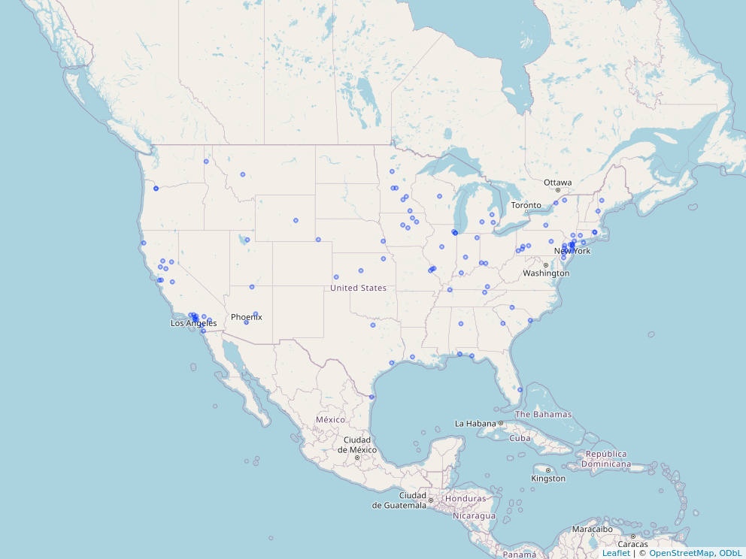

Figure 3.1: Map of Analyzed Sites

## 3.3 Estimating locations and population counts of residents

EPA’s EJAM (Environmental Justice Analysis Multisite) tool was used to develop this analysis. EPA’s [EJAM tool](https://usepa.github.io/EJAM/index.html) is a user-friendly web app that can summarize demographics and environmental conditions for any list of places in the nation.

### 3.3.1 Spatial resolution of data

The analysis used EPA’s EJAM tool and EJScreen version 2.2 with demographic data based on the Census Bureau’s 2017-2021 American Community Survey (ACS) 5-year summary file, and the corresponding version of Decennial Census information on geographic boundaries and FIPS codes for blocks, block groups, tracts, counties, and states. Demographic and environmental indicators were at block group resolution. Locations of residential populations were at block resolution (the highest resolution available from the Census Bureau) and then summarized by block group. Once site locations are input to EJAM, the residential populations are then analyzed by location, and then summarized as percentiles and averages across all sites input to EJAM.

See [EJScreen methodology](https://www.epa.gov/ejscreen/technical-information-and-data-downloads) for details.

### 3.3.2 Analytic method for buffering, and tools used to implement that method

The basic methodology and data used for this analysis are the same as those used in EPA’s EJScreen tool, with a few exceptions described below, and are described in detail in EJScreen’s documentation, at [EJScreen](https://epa.gov/ejscreen) and with more technical details available at [EJScreen technical documentation page](https://www.epa.gov/ejscreen/technical-information-about-ejscreen).

Like EJScreen, EJAM identifies residents near a given site by finding which Census block points are nearby and counts the full block population if that point is nearby. The percentage of each block group’s population that is estimated as inside a buffer is based on which Census block internal points are included in the buffer and using a block weight. The block weight is the Census 2020 block population as a fraction of the parent block group’s Census 2020 population (which is not quite the same as the ACS population count). That block weight is a fraction of the parent block group and is used to estimate how many of the block groups residents are nearby or in the buffer.

The only notable differences between the EJScreen and EJAM calculations of proximity and indicators are the following:

* EJAM may include additional demographic or environmental indicators.
* For a proximity analysis (to characterize everyone living within a certain certain distance from a point such as a facility), EJAM identifies which residents live nearby using a slight variation on how the distance to each Census block is measured. While EJScreen uses ESRI’s ArcGIS calculations, EJAM calculates the distance using formulas implemented in the R language for statistical computing (R Core Team 2022). These measurements provide almost identical results for estimated distance from the average person in a block to a given site point.
* EJAM aggregates indicator values within and across locations, converts them to percentiles, and performs other summary calculations using the same formulas as EJScreen to the greatest extent possible, but in R rather than within EJScreen itself. There may be slight differences between raw scores and percentiles in EJScreen and EJAM in some cases.

## 3.4 Demographic and environmental indicators

The demographics indicators included in EJAM are the same as those in EJScreen as well as additional race/ethnicity subgroups that comprise the total count of people of color. People of Color (POC) are defined as all other than those self-identifying in ACS survey data as white, single race, not Hispanic or Latino - i.e., non-Hispanic white alone (“NHWA”). The subgroups include Hispanic or Latino (“hispanic”), several groups that are not Hispanic but of only single race (e.g., Asian, or more specifically non-Hispanic Asian alone), non-Hispanic other single race, and non-Hispanic multiracial.

The environmental indicators included in EJAM are the same as those in EJScreen.

See [EJScreen methodology](https://www.epa.gov/ejscreen/technical-information-and-data-downloads) for details.

# 4 Findings

## 4.1 Summary of results

Table 4.1 shows a few summary characteristics of the locations analyzed. Out of sites analyzed, 1306189.4 residents are accounted for within 2 miles of the site geolocation. “Percent population accounted for at 10% of facilities” represents the share of population of all sites that is represented by the 10% of sites that have the highest population. The “Population living within radius of at least 2 facilities” is the number of people that live within the radius of at least 2 facilities.

Table 4.1: Summary characteristics of facilities analyzed.

|  | Summary characteristic | Value |
| --- | --- | --- |
|  | Site count | 100 |
|  | States with facilities | 32 |
|  | Facilties missing data | 0 |
|  | Total population | 1,306,189 |
| 10% | Percent population accounted for at 10% of facilities | 59.91 |
|  | Population living within radius for at least 2 facilities | 0 |

## 4.2 Demographic indicator results

In EJAM, values are compared to state or national average and presented as a ratio. This ratio is used as an indicator to detect any disproportionate populations living within the radius of sites.

*Comparison to State Average*

To detect increased potential impact, demographic population percentages locally are compared to state and national averages. The ratio between the local and state averages and the ratio between local and national averages are used as a reference to detect potential disparity. Out of the demographic indicators and sites analyzed, the greatest ratio compared to the state average is ratio to state average of percent People of Color with a rato value of 1.279.

An above average percentage for any demographic indicator is any ratio greater than one. For the facilities analyzed, 8 demographic indicators were calculated on average to be greater than 1.01 times the state average for each indicator. At 100% of these sites, at least 1 of the indicators is at least 1.01 times the statewide overall average. The maximum demographic indicators above 1.01 times the state average for any one facility is 5.

For more disproportionate populations, the ratio will be much greater than the average, such as more than two times or more than three times. For the facilities analyzed, 0 demographic indicators were calculated on average to be greater than two times the state average for each indicator. There are no demographic indicators above the two times the state average. At 100% of these sites, at least 1 of the indicators is at least 2 times the statewide overall average. The maximum demographic indicators above 2 times the state average for any one facility is 27. There are no demographic indicators above the 3 times threshold or 5 times threshold when compared to the state average.

Additionally, facilities can have increased exposure on certain demographics based on the population contained within the 2 miles. 46.2% of the population analyzed live near facilities above the two times threshold, and 15.9% of the population within 2 miles of a facility three times above the state average.

*Comparison to U.S. Average*

Similar to state average comparisons, the comparison to national averages provides additional insights on population characteristics. When compared to the national average, the demographic indicator with the greatest ratio is ratio to US average of percent Limited English with a value of 1.625.

For the facilities analyzed, 8 demographic indicators were calculated to be greater than 1.01 times the national average for each indicator. At 100% of these sites, at least 1 of the indicators is at least 1.01 times the statewide overall average. The maximum demographic indicators above 1.01 times the state average for any one facility is 5.

0 demographic indicators were calculated to be greater than two times the national average for each indicator. There are no demographic indicators above the two times the national average. At 100% of these sites, at least 1 of the indicators is at least 2 times the statewide overall average. The maximum demographic indicators above 2 times the state average for any one facility is 29.

There are no demographic indicators above the 3 times threshold or 5 times threshold when compared to the national average.

49.8% of the population analyzed live near facilities above the two times threshold, and 32.9% of the population within 2 miles of a facility three times above the national average.

### 4.2.1 Data Table. Demographic Indicators

Table 4.2 shows key results for the analysis of demographics in these locations. The table shows each demographic group’s share of the residential population in these locations and compares that to their shares of statewide and nationwide population.

Table 4.2: Demographic Indicators Table

| **Socioeconomic Indicators** | **Value** | **Average in State***1* | **Percentile in State***1* | **Average in USA** | **Percentile in USA** | **Ratio to State Avg.** | **Ratio to USA Avg.** |
| --- | --- | --- | --- | --- | --- | --- | --- |
| Demographic Index | 44% | 35% | 64 | 35% | 68 | 1.2 | 1.3 |
| Supplemental Demographic Index | 16% | 14% | 61 | 14% | 64 | 1.1 | 1.1 |
| % People of Color | 55% | 43% | 64 | 39% | 69 | 1.3 | 1.4 |
| % Low Income | 33% | 28% | 61 | 31% | 59 | 1.2 | 1.1 |
| % Unemployed | 6% | 6% | 61 | 6% | 66 | 1.0 | 1.1 |
| % in limited English-speaking Households | 8% | 6% | 68 | 5% | 82 | 1.3 | 1.6 |
| % with Less Than High School Education | 13% | 12% | 59 | 12% | 67 | 1.1 | 1.1 |
| % under Age 5 | 6% | 5% | 57 | 6% | 59 | 1.1 | 1.0 |
| % over Age 64 | 14% | 17% | 44 | 17% | 44 | 0.8 | 0.8 |
| Low life expectancy | 18% | 18% | 45 | 20% | 35 | 1.0 | 0.9 |
| *1*Avg. in state means the average indicator value, among all the residents at these sites, using the statewide value in each resident's state. Percentile in state means the same, but using the site-specific value (expressed as a percentile) where each resident lives. | | | | | | | |

### 4.2.2 Data Visualization. Barplot of demographic indicators.

Figure 4.1 shows the distribution for demographic indicators for the facilities analyzed.

Figure 4.1: Demographic Indicators Barplot

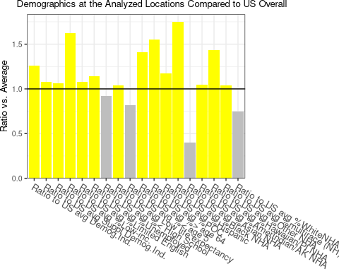

### 4.2.3 Key demographic groups based on magnitude of disparities across facilities analyzed

Based on the analysis, ratio to state average of percent Limited English has the most facilities with values two times greater than the state average (13). 36.4% of the population is included in this estimate.

Ratio to state average of percent Limited English has the most facilities with values three times greater than the state average (5). 13.3% of the population is included in this estimate.

Ratio to state average of percent Limited English has the most facilities with values five times greater than the state average (1). 0.9% of the population is included in this estimate.

The largest disparity for a group/indicator indicates over-representation of that group. For relative disparity, percentile for Low life expectancy has the largest difference of local percentage compared to U.S. percentage. The state level (45.128) is greater than the national level (35) by 10.128.

There are no indicators greater than the 90th percentile at the state level. There are no indicators greater than the 90th percentile at the national level. There are no indicators greater than the 90th percentile at the state level. The indicators greater than the 80th percentile at the national level are as follows: US percentile for of percent in limited English-speaking Households.

State percentile for of percent in limited English-speaking Households had the largest max mean percentile with a value of 67.785 at the state level. US percentile for of percent in limited English-speaking Households had the largest max mean percentile with a value of 82 at the national level.

ratio to US average of percent Limited English had the largest ratio to the U.S. average, and ratio to state average of percent People of Color had the largest ratio when compared to the state average. The values for these ratios are 1.625 and 1.279 respectively.

### 4.2.4 Demographics at key sites

The largest single ratio compared to state average out of all facilities was for ratio to state average Supplementary Demographic Index with the value 6.695. This facility impacts 0.3% of the total population.

The largest single ratio compared to national average out of all facilities was for ratio to US average Supplementary Demographic Index with the value 5.121. This facility impacts 0.3% of the total population.

1 key sites have over half of demographic indicators more than 2x the US average. There are 10 demographic indicators included in EJAM, and therefore, over half represents over 5 indicators. These key sites represent 1.1% of the total population.

The state with the most key sites is TX (1).

### 4.2.5 Data Visualization. Plots of demographic indicators.

Figure 4.2 displays the ratio of demographic indicators compared to the U.S. average across all of the facility sites.

Figure 4.2: Demographic Indicators Ridgeline Plot

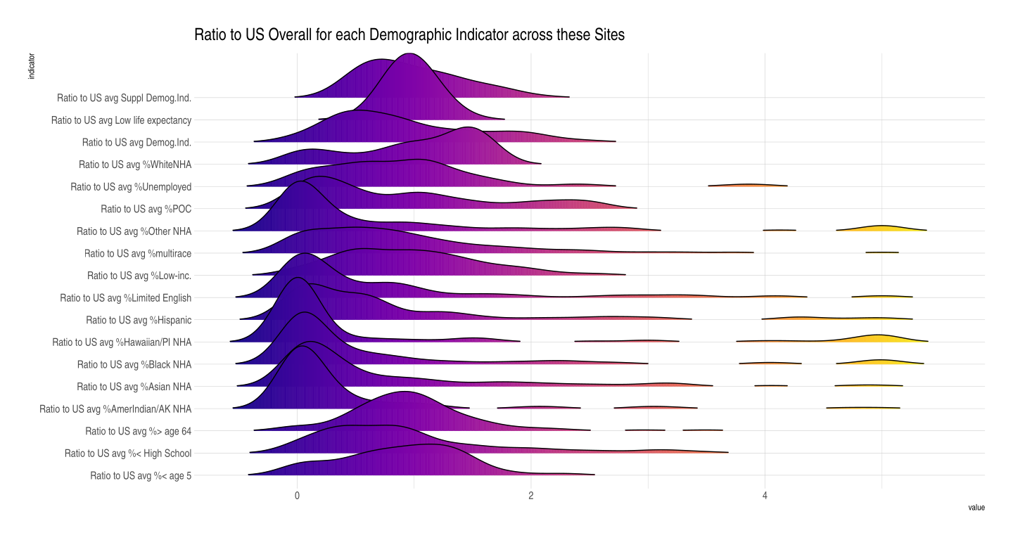

Figure 4.3: Demographic Indicators Resident Barplot

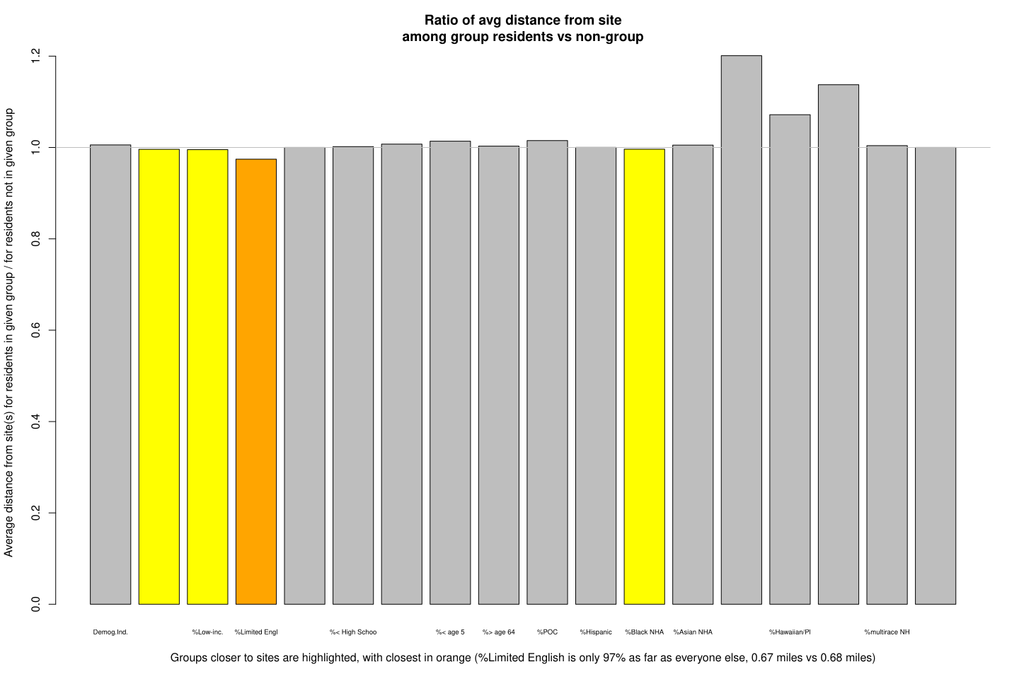

## 4.3 Environmental indicator results

*Comparison to State Average*

Overall, the greatest ratio compared to the state average is ratio to state average TSDF with a value of 2.321.

For the facilities analyzed, 11 environmental indicators were calculated on average to be greater than 1.01 times the state average for each indicator. At 100% of these sites, at least 1 of the indicators is at least 1.01 times the statewide overall average. The maximum environmental indicators above 1.01 times the state average for any one facility is 5.

For the facilities analyzed, 2 environmental indicators were calculated on average to be greater than two times the state average for each indicator. The environmental indicators above the two times threshold are as follows: ratio to state average TSDF, ratio to state average UST. At 100% of these sites, at least 1 of the indicators is at least 2 times the statewide overall average. The maximum environmental indicators above 2 times the state average for any one facility is 20.

There are no environmental indicators above the 3 times threshold or 5 times threshold when compared to the state average.

76.3% of the population analyzed live near facilities above the two times threshold, and 42.2% of the population within 2 miles of a facility three times above the state average.

*Comparison to U.S. Average*

Overall, the greatest ratio compared to the national average is ratio to US average TSDF with a value of 4.191.

For the facilities analyzed, 10 environmental indicators were calculated to be greater than 1.01 times the national average for each indicator. At 100% of these sites, at least 1 of the indicators is at least 1.01 times the nationwide overall average. The maximum environmental indicators above 1.01 times the state average for any one facility is 5.

For the facilities analyzed, 4 environmental indicators were calculated to be greater than two times the national average for each indicator. The environmental indicators above the two times threshold are as follows: ratio to US average Diesel PM, ratio to US average Traffic, ratio to US average TSDF, ratio to US average UST. At 100% of these sites, at least 1 of the indicators is at least 2 times the nationwide overall average. The maximum environmental indicators above 2 times the state average for any one facility is 17.

When compared to the national average, environmental indicators above 3 times threshold are ratio to US average TSDF, ratio to US average UST, and there are no environmental indicators above the 5 times threshold.

91.4% of the population analyzed live near facilities above the two times threshold, and 80.2% of the population within 2 miles of a facility three times above the national average.

### 4.3.1 Data Table. Summary of Environmental Indicators

Table 4.3 shows key results for the analysis of environmental metrics in these locations. The table shows each environmental indicators’ share of the residential population in these locations and compares that to their shares of statewide and nationwide population.

Table 4.3: Environmental Indicators Table

| **Pollution and Sources** | **Value** | **Average in State***1* | **Percentile in State***1* | **Average in USA** | **Percentile in USA** | **Ratio to State Avg.** | **Ratio to USA Avg.** |
| --- | --- | --- | --- | --- | --- | --- | --- |
| Particulate Matter (PM 2.5 in ug/m3) | 8.67 | 8.01 | 71 | 8.08 | 64 | 1.1 | 1.1 |
| Ozone (ppb) | 63.6 | 63.0 | 53 | 61.6 | 67 | 1.0 | 1.0 |
| Air Toxics Diesel Particulate Matter (ug/m3) | 0.65 | 0.37 | 75 | 0.26 | 95 | 1.7 | 2.5 |
| Air Toxics Cancer Risk (risk per million) | 30 | 25 | 37 | 25 | 5 | 1.2 | 1.2 |
| Air Toxics Respiratory Hazard Index | 0.40 | 0.32 | 44 | 0.31 | 70 | 1.3 | 1.3 |
| Toxic Releases to Air | 2,053 | 1,874 | 65 | 4,612 | 73 | 1.1 | 0.4 |
| Traffic Proximity and Volume (daily traffic count/distance to road) | 488 | 327 | 74 | 212 | 90 | 1.5 | 2.3 |
| Lead Paint Indicator (% pre-1960s housing) | 0.53 | 0.41 | 62 | 0.30 | 76 | 1.3 | 1.8 |
| Superfund Proximity (site count/km distance) | 0.20 | 0.22 | 61 | 0.13 | 85 | 0.9 | 1.5 |
| RMP Proximity (facility count/km distance) | 0.40 | 0.38 | 60 | 0.43 | 72 | 1.1 | 0.9 |
| Indicator for Hazardous Waste Proximity (facility count/km distance) | 8.1 | 3.5 | 75 | 1.9 | 94 | 2.3 | 4.2 |
| Underground Storage Tanks (UST) indicator | 15.2 | 6.6 | 80 | 3.9 | 93 | 2.3 | 3.8 |
| Wastewater Discharge Indicator (toxicity-weighted concentration/distance) | 9 | 7 | 68 | 22 | 96 | 1.4 | 0.4 |
| *1*Avg. in state means the average indicator value, among all the residents at these sites, using the statewide value in each resident's state. Percentile in state means the same, but using the site-specific value (expressed as a percentile) where each resident lives. | | | | | | | |

### 4.3.2 Data Visualization. Barplot of environmental indicators.

Figure 4.4 shows the distribution for environmental indicators for the facilities analyzed.

Figure 4.4: Environmental Indicators Barplot

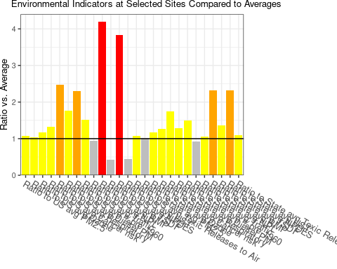

### 4.3.3 Key environmental indicators distribution across the residents and sites

Based on the analysis, Ratio to State avg % built pre-1960 has the most facilities with values two times greater than the state average (11). 12.2% of the population is included in this estimate.

Ratio to state average of percent built pre-1960 has the most facilities with values three times greater than the state average (0). 0% of the population is included in this estimate.

Ratio to state average of percent built pre-1960 has the most facilities with values five times greater than the state average (0). 0% of the population is included in this estimate.

The largest disparity for a indicator indicates over-representation of that indicator. For relative disparity, percentile for Air Toxics Cancer Risk (risk per million) has the largest difference of local percentage compared to U.S. percentage. The state level (37.438) is greater than the national level (5) by 32.438.

There are no indicators greater than the 90th percentile at the state level.

The indicators greater than the 90th percentile at national level are as follows: US percentile for Air Toxics Diesel Particulate Matter (ug/m3), US percentile for Traffic Proximity and Volume (daily traffic count/distance to road), US percentile for Hazardous Waste Proximity (facility count/km distance), US percentile for Wastewater Discharge Indicator (toxicity-weighted concentration/distance), US percentile for Underground Storage Tanks (UST) indicator.

There are no indicators greater than the 80th percentile at the state level.

The indicators greater than the 80th percentile at national level are as follows: US percentile for Air Toxics Diesel Particulate Matter (ug/m3), US percentile for Traffic Proximity and Volume (daily traffic count/distance to road), US percentile for Superfund Proximity (site count/km distance), US percentile for Hazardous Waste Proximity (facility count/km distance), US percentile for Wastewater Discharge Indicator (toxicity-weighted concentration/distance), US percentile for Underground Storage Tanks (UST) indicator.

State percentile for Underground Storage Tanks (UST) indicator had the largest max mean percentile with a value of 79.897 at the state level. US percentile for Wastewater Discharge Indicator (toxicity-weighted concentration/distance) had the largest max mean percentile with a value of 96 at the national level.

Overall, ratio to US average TSDF had the largest ratio to the U.S. average, and ratio to state average TSDF had the largest ratio when compared to the state average. The values for these ratios are 4.191 and 2.321 respectively.

### 4.3.4 Environmental indicators at key sites

The largest single ratio compared to state average out of all facilities was for ratio to state average RMP with the value 50.225. This facility impacts 0.3% of the total population.

The largest single ratio compared to national average out of all facilities was for ratio to US average NPDES with the value 25.063. This facility impacts 0.3% of the total population.

0 key sites have over half of environmental indicators more than 2x the US average. There are 10 environmental indicators included in EJAM, and therefore, over half represents over 5 indicators. These key sites represent 0% of the total population.

There are no key sites in the data analyzed.

### 4.3.5 Data Visualization. Plot of environmental indicators.

Figure 4.5 displays the ratio of environmental indicators compared to the U.S. average across all of the facility sites.

Figure 4.5: Environmental Indicators Ridgeline Plot

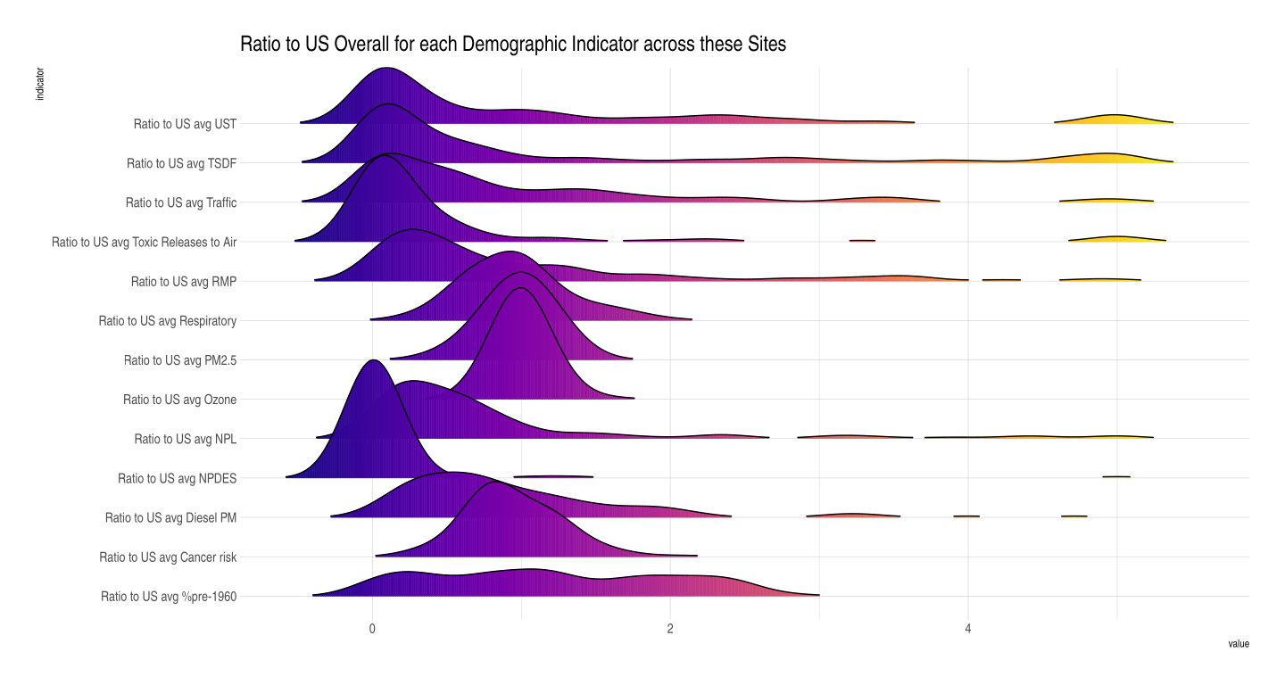

## 4.4 Combination of demographic and environmental conditions in these locations

In summary, EJ indices act as a metric for the combination of environmental and demographic characteristics. Out of 12 EJ indicators, the largest 3 state percentiles for EJ are as follows:

* State percentile for EJ Supplemental Index for Hazardous Waste Proximity (72)
* State percentile for EJ Index for Hazardous Waste Proximity (72)
* State percentile for EJ Supplemental Index for Air Toxics Diesel Particulate Matter (72)

The largest 3 national percentiles for EJ are as follows:

* State percentile for EJ Supplemental Index for Hazardous Waste Proximity (82)
* US percentile for EJ Supplemental Index for Air Toxics Diesel Particulate Matter (82)
* US percentile for EJ Supplemental Index for Hazardous Waste Proximity (82)

# 5 Appendices

## 5.1 Appendix 1 - Statistics overall / for all sites in aggregate

## [1] "NA"

## 5.2 Appendix 2 - Detailed tables of statistics for each site

e.g. how many of 12 are >x? does it have any high scores for any E? any D? etc.

## 5.3 Appendix 3 - Detailed tables of statistics for each indicator

### 5.3.1 **What is Score of people/sites at key thresholds: What is the X (useful) percentile

value, for this indicator (as %ile of people nearby or of sites)?**

* min
* min other than zero?
* mean
* 25th %ile of these sites or people (25% have lower than this, and 75% have higher than this – those are same if no ties with this value, but can differ if multiple places have this same exact indicator score)
* median (half of these sites or people have a score that is >= this, and half have <= this)
* 75th %ile of these sites or people (if a tied value, would want both >75 and <25%)
* max

### 5.3.2 **How many people/sites have score > key thresholds:  What % & what # of sites & people have this indicator score (raw or percentile) >= x (useful threshold)?**

* **For percentiles**
  + % of sites w data where >=80
  + % of sites w data where >=90
  + % of sites w data where >=95
  + # of sites where >=95
* **For ratios to State or USA average overall % of sites w data where >1 not=1**
  + % of sites w data where ratio is >=2
  + % of sites w data where >=3
  + % of sites w data where >=5
  + % of sites w data where >=10
  + # of sites w data where >=10
* **for 12 EJ indexes, how many of the indexes are above a given threshold?**
  + # of sites w data where >=1
  + # of sites w data where >1 not =1
  + # of sites w data where >=4

## 5.4 Appendix 4 - notes on how to describe places generically/ in parameters

HOW TO REFER TO THE PLACES STUDIED (near these facilities vs more general language)

Note: this could be a “proximity analysis” in cases where it relies on circular buffers around facility points to define buffers that include residents within a fixed distance from one or more facilities/sites. But it more generally could be an EJ analysis that describes environmental and demographic conditions among residents in any specified places, such as all the places where air quality modeling suggests risk is currently above 1 in 1 million, for example. So the language should be flexible and refer to something like this:

FOR NON-PROXIMITY ANALYSIS, GENERALLY ANY KIND OF BUFFERS/PLACES ANALYZED:

The demographics of residents in …

The demographic / environmental indicators in …

Percent low income among residents in …

The environmental conditions in …

The environmental indicators for the average resident in …

The PM2.5 levels in …

Residents in …

… these locations

… these places

… these areas

… the analyzed locations

FOR PROXIMITY ANALYSIS SPECIFICALLY, EASIER TO SAY one of these:

Residents / conditions …

… within x miles of these sites…

… within x miles of any of these sites…

… nearby

… near these sites

… near any of these sites

## 5.5 Appendix 5 - List of Abbreviations

* AAAS American Association for the Advancement of Science
* ACS American Community Survey, Census Bureau
* AFO Animal Feeding Operation
* AirToxScreen The Air Toxics Screening Assessment, EPA screening tool
* ANPR/ ANPRM Advance Notice of Proposed Rule/Rulemaking
* AO Office of the Administrator, USEPA
* API American Petroleum Institute
* API Application Programming Interface; or American Petroleum Institute
* AQI Air Quality Index
* ARP / ARPA American Rescue Plan Act
* BACT Best Available Control Technology
* Benmap (EPA criteria pollutants risk and benefit modeling tool)
* bg Census Block Group
* BR Biennial Report (under RCRA)
* CAA Clean Air Act
* CAFOs Concentrated Animal Feeding Operations
* CAMD Clean Air Markets Division, USEPA
* CARB California Air Resources Board
* CBG Census Block Group
* CDR Chemical Data Reporting (TSCA)
* CEQ Council on Environmental Quality, Executive Office of the President
* CERCLA Comprehensive Environmental Response, Compensation, and Liability Act / Superfund
* CFC Chlorofluorocarbon(s)
* CO Carbon Monoxide
* CPSC Consumer Product Safety Commission
* CRA Congressional Review Act
* CWA Clean Water Act
* DHS Department of Homeland Security
* DMR Discharge Monitoring Report (under CWA)
* DoD Department of Defense
* DOE Department of Energy
* DOT Department of Transportation
* dpm diesel particulate matter
* ECHO Enforcement and Compliance History Online, USEPA OECA
* EDGAR Electronic Data Gathering, Analysis, and Retrieval database (SEC)
* EGU electricity generating unit in a power plant
* EJ Environmental Justice
* EJAM The Environmental Justice Analysis Multi-site tool developed by USEPA
* EJScreen / EJSCREEN Environmental Justice Screening and mapping tool, USEPA
* ELG effluent limitation guideline
* EO Executive Order
* EP313 EPCRA Section 313 (established TRI)
* EPA United States Environmental Protection Agency
* EPCRA Emergency Planning and Community Right-to-Know Act
* ERNS Emergency Response Notification System
* ESA Endangered Species Act
* FAA Federal Aviation Administration
* FAQ Frequently Asked Questions
* FDA Food and Drug Administration
* FESOP Federally Enforceable State Operating Permit (CAA program)
* FIFRA Federal Insecticide, Fungicide, and Rodenticide Act
* FIP Federal Implementation Plan (CAA program)
* FIPS Codes Federal Information Processing Standards codes for geographic locations such as Census block groups
* FR, FRN Federal Register, FR Notice (but sometimes FR refers to a Final Rule)
* FRS Facility Registry Service
* GACT Generally Available Control Technology
* GAO Government Accountability Office
* GHG greenhouse gas
* HAP hazardous air pollutant (air toxic)
* HHS / DHHS Department of Health and Human Services
* HI Hazard Index, for HAPs
* HPV High Priority Violation (under CAA; also see SNC)
* ICIS Integrated Compliance Information System
* ICR information collection request
* ID Identifier or Identification Number
* IRA Inflation Reduction Act
* IRIS Integrated Risk Information System
* LOEL lowest observable effect level
* LQG Large Quantity Generator (RCRA Hazardous Waste)
* MACT Maximum Achievable Control Technology (CAA program)
* MIR maximum individual risk
* NAAQS National Ambient Air Quality Standards (for criteria air pollutants, CAA program)
* NAICS North American Industry Classification System
* NCEE National Center for Environmental Economics, USEPA
* NDZ no discharge zone
* NEJAC EPA’s National Environmental Justice Advisory Council
* NESHAP National Emission Standards for Hazardous Air Pollutants (CAA program)
* NEXUS analytic tool, USEPA/OAR
* NGO nongovernmental organization
* NHTSA National Highway Traffic Safety Administration
* NOAA National Oceanic and Atmospheric Administration
* NOEL no observable effect level
* NOV Notice of Violation
* NOx Nitrogen Oxides
* NPDES National Pollutant Discharge Elimination System (CWA permit program)
* NPL National Priority List (related to Superfund)
* NRPM Notice of Proposed Rulemaking, or proposed rule or proposal
* NSPS New Source Performance Standards (CAA program)
* NSR New Source Review (CAA program)
* O3 ozone
* OA Office of the Administrator, USEPA
* OAR Office of Air and Radiation, USEPA
* OCHP Office of Children’s Health Protection, USEPA
* OCIR Office of Congressional and Intergovernmental Relations, USEPA
* OCSPP Office of Chemical Safety and Pollution Prevention, USEPA
* OECA Office of Enforcement and Compliance Assurance, USEPA
* OEI Office of Environmental Information, USEPA
* OEJ Office of Environmental Justice, USEPA
* OGC Office of General Counsel, USEPA
* OGWDW Office of Ground Water and Drinking Water, USEPA
* OIG / IG Office of Inspector General / Inspector General, USEPA
* OIRA Office of Information and Regulatory Affairs, OMB
* OITA Office of International and Tribal Affairs, USEPA
* OLEM Office of Land and Emergency Management, USEPA
* OMB Office of Management and Budget
* OMS Office of Mission Services, USEPA
* OMS Office of Mission Support, USEPA
* OP Office of Policy, or the Policy Office, USEPA
* ORD Office of Research and Development, USEPA
* ORPM Office of Regulatory Policy and Management, USEPA
* OSA Office of Science Advisor, USEPA
* OSHA Occupational Safety and Health Administration
* OTAQ Office of Transportation Air Quality, USEPA
* OW Office of Water, USEPA
* OWOW Office of Wetlands, Oceans and Watersheds, USEPA
* Pb lead
* PCE Partial Compliance Evaluation
* PEL Permissible Exposure Limits
* PFAS, e.g., PFOS, PFOA Per- and polyfloroalkyl substances (PFOS and PFOA are the 8-carbon PFAS)
* PM, PM2.5, PM10 Particulate Matter
* POC people of color
* POTWs Publicly Owned Treatment Works
* PRA Paperwork Reduction Act
* PSD Prevention of Significant Deterioration (CAA program)
* QNCR Quarterly Noncompliance Report (under CWA)
* RCRA Resource Conservation and Recovery Act
* RCRAInfo Resource Conservation and Recovery Act Information System
* RE Risk Evaluation
* REL Reference Exposure Level
* RFA reg. Flex analysis or request for applications
* RfC reference concentration (toxicology)
* RfD reference dose (toxicology)
* RFF Resources for the Future
* RFG reformulated gasoline
* RFS renewable fuel standards
* RMP Risk Management Plan
* RNC Reportable Noncompliance (under CWA)
* RSEI risk estimation tool based on TRI
* RTP Research Triangle Park, NC, USEPA
* SaRA analytic tool, USEPA/OAR
* SARA Superfund Amendments and Reauthorization Act
* SDWA Safe Drinking Water Act
* SDWIS Safe Drinking Water Information System
* SEC U.S. Securities and Exchange Commission
* SES socio-economic status
* SIC Standard Industrial Classification
* SIP State Implementation Plan (under CAA)
* SNC Significant Noncompliance (or Noncomplier) (also see HPV)
* SOx Sulfur Oxides
* SOx oxides of sulfur
* SQG Small Quantity Generator (RCRA Hazardous Waste)
* TOSHI Target-Organ-Specific Hazard Index, for HAPs
* TRC Technical Review Criteria (under CWA)
* TRI Toxic Release Inventory (EPCRA)
* TRIS Toxics Release Inventory System
* TSCA Toxic Substances Control Act
* TSD technical support document
* TSDF Treatment, Storage, and Disposal Facility (RCRA Hazardous Waste)
* UIC Underground Injection Control
* USCG United States Coast Guard
* USDA United States Department of Agriculture
* USEPA United States Environmental Protection Agency
* UST underground storage tank
* VOC Volatile Organic Compound
* VSQG Very Small Quantity Generator (RCRA Hazardous Waste)
* WHEJAC White House Environmental Justice Advisory Council
* WOTUS Waters of the United States

# 6 Author contributions

The US EPA was responsible for planning this analysis and defining the locations to be analyzed. The US EPA was responsible for completing the manuscript. All authors evaluated the literature on previous relevant analyses. All authors contributed to the writing and reviewing of the manuscript and agree on its contents.

# 7 Acknowledgements

We thank ____ for helpful research assistance and ___ for suggesting useful background literature.

# References

R Core Team. 2022. *R: A Language and Environment for Statistical Computing*. Vienna, Austria: R Foundation for Statistical Computing. <https://www.R-project.org/>.