­

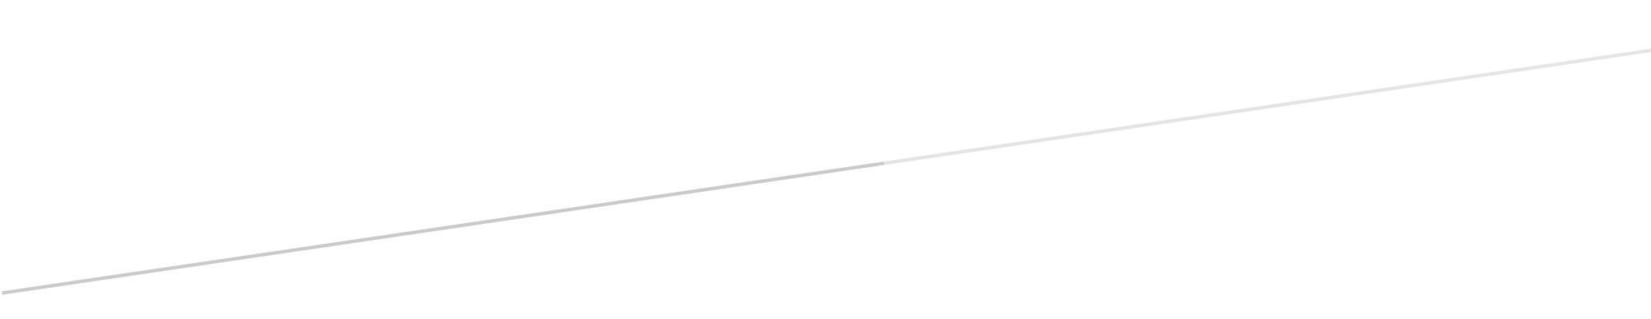

**Alex Carbajal**

**Washington State University Tri-Cities**

**May 3, 2024**

Homework 4

**Table of Contents:**

|  |
| --- |
|  |
| 1. Introduction |
| 1.0 Purpose |
|  |
| 1. Problems |
| 2.0 goto |
| 2.1 Static and Dynamic Scope |
| 2.2 Parameter Passing |
| 2.3 Stack and Stack-Dynamic |
| 2.4 Activation Record |
|  |
| 1. Design/Solution |
| 3.0 Design Overview |
| 3.1 Design Process |
| 3.1.1 goto |
| 3.1.2 Static and Dynamic Scope |
| 3.1.3 Parameter Passing |
| 3.1.4 Stack and Stack-Dynamic |
| 3.1.5 Activation Record |
|  |
| 1. Analysis of Learning |
|  |
| Appendix |
| Source Code |
| Commands for Running |

**1 Introduction:**

Homework description ……….

1. Purpose:

The goal of this document is to ……………

**2 Problems:**

2.0 goto:

2.1 Static and Dynamic Scope:

2.2 Parameter Passing:

2.3 Static and Stack-Dynamic:

2.4 Activation Record:

**3 Design/Solution:**

3.0 Design Overview:

3.1 Design Process:

3.1.1 goto:

3.1.2 Static and Dynamic Scope:

3.1.3 Parameter Passing:

3.1.4 Static and Stack-Dynamic:

3.1.5 Activation Record:

* 1. **4 Analysis of Learning:**

In this programming assignment we got the opportunity to learn …..

* 1. **Appendix**

**Source Code:**

* 1. **Commands for Running**: