Alexander Adams
Enhancement Two: Algorithms and Data Structure

The artifact I chose is my Corner Grocer Item Tracker program. It reads a list of grocery items from a file and counts how many times each item shows up. It stores the data in a map and lets the user search for items, see all items, view a histogram, and now also see sorted results and top items.
Justification
The program uses a map to store each item and their count, which makes it easy to look things up quickly. One of the main things I added to this program was sorting. Since maps don’t sort by value, I moved the data into a vector and used sort to organize it from highest to lowest. I also added the option to show only the top N items, which I think makes the program more useful.
Map to store each item and how many times it appears.
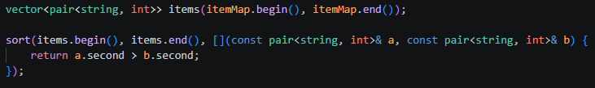
Data moved into vector and sorted from highest to lowest frequency.

Enhancements
The biggest upgrades were adding sorting and the top items feature. Before, the program could only show items in alphabetical order. Now it can show the most purchased items first, which makes more sense for this type of program. I also added some basic input validation, so the program doesn’t break if the user types something wrong or enters a bad number.
Course Outcomes Reflection
With these changes, I worked more with data structures like maps and vectors and used sorting to organize data in a better way. I also improved the program by adding new functionality instead of just keeping it basic. This still lines up well with my course outcomes.
Reflection on Process
While working on this, I got a better understanding of how to use multiple data structures together. I didn’t really get why we needed vectors at first, but it made sense once I used it for sorting. The biggest challenge was figuring out how sorting works with pairs and making sure everything compiled and ran correctly. I also had to fix a few issues with running the C++ program in VS Code, which helped me get more comfortable with that. | 