Alexander Adams
Enhancement One: Software Design and Engineering

For this enhancement, I used my Travlr Getaways full-stack project from my CS 465 class. I finished that class about a month ago. It’s a web app where users can view, add, and edit trips. The frontend is built with Angular and the backend uses Express and MongoDB.
Why I Picked This
I picked this project because it’s one of the only ones I have that actually connects everything together (frontend, backend, and database). It feels more like a real app instead of just small assignments. I focused on the trip listing page because it was basic before and had room for improvement.
What I Changed / Improved
The main thing I added was a search feature. This improved the artifact by making the trip page more useful and interactive instead of only showing a full unfiltered list.
Before, the page just showed every trip. Now you can type something in and filter the trips.
To make that work I had to:
- add a search box in Angular
- pass the search term into the service
- send it to the backend using a query parameter
- update the UI based on what comes back
I also added messages so the user actually knows what’s happening:
- how many trips are showing
- when only one trip shows
- when nothing matches
Full list of trips
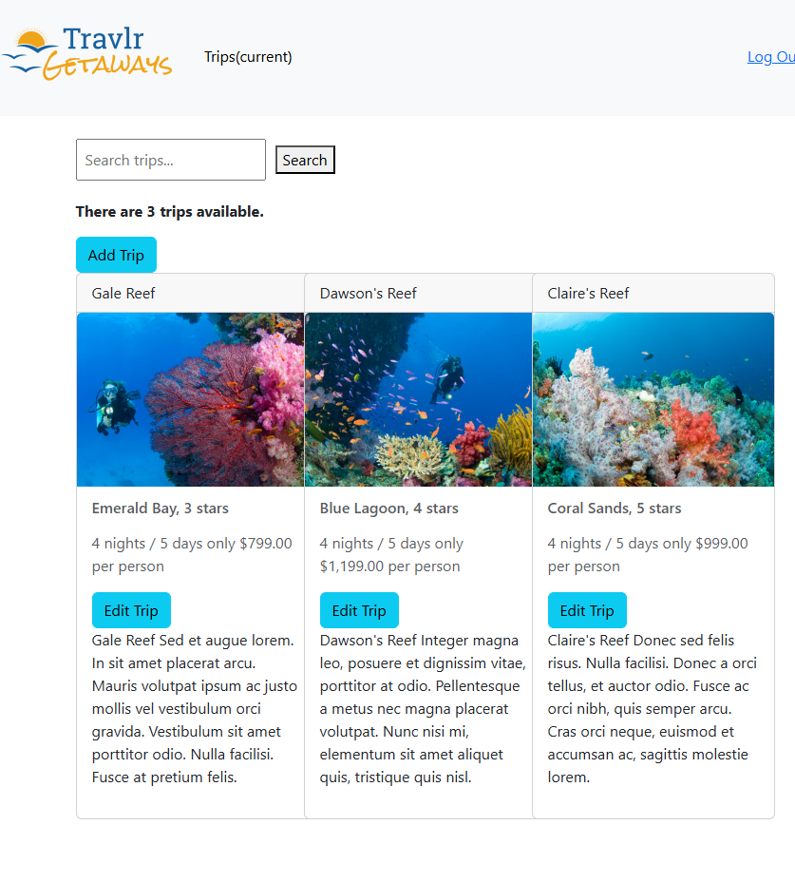
Filtered results for “gale”  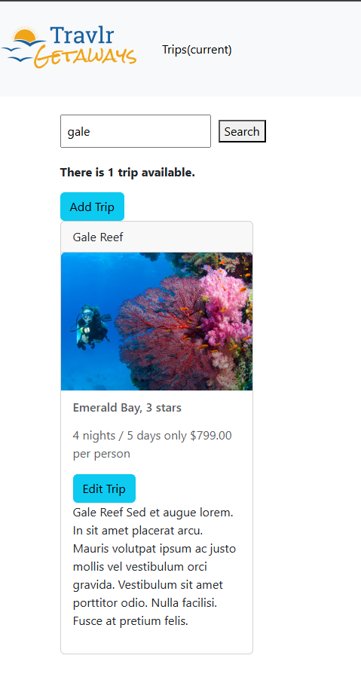 | No Results for “xyz”  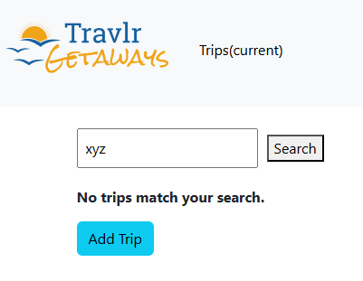

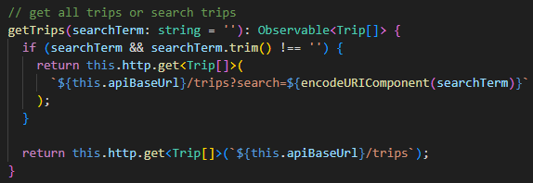
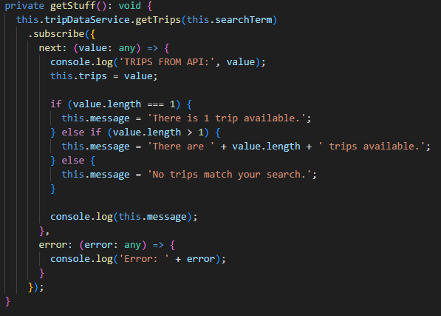
I included some code snippets showing how I implemented the search feature. The service handles sending the search query to the backend, while the component processes the results and updates the UI accordingly.
Course Outcomes
This shows I can build and improve a working system instead of just writing code in isolation. I used Angular, API calls, and backend filtering together, which is something you would do in a real-world project. It also shows I can take an existing project and improve it instead of starting from scratch, which I think is more realistic since most work involves modifying and building on existing systems.
Reflection
This part was honestly more about debugging than just adding a feature. At the start, I ran into a lot of issues like Angular import errors, the service not exporting correctly, and the frontend not connecting to the backend. It took some time to figure out what was actually wrong, but once I fixed those problems, everything started working as expected.
Even something simple like adding a search feature required changes in multiple places, including the UI, the service, and the backend. I also realized how important small details are. Adding a message when no results are found makes a big difference. Without that, it just looks like nothing is happening and feels broken.

