Alexander Adams
Milestone Four Enhancement: Databases

The artifact I selected for this enhancement is a web-based dashboard application built using Python, Dash, and MongoDB. I originally created this about eight months ago in my Client/Server Development class. The dashboard allowed users to view filtered animal data based on predefined categories like Water Rescue, Mountain/Wilderness, and Disaster Tracking. For this milestone, I enhanced the original version to make it more interactive and flexible for the user.
Justification for Inclusion
I chose this artifact because it shows full-stack concepts including working with a database, backend logic, and a user interface. It demonstrates how I can take raw data from MongoDB and turn it into something visual and interactive using Dash.
In the original version, the filtering system was very limited because it relied on hardcoded categories. The query logic was built around specific preset options, which meant users could not customize what they were searching for.
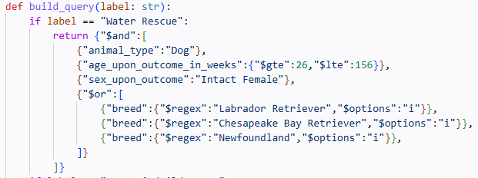
In the enhanced version, I redesigned the filtering system so users can choose their own filters using dropdowns and a text input. This allows them to filter by animal type, sex, and even search for specific breeds.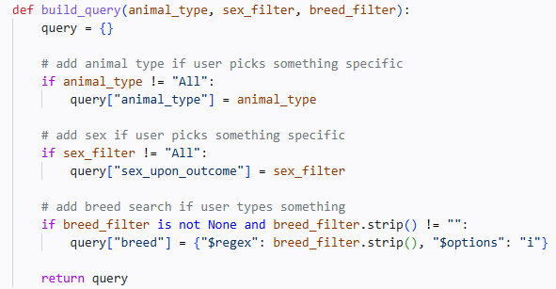

I also updated the interface to include these new controls.
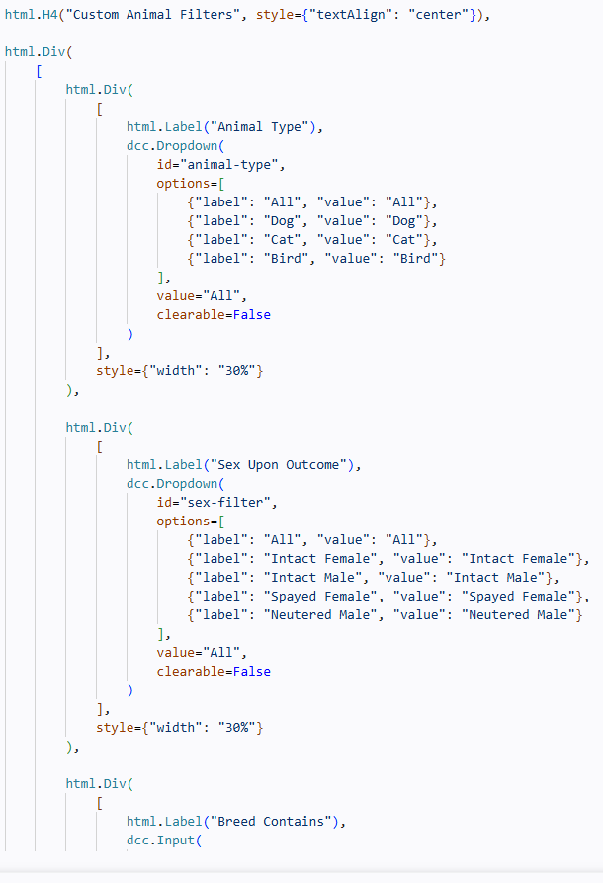
I think these changes improved the functionality significantly and made the application more user-friendly.

Course Outcomes Reflection
For this enhancement, I focused on improving my skills in working with databases, backend logic, and user interface design. I believe I met the outcomes I originally planned in Module One, especially in terms of integrating MongoDB with a Python application and building a more interactive front end.
One thing that improved compared to my original plan was how much more comfortable I became with modifying queries dynamically instead of relying on hardcoded logic.
Reflection on the Enhancement Process
While working on this enhancement, I learned a lot about how everything connects together, especially between the database and the user interface. One of the biggest things I learned was how to build dynamic MongoDB queries based on user input instead of fixed conditions.
I also got more experience working with Dash callbacks and making sure the table, map, and chart all update correctly at the same time.
One challenge I ran into was getting everything to run locally. The original setup used a remote environment, so switching it to run on my own machine required installing MongoDB, setting up the database, and fixing connection issues. This took some trial and error, but it helped me understand how the system actually works behind the scenes. It gave me more confidence in working with full applications instead of just controlled environments.

The enhanced dashboard allows users to apply custom filters and see the results update in real time across the table, map, and chart.
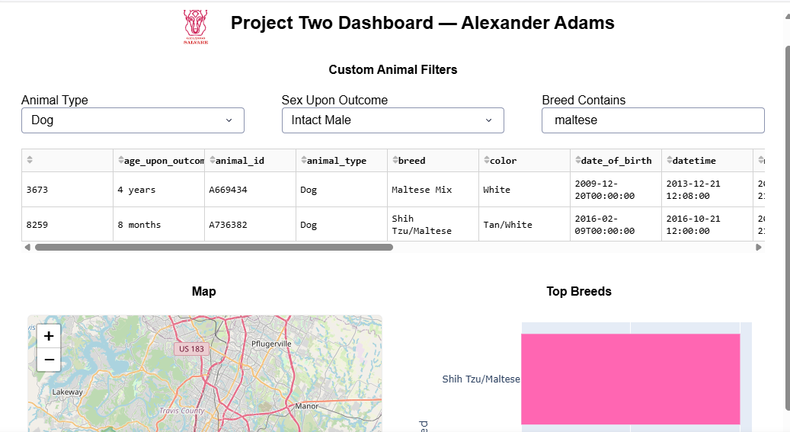
Enhanced dashboard
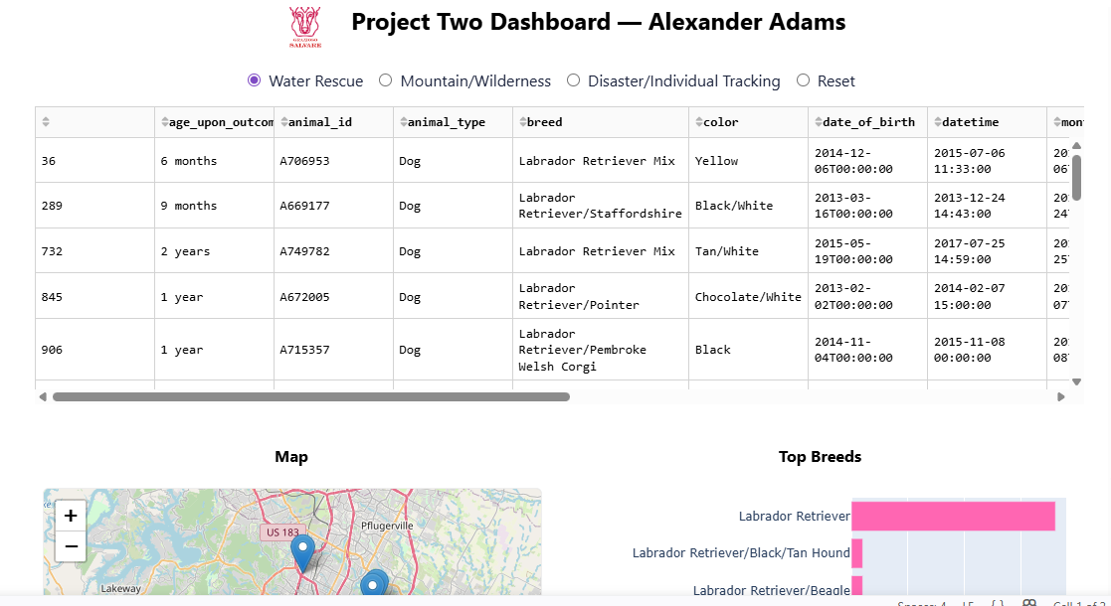Original dashboard

