BlueRetro: Xbox One gamepad as an NES joystick — oscilloscope verification
Document version: 1.0 · Date: 2026-10-01 · Measurement date: 2026-09-30
Related document: blueretro-murmulator-project-summary_EN.md, section "Oscilloscope signal verification (confirmed)".

1. Test objective
Verify that BlueRetro (ESP32 D1 mini, firmware v25.04_hw1, NES / GamePad mode) correctly passes Xbox One gamepad button presses to the Murmulator using the NES shift-register protocol: each button appears on the DATA line in its own bit position, in the correct phase relative to CLOCK and LATCH.

2. Oscilloscope connection and settings
Oscilloscope input | Signal | Note
CH1 (yellow) | DATA | In Fig. 1 (01_LATCH_signal) CH1 is connected to LATCH
CH2 (blue) | CLOCK | All figures
EXT TRIG | LATCH | Triggering on the rising edge of LATCH

Parameter | Value
Vertical scale CH1 / CH2 | 2 V/div / 2 V/div
Timebase | 200 µs/div
Trigger | Ext, rising edge, level 1.08 V
Trigger point position (T marker) | ≈1 division from the left edge of the screen

Capture order: Fig. 1 — LATCH signal; Fig. 2 — no button pressed; Figs. 3–10 — exactly one button pressed at a time, in NES bit order (from bit 0 to bit 7).

3. Expected NES protocol behavior
- Inverted logic: LOW = button pressed, HIGH = released.
- On the LATCH edge, bit 0 (button A) is placed on DATA immediately — without a clock pulse.
- Each subsequent CLOCK pulse shifts the register: bits 1–7 appear one per clock (≈80 µs per bit).
- Bit order: A, B, Select, Start, Up, Down, Left, Right.

4. Summary of results
Fig. | Xbox One button | NES button | Bit | Result
1 | — (LATCH signal) | — | — | Period ≈1200 µs, pulse ≈40 µs
2 | nothing pressed | — | — | DATA = HIGH in all 8 bits ✔
3 | A | A | 0 | LOW at bit position 0 ✔
4 | X | B | 1 | LOW at bit position 1 ✔
5 | View | Select | 2 | LOW at bit position 2 ✔
6 | Menu | Start | 3 | LOW at bit position 3 ✔
7 | D-pad Up | Up | 4 | LOW at bit position 4 ✔
8 | D-pad Down | Down | 5 | LOW at bit position 5 ✔
9 | D-pad Left | Left | 6 | LOW at bit position 6 ✔
10 | D-pad Right | Right | 7 | LOW at bit position 7 ✔

Result: all 8 buttons appear on the DATA line in the expected bit position; the Xbox One → NES mapping (A→A, X→B, View→Select, Menu→Start, D-pad→Up/Down/Left/Right) and the bit order are confirmed (confirmed).

5. Additional observation: CLOCK polling mode
In Figs. 1–2 CLOCK runs continuously and LATCH repeats every ≈1200 µs. In Figs. 3–10 LATCH is followed by a burst of ≈12–13 CLOCK pulses, after which the CLOCK line stays HIGH and the next LATCH does not appear within the screen window (≈1.8 ms after the trigger). In other words, the Murmulator polling period differed between captures. This does not affect reading correctness: in both modes there are more than 8 clocks. The reason for the difference has not been established.

6. Oscillograms

Fig. 1. LATCH signal
File: 01_LATCH_signal.jpg · CH1 = LATCH, CH2 = CLOCK, EXT TRIG = LATCH
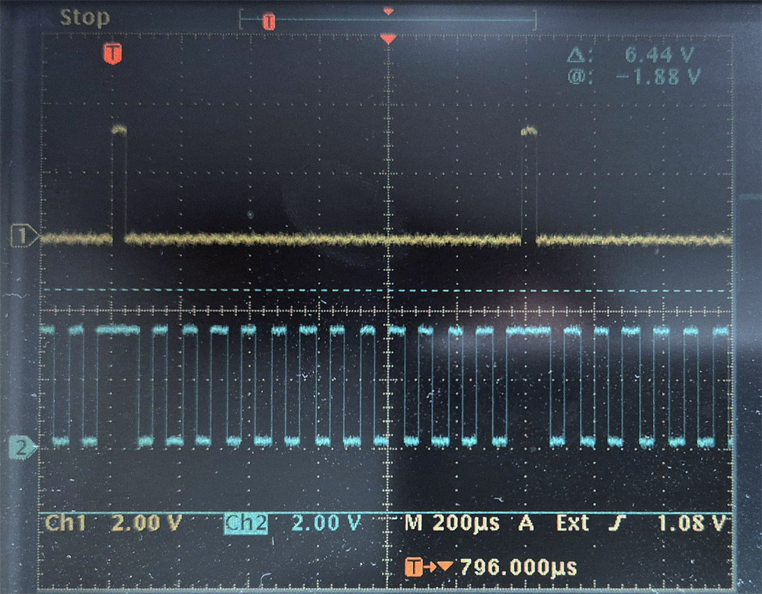
- CH1 (LATCH): short positive pulses ≈40 µs wide with a period of ≈1200 µs (≈6 divisions) — polling rate ≈833 Hz.
- CH2 (CLOCK): a continuous clock train with a period of ≈80 µs (≈12.5 kHz); around the LATCH pulse the CLOCK line is held HIGH.

Fig. 2. No button pressed
File: 02_no_button_pressed.jpg · CH1 = DATA, CH2 = CLOCK, EXT TRIG = LATCH
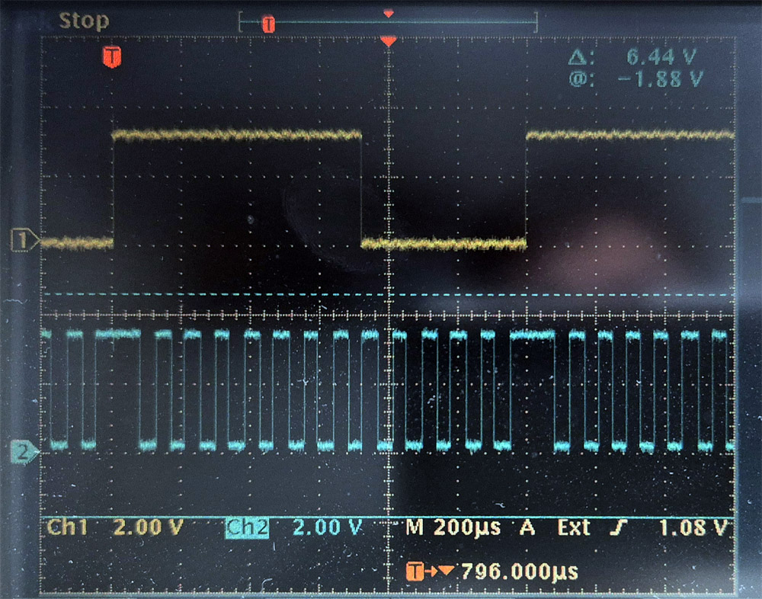
- After the LATCH edge the DATA line stays HIGH for all 8 bits (≈700 µs) — all buttons released.
- After the 8th bit DATA goes LOW and stays there until the next LATCH; at the next LATCH HIGH is loaded again. This matches the original NES controller: after 8 bits the shift register outputs LOW.

Fig. 3. Button A (Xbox A) — bit 0
File: 03_A_(xbox_A).jpg · CH1 = DATA, CH2 = CLOCK, EXT TRIG = LATCH
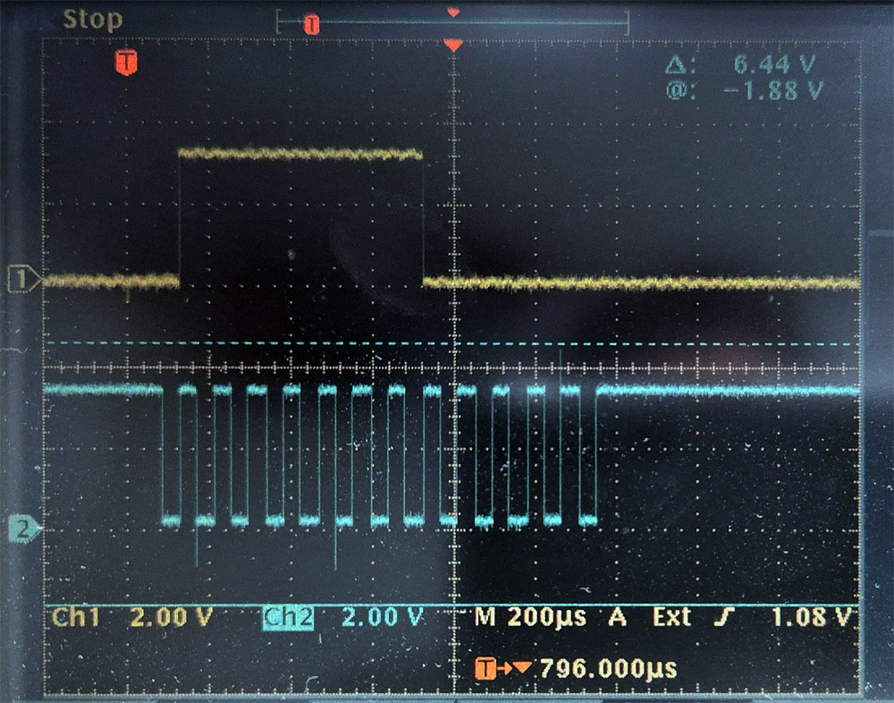
- DATA is LOW immediately after the LATCH edge, before the first CLOCK pulse — bit 0 is placed on the line by the latch, without a clock pulse.
- With the first CLOCK pulse DATA goes HIGH (bits 1–7 — buttons released); after the 8th bit — LOW.

Fig. 4. Button B (Xbox X) — bit 1
File: 04_B_(xbox_X).jpg · CH1 = DATA, CH2 = CLOCK, EXT TRIG = LATCH
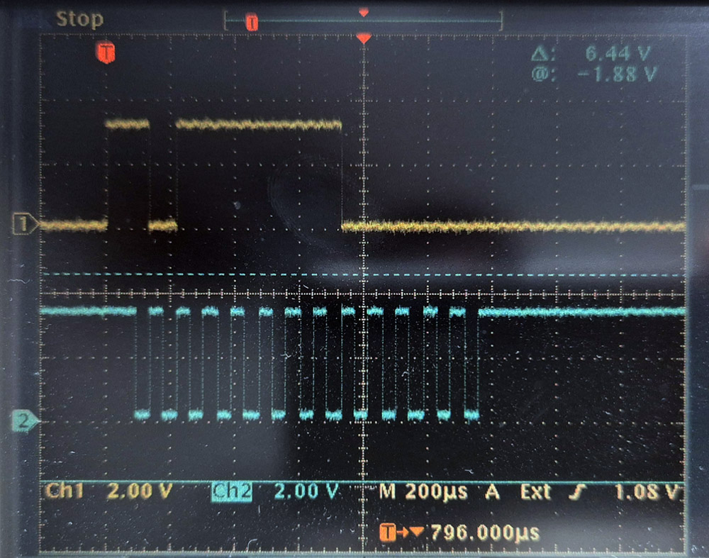
- A LOW pulse ≈80 µs long (one CLOCK period) in the second bit position after LATCH.

Fig. 5. Button Select (Xbox View) — bit 2
File: 05_SELECT_(xbox_view).jpg · CH1 = DATA, CH2 = CLOCK, EXT TRIG = LATCH
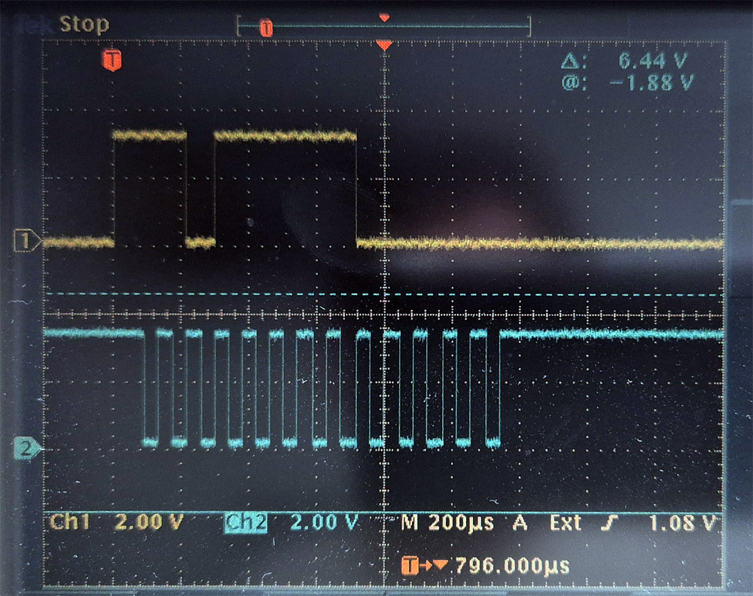
- A ≈80 µs LOW pulse in the third bit position after LATCH.

Fig. 6. Button Start (Xbox Menu) — bit 3
File: 06_START_(xbox_menu).jpg · CH1 = DATA, CH2 = CLOCK, EXT TRIG = LATCH
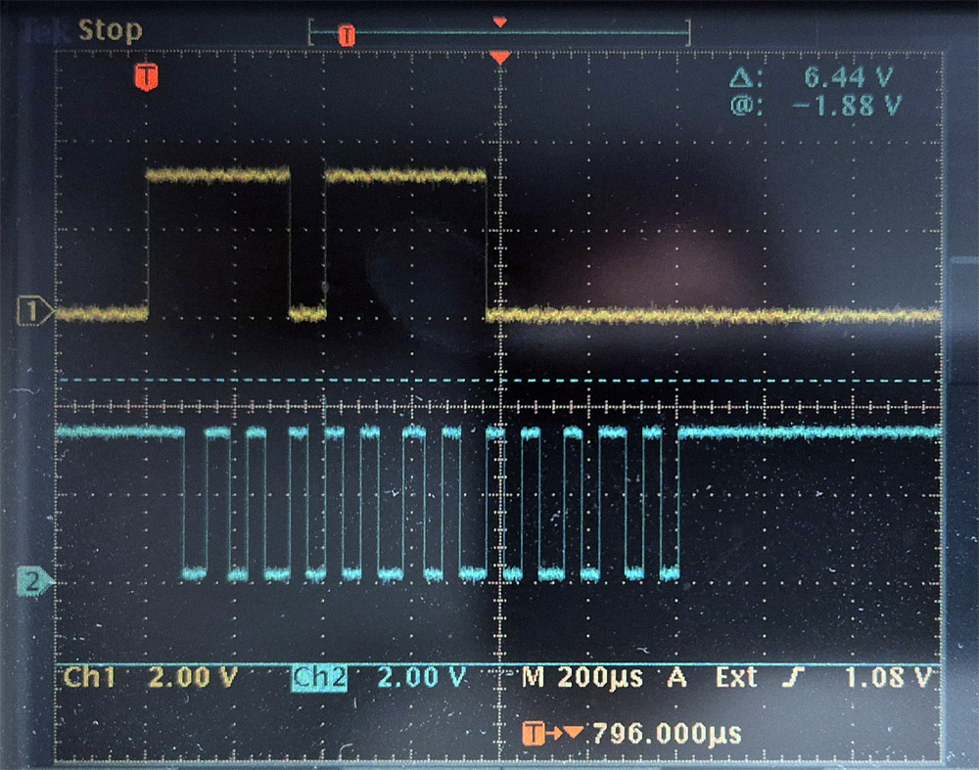
- A ≈80 µs LOW pulse in the fourth bit position after LATCH.

Fig. 7. Up (Xbox D-pad Up) — bit 4
File: 07_up_(xbox_dpad_up).jpg · CH1 = DATA, CH2 = CLOCK, EXT TRIG = LATCH
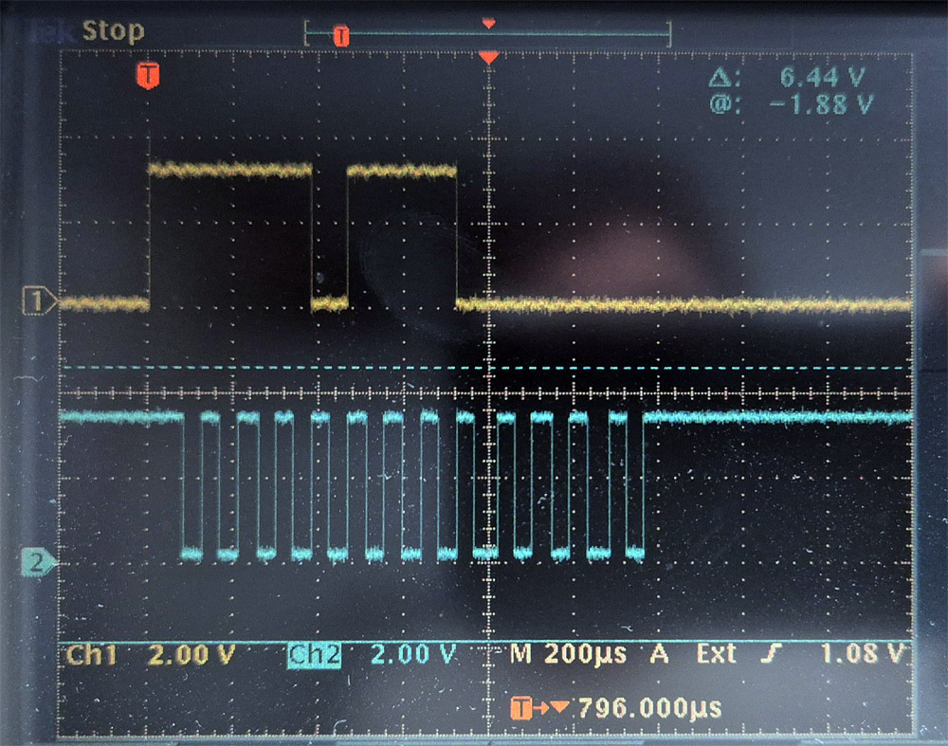
- A ≈80 µs LOW pulse in the fifth bit position after LATCH.

Fig. 8. Down (Xbox D-pad Down) — bit 5
File: 08_down_(xbox_dpad_down).jpg · CH1 = DATA, CH2 = CLOCK, EXT TRIG = LATCH
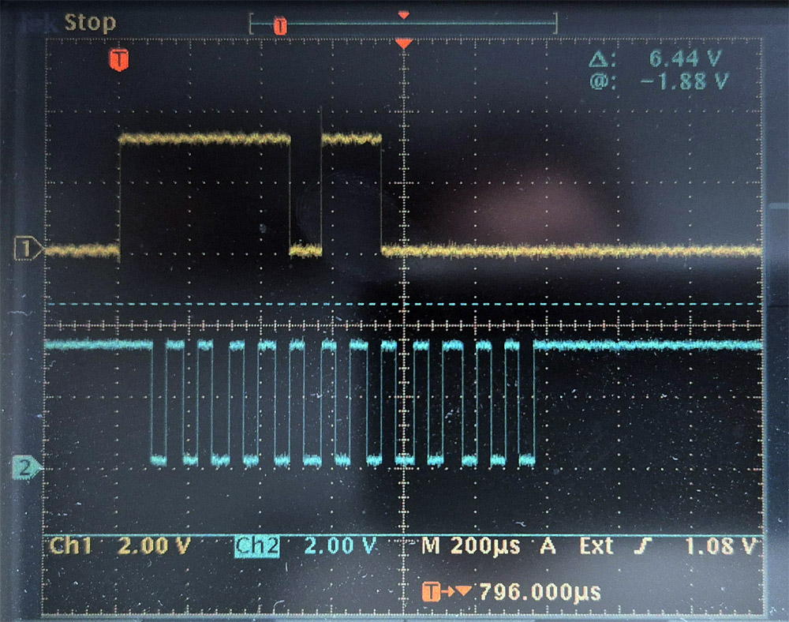
- A ≈80 µs LOW pulse in the sixth bit position after LATCH.

Fig. 9. Left (Xbox D-pad Left) — bit 6
File: 09_left_(xbox_dpad_left).jpg · CH1 = DATA, CH2 = CLOCK, EXT TRIG = LATCH
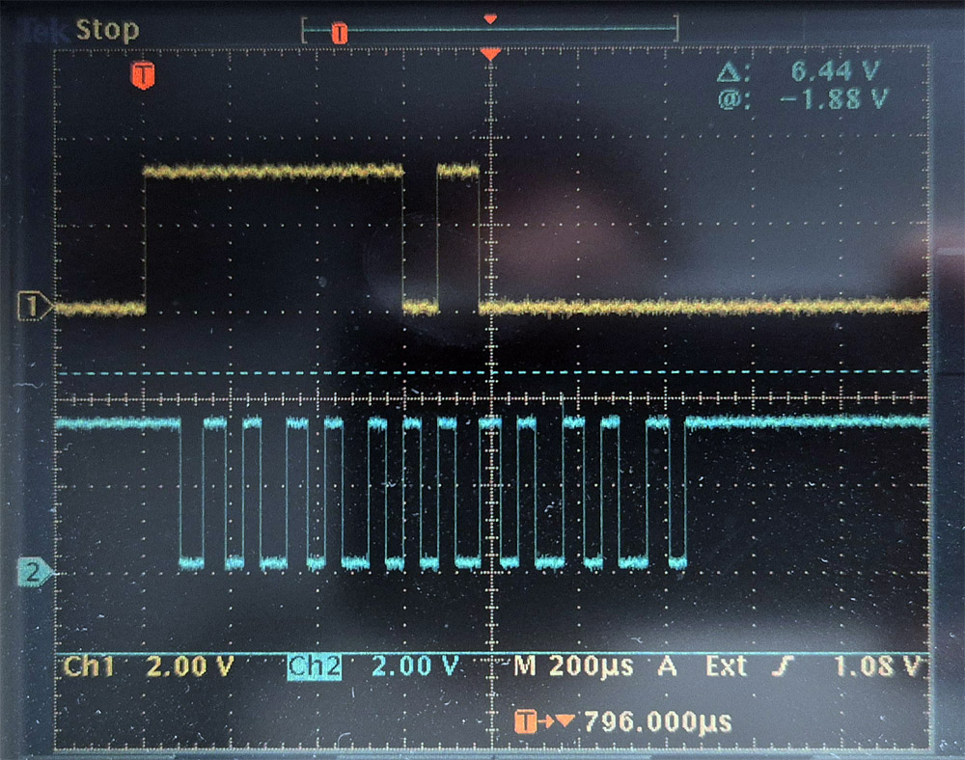
- A ≈80 µs LOW pulse in the seventh bit position after LATCH.

Fig. 10. Right (Xbox D-pad Right) — bit 7
File: 10_right_(xbox_dpad_right).jpg · CH1 = DATA, CH2 = CLOCK, EXT TRIG = LATCH
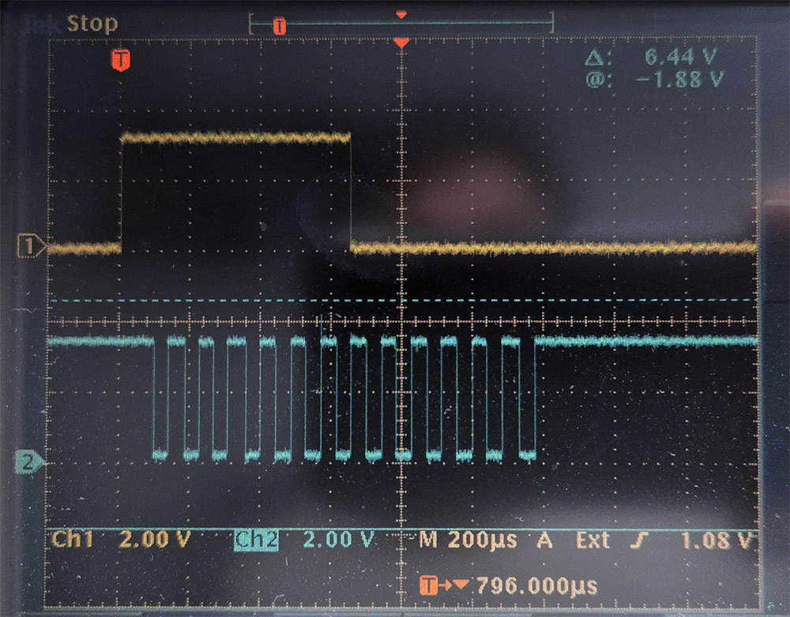
- Bit 7 is the last one, so its LOW merges with the LOW level after the 8th bit: there is no separate pulse; the HIGH section ends one clock earlier than with "no button pressed" (see Fig. 2).

