Murmulator VGA — PS/2 modifier oscillograms
Reference CLK/DATA captures for Left/Right Ctrl, Alt, Shift
Oscilloscope: Tektronix · Ch1 (yellow) = DATA, Ch2 (green) = CLK · M = 400µs/div · 22 May 2025
All signals were captured on a real Murmulator VGA 7x9 device (YD-RP2040) as part of diagnosing a character corruption problem with PS/2 input (Lode Runner). The goal is to check CLK/DATA signal integrity for each modifier separately for make and break codes.
Overall conclusion for all 8 captures: the signals for all modifiers (Left/Right Ctrl, Left/Right Alt, Left/Right Shift) are clean, with no ringing or edge distortion — both for single-byte codes and for multi-byte E0 sequences. This indicates that the cause of the non-standard/incorrect behavior of individual keys (Right Shift, Right Alt → Backspace/Delete; the problem in Lode Runner) lies at the firmware/logic level, not in the physical integrity of the PS/2 signal.

Left Ctrl
Scan code 0x14, no E0 prefix. Function on the Spectrum: SYMBOL SHIFT.

Make code (press)
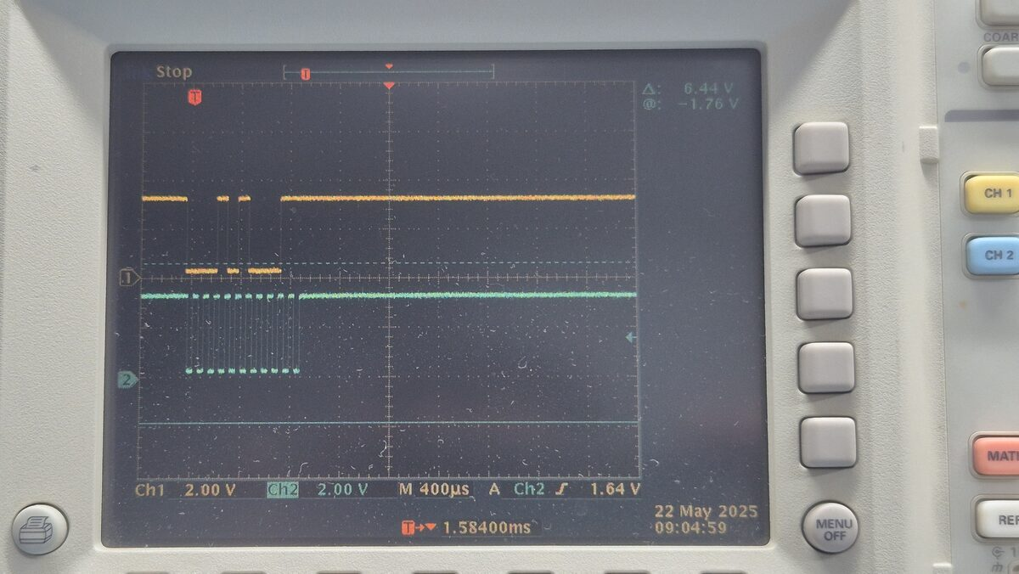
A single block of ~11 clock pulses on CLK — one PS/2 frame (make code 0x14)

Break code (release)
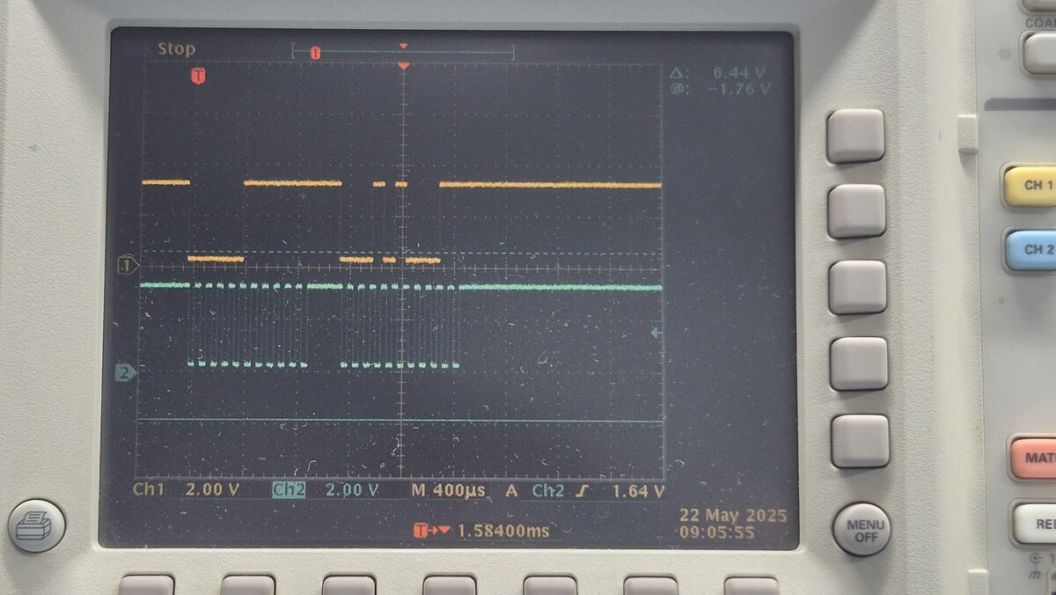
Two pulse blocks — break code F0+14 (two bytes)
Conclusions:
- Both channels clean, sharp edges, no ringing or dips
- Reference for comparison with E0-prefixed keys

Right Ctrl
Scan code E0 14, with E0 prefix. Function on the Spectrum: SYMBOL SHIFT (confirmed to duplicate Left Ctrl).

Make code (press)
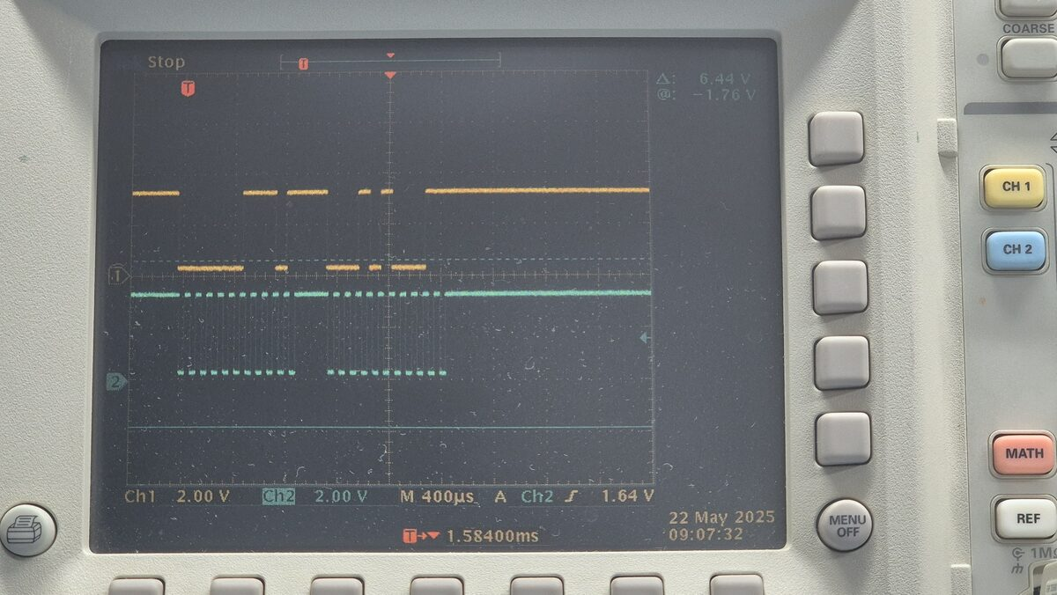
Two pulse blocks — make code E0+14 (two bytes)

Break code (release)
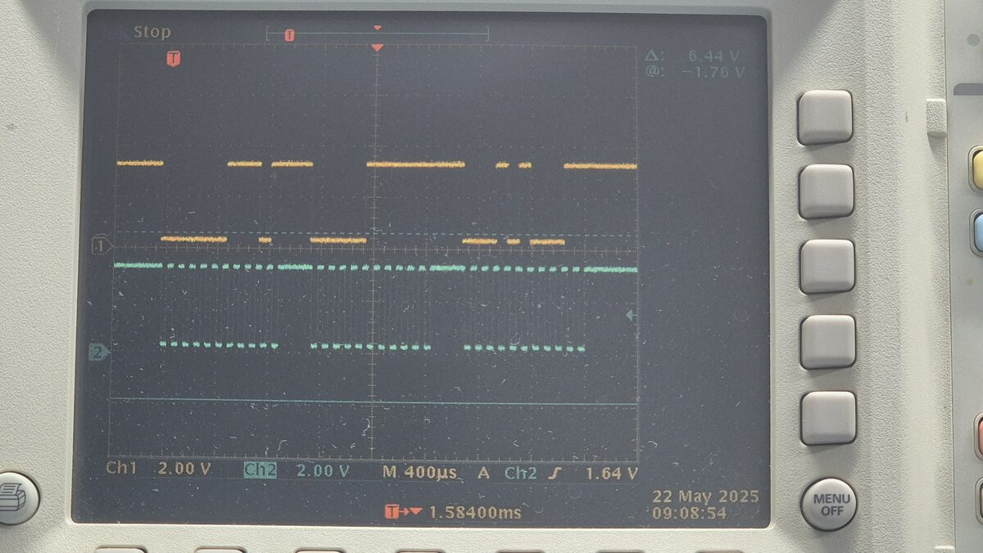
Three pulse blocks — break code E0+F0+14 (three bytes)
Conclusions:
- The full 3-byte E0 cycle is transmitted cleanly
- Confirms that the transmission of multi-byte E0 sequences is physically sound for this key

Left Alt
Scan code 0x11, no E0 prefix. Function on the Spectrum: not confirmed in this session.

Make code (press)
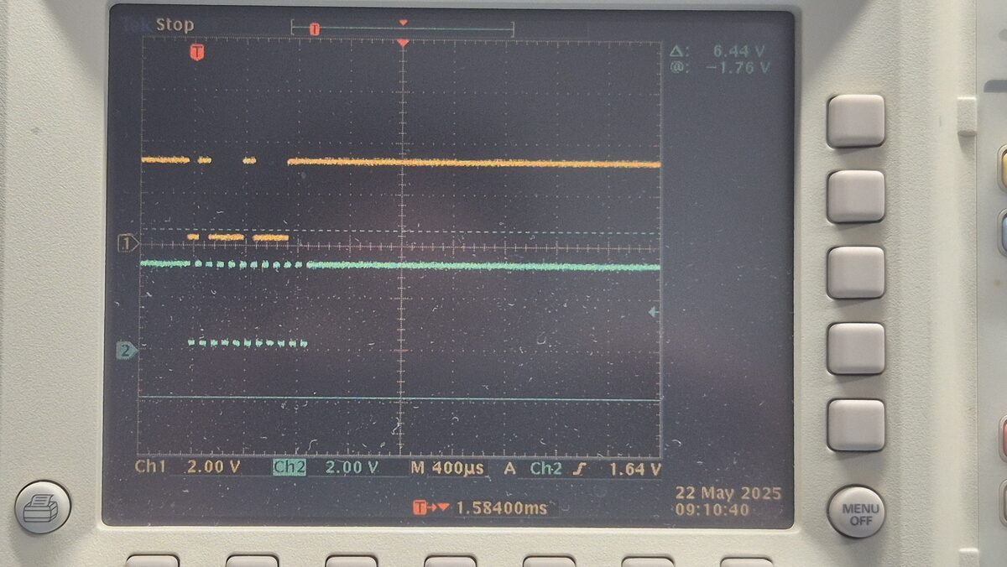
A single pulse block — make code 0x11 (one byte)

Break code (release)
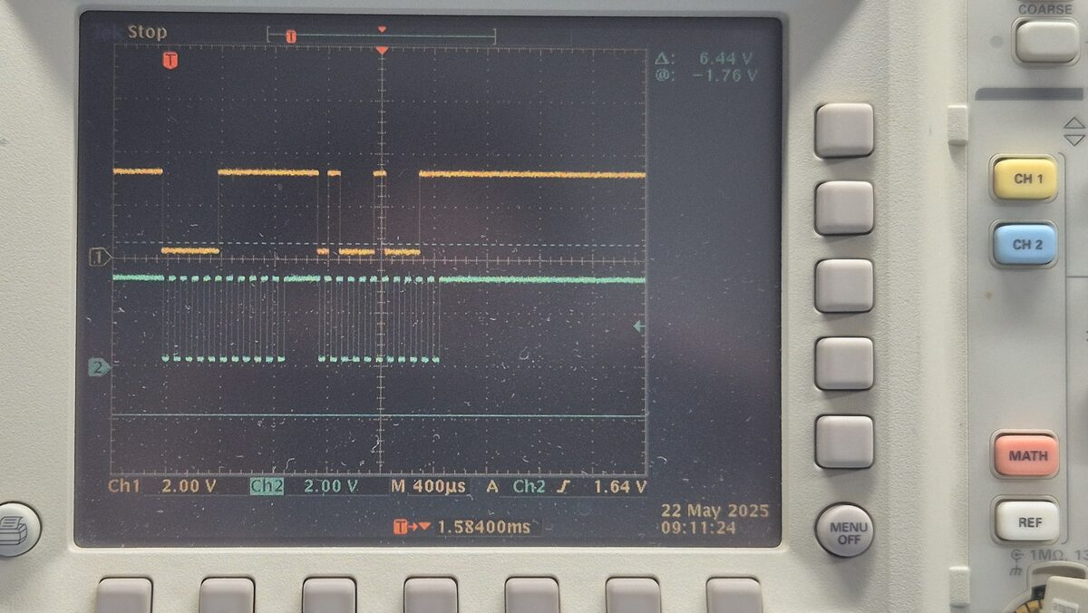
Break code F0+11 (two bytes), no E0 prefix
Conclusions:
- Clean signal, no distortion

Right Alt
Scan code E0 11, with E0 prefix. Observed behavior on the Spectrum: Backspace/Delete.

Make code (press)
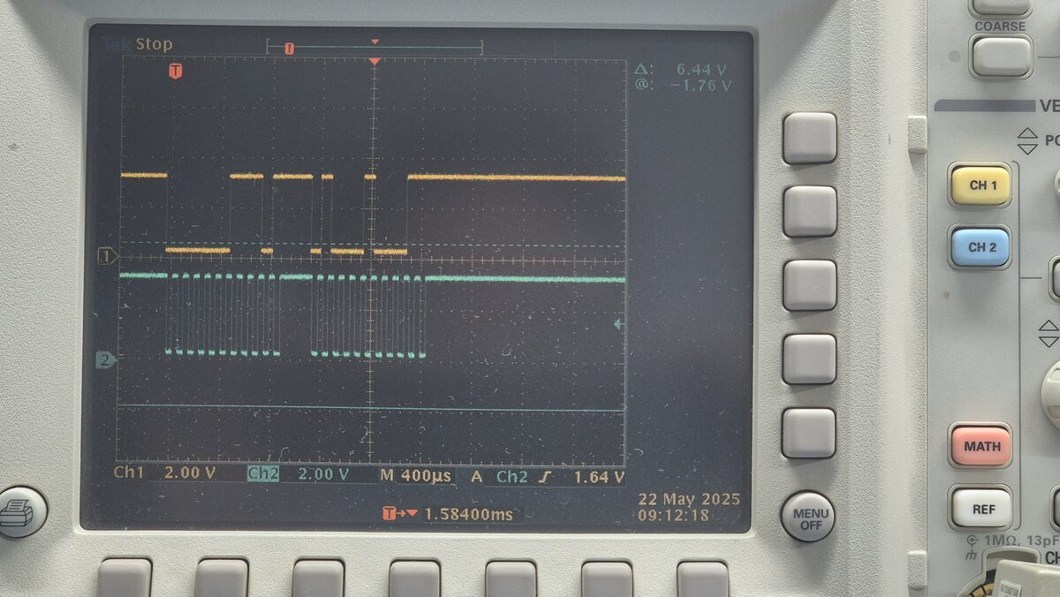
Two pulse blocks — make code E0+11 (two bytes)

Break code (release)
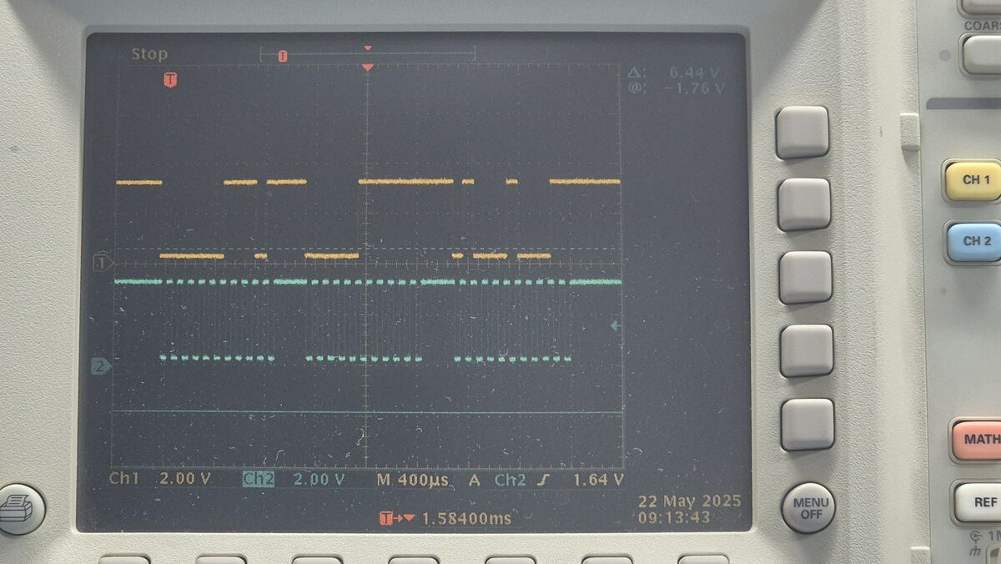
Three pulse blocks — break code E0+F0+11 (three bytes)
Conclusions:
- The full 3-byte E0 cycle is transmitted without errors
- Confirms that the Backspace/Delete behavior is the result of the firmware processing a correctly received code, not a consequence of a corrupted signal

Left Shift
Scan code 0x12, no E0 prefix. Function on the Spectrum: CAPS SHIFT.

Make code (press)
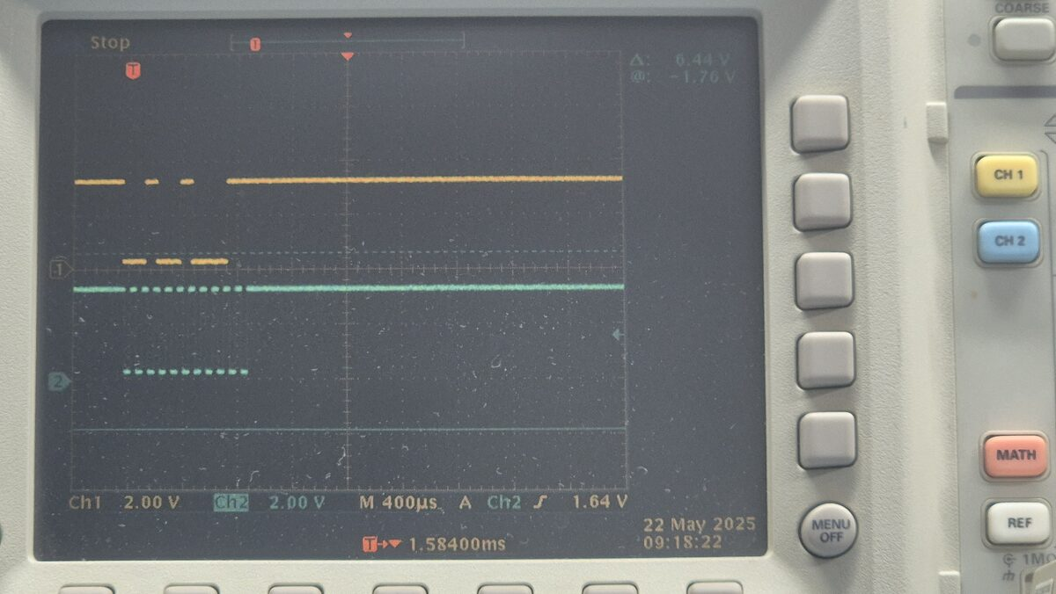
A single pulse block — make code 0x12 (one byte)

Break code (release)
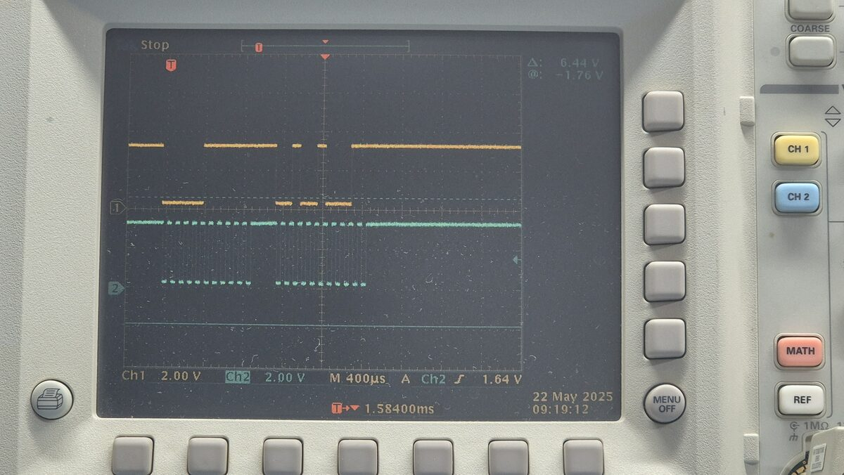
Two pulse blocks — break code F0+12 (two bytes)
Conclusions:
- Clean signal, no distortion

Right Shift
Scan code 0x59 — important: NO E0 prefix (an exception among the "right-hand" keys in PS/2 Scan Set 2). Observed behavior on the Spectrum: Backspace/Delete.

Make code (press)
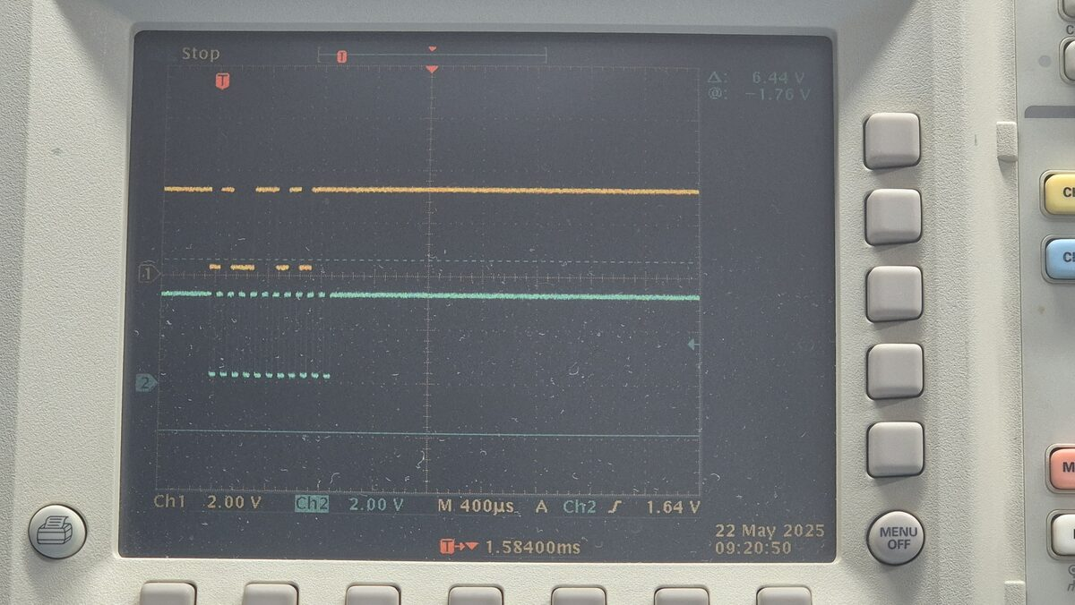
A single pulse block — make code 0x59 (one byte, no E0!)

Break code (release)
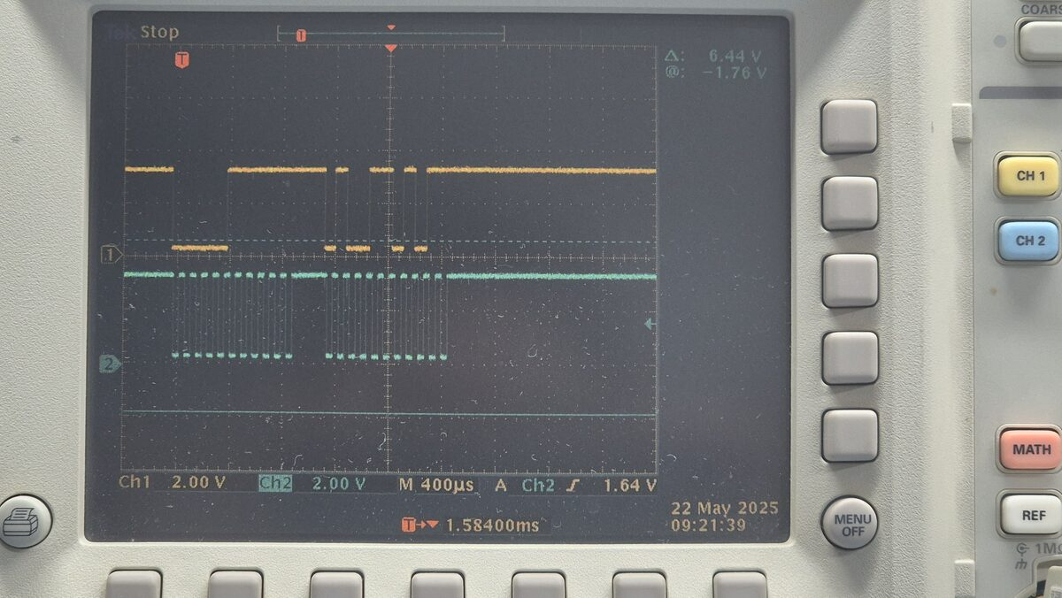
Two pulse blocks — break code F0+59 (two bytes), no E0 prefix
Conclusions:
- Important clarification: Right Shift is not an E0 code, unlike Right Ctrl and Right Alt
- Since the "problem" keys include both an E0 code (Right Alt) and a non-E0 code (Right Shift), the Backspace/Delete pattern is not related to the presence of the E0 prefix as such
- Points to mapping of specific scan codes (0x59 and E0 11) in the Tecnocat firmware, rather than to the class of E0 sequences as a whole

Summary table
Key | Scan code (make) | E0 prefix | Frames (make/break) | Function on the Spectrum
Left Ctrl | 0x14 | No | 1 / 2 | SYMBOL SHIFT
Right Ctrl | E0 14 | Yes | 2 / 3 | SYMBOL SHIFT (duplicates)
Left Alt | 0x11 | No | 1 / 2 | not confirmed
Right Alt | E0 11 | Yes | 2 / 3 | Backspace/Delete
Left Shift | 0x12 | No | 1 / 2 | CAPS SHIFT
Right Shift | 0x59 | No | 1 / 2 | Backspace/Delete

All captures were taken on 22 May 2025 with a Tektronix oscilloscope, timebase M = 400µs/div, channel 1 (yellow) = DATA, channel 2 (green) = CLK.

