Predicting NBA Shot Outcomes
A layered spatial (GAM), contextual (XGBoost), and player-effects (mixed-model) approach

Alexander M. Susi
Oklahoma City Thunder · Analyst Intern Technical Project
2026-09-23
Table of Contents
1. Introduction 2
2. Exploratory Data Analysis 2
3. Layer 1 – Shot Location 5
4. Layer 2 – Shot Context 6
4.1. Feature Set 7
4.2. Feature Importance 8
4.3. Alternatives tested: Random Forest, Neural Network, and Ensembles 11
5. Layer 3 – Logistic Mixed-Effects Models 12
5.1. A negative result: partial-credit defenders 13
5.2. Player leaderboards 13
6. Final Predictions 15
6.1. Conclusion 16

Introduction
This report develops a framework to predict the probability that a non-fouled NBA field goal attempt is made. The training data hold 425,719 labeled regular-season shots with a binary make-or-miss outcome, and the finished model must predict 213,977 unlabeled test shots. Submissions are graded against the Thunder’s proprietary shot quality model using log loss as the evaluation metric, which rewards calibrated probabilities and punishes confident incorrect predictions.
Shot outcomes are largely products of three components: shot location, the situation around it (how open the shooter is, dribbles taken before shooting, etc.), and who takes and contests it. I model this structure as three distinct layers, each building upon the previous layer:
- Shot location – A single binomial generalized additive model (GAM) fits a smooth surface of field goal percentage over the court and returns one spatial score, gam_logit.
- Shot context – Three gradient-boosted tree models (XGBoost), one each for rim, midrange, and three-point shots, read gam_logit together with situational features and return a player-agnostic shot quality probability q.
- Player effects – Three mixed-effects models use the shot quality logit as an offset and add partially pooled shooter and defender effects to give the final make probability p.
This keeps each layer interpretable and lets me measure the incremental predictive power added by comparing each model’s log loss with the prior layer’s log loss. In theory, each model should have a better (lower) log loss with additional information added.

Exploratory Data Analysis
My first step was to group shots into 3 distinct classes by region: rim, midrange, and 3-point attempts, as these are all fundamentally different shots. Rim attempts are those within five feet, three-point attempts use the supplied three column, and midrange holds the remaining two-point shots. The three shot classes differ significantly in average field goal percentage (FG%), which is why splitting on class improves predictive power over a naïve estimation.
Table 1. Field goal percentage by shot class (full training set). ADD LOG LOSS IN THIS TABLE
Shot class | Attempts | FG%
Rim (≤5 ft) | 124,832 | 63.6%
Midrange | 124,126 | 41.8%
Three-point | 176,761 | 36.1%
All shots | 425,719 | 45.8%

Contester information adds significant information too. Field goal percentage falls steadily as contesters are added, and the impact is greater at the rim than for midrange and 3-pointers.
Table 2. FG% (and attempts) by number of contesters and shot class.
Contesters | Rim | Midrange | 3-Point
0 | 91.8% (18,335) | 52.0% (6,143) | 39.6% (21,529)
1 | 63.6% (70,587) | 42.8% (89,312) | 35.7% (150,110)
2 | 49.6% (33,566) | 36.9% (26,983) | 33.5% (5,088)
3 | 40.9% (2,325) | 31.8% (1,671) | 18.2% (33)
4 | 42.1% (19) | 29.4% (17) | 0.0% (1)

Additionally, gamestate separates transition and direct second-chance attempts (each about 51%) from halfcourt offense (43.7%), so I added binary variables for transition and second-chance shots. Shot type is highly predictive but heavily confounded with location: dunks convert 88.5% and heaves 9.5%, largely because of distance. I kept shot-type indicators only where they add non-redundant signal (binary variables for dunk, floater, tip, and post at the rim; post at midrange).
Table 3. FG% by game state and by shot type (full training set).
Game state | FG%
Halfcourt | 43.7%
Transition | 51.2%
Direct second chance | 51.4%

Shot type | FG% | Avg Shot Distance (ft) | Avg Shooter Speed
Dunk | 88.5% | 2.1 | 7.5
Layup | 53.5% | 3.8 | 8.8
Tip | 48.1% | 2.6 | 3.9
Post | 45.4% | 8.7 | 4.5
Floater | 41.7% | 9.7 | 6.0
Jumper | 37.8% | 23.0 | 1.8
Heave | 9.5% | 44.8 | 8.2

Figure 1 shows FG% by number of dribbles before the shot, split by class. Note that due to sparse data, I labeled all shots with 10 or more dribbles as having 10 for plotting purposes. Every class falls steeply from zero to about three dribbles and then levels off. Notably, midrange and 3-point percentages appear to gradually increase with more dribbles. Any player who dribbles that many times before shooting is probably a high-end shot creator; as such, including raw number of dribbles beyond a certain threshold in a shot quality model will likely conflate shooting percentage with shooting ability. Therefore, I added a variable called dribblesbefore_cap3 where any shot with 3 or more dribbles was capped at 3.
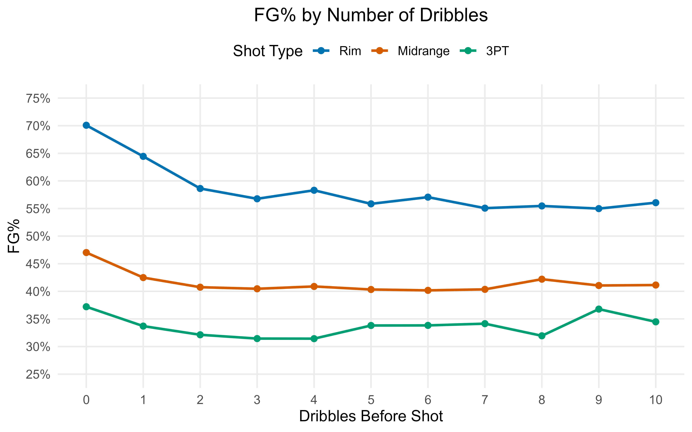
Figure 1. Field goal percentage by dribbles before the shot, by class. Each class falls from 0 to about 3 dribbles and then flattens; so dribbles are capped at three in the context model.
Figure 2 shows field goal percentage by calendar month for the two training seasons. If there was a quantifiable month effect on shot outcomes, a similar trend would appear in both seasons. The curves differ in shape and timing, and the spread is only about 2.5 percentage points that looks like random noise. The test set is a different season, so any month pattern learned here would probably not carry over. For this, I chose to exclude month and season identity as predictors.
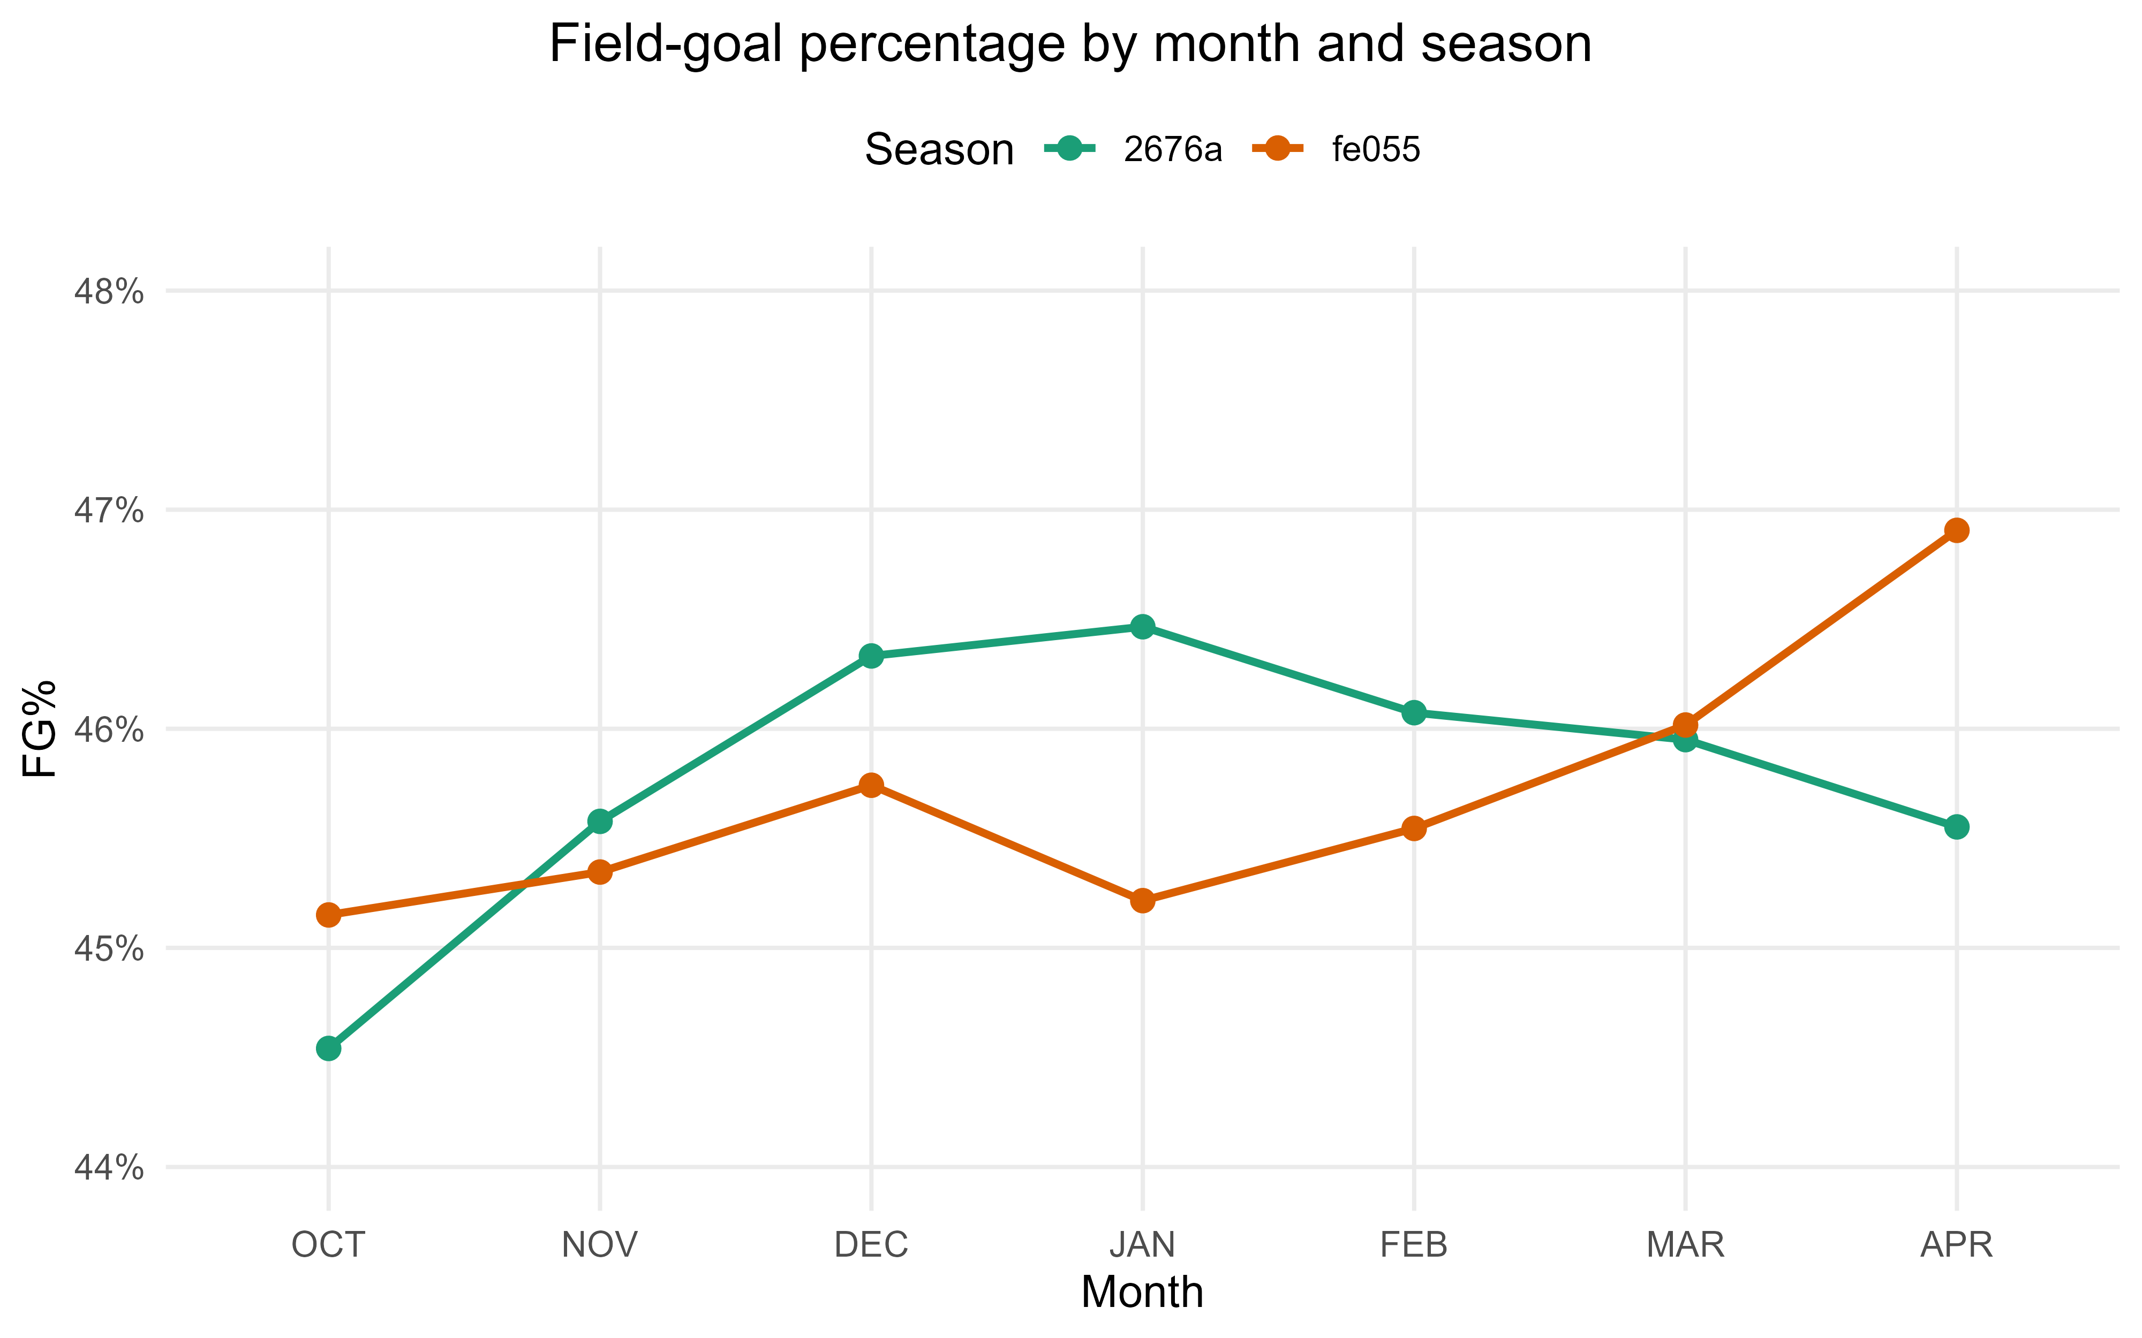
Figure 2. FG% by month for the two training seasons. The inconsistent, low-amplitude patterns, together with an unseen test season, argue against using month or season as features.
I also noticed some uncontested shots have a defender within 3.5 feet and many contested shots do not. Stratifying by class showed these were not labeling errors. Among uncontested rim attempts, field goal percentage barely changes across a 3.5-foot cutoff (about 92% on both sides), which fits trailing transition defenders who arrive late without affecting a layup or dunk. The brief also states explicitly that the closest defender need not be a contester. Without video evidence to verify such examples, I kept the supplied labels.

Layer 1 – Shot Location
Across the court, before anything else is known, how does make probability vary with location? The relationship is smooth but strongly nonlinear, with a sharp peak at the rim, a fast falloff through the paint, a broad midrange trough, and a small bump near the 3-point arc. A generalized additive model (GAM) works well, as it estimates a flexible, penalized surface from the data with no specified distance bins, and its smoothing parameter controls sparse areas of the court.
Writing outcome_i for the make indicator and pi_loc for the location-only make probability, the binomial model’s linear predictor is a joint two-dimensional spline of the shot coordinates:
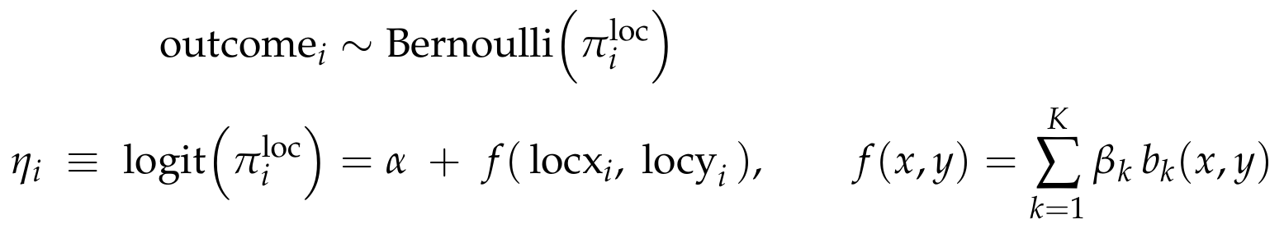
The spline is one joint surface over both coordinates, so it can bend differently along the baseline than along the wings. I fit it with mgcv::bam, which fits the 425,000-row model in under a minute.
Regularizing toward a stable baseline. I deliberately strengthened the smoothing (gamma = 5), which cut the effective degrees of freedom by about 30% at a negligible log loss cost. The initial heatmap (gamma = 1) showed local pockets, dim spots in the midrange and bright spots in the deep corners, that most likely reflect which shooters take those shots (e.g. specialists attempt long threes) rather than an intrinsic property of the location. Because a location-only model averages over the shooters seen at each spot, a lightly penalized surface would bake that selection bias into the baseline. A smoother surface gives a more stable estimation and leaves shooter skill out.
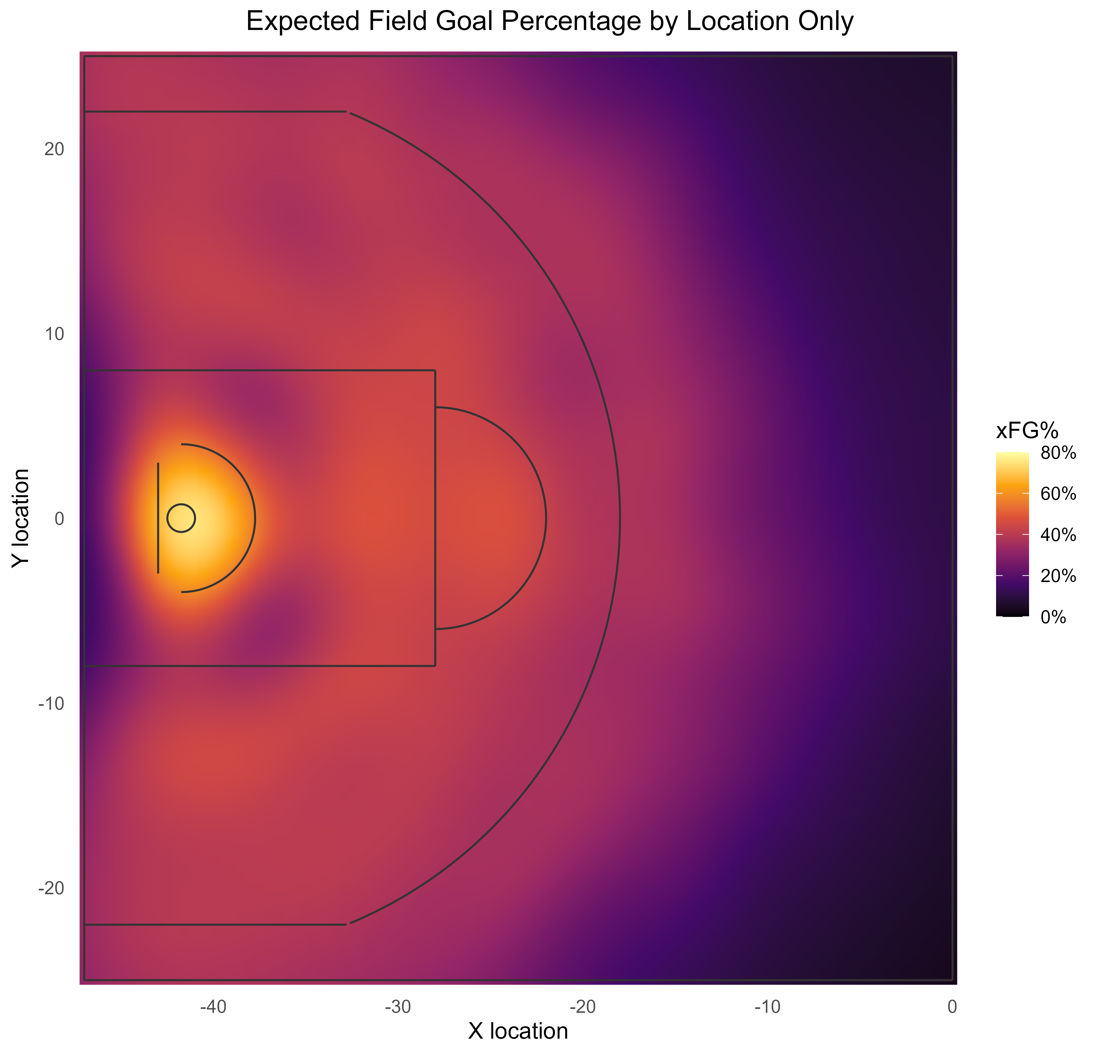
Figure 3. Expected FG% by location from the joint 2D GAM smooth. The surface peaks at nearly 80% at the rim and decays outward; deep-backcourt regions are smooth extrapolation over sparse data.
TURN THIS PARAGRAPH INTO A TABLE As a benchmark, the GAM scores 0.6539 on the validation set, between the class-only baseline (0.6609) and the full context model. The decomposition is telling: separating the three classes captures most of the coarse spatial signal (0.6896 down to 0.6609), and the detailed surface adds a smaller increment (0.6609 down to 0.6539) concentrated at the rim, where the make-probability gradient is steepest. A single scalar necessarily compresses the floor, so two locations with the same gam_logit look identical to later layers unless another feature separates them. I accept that in this version, which is exactly why the context layer treats gam_logit as one feature among many.

Layer 2 – Shot Context
The next layer estimates shot quality: given the location-based shot probability and the context at the time of release, how likely is a make before we know who is shooting? Three features of the problem point to gradient-boosted trees. The situational inputs are numerous, correlated, and interact nonlinearly; several are informatively missing, since contester distances two through four do not exist when there are fewer contesters, and boosted trees route missing values natively instead of forcing an imputation; and tree ensembles are strong, well-calibrated probability estimators that support SHAP attributions.
For a shot i in class c(i), the model maps the location score eta_i (the value of gam_logit) and the context vector z_i to a shot quality logit through an additive ensemble of regression trees F_c:
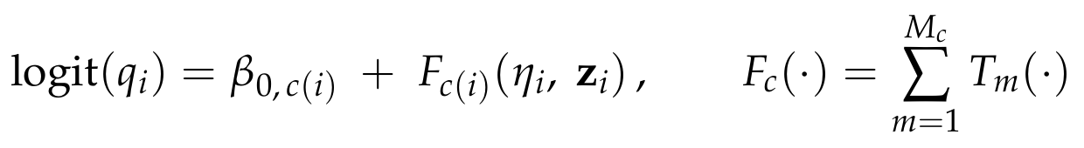
Three models, one per class. The context-to-make map differs sharply by class, so rim, midrange, and three-point shots get separate models with their own feature sets. Every valid shot routes to exactly one model. Using 3 separate models also permits for the estimation of player random effects for each shot class. This is intuitive as any given player has different underlying abilities for rim, midrange, and 3-pointers (both on offense and defense).
The GAM score enters as a feature. gam_logit is an ordinary predictor, so the trees can reshape or partly discount the spatial baseline after conditioning on the situation; the code never sets it as a fixed XGBoost base margin. The trees train on out-of-fold GAM scores, from a GAM that never saw the training row's outcome, while new rows are scored by a GAM fit on all the fitting data; this helps to limit leakage and prevent overly-optimistic prediction results.

Feature Set
The output of the GAM (gam_logit) is used as a proxy for shot location; locationx, locationy, distance, and angle stay out so the trees see one smoothed spatial input. Player and team identities stay out to keep the models player-agnostic. The retained features, shared across classes unless noted, are:
- Spatial base: gam_logit.
- Contest: num_contesters and the recorded contester distances distcont1 through distcont4, with native missingness. closestdefdist is dropped as redundant with the contester distances.
- Defender approach: closing rate over the final 1 second and final quarter-second, net separation created before release, and a closing-acceleration term, all built from the recorded approach trajectory and set to NA when the closest defender is not the recorded contester.
- Situation: shotclock, shooterspeed, transition, secondchance, and dribbles_cap3.
- Shot type (class-specific): dunk, tip, and post at the rim; post at midrange; none for threes.
An important caveat regarding the approach-derived features is that the data do not confirm that the same defender is tracked across the 1-second window. For purposes of this project, I assumed that the approach data is always referring to the closest defender.
In order to limit overfitting, hyperparameter tuning was performed using a small grid over tree depth and minimum child weight, a slow learning rate, L2 regularization, and early stopping, with depth and rounds chosen on a clean tuning split held out inside the fitting data so no selection step sees the evaluation rows. ADD LOG LOSS TABLE COMPARING NAÏVE, NAÏVE BY SHOT CLASS, GAM, AND XGBOOST The context layer cut validation log loss from the GAM's 0.6539 to 0.6288, a 3.8% relative gain. Almost all of it comes from the rim: rim shots are about 30% of validation shots and supply more than 80% of the GAM-to-context improvement, where contest and shot-type information is most decisive.

Feature Importance
At the rim, nearest-contester distance, a dunk indicator, gam_logit, the contester count, and dribbles dominate, and a missing contester distance (an uncontested shot) pushes hard toward a make. Midrange leans on contester distance, gam_logit, shooterspeed, and the clock. Threes put contester distance first, then the shot clock, the late closeout rate, gam_logit, and shooter speed. The rim model's reliance on openness and dunks, and the flatter three-point structure, match the exploratory analysis and explain why context helps rim shots most. Another way to interpret this is that a wide-open layup will go in very often, regardless of the shooter. On the contrary, a wide-open 3-pointer’s success rate is much more dependent on the underlying skill of the shooter.
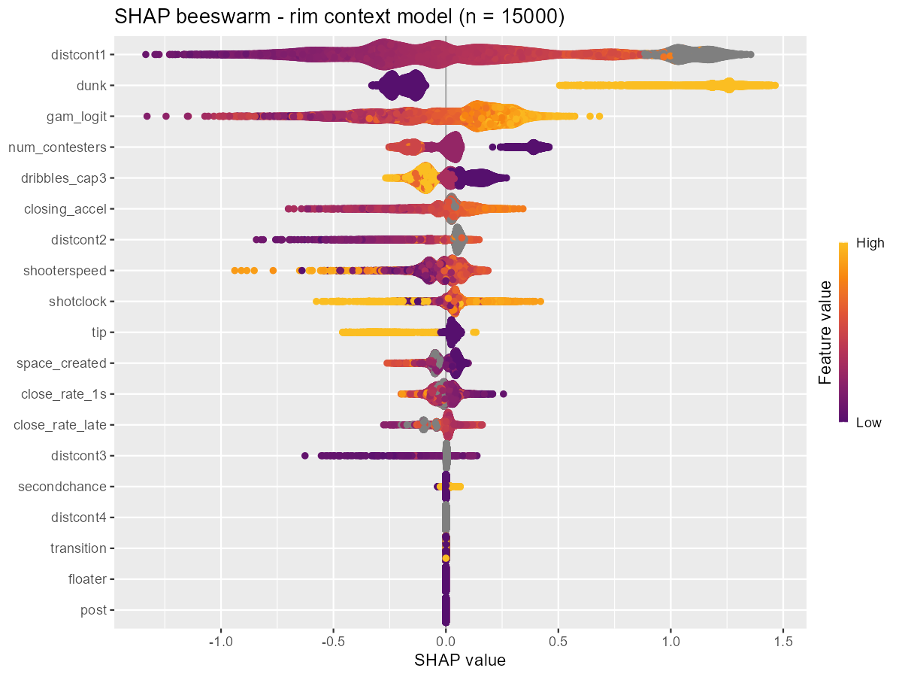
Figure 4. SHAP summary for the rim context model. Nearest-contester distance, dunk, GAM score, contester count, and capped dribbles drive predictions; grey points are missing (uncontested) contester distances and approach-derived features.
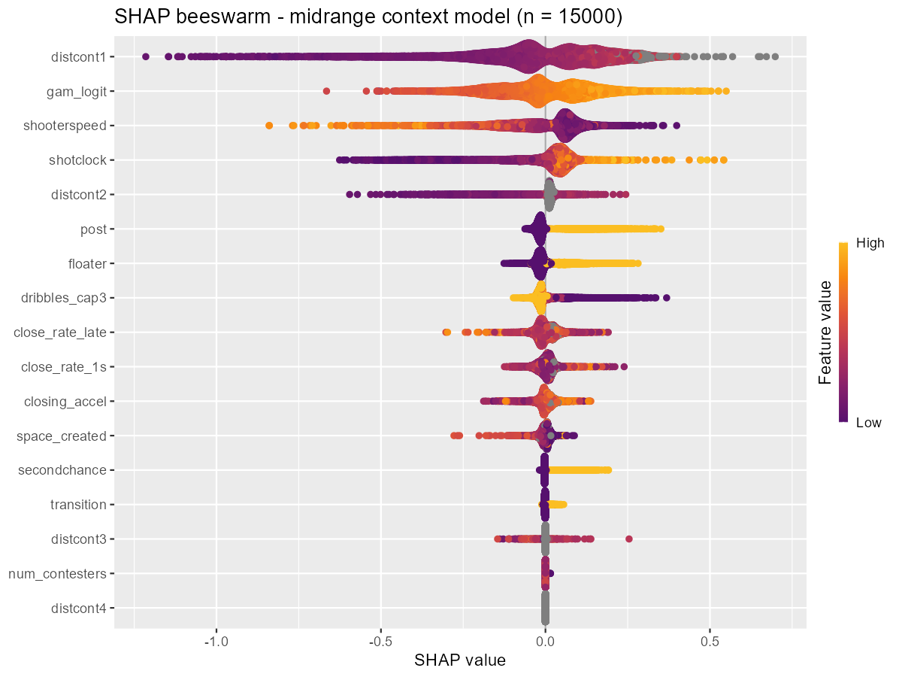
Figure 5. SHAP summary for the midrange context model. Contester distance, the GAM score, shooter speed, and the shot clock lead.
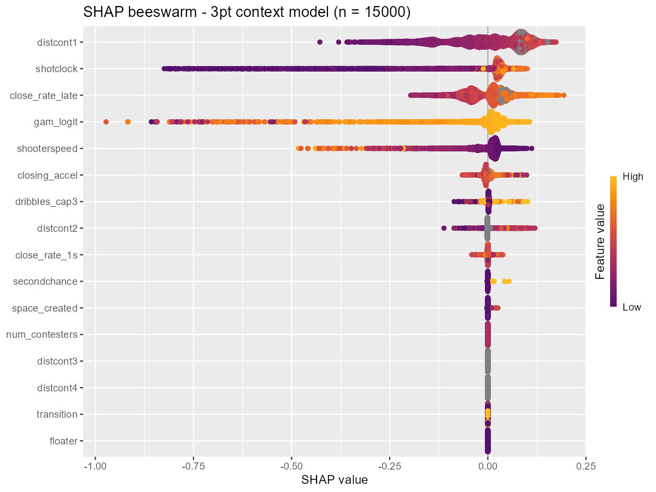
Figure 6. SHAP summary for the three-point context model. Contester distance ranks first, then the shot clock, late closeout rate, GAM score, and shooter speed; effects are compressed, reflecting a flatter openness gradient beyond the arc.
The shot quality probabilities are well-calibrated on validation across all three classes, tracking the reliability diagonal over the range each class occupies. Calibration matters here because log loss punishes miscalibration directly. USE DIFFERENT SCALES FOR EACH SHOT CLASS. THIS GRAPH SHOULD ONLY SHOW XGBOOST CALIBRATION
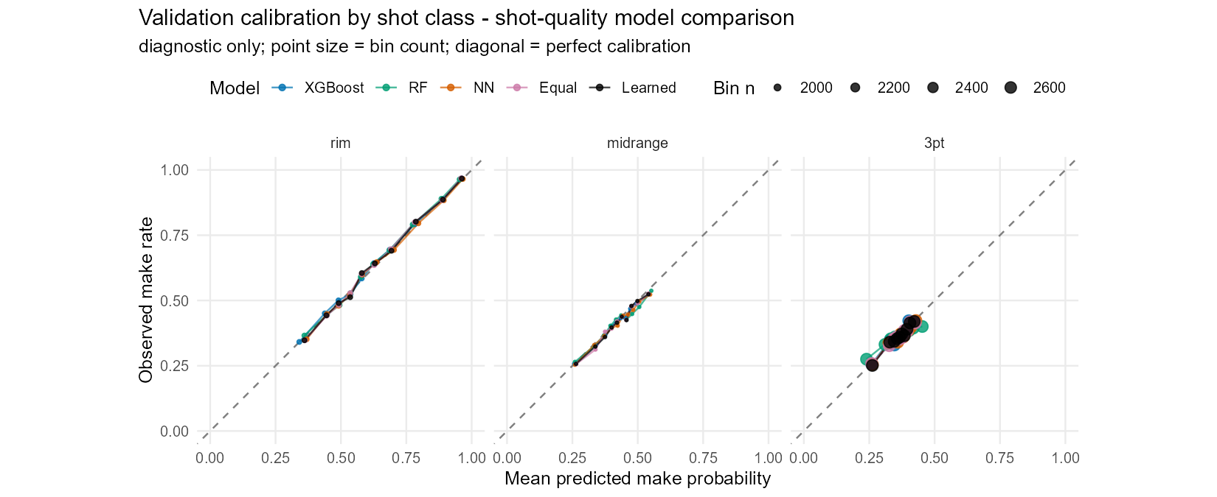
Figure 7. Validation reliability by class for the shot quality models (all learners shown). Points lie on the diagonal, indicating well-calibrated probabilities; three-point and midrange predictions occupy a narrower probability range than rim.

Alternatives tested: Random Forest, Neural Network, and Ensembles
Before settling on XGBoost, I tested whether another learner or a blend could beat it on the same problem: the same gam_logit signal, the same features, the same routing, and the same cross-fitting. I compared a random forest, a neural network, an equal-weight average of the three, and a learned nonnegative blend whose weights were fit on cross-fitted fitting-set predictions and then applied to validation.
XGBoost was the best standalone learner overall and in every shot class, and the forest and network were each worse. The two ensembles slightly beat XGBoost, but by a margin close to rounding error: the learned blend improved validation log loss by about 0.0005, roughly 0.07% of the loss and under 2% of the improvement the context layer had already made over the GAM.
Table 4. Shot quality learners on the 63,766-shot validation set (log loss; lower is better).
Model | Log loss | vs. XGBoost
XGBoost (production) | 0.62881 | 0
Random forest | 0.63086 | +0.00205
Neural network | 0.62947 | +0.00066
Equal-weight blend | 0.62846 | -0.00034
Learned blend | 0.62834 | -0.00047

The best single model was already XGBoost, the learned weights (0.42 XGBoost, 0.10 forest, 0.48 network) buy a fifth of a thousandth of a nat, and promoting a blend would mean maintaining three model families across three classes, two preprocessing pipelines, a neural-network dependency, blend-weight fitting, and a full re-cross-fitting for the player layer, while giving up the clean single-model SHAP explanations. I kept XGBoost for production and keep the comparison in the report as evidence. In this case, the added complexity did not add enough predictive power to be worth the tradeoff.

Layer 3 – Logistic Mixed-Effects Models
Once shot quality is accounted for, do some shooters convert more than their shot quality predicts, and do some defenders suppress makes more than the contest situation implies? Player shot counts vary significantly, and the test set is a new season. As such, the model needs to handle repeated samples of varying sizes from a common distribution. It also must be able to handle unseen values in the test set (i.e. rookies). This led to a mixed-effects model with partial pooling.
I fit three class-specific logistic mixed models on the fitting-set outcomes. Writing q_oof for the cross-fitted shot quality probability, the shot quality logit enters as an offset, so the random effects estimate the residual adjustment beyond shot quality. Each model has a class intercept, a shooter random intercept s, and a defender random effect d switched on only by the contest gate g_i:
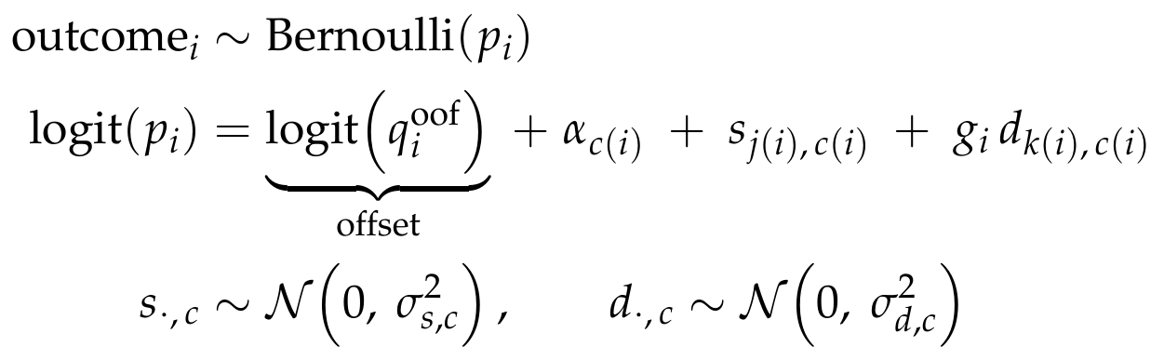
The gate ties the defender term to the nearest contester and zeroes it on an uncontested shot:
Partial pooling shrinks a lower-sample player's effect toward zero, so his prediction stays closer to the shot quality baseline, while a player seen a thousand times can move meaningfully. I fit the models with lme4.
Modeling the offset. To avoid leakage, the shot quality offset that trains this layer comes from cross-fitting the whole GAM-to-XGBoost procedure across three outer folds of the fitting set, so no shot's quality offset was produced by a model that saw its own outcome. This is stricter than using out-of-fold GAM features alone, because the entire upstream procedure, including its tuning, stays inside each outer training fold.

A negative result: partial-credit defenders
I also built a model utilizing distance-weighted multiple-membership defender term that splits credit across all contesters by proximity, fit with Bayesian approximations (mean-field variational inference, then Pathfinder). Both failed their diagnostics badly, with large Pareto-k values and near-zero estimated player variances. The predictions they produced were valid probabilities, yet the fits themselves were untrustworthy, and they did not beat the simpler model. I kept the single-nearest-contester lme4 model for production.
The estimated variance components behave sensibly. Shooter effects appear in every class, while the defender effect is large at the rim, modest at midrange, and nearly gone beyond the arc, which fits the intuition that rim protection suppresses makes far more than a three-point closeout. The class intercepts are small, so the shot quality offset was already well-calibrated.
Table 5. Player-layer variance components (standard deviations on the log-odds scale), fit set.
Shot class | Shots | Class intercept | Shooter SD | Defender SD | # Shooters | # Defenders
Rim | 87,152 | +0.031 | 0.199 | 0.242 | 747 | 736
Midrange | 86,892 | -0.039 | 0.167 | 0.090 | 744 | 752
Three-point | 123,622 | -0.047 | 0.146 | 0.059 | 720 | 752

Player leaderboards
The fitted effects read as a leaderboard, shown below for the rim, where they matter most. For each player I report the estimated log-odds effect, its percentage-point translation at the class reference, the number of (contested) attempts behind it, the mean shot quality expectation from the context model, and the observed conversion rate. The percentage-point column evaluates the effect as a contrast at a fixed class reference:
The gap between expected and observed field goal percentage is what the effect captures after shrinkage. The top rim shooter converts 78.0% against a 62.1% shot quality expectation and earns a +11.8-point effect, while partial pooling keeps thinly sampled players out of the extremes. Defender effects use the opposite sign, where a negative effect suppresses opponent makes, and the strongest rim protectors hold opponents roughly 12 to 15 points below expectation on contested shots.
Table 6. Rim shooter effects: five most and five least effective by estimated random effect (fit set).
Shooter | Effect | PP | Attempts | Exp FG% | Act FG%
a2db3a89dd | +0.628 | +11.8 | 282 | 62.1 | 78.0
14f1a35113 | +0.566 | +10.7 | 542 | 57.2 | 70.3
4498318275 | +0.536 | +10.3 | 739 | 65.2 | 75.4
c56c1e9130 | +0.449 | +8.8 | 286 | 61.0 | 73.4
b67a1aff5a | +0.429 | +8.4 | 729 | 57.0 | 65.0
9e884511eb | -0.327 | -7.4 | 165 | 68.1 | 57.0
8916e1c710 | -0.340 | -7.7 | 129 | 62.7 | 49.6
188070e015 | -0.372 | -8.5 | 206 | 59.1 | 46.1
547895506a | -0.318 | -7.2 | 463 | 67.3 | 58.5
6106b1bccb | -0.301 | -6.8 | 568 | 71.7 | 64.8

Table 7. Rim defender effects: five best (most make-suppressing) and five weakest, by estimated effect (fit set).
Defender | Effect | PP | Contested att. | Exp FG% | Act FG%
b3c28fe3af | -0.631 | -14.8 | 581 | 60.0 | 46.5
835f46c9f8 | -0.538 | -12.5 | 341 | 58.6 | 46.3
91f4f737b5 | -0.515 | -12.0 | 374 | 56.0 | 43.9
0791320284 | -0.495 | -11.5 | 660 | 58.2 | 47.9
8efeafe542 | -0.493 | -11.4 | 272 | 57.7 | 45.2
298574f6e3 | +0.360 | +7.2 | 52 | 63.0 | 82.7
2951ede20e | +0.364 | +7.3 | 198 | 58.5 | 70.7
78d849f72c | +0.402 | +7.9 | 86 | 62.1 | 80.2
46a7a7ad66 | +0.424 | +8.3 | 59 | 60.4 | 83.1
d609c7c1e9 | +0.465 | +9.1 | 167 | 57.7 | 73.7

These effects describe conditional predictive associations. They do not measure causal skill, defensive value, or shot prevention, and the defender term captures only residual make-suppression when a player is the recorded nearest contester, so single-contester attribution approximates crowded plays. Adding the player layer cut validation log loss from 0.6288 to 0.6258, a small but consistent gain that is again largest at the rim. Because the offset already removed shot quality, this layer does modest work on top of a calibrated baseline.

Final Predictions
Development used one fixed split of the labeled data, keyed by shot id and stratified by season and class: 70% to fit all layers, 15% as a selection set for comparing settings and measuring each layer's increment, and 15% as a final holdout frozen until the pipeline was fixed. Every line above the last two in Table 8 is a selection-set number used to make a decision; the holdout exists to check that those decisions generalize.
Table 8. Log-loss progression down the model stack. Validation is the selection set; the frozen holdout confirms the two production stages.
Model stage | Validation | Final holdout
Overall mean-FG% baseline | 0.6896
Shot-class baseline | 0.6609
Location GAM | 0.6539
+ Context XGBoost (shot quality) | 0.6288 | 0.6301
+ Player effects (production) | 0.6258 | 0.6273

The frozen holdout tells the same story as the selection set, slightly attenuated: shot quality scores 0.6301 and the full player-adjusted model 0.6273 on 64,287 untouched shots. The close agreement between selection and holdout is the best evidence that the pipeline is not overfit and that the cross-fitting did its job. The test set is a new season, but nearly all of its shooters and defenders appear in training (about 99.5% and 99.2%), so the player layer applies to almost every test row, and the small unseen fraction gets a zero adjustment and falls back to shot quality.
From assessment to submission. For the production predictions the whole pipeline is refit on all labeled data: the GAM-to-XGBoost procedure is cross-fit across the full set to regenerate honest shot quality offsets, the three mixed models are refit on those offsets, and the frozen recipe scores the 213,977 test shots to fill submission.csv in the template's row order. The holdout figure of 0.6273 is my best estimate of out-of-sample log loss against observed outcomes; the contest instead scores against an in-house probability model, so I read it as a faithful local proxy.

Conclusion
The process mattered as much as the result. Cross-fitting is subtle: an early tuning routine let GAM features leak across boosting folds, and an early player pipeline inherited hyperparameters chosen on data it was meant to exclude. Both were fixed so that every prediction excludes its own outcome from all upstream fitting and selection, down to the feature-generating fits. A quiet probability-conversion bug, an out-of-fold column computed from the wrong logit, surfaced only because a difference diagnostic was zero everywhere it should have varied. The multiple-membership defender model was a genuine dead end whose diagnostics told the truth even when its scores looked fine. And attributing each contested shot to a single nearest contester is a defensible simplification that still approximates crowded plays.
Several extensions would be worth the time. Player-season dynamics and separate shot-creation and finishing effects could sharpen the player layer. A trustworthy Bayesian fit of the distance-weighted defender model, or a well-tuned monotone or contextual GAM, might recover the sliver of signal the ensembles hinted at. Most of all, because the test set is a new season, explicit cross-season pooling and a calibration check against the in-house reference probabilities, if they became available, would close the one generalization gap the local holdout cannot measure. The shipped model is deliberately the transparent, well-validated one: a smooth spatial base, three explainable context models, and a shrinkage-based player layer, each earning its place on the validation and holdout evidence above.

https://www.nba.com/stats/help/glossary

