Predicting NBA Shot Outcomes
A layered spatial (GAM), contextual (XGBoost), and player-effects (mixed-model) approach

Alexander M. Susi

Oklahoma City Thunder · Analyst Intern Technical Project
2026-09-23
Table of Contents
1. Introduction 2
2. Exploratory Data Analysis 2
3. Location layer: a binomial GAM 6
4. Context layer: class-specific XGBoost 8
4.1. Feature set and exclusions 9
4.2. What the models learned 10
5. Alternatives tested: random forest, neural network, and ensembles 13
6. Player layer: logistic mixed-effects models 14
6.1. A negative result: partial-credit defenders 15
6.2. Player leaderboards 15
7. Final assessment and predictions 17
7.1. Reflections, pitfalls, and improvements 17

Introduction
This report develops a model for the probability that a non-fouled field goal attempt is made. The training data hold 425,719 labeled regular-season shots with a binary make-or-miss outcome, and the finished model must score 213,977 unlabeled test shots. Submissions are graded by log loss against an in-house reference model, so the working metric throughout is the log loss between a predicted probability p_i and the observed outcome y_i:
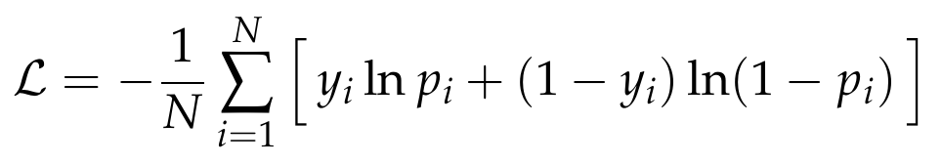
Log loss rewards calibrated probabilities and punishes confident mistakes, so I judge every modeling choice by its effect on out-of-sample log loss.
A shot outcome is the product of three components: where the shot is taken from, the situation around it (how open the shooter is, how the defense closes out, the clock, the shot type, dribbles taken before shooting, etc.), and who takes and contests it. I model this generative structure directly, as three stacked layers that each capture one force:
• Shot location – A single binomial generalized additive model (GAM) fits a smooth surface of make probability over the court and returns one spatial score, gam_logit.
• Shot context – Three gradient-boosted tree models (XGBoost), one each for rim, midrange, and three-point shots, read gam_logit together with situational features and return a player-agnostic shot quality probability q.
• Player effects – Three logistic mixed-effects models use the cross-fitted shot quality logit as an offset and add partially pooled shooter and defender effects to give the final make probability p.
Building models in stages keeps each layer interpretable and lets me measure the predictive power of each layer individually.

Exploratory data analysis
I began by checking the data against the brief and deciding which raw fields deserved to become features. The outcome field is a clean logical with no missing values and an overall make rate of 45.8%. One loading detail mattered: the fourth-contester columns are almost entirely missing near the top of the file, so a naive read drops their few real values, and the loader forces those columns to their correct types.
Shot class is the primary axis of variation and the backbone of the model. Rim attempts are those within five feet, three-point attempts use the supplied three flag, and midrange holds the remaining two-point shots. The three shot classes convert at very different rates, which is why splitting on class already improves sharply on a single global rate.
Table 1. Field goal percentage by shot class (full training set).
Shot class | Attempts | FG%
Rim (≤5 ft) | 124,832 | 63.6%
Midrange | 124,126 | 41.8%
Three-point | 176,761 | 36.1%
All shots | 425,719 | 45.8%

Contest information is the strongest situational signal. Field goal percentage falls steadily as contesters are added, and the drop is far steeper at the rim than beyond the arc.
Table 2. FG% (and attempts) by number of contesters and shot class. Contest pressure degrades rim shots most.
Contesters | Rim | Midrange | Three-point
0 | 91.8% (18,335) | 52.0% (6,143) | 39.6% (21,529)
1 | 63.6% (70,587) | 42.8% (89,312) | 35.7% (150,110)
2 | 49.6% (33,566) | 36.9% (26,983) | 33.5% (5,088)
3 | 40.9% (2,325) | 31.8% (1,671) | 18.2% (33)
4 | 42.1% (19) | 29.4% (17) | 0.0% (1)

Two smaller summaries shaped the feature set. Game state separates transition and direct second-chance attempts (each about 51%) from halfcourt offense (43.7%), so I kept transition and second-chance indicators. Shot type is highly predictive but heavily confounded with location and openness: dunks convert 88.5% and heaves 9.5%, largely because of distance and how contested the attempt is. I kept shot-type indicators only where they add non-redundant signal (dunk, tip, and post at the rim; post at midrange).
Table 3. FG% by game state and by shot type (full training set).
Game state | FG%
Halfcourt | 43.7%
Transition | 51.2%
Direct second chance | 51.4%

Shot type | FG% | Avg dist (ft) | Avg speed
Dunk | 88.5% | 2.1 | 7.5
Layup | 53.5% | 3.8 | 8.8
Tip | 48.1% | 2.6 | 3.9
Post | 45.4% | 8.7 | 4.5
Floater | 41.7% | 9.7 | 6.0
Jumper | 37.8% | 23.0 | 1.8
Heave | 9.5% | 44.8 | 8.2

Two plots settled decisions that are easy to get wrong. The first shows field goal percentage by number of dribbles, split by class. Every class falls steeply from zero to about three dribbles and then flattens into a noisy plateau. The zero-to-three range is real shot quality signal; past three dribbles the differences mostly track which players take long isolation sequences, which reflects shot-creation and shooting ability more than shot context. Because identity lives in the third layer, handing raw dribble counts to the context model would let shooting ability leak into shot quality. I capped dribbles at three, which keeps the ordered 0/1/2/3-plus signal and drops the ability-laden tail.
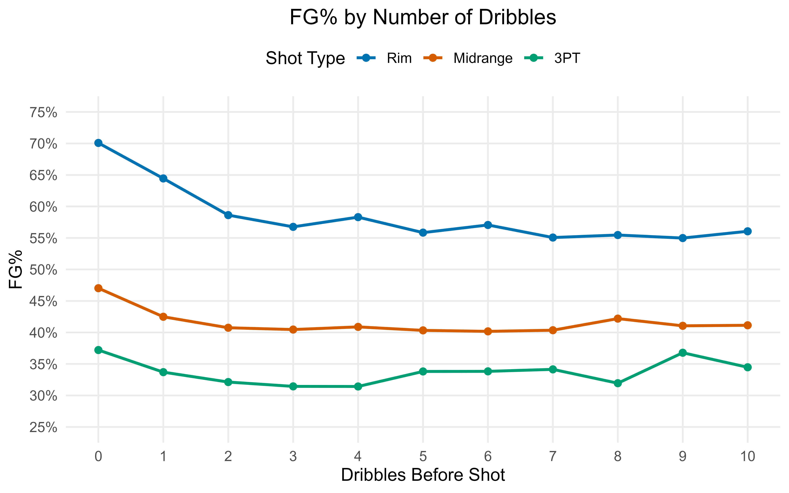
Figure 1. Field goal percentage by dribbles before the shot, by class. Each class falls from 0 to about 3 dribbles and then plateaus; the flat tail reflects shot-creation ability, so dribbles are capped at three in the context model.
The second plot shows field goal percentage by calendar month for the two training seasons. A transferable month effect would trace similar curves in both seasons. Instead the curves disagree in shape and timing, and the whole spread is a narrow band of about two-and-a-half points that looks like sampling noise. The test set is a different season, so any month pattern learned here would not carry over. I excluded month and season identity as predictors, which is a leakage decision as much as a performance one.
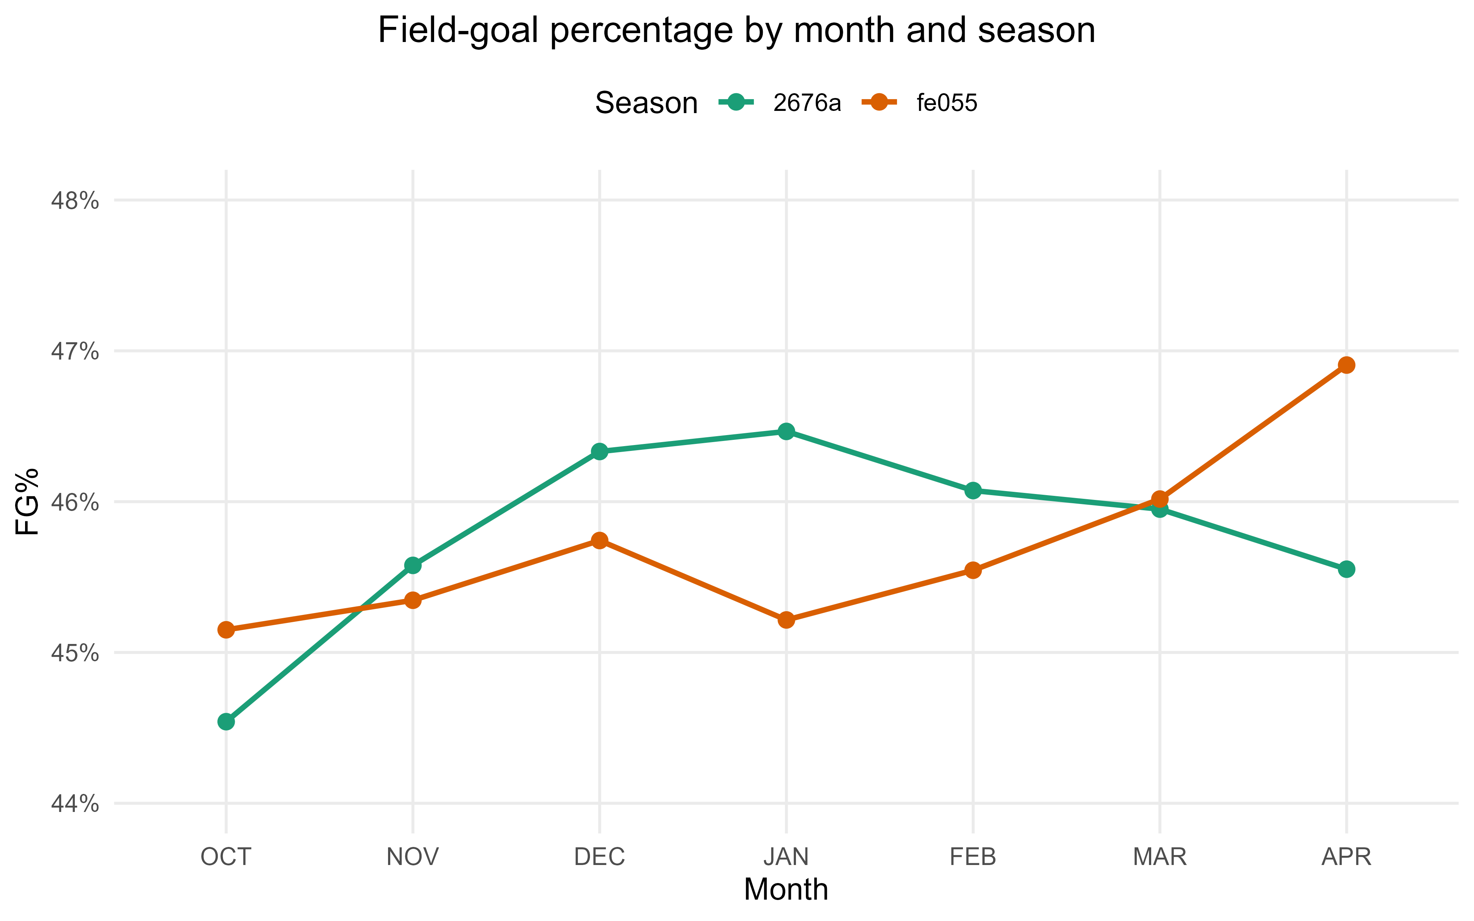
Figure 2. FG% by month for the two training seasons. The inconsistent, low-amplitude patterns, together with an unseen test season, argue against using month or season as features.
A final exploration looked at the apparent disagreement between the contested label and nearest-defender distance, since some uncontested shots have a defender within 3.5 feet and many contested shots do not. Stratifying by class showed these were not labeling errors. Among uncontested rim attempts, field goal percentage barely changes across a 3.5-foot cutoff (about 92% on both sides), which fits trailing transition defenders who arrive late without affecting a layup or dunk. The brief also states plainly that the closest defender need not be a contester. I kept the supplied labels and tied defender attribution in the player layer to recorded contesters.

Location layer: a binomial GAM
The first layer answers a narrow question: across the floor, and before anything else is known, how does make probability vary with location? The relationship is smooth but strongly nonlinear, with a sharp peak at the rim, a fast falloff through the paint, a broad midrange trough, and a partial recovery near the arc, and it is genuinely two-dimensional because the value of a step in x depends on y. A generalized additive model fits this directly: it estimates a flexible, penalized surface from the data with no hand-specified distance bins, and its penalty controls the many sparse corners of the court.
Writing outcome_i for the make indicator and pi_loc for the location-only make probability, the model is a binomial GAM whose linear predictor is a single joint two-dimensional thin-plate spline of the signed coordinates:
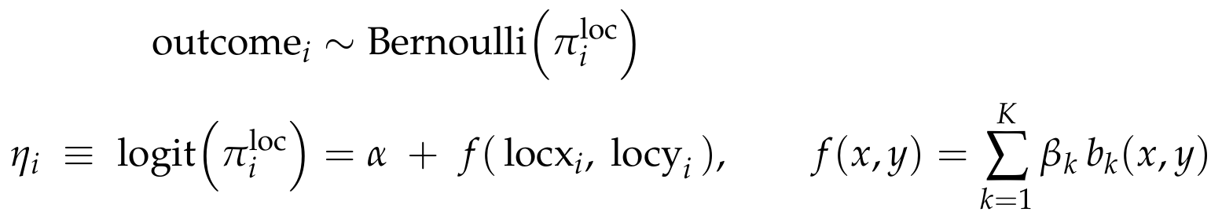
The spline is one joint surface over both coordinates, so it can bend differently along the baseline than along the wings. I fit it with mgcv::bam using fast REML and discrete binning, which fits the 425,000-row model in well under a minute, and I use a basis dimension of 150, which basis-diagnostic checks confirmed is ample. The coefficients are estimated by penalized likelihood, where the thin-plate penalty charges for curvature and the smoothing parameter controls its strength:
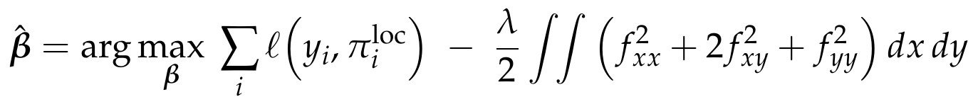
Regularizing toward a stable baseline. I deliberately strengthened the smoothing (gamma = 5), which cut the effective degrees of freedom by about 30% at a negligible standalone log loss cost, on the order of 0.0002. The reasoning is interpretive. The heatmap shows local pockets, dim spots in the midrange and bright spots in the deep corners, that most likely reflect which shooters take those shots (specialists attempt long threes) rather than an intrinsic property of the location. Because a location-only model averages over the shooters seen at each spot, a lightly penalized surface would bake that selection into the baseline. A smoother surface gives a more stable starting point and leaves shooter skill to the layer built for it. It does not remove selection or make the surface causal; it keeps the baseline from over-committing to sparse pockets.
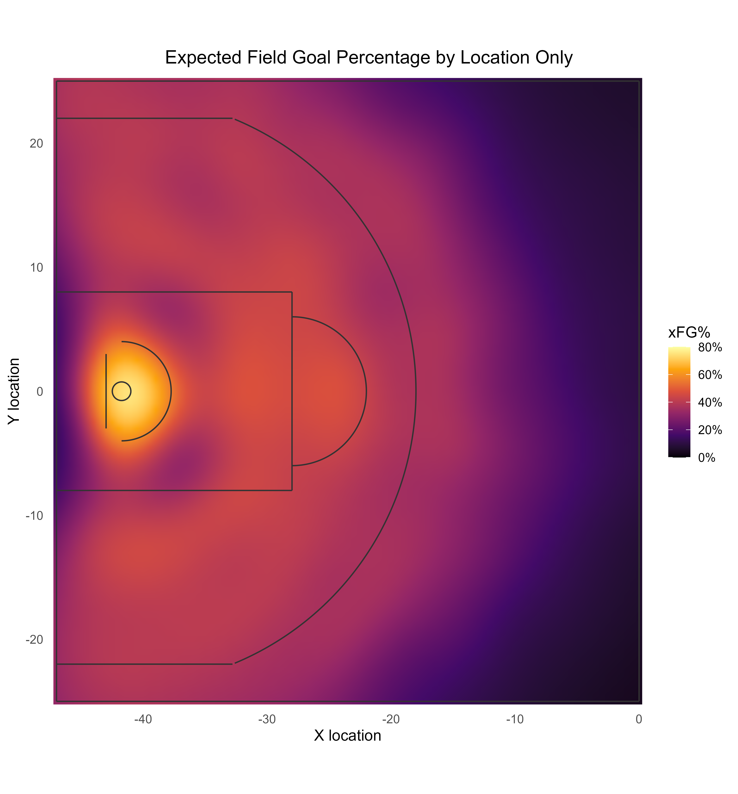
Figure 3. Expected FG% by location from the joint 2D GAM smooth. The surface peaks above 80% at the rim and decays outward; deep-backcourt regions are smooth extrapolation over sparse data and should be read with care.
As a benchmark, the GAM scores 0.6539 on the validation set, between the class-only baseline (0.6609) and the full context model. The decomposition is telling: separating the three classes captures most of the coarse spatial signal (0.6896 down to 0.6609), and the detailed surface adds a smaller increment (0.6609 down to 0.6539) concentrated at the rim, where the make-probability gradient is steepest. A single scalar necessarily compresses the floor, so two locations with the same gam_logit look identical to later layers unless another feature separates them. I accept that in this version, which is exactly why the context layer treats gam_logit as one feature among many.

Context layer: class-specific XGBoost
The context layer estimates shot quality: given the location score and the situation, how likely is a make before we know who is shooting? Three features of the problem point to gradient-boosted trees. The situational inputs are numerous, correlated, and interact nonlinearly; several are informatively missing, since contester distances two through four do not exist when there are fewer contesters, and boosted trees route missing values natively instead of forcing an imputation; and tree ensembles are strong, well-calibrated probability estimators that support SHAP attributions, which the brief values for explainability.
For a shot i in class c(i), the class model maps the location score eta_i (the value of gam_logit) and the context vector z_i to a shot quality logit through an additive ensemble of regression trees F_c:
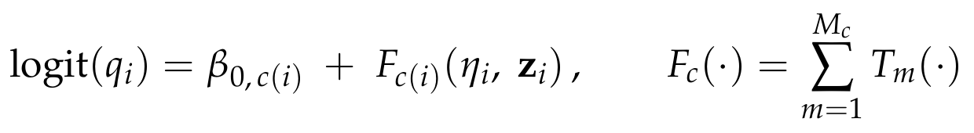
The trees are grown by gradient boosting to minimize log loss plus a complexity penalty, so the ensemble stays regularized:
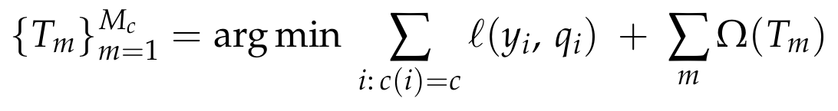
Three models, one per class. The context-to-make map differs sharply by class, so rim, midrange, and three-point shots get separate models with their own feature sets. Contest pressure and shot type dominate at the rim, while beyond the arc the openness signal is flatter and the clock and closeout matter more. Every valid shot routes to exactly one model.
The GAM score enters as a feature. gam_logit is an ordinary predictor, so the trees can reshape or partly discount the spatial baseline after conditioning on the situation; the code never sets it as a fixed XGBoost base margin. To keep the stack honest, the trees train on out-of-fold GAM scores, from a GAM that never saw the training row's outcome, while new rows are scored by a GAM fit on all the fitting data. This cross-fitted stacking keeps the context model from being handed an over-optimistic spatial feature.

Feature set and exclusions
I chose features with an explicit allowlist instead of passing every column to the model. Location enters only through gam_logit; raw coordinates, distance, and angle stay out so the trees see one smoothed spatial channel. Player and team identities stay out to keep the layer player-agnostic. The retained features, shared across classes unless noted, are:
• Spatial base: gam_logit.
• Contest: num_contesters and the recorded contester distances distcont1 through distcont4, with native missingness. closestdefdist is dropped as redundant with the contester distances.
• Defender approach: closing rate over the final one second and final quarter-second, net separation created before release, and a closing-acceleration term, all built from the recorded approach trajectory and masked when the closest defender is not the recorded contester.
• Situation: shotclock, shooterspeed, transition and second-chance indicators, and dribbles_cap3.
• Shot type (class-specific): dunk, tip, and post at the rim; post at midrange; none added for threes.
The approach features carry a caution I keep visible: they measure changes in recorded shooter-defender separation, and the data do not confirm that the same defender is tracked across the window. I treat them as separation-change signals. Their sometimes counterintuitive SHAP directions, where a fast late closeout is associated with a higher make probability, read as selection: a late-arriving defender implies an initially open shot. I do not read them causally.
Tuning was deliberately restrained to fit the time budget and limit overfitting, using a small grid over tree depth and minimum child weight, a slow learning rate, L2 regularization, and early stopping, with depth and rounds chosen on a clean tuning split held out inside the fitting data so no selection step sees the evaluation rows. The context layer cut validation log loss from the GAM's 0.6539 to 0.6288, a 3.8% relative gain. Almost all of it comes from the rim: rim shots are about 30% of validation shots and supply more than 80% of the GAM-to-context improvement, where contest and shot-type information is most decisive.

What the models learned
SHAP beeswarm plots make the fitted logic legible. At the rim, nearest-contester distance, a dunk indicator, gam_logit, the contester count, and dribbles dominate, and a missing contester distance (an uncontested shot) pushes hard toward a make. Midrange leans on contester distance, gam_logit, shooterspeed, and the clock. Threes put contester distance first, then the shot clock, the late closeout rate, gam_logit, and shooter speed. The rim model's reliance on openness and dunks, and the flatter three-point structure, match the exploratory analysis and explain why context helps rim shots most.
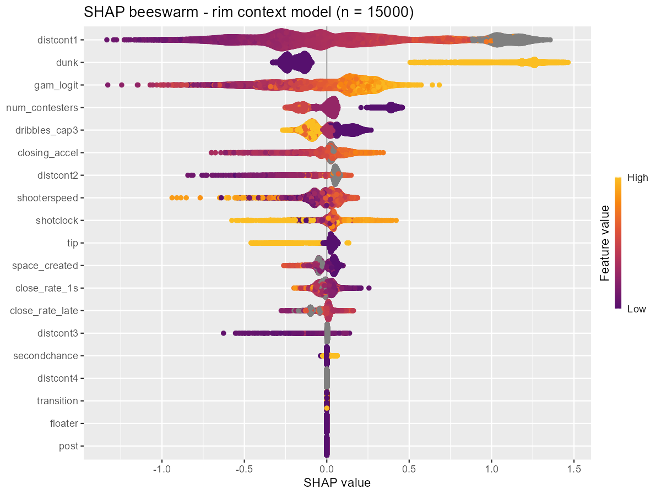
Figure 4. SHAP summary for the rim context model. Nearest-contester distance, dunk, GAM score, contester count, and capped dribbles drive predictions; grey points are missing (uncontested) contester distances.
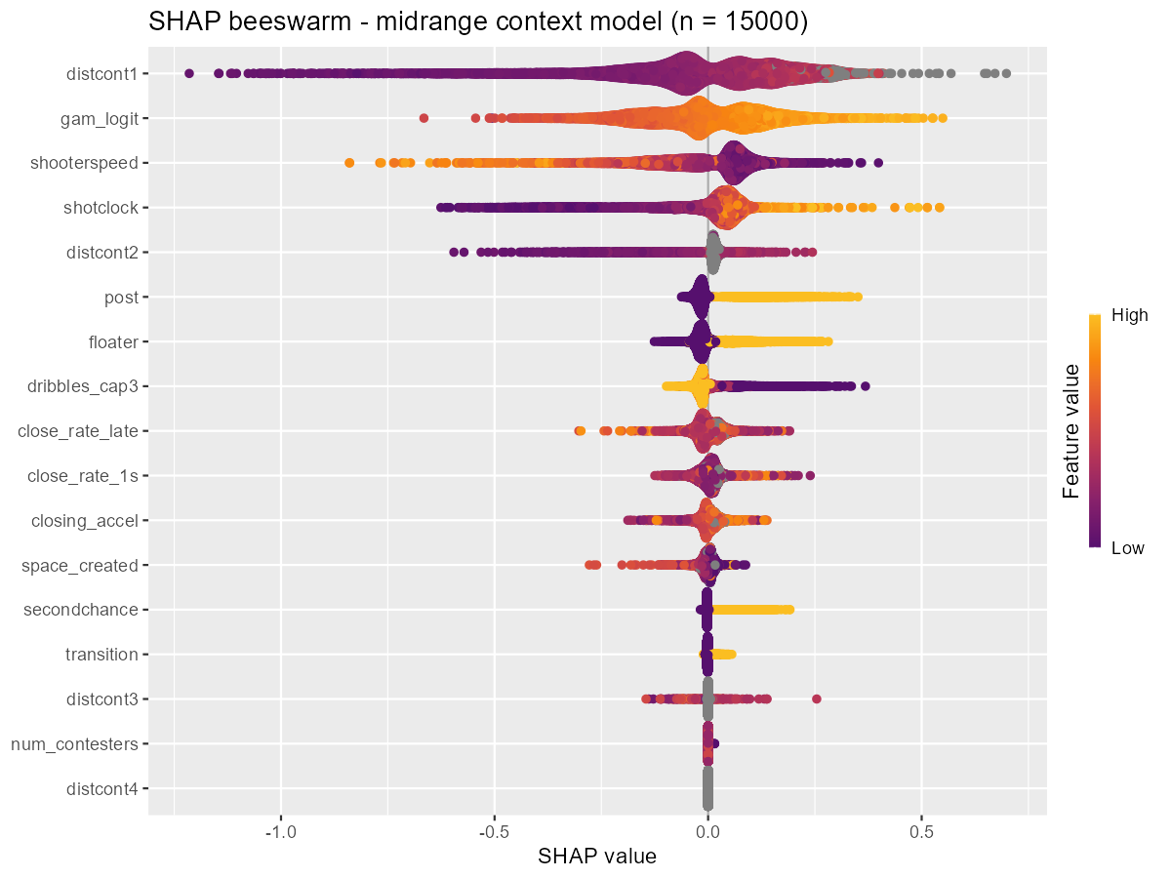
Figure 5. SHAP summary for the midrange context model. Contester distance, the GAM score, shooter speed, and the shot clock lead.
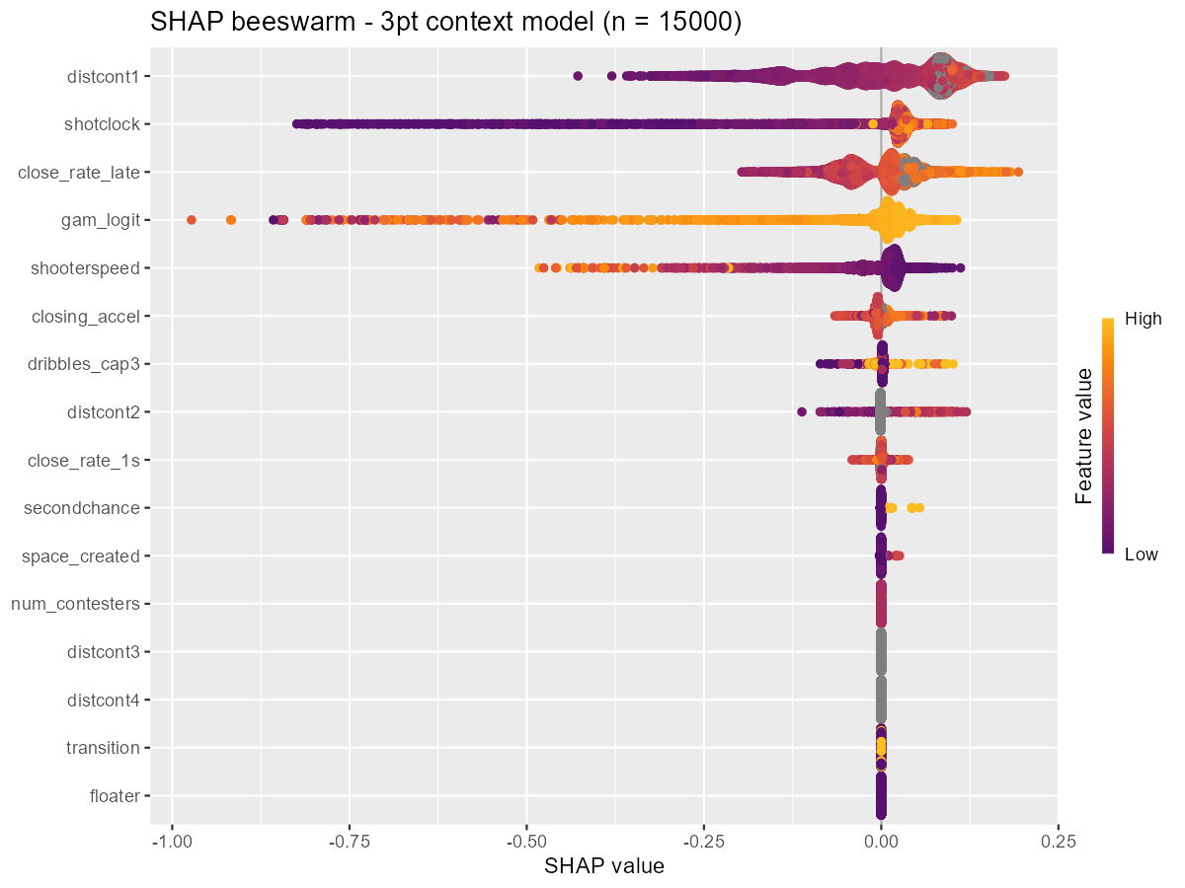
Figure 6. SHAP summary for the three-point context model. Contester distance ranks first, then the shot clock, late closeout rate, GAM score, and shooter speed; effects are compressed, reflecting a flatter openness gradient beyond the arc.
The shot quality probabilities are well-calibrated on validation across all three classes, tracking the reliability diagonal over the range each class occupies. Calibration matters here because log loss punishes miscalibration directly.
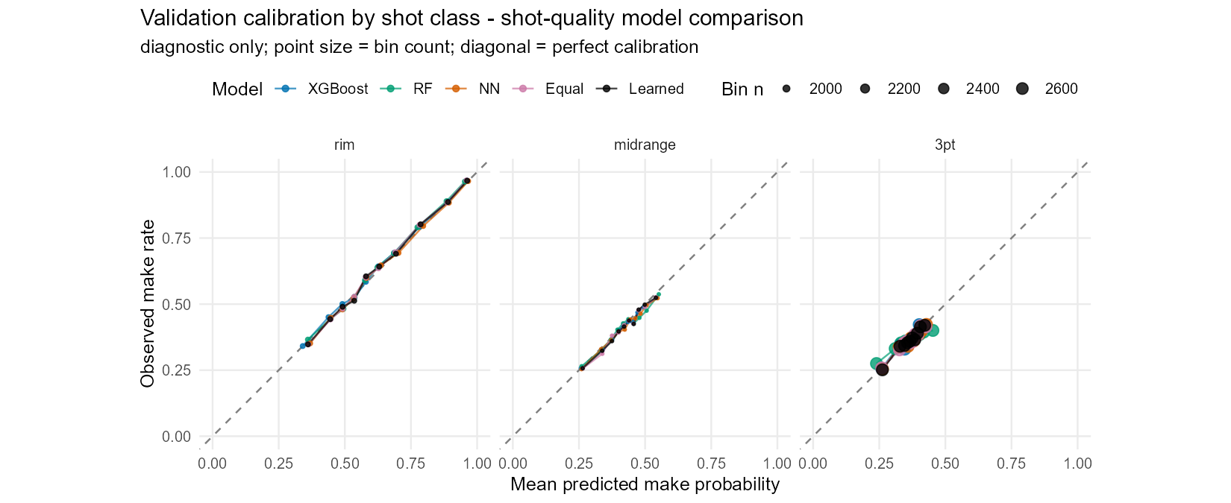
Figure 7. Validation reliability by class for the shot quality models (all learners shown). Points lie on the diagonal, indicating well-calibrated probabilities; three-point and midrange predictions occupy a narrower probability range than rim.

Alternatives tested: random forest, neural network, and ensembles
Before settling on XGBoost, I tested whether another learner or a blend could beat it on the same problem: the same gam_logit signal, the same features, the same routing, and the same cross-fitting. I compared a probability random forest, a small feed-forward neural network, an equal-weight average of the three, and a learned nonnegative blend whose weights were fit on cross-fitted fitting-set predictions and then applied to validation.
Each alternative got preprocessing suited to its family (median imputation with missingness indicators for the forest and network, plus standardization for the network) and a modest search. One process fix is worth recording: an early version returned early-stopped networks trained on only part of the data, unlike the fully trained forest and boosted models. The corrected version records the chosen epoch count and refits the network on all eligible rows, so the comparison is fair. The blend's own fitting-set score describes weights fit to their own training rows, so it overstates the ensemble's real accuracy.
The result is quietly decisive. XGBoost was the best standalone learner overall and in every class, and the forest and network were each worse. The two blends edged below XGBoost, but by a margin close to rounding error: the learned blend improved validation log loss by about 0.0005, roughly 0.07% of the loss and under 2% of the improvement the context layer had already made over the GAM. The equal-weight average captured most of even that, and a paired bootstrap put the blend gains just outside zero, so the effect is real and tiny.
Table 4. Shot quality learners on the 63,766-shot validation set (log loss; lower is better).
Model | Log loss | vs. XGBoost
XGBoost (production) | 0.62881 | 0
Random forest | 0.63086 | +0.00205
Neural network | 0.62947 | +0.00066
Equal-weight blend | 0.62846 | -0.00034
Learned blend | 0.62834 | -0.00047

The best single model was already XGBoost, the learned weights (0.42 XGBoost, 0.10 forest, 0.48 network) buy a fifth of a thousandth of a nat, and promoting a blend would mean maintaining three model families across three classes, two preprocessing pipelines, a neural-network dependency, blend-weight fitting, and a full re-cross-fitting for the player layer, while giving up the clean single-model SHAP explanations. I kept XGBoost for production and keep the comparison in the report as evidence. The brief's emphasis on explainability and disciplined process points the same way: a negligible, hard-won gain does not justify the added complexity.

Player layer: logistic mixed-effects models
The first two layers know nothing about identity. The third asks what is left once shot quality is accounted for: do some shooters convert more than their shot quality predicts, and do some defenders suppress makes more than the contest situation implies? Two facts about the data shape the answer. Player shot counts are wildly unequal, from a handful to thousands, and the test set is a new season, so the model must degrade gracefully for lightly seen and unseen players. Both point to a mixed-effects model with partial pooling. Raw per-player make rates or unregularized indicators would overfit the sparse tail badly.
I fit three class-specific logistic mixed models on the fitting-set outcomes. Writing q_oof for the cross-fitted shot quality probability, the shot quality logit enters as an offset, so the random effects estimate only the residual adjustment beyond shot quality. Each model has a class intercept, a shooter random intercept s, and a defender random effect d switched on only by the contest gate g_i:
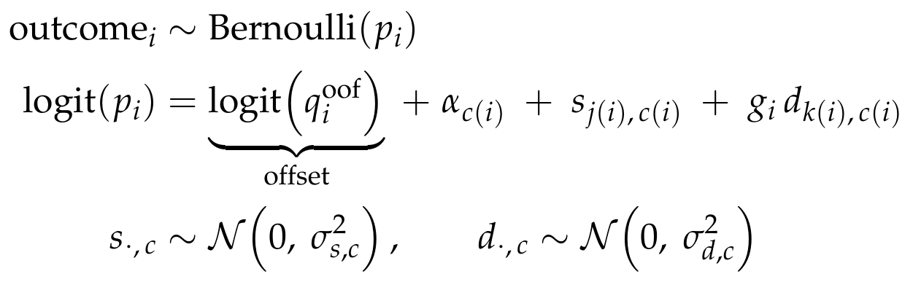
The gate ties the defender term to the recorded nearest contester and zeroes it on an uncontested shot:
Partial pooling shrinks a poorly-sampled player's effect toward zero, so his prediction stays at the shot quality baseline, while a player seen a thousand times can move meaningfully. I fit the models with lme4 (a glmmTMB fit was the original intent; lme4 was the installed, reliable fallback).
Modeling the offset honestly. The offset that trains this layer comes from cross-fitting the whole GAM-to-XGBoost procedure across three outer folds of the fitting set, so no shot's quality offset was produced by a model that saw its own outcome. This is stricter than using out-of-fold GAM features alone, because the entire upstream procedure, including its tuning, stays inside each outer training fold. An in-sample XGBoost prediction would have handed the player model a residual it could explain for free.

A negative result: partial-credit defenders
I also built the theoretically nicer model: a distance-weighted multiple-membership defender term that splits credit across all contesters by proximity, fit with Bayesian approximations (mean-field variational inference, then Pathfinder). Both failed their diagnostics badly, with large Pareto-k values and near-zero estimated player variances that erased almost the entire rim gain. The predictions they produced were valid probabilities, yet the fits themselves were untrustworthy, and they did not beat the simpler model. I kept the single-nearest-contester lme4 model for production and report the multiple-membership work as an instructive dead end.
The estimated variance components behave sensibly. Shooter effects appear in every class, while the defender effect is large at the rim, modest at midrange, and nearly gone beyond the arc, which fits the intuition that rim protection suppresses makes far more than a three-point closeout. The class intercepts are small, so the shot quality offset was already well-calibrated.
Table 5. Player-layer variance components (standard deviations on the log-odds scale), fit set.
Shot class | Shots | Class intercept | Shooter SD | Defender SD | # Shooters | # Defenders
Rim | 87,152 | +0.031 | 0.199 | 0.242 | 747 | 736
Midrange | 86,892 | -0.039 | 0.167 | 0.090 | 744 | 752
Three-point | 123,622 | -0.047 | 0.146 | 0.059 | 720 | 752

Player leaderboards
The fitted effects read as a leaderboard, shown below for the rim, where they matter most. For each player I report the estimated log-odds effect, its percentage-point translation at the class reference, the number of (contested) attempts behind it, the mean shot quality expectation from the context model, and the observed conversion rate. The percentage-point column evaluates the effect as a contrast at a fixed class reference:
The gap between expected and observed field goal percentage is what the effect captures after shrinkage. The top rim shooter converts 78.0% against a 62.1% shot quality expectation and earns a +11.8-point effect, while partial pooling keeps thinly sampled players out of the extremes. Defender effects use the opposite sign, where a negative effect suppresses opponent makes, and the strongest rim protectors hold opponents roughly 12 to 15 points below expectation on contested shots.
Table 6. Rim shooter effects: five most and five least effective by estimated random effect (fit set).
Shooter | Effect | PP | Attempts | Exp FG% | Act FG%
a2db3a89dd | +0.628 | +11.8 | 282 | 62.1 | 78.0
14f1a35113 | +0.566 | +10.7 | 542 | 57.2 | 70.3
4498318275 | +0.536 | +10.3 | 739 | 65.2 | 75.4
c56c1e9130 | +0.449 | +8.8 | 286 | 61.0 | 73.4
b67a1aff5a | +0.429 | +8.4 | 729 | 57.0 | 65.0
9e884511eb | -0.327 | -7.4 | 165 | 68.1 | 57.0
8916e1c710 | -0.340 | -7.7 | 129 | 62.7 | 49.6
188070e015 | -0.372 | -8.5 | 206 | 59.1 | 46.1
547895506a | -0.318 | -7.2 | 463 | 67.3 | 58.5
6106b1bccb | -0.301 | -6.8 | 568 | 71.7 | 64.8

Table 7. Rim defender effects: five best (most make-suppressing) and five weakest, by estimated effect (fit set).
Defender | Effect | PP | Contested att. | Exp FG% | Act FG%
b3c28fe3af | -0.631 | -14.8 | 581 | 60.0 | 46.5
835f46c9f8 | -0.538 | -12.5 | 341 | 58.6 | 46.3
91f4f737b5 | -0.515 | -12.0 | 374 | 56.0 | 43.9
0791320284 | -0.495 | -11.5 | 660 | 58.2 | 47.9
8efeafe542 | -0.493 | -11.4 | 272 | 57.7 | 45.2
298574f6e3 | +0.360 | +7.2 | 52 | 63.0 | 82.7
2951ede20e | +0.364 | +7.3 | 198 | 58.5 | 70.7
78d849f72c | +0.402 | +7.9 | 86 | 62.1 | 80.2
46a7a7ad66 | +0.424 | +8.3 | 59 | 60.4 | 83.1
d609c7c1e9 | +0.465 | +9.1 | 167 | 57.7 | 73.7

These effects describe conditional predictive associations. They do not measure causal skill, defensive value, or shot prevention, and the defender term captures only residual make-suppression when a player is the recorded nearest contester, so single-contester attribution approximates crowded plays. Adding the player layer cut validation log loss from 0.6288 to 0.6258, a small but consistent gain that is again largest at the rim. Because the offset already removed shot quality, this layer does modest, honest work on top of a calibrated baseline.

Final assessment and predictions
Development used one fixed split of the labeled data, keyed by shot id and stratified by season and class: 70% to fit all layers, 15% as a selection set for comparing settings and measuring each layer's increment, and 15% as a final holdout frozen until the pipeline was fixed. Every line above the last two in Table 8 is a selection-set number used to make a decision; the holdout exists to check that those decisions generalize.
Table 8. Log-loss progression down the model stack. Validation is the selection set; the frozen holdout confirms the two production stages.
Model stage | Validation | Final holdout
Overall mean-FG% baseline | 0.6896
Shot-class baseline | 0.6609
Location GAM | 0.6539
+ Context XGBoost (shot quality) | 0.6288 | 0.6301
+ Player effects (production) | 0.6258 | 0.6273

The frozen holdout tells the same story as the selection set, slightly attenuated: shot quality scores 0.6301 and the full player-adjusted model 0.6273 on 64,287 untouched shots. The close agreement between selection and holdout is the best evidence that the pipeline is not overfit and that the cross-fitting did its job. The test set is a new season, but nearly all of its shooters and defenders appear in training (about 99.5% and 99.2%), so the player layer applies to almost every test row, and the small unseen fraction gets a zero adjustment and falls back to shot quality.
From assessment to submission. For the production predictions the whole pipeline is refit on all labeled data: the GAM-to-XGBoost procedure is cross-fit across the full set to regenerate honest shot quality offsets, the three mixed models are refit on those offsets, and the frozen recipe scores the 213,977 test shots to fill submission.csv in the template's row order. The holdout figure of 0.6273 is my best estimate of out-of-sample log loss against observed outcomes; the contest instead scores against an in-house probability model, so I read it as a faithful local proxy.

Reflections, pitfalls, and improvements
The process mattered as much as the result. Cross-fitting is subtle: an early tuning routine let GAM features leak across boosting folds, and an early player pipeline inherited hyperparameters chosen on data it was meant to exclude. Both were fixed so that every prediction excludes its own outcome from all upstream fitting and selection, down to the feature-generating fits. A quiet probability-conversion bug, an out-of-fold column computed from the wrong logit, surfaced only because a difference diagnostic was zero everywhere it should have varied. The multiple-membership defender model was a genuine dead end whose diagnostics told the truth even when its scores looked fine. And attributing each contested shot to a single nearest contester is a defensible simplification that still approximates crowded plays.
Several extensions would be worth the time. A game identifier, absent here, would allow game-level clustering for honest uncertainty intervals and let the model borrow strength within games. Player-season dynamics and separate shot-creation and finishing effects could sharpen the player layer. A trustworthy Bayesian fit of the distance-weighted defender model, or a well-tuned monotone or contextual GAM, might recover the sliver of signal the ensembles hinted at. Most of all, because the test set is a new season, explicit cross-season pooling and a calibration check against the in-house reference probabilities, if they became available, would close the one generalization gap the local holdout cannot measure. The shipped model is deliberately the transparent, well-validated one: a smooth spatial base, three explainable context models, and a shrinkage-based player layer, each earning its place on the validation and holdout evidence above.

https://www.nba.com/stats/help/glossary

