Modeling Shot-Make Probability for Non-Fouled Field-Goal Attempts
A layered spatial (GAM), contextual (XGBoost), and player-effects (mixed-model) approach
Alexander M. Susi
Analyst Intern Technical Project · September 2026
1 INTRODUCTION
This report describes a model that predicts the probability a non-fouled field-goal attempt is made. The training data contain 425,719 labeled regular-season shots; the target is the binary make/miss outcome. Predictions are required for 213,977 unlabeled test shots and are scored by log loss against an in-house reference model. Because log loss rewards well-calibrated probabilities rather than hard classifications, every modeling decision below is judged primarily by its effect on out-of-sample log loss and by the honesty of the validation that produced it.
The central modeling problem is that a shot's make probability is driven by three conceptually distinct forces that are easy to conflate: where the shot was taken from, the context in which it was taken (how open the shooter was, how the defense closed out, the clock, the shot type), and who took and contested it. Folding all three into a single flat model invites leakage between shot quality and player identity, and makes the result difficult to explain. I therefore decompose the problem into three stacked layers, each matched to the structure of the signal it captures:
• Location layer - a single binomial generalized additive model (GAM) fits a smooth two-dimensional surface of make probability over the court. This is a compact, player-agnostic spatial baseline.
• Context layer - three class-specific gradient-boosted tree models (XGBoost), one each for rim, midrange, and three-point attempts, take the GAM score plus contextual features and estimate a player-agnostic shot-quality probability.
• Player layer - three logistic mixed-effects models (one per shot class) use the cross-fitted shot-quality logit as an offset and add partially pooled shooter and defender effects, yielding the final make probability.
The layering is deliberate. Each stage adds only the kind of information it is well suited to represent, and each is validated on its own increment. The remainder of the report follows the build order: exploratory analysis that motivated the feature and split decisions; the location GAM; the context XGBoost models and the feature engineering behind them; the random-forest, neural-network, and ensemble alternatives that were tested and rejected for production; the player mixed-effects layer; and the final assessment and prediction workflow. Throughout, I distinguish results measured on a held-out selection set from the frozen final-holdout assessment, and I flag the assumptions and pitfalls that a reader should weigh when trusting the numbers.
A recurring theme is that excluding player identity from the first two layers does not make their output causal or free of selection effects; a location-and-context model still learns from the mixture of players who actually take each kind of shot. The player layer is where identity is modeled explicitly, with shrinkage, and it is the only layer that should be read as a statement about individuals.
2 EXPLORATORY DATA ANALYSIS
Exploration served three goals: to verify the data against the brief, to define shot classes and the target cleanly, and to decide which raw fields deserved to become model features. The supplied files matched the brief exactly (425,719 training and 213,977 testing rows). Coordinates are signed full-court feet with the offensive basket anchored at x = -41.75, y = 0, and the supplied distance equals the Euclidean distance to that anchor to numerical precision. The outcome field is a clean logical with no missing values and an overall make rate of 45.8%. One data-loading subtlety mattered: the fourth-contester distance and identity columns are almost entirely missing near the top of the file, so a naive reader silently drops their few real values; the loader forces those columns to their correct types.
Shot class is the primary axis of variation and the backbone of the whole model. Following the project definitions, rim attempts are those within five feet, three-point attempts use the supplied flag, and midrange is the remaining two-point attempts. A schema check confirmed zero conflicts between the three-point flag and distance, so routing is unambiguous. The three classes have very different baseline conversion rates, which is why the class-naive baseline is already a large improvement over a single global rate.
Table 1. Field-goal percentage by shot class (full training set).
Shot class | Attempts | FG%
Rim (≤5 ft) | 124,832 | 63.6%
Midrange | 124,126 | 41.8%
Three-point | 176,761 | 36.1%
All shots | 425,719 | 45.8%

Contest information is the strongest context signal. A cross-tabulation of the contested flag against the recorded contester count showed that contested is exactly the indicator that the count exceeds zero across all 425,719 rows, so the binary flag carries no information beyond the count and was dropped from the model in favor of num_contesters. Field-goal percentage falls monotonically as the number of contesters rises, and the effect is far larger at the rim than beyond the arc - contests separate rim opportunities much more strongly than three-point opportunities, which foreshadows where the context layer earns its gains.
Table 2. FG% (and attempts) by number of contesters and shot class. Contest pressure degrades rim shots most.
Contesters | Rim | Midrange | Three-point
0 | 91.8% (18,335) | 52.0% (6,143) | 39.6% (21,529)
1 | 63.6% (70,587) | 42.8% (89,312) | 35.7% (150,110)
2 | 49.6% (33,566) | 36.9% (26,983) | 33.5% (5,088)
3 | 40.9% (2,325) | 31.8% (1,671) | 18.2% (33)
4 | 42.1% (19) | 29.4% (17) | 0.0% (1)

Two smaller summaries shaped the feature set. Game state separates transition and direct second-chance attempts (each about 51% FG) from halfcourt offense (43.7%), so transition and second-chance indicators were retained. Shot type is highly predictive but strongly confounded with location and openness: dunks convert 88.5% and heaves 9.5%, but these differences largely reflect distance and how contested the attempt is rather than an independent effect of the label. Shot-type indicators were therefore kept only for the classes where they add non-redundant information (dunk, tip, and post at the rim; post at midrange).
Table 3. FG% by game state and by shot type (full training set).
Game state | FG%
Halfcourt | 43.7%
Transition | 51.2%
Direct second chance | 51.4%

Shot type | FG% | Avg dist (ft) | Avg speed
Dunk | 88.5% | 2.1 | 7.5
Layup | 53.5% | 3.8 | 8.8
Tip | 48.1% | 2.6 | 3.9
Post | 45.4% | 8.7 | 4.5
Floater | 41.7% | 9.7 | 6.0
Jumper | 37.8% | 23.0 | 1.8
Heave | 9.5% | 44.8 | 8.2

Two exploratory plots settled feature decisions that are easy to get wrong. The first is field-goal percentage by number of dribbles before the shot, split by class. Every class shows a steep decline from zero to roughly three dribbles and then a flat, noisy plateau. The catch-and-shoot-to-a-few-dribbles range is informative shot-quality signal; beyond three dribbles the marginal differences are dominated by which players take long isolation dribble sequences - a shot-creation and shooting-ability effect, not a shot-context effect. Because player identity is modeled separately in the third layer, feeding raw high dribble counts into the context model would conflate shot quality with shooting ability. Dribbles were therefore capped at three, preserving the ordered 0/1/2/3+ signal while discarding the ability-laden tail.
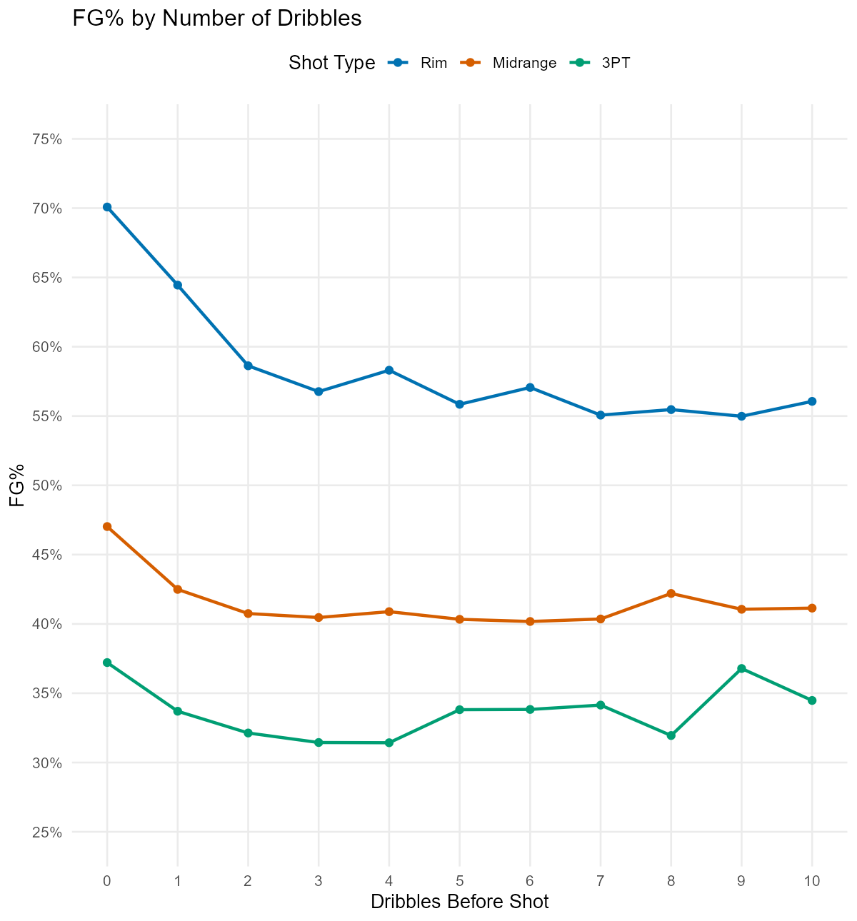
Figure 1. FG% by dribbles before the shot, by class. All classes drop from 0 to ~3 dribbles then plateau; the flat tail reflects shot-creator ability, motivating a cap at three dribbles in the context model.
The second plot is field-goal percentage by calendar month, drawn separately for the two training seasons. If month carried a stable, transferable signal, the two seasons would trace similar curves. They do not: the month-to-month trajectories disagree in both shape and timing, and the entire spread is a narrow band of roughly two-and-a-half percentage points that is consistent with sampling noise. Critically, the test set is an entirely new season, so any month-level idiosyncrasy learned from the training seasons would not transfer. Month (and season identity) were therefore excluded as predictors. This is a leakage-avoidance decision as much as a performance one: the model should not lean on a calendar artifact that cannot generalize to the unseen test season.
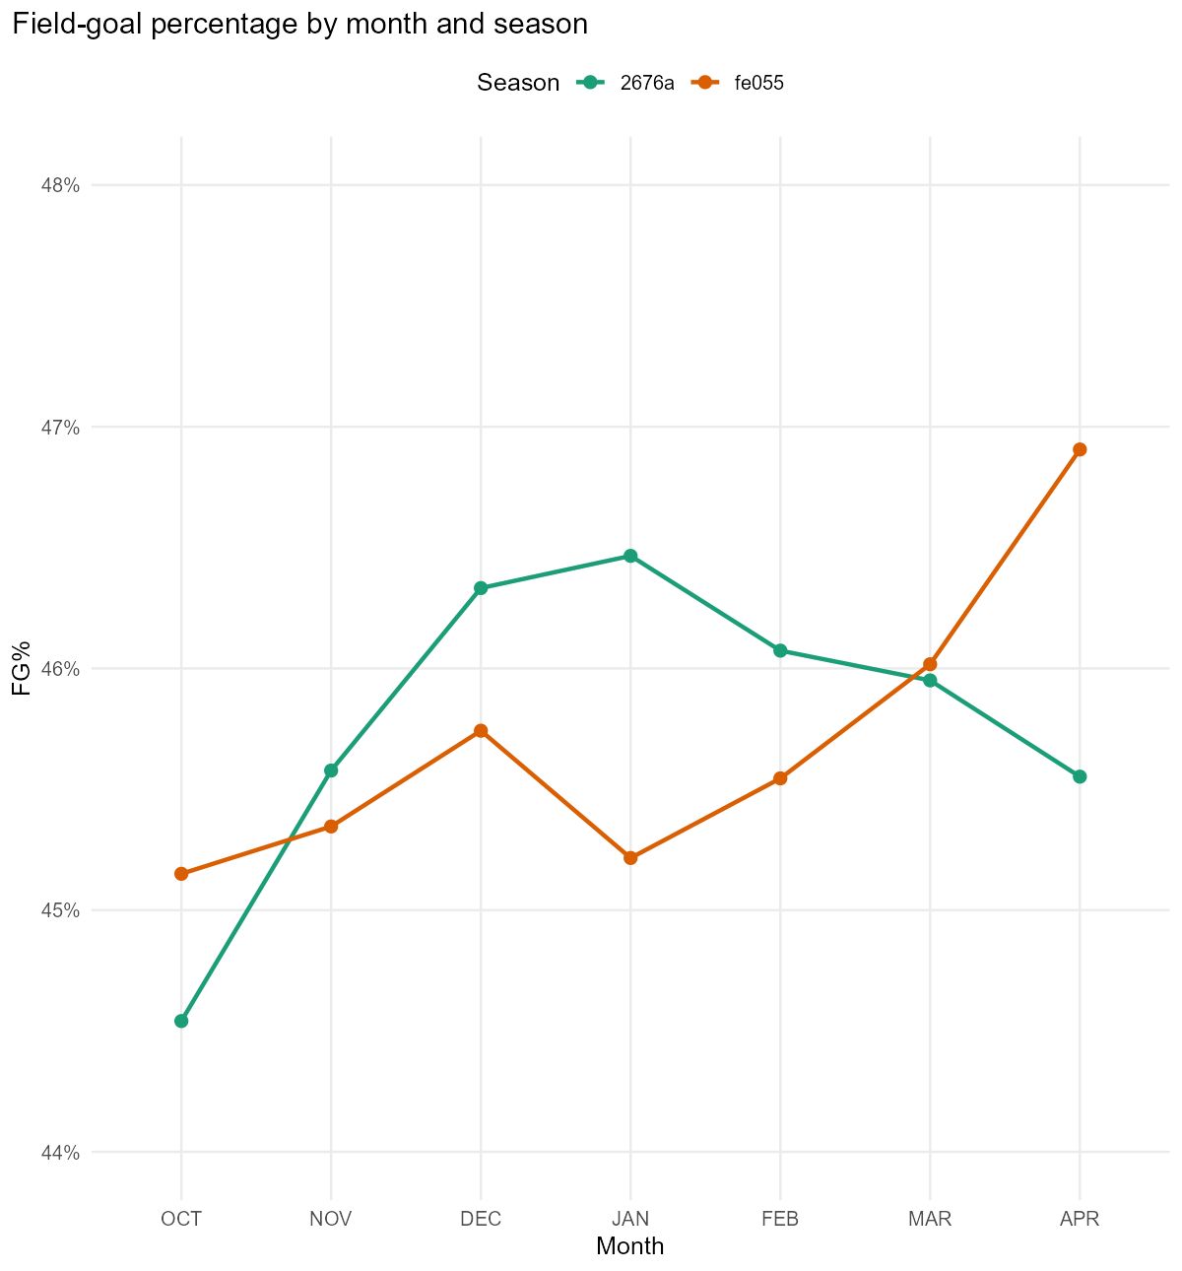
Figure 2. FG% by month for the two training seasons. The inconsistent, low-amplitude patterns - and an unseen test season - argue against using month or season as features.
A separate exploration examined the apparent disagreement between the contested label and nearest-defender distance (some uncontested shots have a defender within 3.5 feet, and many contested shots do not). Stratifying by class showed that these are not labeling errors: among uncontested rim attempts, FG% is essentially unchanged on either side of a 3.5-foot cutoff (about 92% both ways), consistent with trailing transition defenders who arrive late without affecting a layup or dunk. The brief also states explicitly that the closest defender need not be a contester. The supplied labels were therefore preserved rather than overwritten with a distance rule, and defender attribution in the player layer is tied to recorded contesters, not to the nearest defender.
3 LOCATION LAYER: A BINOMIAL GAM
The first layer answers a narrow question: holding nothing else fixed, how does make probability vary across the floor? The relationship between location and conversion is smooth but highly nonlinear - a sharp peak at the rim, a rapid falloff through the paint, a broad midrange trough, and a partial recovery near the arc - and it is genuinely two-dimensional, because the value of an x-coordinate depends on the y-coordinate (a step toward the baseline is not the same as a step toward the top of the key). A generalized additive model is the natural tool: it estimates a flexible, penalized smooth directly from the data without requiring hand-specified distance bins or an assumed functional form, and its penalty guards against overfitting the many sparse corners of the court.
The model is a single binomial-logit GAM with one joint two-dimensional thin-plate spline of the signed coordinates - not two additive one-dimensional smooths, so the surface can bend differently along the baseline than along the wings. The basis dimension is 150, which basis diagnostics confirmed is ample for the recovered complexity. Fitting uses mgcv's bam with fast REML and discrete covariate binning, which makes a 425,000-row penalized fit run in well under a minute and keeps the whole cross-fitting pipeline tractable within the project's time budget. Predictions are taken on the link (log-odds) scale and named gam_logit; this single number is the layer's entire contribution downstream.
Regularization toward a stable baseline. The smoothing was deliberately strengthened (gamma = 5), reducing the effective degrees of freedom by roughly 30% at a negligible standalone log-loss cost (on the order of 0.0002). The motivation is interpretive rather than metric-chasing. The heatmap revealed local pockets - dim spots in the midrange, bright spots in the deep corners - that plausibly reflect which shooters take those shots (specialists disproportionately attempt long threes) rather than an intrinsic property of the location. A location-only model necessarily averages over the shooters and contexts observed at each spot, so a lightly penalized fit would bake that selection into the spatial baseline. A smoother surface yields a more stable, general starting point and defers shooter effects to the layer designed for them. This does not remove selection or make the surface causal; it simply avoids over-committing the baseline to sparse local patterns.
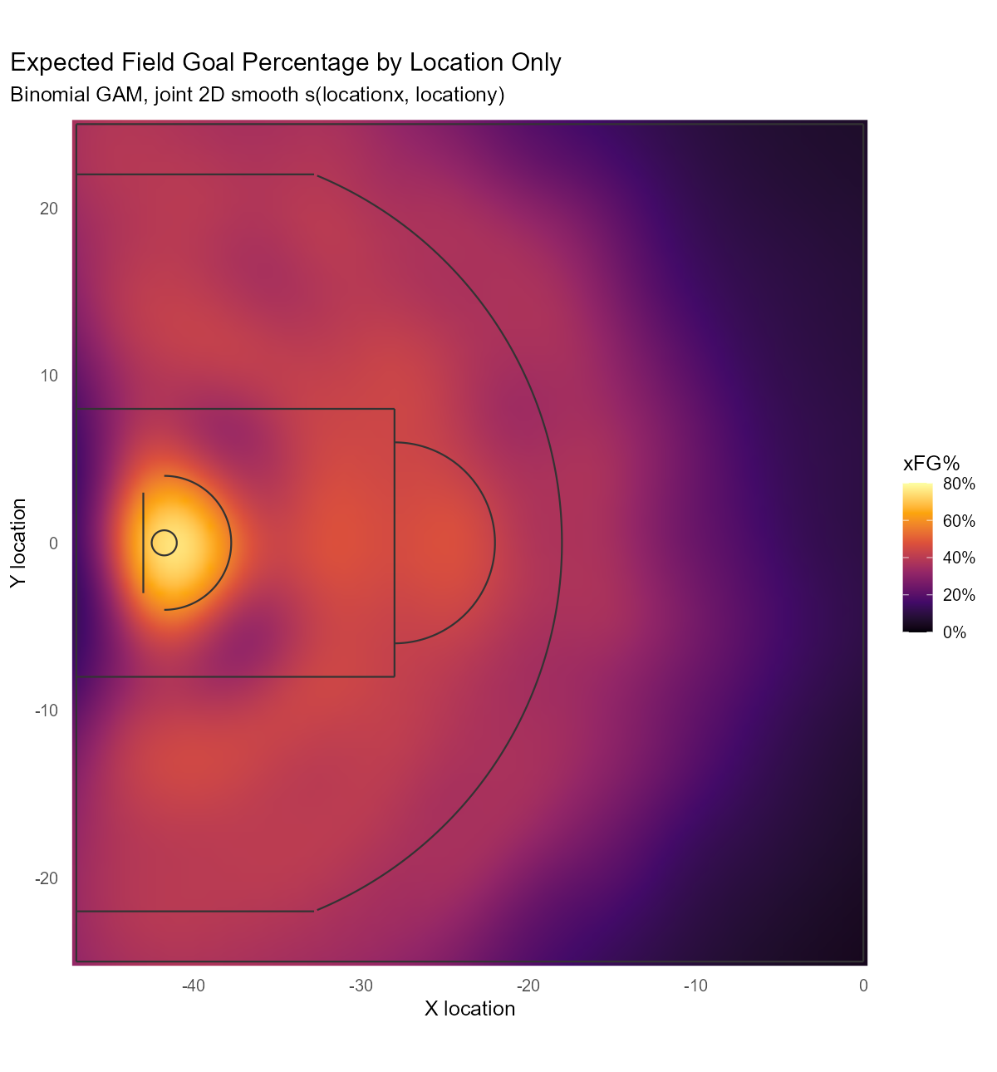
Figure 3. Expected FG% by location from the joint 2D GAM smooth. The surface peaks above 80% at the rim and decays outward; deep-backcourt regions are smooth extrapolation over sparse data and should not be over-read.
As a benchmark, the GAM's validation log loss (0.6539) sits between the shot-class-naive baseline (0.6609) and the full context model. The decomposition is informative: distinguishing the three shot classes already captures most of the coarse spatial signal (0.6896 to 0.6609), and the detailed location surface adds a further, smaller increment (0.6609 to 0.6539) concentrated at the rim, where the make-probability gradient is steepest. The GAM is thus a strong, compact spatial summary - but a single scalar necessarily compresses the floor, so two locations with the same GAM score are indistinguishable to later layers unless another feature separates them. That limitation is accepted for this version and is exactly why the context layer treats the GAM score as one feature among many rather than as a fixed offset.
4 CONTEXT LAYER: CLASS-SPECIFIC XGBOOST
The context layer estimates player-agnostic shot quality: given where the shot came from and the situation around it, how likely is a make before we know who is shooting? Three properties of the problem point to gradient-boosted trees. First, the context features are numerous, correlated, and interact nonlinearly (a fast closeout matters differently for an open catch-and-shoot than for a contested pull-up). Second, several features are informatively missing - contester distances two through four simply do not exist when there are fewer contesters - and XGBoost handles missingness natively by learning a default split direction rather than forcing an imputation. Third, tree ensembles are strong, well-calibrated probability estimators out of the box and support SHAP attributions, which the brief values for explainability. A boosted-tree context model on top of a smooth spatial base is a pragmatic, transparent choice.
Three models, not one. Separate rim, midrange, and three-point models are fit because the context-to-make mapping differs sharply by class: contest pressure and shot type dominate at the rim, while for threes the openness signal is flatter and the clock and closeout matter more. Class-specific models let each learn its own structure and its own feature set, and they mirror the routing already used to define the target. Every valid shot routes to exactly one model.
The GAM score is a feature, not a margin. gam_logit enters as an ordinary predictor, so the trees can reshape, interact with, or partly discount the spatial baseline after conditioning on context - they are not forced to preserve it as a fixed offset. To keep this honest, the trees are trained on out-of-fold GAM scores (a GAM that never saw the training row's outcome), while genuinely new rows receive scores from a GAM fit on all fitting data. This cross-fitted stacking prevents the context model from being handed an over-optimistic spatial feature.
The feature set was chosen by an explicit allowlist rather than by dumping every column into the model. Location enters only through gam_logit; raw coordinates, distance, and angle are deliberately excluded to avoid giving the trees a second, unsmoothed spatial channel. Player and team identities are excluded to keep the layer player-agnostic. The retained features, shared across classes unless noted, are:
• Spatial base: gam_logit.
• Contest: num_contesters and the recorded contester distances distcont1-distcont4 (with native missingness). closestdefdist is excluded as redundant with the contester distances.
• Defender approach: closing rate over the final one second and final quarter-second, net separation created before release, and a closing-acceleration term - all derived from the recorded approach trajectory and masked when the closest defender is not the recorded contester.
• Situation: shot clock, shooter speed, transition and second-chance indicators, and dribbles capped at three.
• Shot type (class-specific): dunk, tip, and post at the rim; post at midrange; none added for threes.
The defender-approach features deserve a caution that is carried into the write-up rather than hidden: they measure changes in recorded shooter-defender separation, not the defender's physical speed, and the data do not confirm that the same defender is tracked across the approach window. They are treated as separation-change signals, and their sometimes counterintuitive SHAP directions (a fast late closeout is associated with a higher make probability) are read as selection effects - a late-arriving defender implies an initially open shot - not as causal claims.
Tuning was intentionally restrained to respect the time budget and avoid overfitting: a small grid over tree depth and minimum child weight, a slow learning rate, L2 regularization, and early stopping, with rounds and depth chosen on a clean tuning split carved out inside the fitting data so that no selection decision peeks at the evaluation rows. Adding the context layer lowered validation log loss from the GAM's 0.6539 to 0.6288, a 3.8% relative improvement over the GAM. The gain is overwhelmingly concentrated at the rim: rim attempts are about 30% of validation shots but contribute more than 80% of the total GAM-to-context improvement, exactly where contest and shot-type information is most decisive.
SHAP beeswarm plots make the fitted logic legible and consistent with basketball intuition. At the rim, the nearest-contester distance, a dunk indicator, the GAM score, the contester count, and dribbles dominate; missing contester distance (an uncontested shot) pushes strongly toward a make. For midrange, contester distance, the GAM score, shooter speed, and the clock lead. For threes, contester distance is first, followed by the shot clock, the late closeout rate, the GAM score, and shooter speed. The rim model's reliance on openness and dunk, and the three-point model's flatter, clock-and-closeout-driven structure, match the EDA and explain why the context layer helps rim shots most.
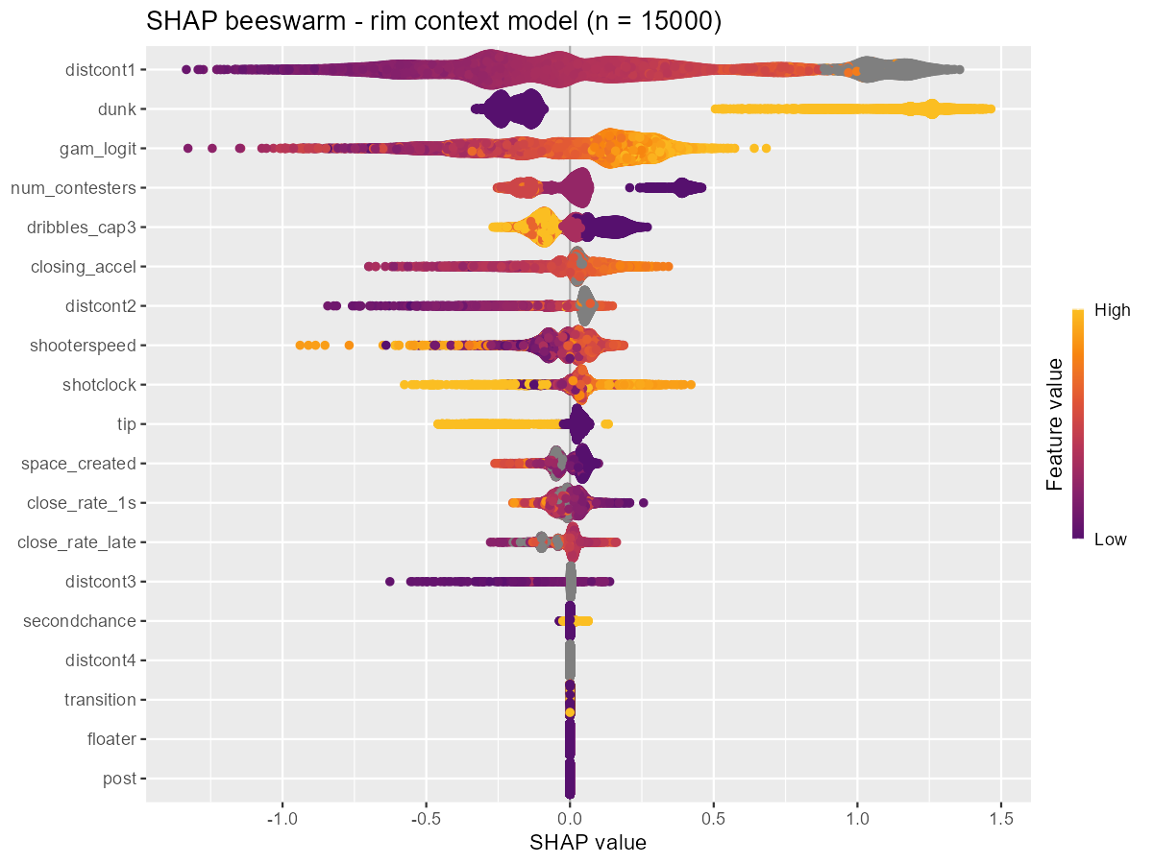
Figure 4. SHAP summary for the rim context model. Nearest-contester distance, dunk, GAM score, contester count, and capped dribbles drive predictions; grey points are missing (uncontested) contester distances.
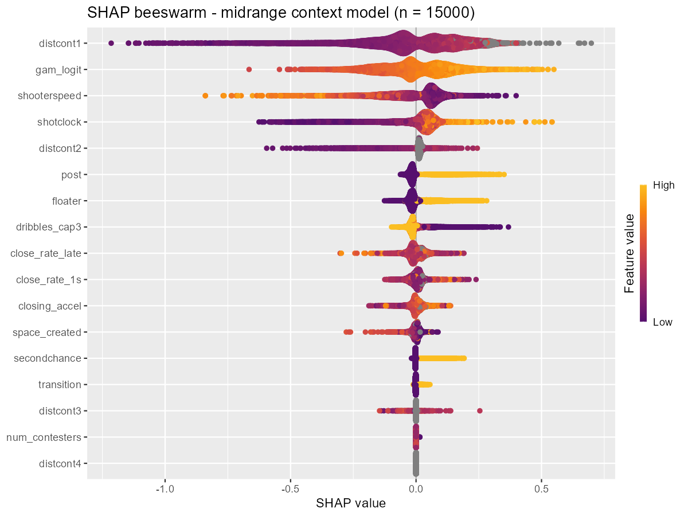
Figure 5. SHAP summary for the midrange context model. Contester distance, the GAM score, shooter speed, and the shot clock lead.
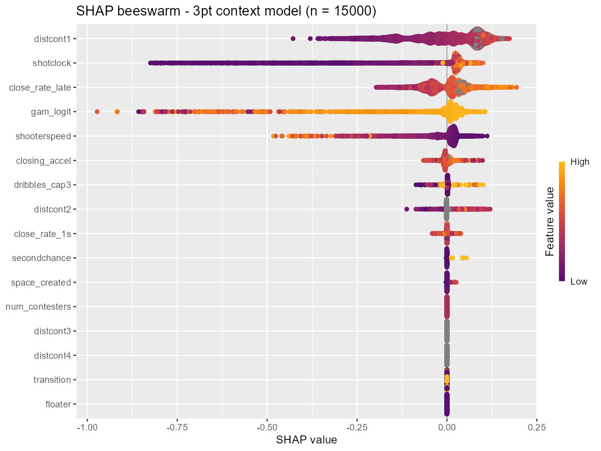
Figure 6. SHAP summary for the three-point context model. Contester distance ranks first, then the shot clock, late closeout rate, GAM score, and shooter speed; effects are compressed, reflecting a flatter openness gradient beyond the arc.
The shot-quality predictions are well-calibrated on the validation set across all three classes, tracking the reliability diagonal closely over the range each class occupies (Figure 7). Calibration is a first-class diagnostic here because log loss punishes miscalibration directly; a model that ranks shots well but is systematically over- or under-confident would score poorly.
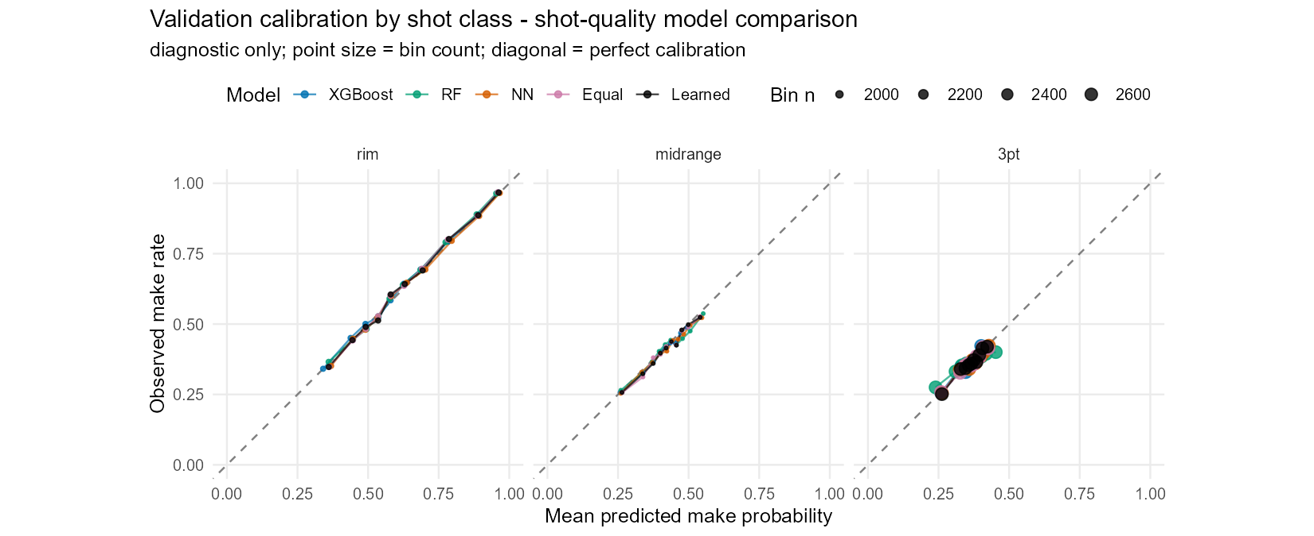
Figure 7. Validation reliability by class for the shot-quality models (all learners shown). Points lie on the diagonal, indicating well-calibrated probabilities; three-point and midrange predictions occupy a narrower probability range than rim.
5 ALTERNATIVES TESTED: RANDOM FOREST, NEURAL NETWORK, AND ENSEMBLES
Before committing to XGBoost for the context layer, I tested whether other learners or a blend could beat it on exactly the same problem - the same GAM spatial signal, the same contextual features, the same class routing, and the same honest cross-fitting. Two additional learners and two ensembles were evaluated: a probability random forest, a small feed-forward neural network, an equal-weight average of the three learners, and a learned nonnegative blend whose weights were fit to cross-fitted fitting-set predictions and then applied to the selection set.
Each alternative received preprocessing appropriate to its family (median imputation with missingness indicators for the forest and network, plus standardization for the network) and a modest, budget-appropriate search rather than an exhaustive one. A process pitfall corrected here is worth recording: an early version returned early-stopped networks trained on only part of the data, unlike the fully trained forest and boosted models; the fix records the selected epoch count and then refits the network on all eligible rows, so the comparison is fair. The learned blend's own fitting-set score is explicitly treated as a training score for the weights, not as an independent test.
The results are decisive in a quiet way. XGBoost was the best standalone learner overall and in every shot class; the random forest and neural network were each worse. The two ensembles did edge below XGBoost, but by a margin small enough to be a rounding error in practical terms: the learned blend improved validation log loss by about 0.0005, roughly 0.07% of the loss and under 2% of the improvement the context layer had already delivered over the GAM. The equal-weight average captured most of even that. A paired bootstrap put the ensemble gains just outside zero, so the effect is real but tiny.
Table 4. Shot-quality learners on the 63,766-shot validation set (log loss; lower is better).
Model | Log loss | vs. XGBoost
XGBoost (production) | 0.62881 | —
Random forest | 0.63086 | +0.00205
Neural network | 0.62947 | +0.00066
Equal-weight blend | 0.62846 | -0.00034
Learned blend | 0.62834 | -0.00047

Given that the best individual model was already XGBoost, that the learned blend's weights (0.42 XGBoost, 0.10 forest, 0.48 network) buy only a fifth of a thousandth of a nat, and that promoting an ensemble would mean maintaining three model families across three classes, two preprocessing pipelines, a neural-network dependency, blend-weight fitting, and a full re-cross-fitting for the downstream player layer - and would forfeit the clean single-model SHAP explanations - I kept XGBoost for production. The brief's emphasis on explainability and disciplined process reinforced the decision: a negligible, hard-won gain does not justify the added complexity and reduced transparency. The comparison is retained as evidence, not discarded.
6 PLAYER LAYER: LOGISTIC MIXED-EFFECTS MODELS
The first two layers are player-agnostic by construction. The third layer asks what remains after shot quality is accounted for: do particular shooters convert more than their shot quality predicts, and do particular defenders suppress makes more than the contest context alone implies? The answer must respect two hard facts about the data. Player shot counts are wildly unequal - some shooters appear thousands of times, many only a handful - and the test set is a new season, so the model must degrade gracefully for lightly-seen and unseen players. Both facts point to a mixed-effects model with partial pooling rather than to raw per-player make rates or unregularized indicator coefficients, which would badly overfit the sparse tail.
Three class-specific logistic mixed models are fit on the fitting-set outcomes. The cross-fitted shot-quality logit enters as an offset, so the random effects estimate only the residual make-probability adjustment beyond shot quality. Each model carries a class intercept (a small baseline correction), a shooter random intercept, and a defender random effect that is gated by the contest indicator so that an uncontested shot receives exactly zero defender adjustment. Partial pooling shrinks poorly-sampled players toward zero - meaning no adjustment relative to their shot-quality baseline, not toward the league average - so a player seen five times barely moves while a player seen a thousand times can move meaningfully. The estimates are fit with lme4 (a glmmTMB implementation was the original intent; lme4 was the installed, reliable fallback).
A tellingly negative result. I also implemented the theoretically nicer model: a distance-weighted multiple-membership defender term that splits credit across all contesters by proximity, fit with Bayesian approximations (mean-field variational inference and, later, Pathfinder). Both failed their approximation diagnostics badly - large Pareto-k values and near-zero estimated player variances that erased almost the entire rim gain. The predictive scores they produced were valid, but the fits were not trustworthy, and they did not beat the simpler model. The honest conclusion was to keep the single-nearest-contester lme4 model for production and to report the multiple-membership work as an instructive dead end rather than an improvement.
The offset that trains this layer is generated by cross-fitting the entire GAM-to-XGBoost procedure across three outer folds of the fitting set, so that no shot's quality offset was produced by a model that saw its own outcome. This is stricter than simply using out-of-fold GAM features: the whole upstream procedure, including its tuning, is confined to each outer training fold. Feeding the player model an in-sample XGBoost prediction would have manufactured a spurious residual for it to explain.
The estimated variance components behave sensibly. Shooter effects are present in every class but the defender effect is large at the rim, modest at midrange, and nearly vanishes beyond the arc - consistent with the intuition that rim protection suppresses makes far more than a three-point closeout does. The class intercepts are small, confirming the shot-quality offset was already well-calibrated.
Table 5. Player-layer variance components (standard deviations on the log-odds scale), fit set.
Shot class | Shots | Class intercept | Shooter SD | Defender SD | # Shooters | # Defenders
Rim | 87,152 | +0.031 | 0.199 | 0.242 | 747 | 736
Midrange | 86,892 | -0.039 | 0.167 | 0.090 | 744 | 752
Three-point | 123,622 | -0.047 | 0.146 | 0.059 | 720 | 752

The fitted effects are readable as a leaderboard, shown below for the rim, where they matter most. For each player the table gives the estimated log-odds effect, its translation into percentage points at the class reference, the number of (contested) attempts behind it, the mean shot-quality expectation from the context model, and the observed conversion rate. The gap between expected and observed FG% is what the effect captures, after shrinkage: the top rim shooter converts 78.0% against a 62.1% shot-quality expectation, earning a +11.8-point effect, while partial pooling keeps thinly-sampled players from dominating the extremes. Defender effects carry the opposite sign convention - a negative effect suppresses opponent makes - and the strongest rim protectors hold opponents roughly 12 to 15 points below expectation on contested attempts.
Table 6. Rim shooter effects - five most and five least effective by estimated random effect (fit set).
Shooter | Effect | PP | Attempts | Exp FG% | Act FG%
a2db3a89dd | +0.628 | +11.8 | 282 | 62.1 | 78.0
14f1a35113 | +0.566 | +10.7 | 542 | 57.2 | 70.3
4498318275 | +0.536 | +10.3 | 739 | 65.2 | 75.4
c56c1e9130 | +0.449 | +8.8 | 286 | 61.0 | 73.4
b67a1aff5a | +0.429 | +8.4 | 729 | 57.0 | 65.0
9e884511eb | -0.327 | -7.4 | 165 | 68.1 | 57.0
8916e1c710 | -0.340 | -7.7 | 129 | 62.7 | 49.6
188070e015 | -0.372 | -8.5 | 206 | 59.1 | 46.1
547895506a | -0.318 | -7.2 | 463 | 67.3 | 58.5
6106b1bccb | -0.301 | -6.8 | 568 | 71.7 | 64.8

Table 7. Rim defender effects - five best (most make-suppressing, negative) and five weakest, by estimated effect (fit set).
Defender | Effect | PP | Contested att. | Exp FG% | Act FG%
b3c28fe3af | -0.631 | -14.8 | 581 | 60.0 | 46.5
835f46c9f8 | -0.538 | -12.5 | 341 | 58.6 | 46.3
91f4f737b5 | -0.515 | -12.0 | 374 | 56.0 | 43.9
0791320284 | -0.495 | -11.5 | 660 | 58.2 | 47.9
8efeafe542 | -0.493 | -11.4 | 272 | 57.7 | 45.2
298574f6e3 | +0.360 | +7.2 | 52 | 63.0 | 82.7
2951ede20e | +0.364 | +7.3 | 198 | 58.5 | 70.7
78d849f72c | +0.402 | +7.9 | 86 | 62.1 | 80.2
46a7a7ad66 | +0.424 | +8.3 | 59 | 60.4 | 83.1
d609c7c1e9 | +0.465 | +9.1 | 167 | 57.7 | 73.7

These effects are conditional predictive associations, not causal measures of skill or defensive value; the defender term captures only residual make-suppression when a player is the recorded nearest contester, and single-contester attribution is an approximation on multi-defender plays. Adding the player layer lowered validation log loss from 0.6288 to 0.6258, a small but consistent gain that, like the context gain, is largest at the rim. A shooter-and-defender model that improves a well-calibrated shot-quality baseline by three-thousandths of a nat is doing modest, honest work; it is not rediscovering shot quality under a different name, because the offset already removed that.
7 FINAL ASSESSMENT AND PREDICTIONS
Model development used a single fixed split of the labeled data, keyed by shot id and stratified by season and class: 70% to fit all layers, 15% as a selection set for comparing settings and measuring each layer's increment, and 15% as a final holdout that was frozen until the pipeline was fixed. Every result above the final row of Table 8 is a selection-set number used to make decisions; the holdout exists to check that those decisions generalize. The table below traces log loss down the full stack.
Table 8. Log-loss progression down the model stack. Validation is the selection set; the frozen holdout confirms the two production stages.
Model stage | Validation | Final holdout
Overall mean-FG% baseline | 0.6896 | —
Shot-class baseline | 0.6609 | —
Location GAM | 0.6539 | —
+ Context XGBoost (shot quality) | 0.6288 | 0.6301
+ Player effects (production) | 0.6258 | 0.6273

The frozen holdout tells the same story as the selection set, only slightly attenuated: shot quality scores 0.6301 and the full player-adjusted model 0.6273 on 64,287 untouched shots. The close agreement between selection and holdout numbers is the strongest evidence that the pipeline is not overfit to the rows used to build it, and that the honest cross-fitting did its job. The test set is a new season, but essentially all of its shooters and defenders appear in training (about 99.5% and 99.2% respectively), so the player layer applies to nearly every test row; the small unseen-player fraction receives a zero adjustment and falls back to the shot-quality prediction.
From assessment to submission. For the production predictions the entire pipeline is refit on all labeled data: the GAM-to-XGBoost procedure is cross-fit across the full set to regenerate honest shot-quality offsets, the three mixed models are refit on those offsets, and the frozen recipe is used to score the 213,977 test shots and populate submission.csv in the template's exact row order. The holdout figure of 0.6273 is the best available estimate of out-of-sample log loss against observed outcomes; the brief's hidden benchmark instead compares against an in-house probability model, so this number is a faithful local proxy rather than a prediction of the contest score.
Reflections, pitfalls, and limitations
The process was as important as the result, and several pitfalls shaped the final design. Cross-fitting is subtle: an early tuning routine let GAM features leak across boosting folds, and an early player-layer pipeline inherited hyperparameters chosen on data it was meant to exclude - both were corrected so that every prediction excludes its own outcome from all upstream fitting and selection, not just from the final estimator. A quiet probability-conversion bug (an out-of-fold column computed from the wrong logit) was caught only because a difference diagnostic was zero everywhere it should not have been. The multiple-membership defender model was a genuine dead end whose diagnostics, not its scores, told the truth. And a defensible but simplifying choice - attributing each contested shot to a single nearest contester - remains an approximation on crowded plays.
Several extensions would be worth pursuing with more time or data. A game identifier (absent here) would enable game-level clustering for honest uncertainty intervals and would let the model borrow strength within games. Player-season dynamics and separate shot-creation versus finishing effects could sharpen the player layer. A reliable Bayesian fit of the distance-weighted defender model, or a well-tuned monotone or contextual GAM, might recover the last fraction of signal the ensembles hinted at. Most consequentially, because the test set is a new season, explicit cross-season partial pooling and a calibration check against the in-house reference probabilities - if they became available - would address the one generalization gap the local holdout cannot fully measure. The model that ships is deliberately the transparent, well-validated one: a smooth spatial base, three explainable context models, and a shrinkage-based player layer, each earning its place on the validation and holdout evidence above.

